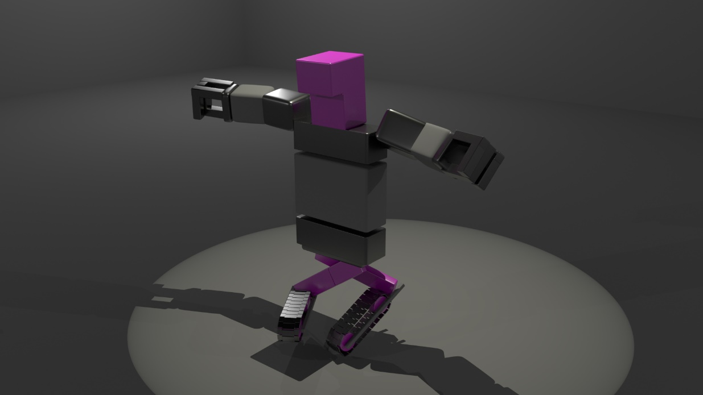

Animation Production

Dance Assignment

Freddie Jones

[Year]

# Pre-production & Planning

The next part of my animation was to make the robot built in the first assignment dance. This involved choosing music, choreographing a dance for that music, animating the movement for the dance, shading the robot model, lighting the scene, and finally rendering the animation.

The first step was to choose the right music. I wanted something with some definitive beats, the viewer could feel the impact of the robot’s movement. So, I listened to a few songs and first decided on a pop song, Dynamite. I felt this worked due to clear beats and a somewhat repetitive nature.

With the song chosen, I then needed to choreograph a dance for that song. For reference, I used YouTube videos. I found videos of people dancing to Dynamite. With these I could start planning out a dance to suit my robot.

# Implementation Process & Discussion

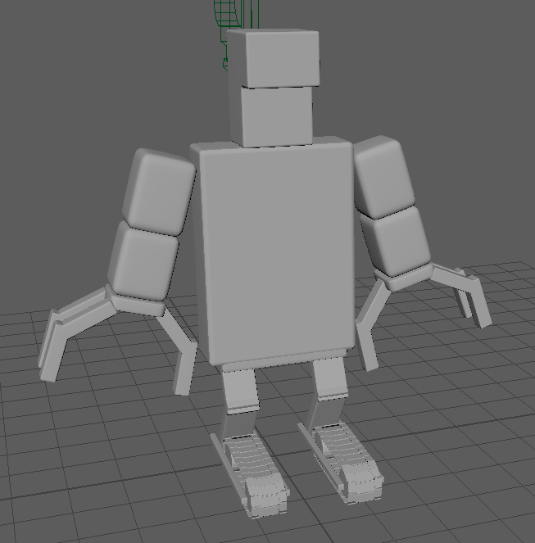Before I started on the actual animation however, I first needed to fix my robot model. At the end of the last assignment, my model was looking very basic, only made up of a few primitives. This wouldn’t make for good looking movement. So, I had to improve the model. This involved splitting up the limbs and torso into separate segments. For example, the arm primitive was split into an upper arm, lower arm and hand segment, with the hand split further into a wrist and fingers. I also slightly bevelled the edges of all the geometry on the model, in order to get specular highlights on the edges.

New model for the robot

The next step was to build the rig for my robot. Building the rig required several steps. The first was placing the joints. I had to place the joints on parts of the model that would bend. For example, on the arms, the joints are placed on the shoulder, elbow and wrist. The joints work as a hierarchy of parents and children. I placed the root joint in the centre of the body, with joints for the upper and lower part of the body. I also had to add spur joints to the limbs, so that when I added IK handles, they weren’t connected to the root joint. I only made the joints on one side of the body however, so I could mirror them perfectly to the other side. Then, I parented the geometry with the appropriate joints. Now when the joints move the limbs move with it. With that the joints were in place.

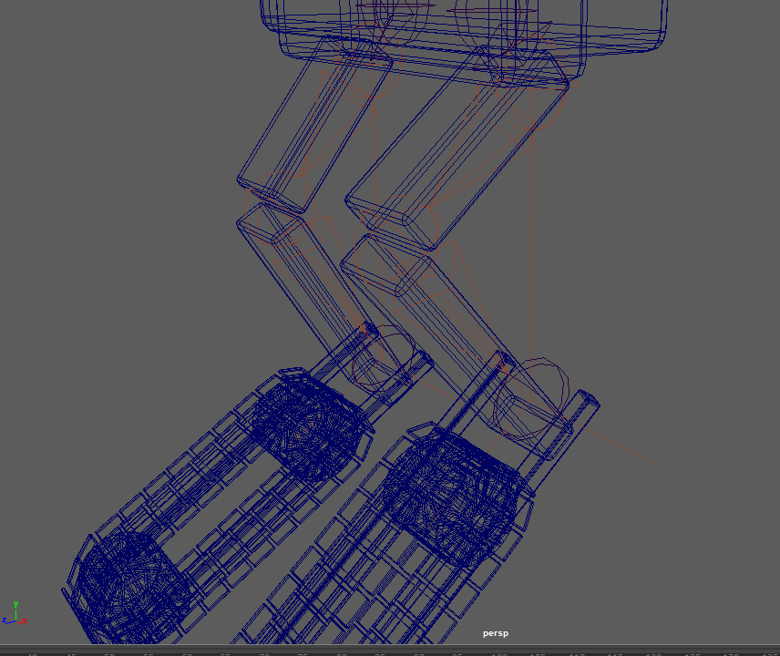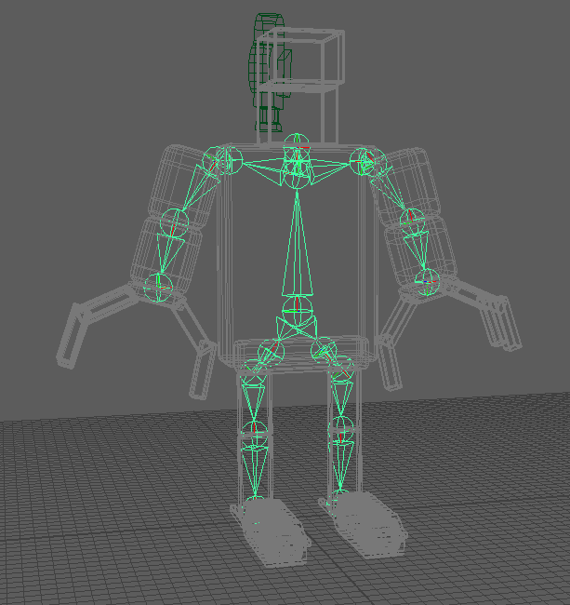Then I had to assign IK handles to the joints. These handles allow better control of the rig, as it negates the need to manually keyframe each joint rotation. I assigned single chain solvers to each set of limb joints. Now when I moved the foot, the whole leg would bend as it should. However, some of the limbs didn’t bend as they should. Like the leg; it would bend sideways as the foot moved up. This was an easy fix, it required me to set the preferred angle of the joints in the limbs, then reassign the IK handles. This fixed the problem. I then parented locators to the IK handles, giving me better controls to use. Now the robot’s rig was finished.

Single chain solver IK handles for the legs of the robot

Joints assigned for the robot

With the rig done and the music sorted, I wanted to play around and experiment with the dance. I played the segment of song on loop and tried to plan a few moves. After getting a second opinion however, I believed I was going in the wrong direction. I was instead encouraged to think about what movements I could make that are special to my robot. What was unique about my robot was that it moved on treads. So, I used that for the grounding of the dance, and instead focussed on roller skating dance moves. I felt these moves could better show off what my robot could do. I looked at more YouTube videos to get an idea of the types of moves the robot could do. I used a few reference videos for some moves. However, with this new direction, I also needed a new song. Pop didn’t feel right anymore. So, I decided to go for funk music instead. After looking on the internet, I found some royalty free funk music that goes well with the style of dance. With the music, the last step was to choreograph the dance. For this, I used my real-life version of the robot to act out some of the moves. I stitched them together after listening to the section of song I’d chosen on loop to work out my dance routine. This also helped me work out the timings of the moves. Now I could start animating the robot.

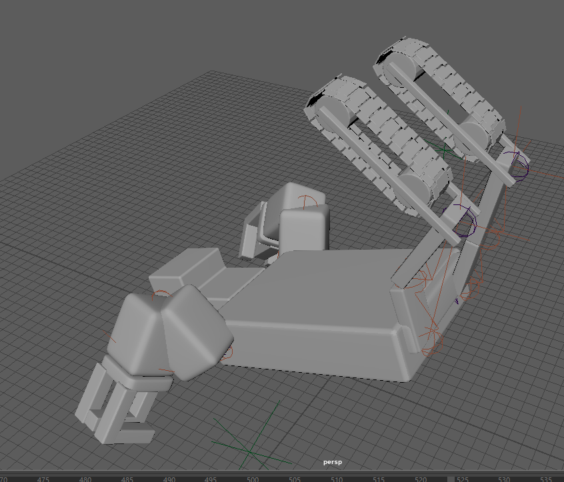The first part of the dance was a kip up. This is were the robot goes from a lying down position to a standing up position, by pushing themselves up. I had to use a video as a reference to make sure I was getting the motion correct. The full motion is the robot putting their arms behind their head, lifting their legs up, then pushing off the ground. While it’s in the air, the robot puts its legs down on the ground and leans forward, pushing the body in to an upright position. I keyframed each pose until the motion was correct.

The robot mid kip up

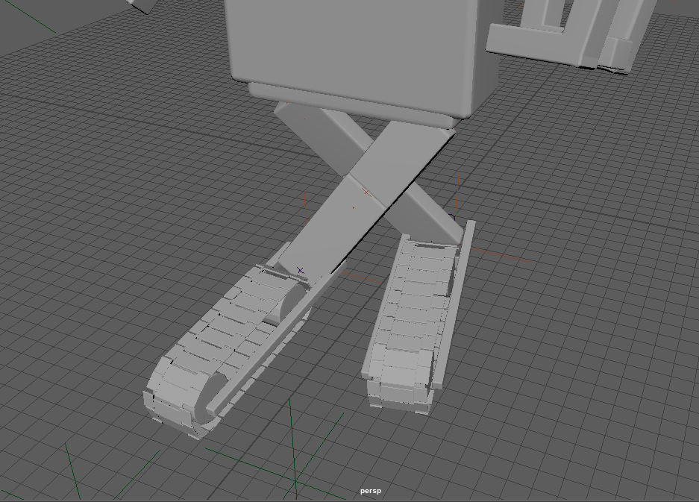The next part of the dance was a criss-cross leg motion on roller skates. This was a repetitive motion, so I decided to use set driven key. This involved keying each IK handle movement to a single attribute, then using that attribute to keyframe on the timeline. And so that is exactly what I did. This came out well, except for a bit of clipping between the feet. After that I planned on having the robot continue this move, while simultaneously travelling in a circular motion. For this initial stage of animation, I didn’t want to put too much time into this, so I simply keyframed the whole model moving in a circle.

Criss crossed legs of the robot

The next move was the robot sliding back into the centre. However, I was presented with a problem. After using set driven key for the IK handles for the legs, I was no longer able to individually keyframe those IK handles. This meant I had to use another set driven key attribute for the sliding motion. This also affected my future workflow, as now all future movement for the legs would have to be done through set driven key. However, this didn’t affect my already keyed frames, like the kip up.

After the slide, the robot does a moonwalk backwards into a spin on one of its feet. The moonwalk was simple to animate, as it’s just the legs moving up and down out of phase. Again however, I had to use set driven key for this move. This worked well for this part as it was a repetitive move while moving the robot back set intervals. The spin was not so easy. Whenever I spun the robot around, the IK handles would cause the limbs to twist around to face the handles. So, for the time being, I only spun the torso around. At this time, I hadn’t quite got what the next move should be to finish the dance routine. So, for the mean time, I wanted to get feedback on the current state of it.

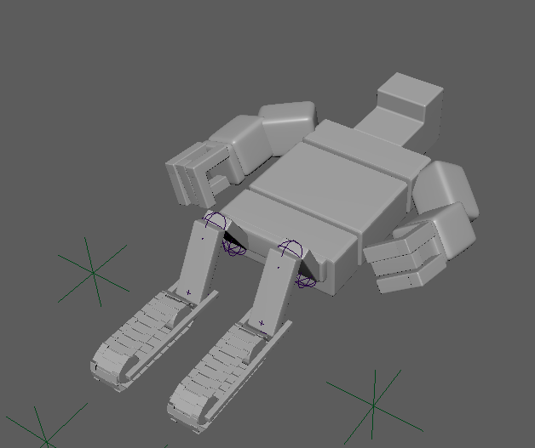After feedback, I felt I was on the right track, so got to work improving the animation as a whole. One idea I decided to take on board was to split the torso into separate parts. This would allow the robot greater flexibility. This only required that I split the geometry and add a couple more joints, then parent them all correctly. Another improvement was in controlling the direction of the feet. To do this, I made a locator, then aim constrained the foot joint to this locator. Now when I moved the locator, the foot followed with it. I did this for both feet. I then had to use these improvements, first with the kip up. However, because I had first keyframed this part before moving to the set driven key workflow, I couldn’t improve on it without redoing it all in set driven key, which is what I did. While there may have been a way to convert the keyframes I already had into a set driven key attribute, I decided it would take more time to find and implement this instead of just redoing it. With this new attribute, I could incorporate the extra torso sections to show the robot’s spine bending as it flips up.

Newer model for the robot with the torso split

Another problem I discovered while redoing the kip up was with how I’d rigged the arms. With the current setup, whenever I moved the arm handles, they would often twist and contort unnaturally. I found that this was a problem with which IK handle solver I had used. What I used was a single chain solver, but I should’ve used a rotate plane solver. This solver restricts how the shoulder rotates to a plane in space. So now when the arm reaches behind his head, it bends how it should, with the elbow sticking up. I fixed this for both arms. With this fixed, the kip up looks really natural.

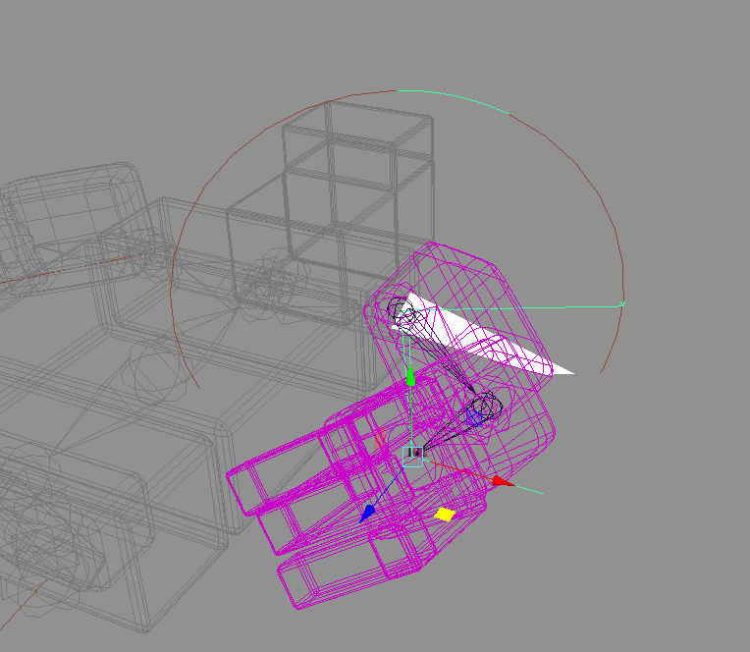Going from the kip up to the criss-cross, I wanted to add to the story. So, I added a little bit where the robot discovers he can slide about on his treads, then wants to dance. Then going into the criss-cross move, I wanted to add to that discovery with the arm movements. Now when he first starts to dance, his arms are out as if trying to balance himself. Once he’s got the hang of it, his arms are going to swing by his side with more confidence, as if he’s really getting into it. This was a simple set driven key attribute to swing the arms. This was especially useful as I could continue this swinging as the robot moves in a circle. The next thing was fixing the criss-cross clipping. This was a simple fix of adding extra poses in between other poses, where it’s clear the robot lifts its legs up over each other. I also added some extra torso movement into the criss-cross set driven key, such as the hips twisting as the robot puts a foot forward, as well as a little bounce. This adds a more natural feel to its movement. As well as this, I also added some force to the circle movement. Now it’s more looks like he’s pushing himself around and there’s momentum.

IK handles for the arms of the robot replaced with rotate plane solver IK handles

Once the criss-cross motion had been finished, I added to the moonwalk. I just added some rhythmic bouncing and posed the robot to be bent over, one hand on his midriff and the other to his face, Michael Jackson style. The next move to fix was the spin. I figured the easiest way to get this to work was to use a set driven key, then pose the robot as the spin progresses. This worked well, especially as I could focus the spin on the foot locator, so the foot would always match the spin.

After that, I had to go through my final dance move. At this point, I had decided to have my robot jump in the air, land on his hands, then spring back up into the air to finally land on his feet. I felt a complex movement for the finally tops the whole dance off nicely. However, I couldn’t find any reference videos of people doing this online. So, I had to freehand it. It came out great though, with the back arching as it’s in the air, and the legs stretching and curling to launch the robot. After using set driven key to get the poses right for the jump, the last bit was to keyframe the whole robot moving forward as he jumps, with a small slide forward as it lands. With that, the choreography and animation were complete.

The final touch was lighting and shading. I went simple with these. Firstly though, I staged the scene. I just went with five planes, one for the floor and four for the walls. Then I added lights. I added four point lights in the corners of the room to light the exterior, then a spotlight on the robot, following it as it danced. This would help keep the viewer focused on the robot, without making it look like it’s dancing in a pitch black room. Lastly, I shaded the robot. I went with mainly blinn shadings, and a few lambert shadings so it wasn’t entirely reflective. I also added a splash of pink-purple to make it colourful and stand out.

# Conclusion

Final lighting and shading

As a whole, I believe the final animation is underwhelming. While the motion is pretty good, the story doesn’t flow with the previous animation. I feel I could’ve emphasized the robot’s discovery of its ability to dance. I could’ve also done better on the staging of the scene. It comes off too rushed. However, as I said earlier, I like how the motion came out. It made me believe the robot was on skates sliding about the room. I’m especially a fan of the final move, it looks really natural. If I were to redo this animation, I would definitely organise it better. Going into this, I believed that I should get the rig done first, then play around with dance moves to see what was feasible. This left me with less time to hash out what the story would be and how it would carry on from the previous one. So, I would’ve planned the choreography out with storyboards or an animatic, as well as blocked out the camera motion. Getting this down would’ve allowed me to build a better stage and improve the overall feel. Given enough time, I could’ve also incorporated the little robot into the dance too. This could’ve been fun seeing the two robots’ side by side.