通知设置相关接口

1. 获取用户的邮箱设置和信息。
2. 请求地址

[http://web.is8.com.cn:8031/om/webpart/mail/EmailDo?action=showEmailConfig](http://117.78.52.164:8003/om/webpart/mail/EmailDo?action=showEmailConfig)

返回值为JSON格式。

1. 参数说明

|  |  |  |
| --- | --- | --- |
| **参数名称** | **含义** | **说明** |
| action | servlet 请求 | showEmailConfig |

1. 返回值

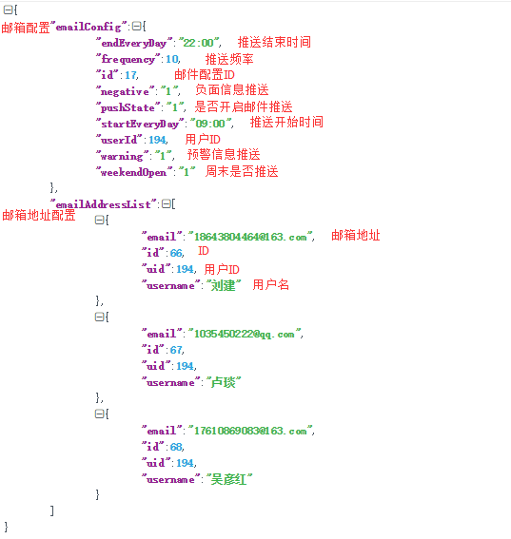

1. 删除邮箱地址
2. 请求地址

[http://web.is8.com.cn:8031/om/webpart/mail/EmailDo?action=removeEmailAddress&id=26](http://117.78.52.164:8003/om/webpart/mail/EmailDo?action=removeEmailAddress&id=26)

1. 参数说明

|  |  |  |
| --- | --- | --- |
| **参数名称** | **含义** | **说明** |
| action | servlet 请求 | removeEmailAddress |
| id | 要被移除的邮箱ID | 如：id=20 |

1. 返回值(JSON类型)

① 删除成功



② 删除失败



1. 新增或修改邮箱配置及地址
2. 请求地址

[http://web.is8.com.cn:8031/om/webpart/mail/EmailDo?action=saveEmailConfig](http://117.78.52.164:8003/om/webpart/mail/EmailDo?action=saveEmailConfig)

&emailConfig={"endEveryDay":"22:00","frequency":10,"id":17,"negative":"1","pushState":"1","startEveryDay":"09:00","userId":194,"warning":"1","weekendOpen":"1"}

&emailAddressList=[{"email":"18643804464@163.com","username":"刘建"},{"email":"1035450222@qq.com","username":"卢琰"}]

1. 参数说明

|  |  |  |
| --- | --- | --- |
| **参数名称** | **含义** | **说明** |
| action | servlet 请求 | 保存邮件配置及地址 |
| emailAddressList | 收件人的地址列表 | JSON格式 |
| emailConfig | 邮箱配置 | JSON格式 |



新增邮箱地址时：

emailAddressList的值 (用户名可以省略)

[{"email":"495563325@qq.com","username":"刘建"},

{"email":"1035450222@qq.com","username":"卢焱"}]

新增邮箱配置时：

emailConfig的值

{"endEveryDay":"21:00","frequency":5,"negative":"1","pushState":"1","startEveryDay":"10:00","warning":"1","weekendOpen":"1"}

修改邮箱地址时：

emailAddressList的值,一定要带ID 才能修改到

[{"email":"495563325@qq.com","username":"刘建","id":66},

{"email":"1035450222@qq.com","username":"卢焱","id":67}]

修改邮箱配置时：

emailConfig 的值,一定要带ID才能修改到。

{"endEveryDay":"22:00","frequency":10,"id":17,"negative":"1","pushState":"1","startEveryDay":"09:00","userId":194,"warning":"1","weekendOpen":"1"}

1. 返回值(JSON类型)
   1. 成功



* 1. 失败



1. 开启和关闭邮件推送
2. 请求地址

<http://web.is8.com.cn/om/webpart/mail/EmailDo?action=updateEamilPushState&pushState=0>

1. 参数说明

|  |  |  |
| --- | --- | --- |
| **参数名称** | **含义** | **说明** |
| action | servle请求 | updateEamilPushState |
| pushState | 邮件推送状态 | 0关闭，1开启 |

1. 返回值(JSON类型)
   1. 登录超时



* 1. 修改状态失败



* 1. 修改状态提示





PS.

1. 邮箱格式要验证
2. 删除邮箱时，如果不是已存在于数据库中的(带ID)，前端动画效果删除但是不发送请求。