Hello! My name is Freddy Jason (haha, just kidding), and I want to tell you how to add a new font to Undertale.

We will need:
- The game itself. This method is suitable for any game made in Game Maker.
- Game Maker: Studio. You can get it for free via Steam.
- Graphics editor with support for alpha channel (transparency).
- Straight arms.

IMPORTANT NOTE: If you use Translatale to translate the game, remember that the gmktool inside it wiil not be able to dum por repack files from the data.win after adding the new fonts. So, translate what you want to test, including the special characters, before adding the new font. Also, if you use Translatale, you can jump step 10 and just let the “trasnlate.txt” file blank.

1. Unpack the data.win file from Undertale unsing my utility WinExtract. To start it conveniently create a bat file. With this structure:

winextract [path of the data.win file] [path to were extract the files]
pause

For example:

winextract D:\Games\Undertale\data.win D:\Undertale_data\
pause

Let’s take a look at what the utility has unpacked.

- CHUNK Folder – contains whole chunks which are only necessary when packaging the game back.
- AUDO Folder – contains the sounds of the game.
- FONT Folder – It contains the extracted fonts and sprites for them
- FONT_new folder – It will be used to replace the fonts
- TXTR folder – It contains sprite sheets
- STRG.txt file – It contains all the strings constants used in the games.
- translate.txt file – It will contain the translated strings.

2. Create a project in Game Maker: Studio. I usually load the default demo project.
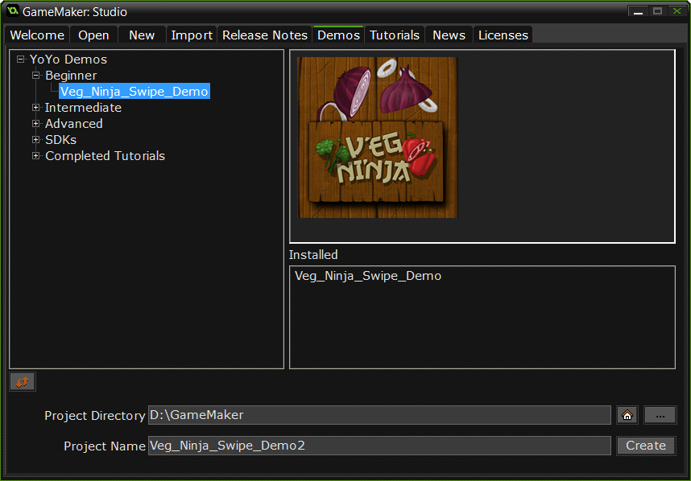

3. Create a new font. You must have the same font that you use in the game. Create it and choose the Font Family you want in the new font properties. Turn anti-aliasing and high quality off for it too look exactly like Undertale fonts.
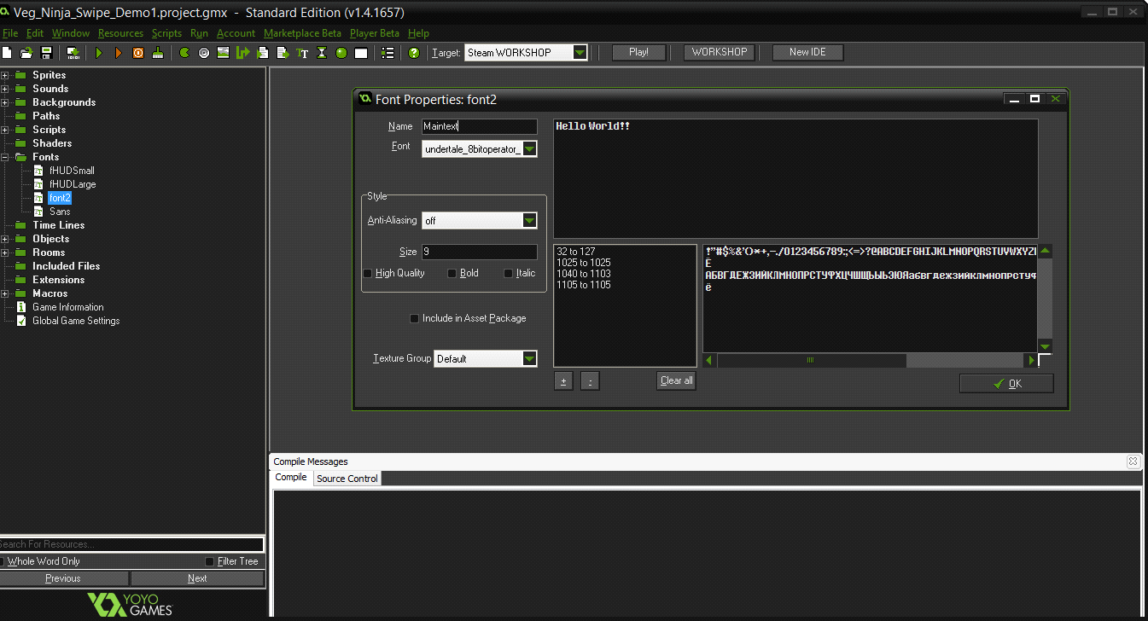

4. Click in the “+” symbol to change the font range and add the necessary symbols.
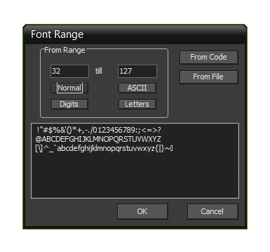
5. Save the project.

6. Go to %project folder%/fonts. Here, including standard fonts of the game, will lie the fonts that we will add in Undertale.

7. Copy new fonts and sprites into FONT_new folder.

8. Now edit patch.txt.
Each line contains 2 parameters, separated by semicolons. For example:

2;2_new.gmx

The order of the parameters: the index of the replaced font, name of new font *.gmx file.

9. Edit translatale.txt. See screenshot:
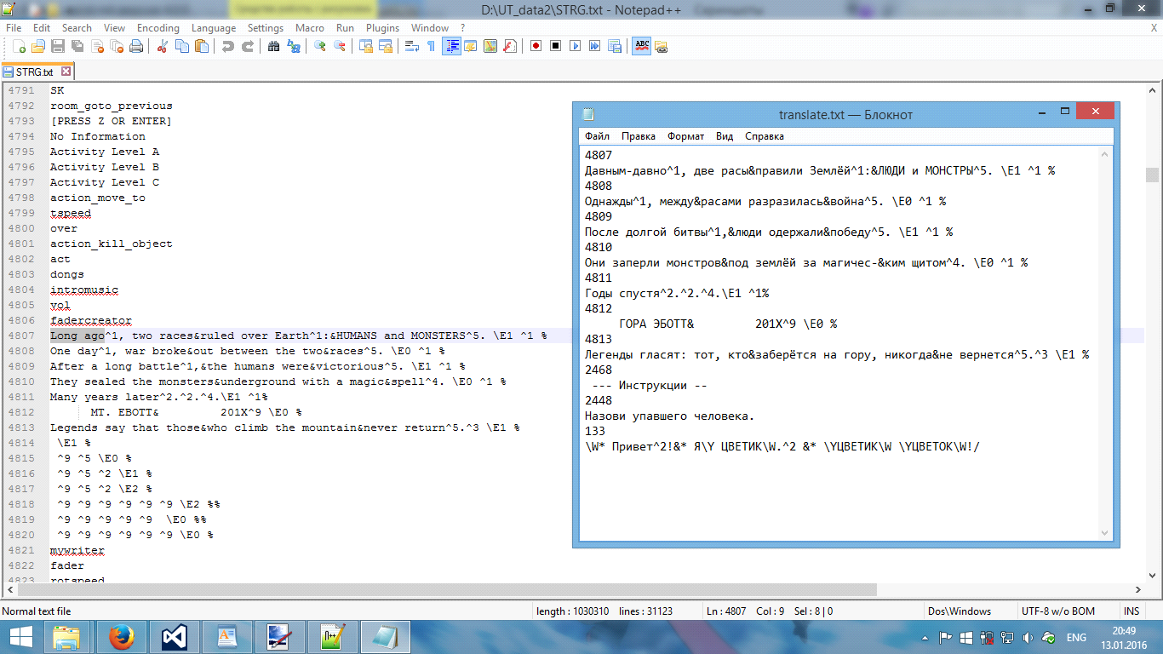

Important! Remember to save the file in UTF-8!

UPD 16.01.16: You can put comments in translate.txt. Use // in the beginning of line (not in middle!)

10. Everything is ready to be repacked with WinPack:

winpack D:\Undertale_data\ D:\Games\Undertale\data.win
pause

12. Done!
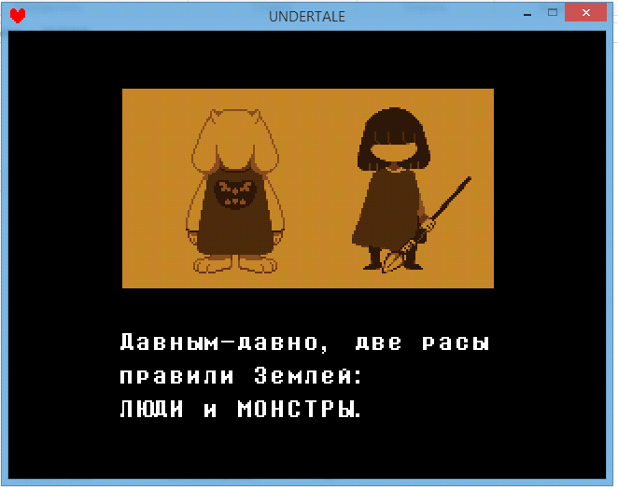

It's very chaotic instruction. If you do not understand, please contact Skype fjay69. Please note that my time zone - GMT + 3.
(So, yeah, this was translated by MEX, a Brazilian, translating from Russian to English :v I personally think it is indeed very well explained.)

