TAKING A LOOK
"COVANOS"
PROJECT

Talking with Sebastian and Juan, they commented my about this project and that little bug into Patients List.

- All server side data are handle using "axios" and “Vuex”.

- “Vuex” implementation is incorrect, must be use mapping. The app works anyways, but is a bad practice accessing to global data that way. Note: "that way" means accessing using store instance directly.

- Development console throws an error in `~/src/api/analysisApi.js`. In line 45 call a method and it has a comment saying "// Se simula el acceso a los datos".

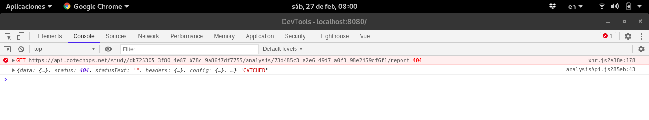

- That error (point 3) occurs every time that data are refresh.

1st bug: talking to Juan I commented him this. For me, this error is within store implementation, specifically in `~/src/store/modules/analysis.js`. But, I'm not sure.

Solution: Every time that the analysis list is open, I set an empty array in `this.analysisList`.

Implementation: `this.analysisList=[]` line 161 `~/src/components/PatientAnalysisList.vue`.

Note: Another solution could be to modify the store, changing the mutation that updates it. But I didn't want to do it because I don't know if that data is used in other components. I was focus on the 2 components where the problem was be.

2nd bug: when data is sorted and studies list is expanded. The expanded list reload again and that don't must be happen.

Possible Solution: Each patient on the list is not related to your study list. I suggest putting the list of studies for each patient within the patient object. After that, just sent the study list from the parent component to child component.

