**Tornado analysis**

*After reading the paper by Fricker, et al., it seems as though some research has been conducted on the relationship between tornado causalities, population density and tornado intensity. We have previously discussed the differences in diurnal tornado casualties. Research has shown that tornadoes after dark as twice as deadly as daytime tornadoes. I would like to focus my capstone on an exploratory analysis of why nighttime tornadoes are twice as deadly as those that occur during the daytime hours. Using a spatial regression using various demographic data, my analysis will seek to determine if there are other factors lending to the increased causalities caused by nighttime tornadoes.*

* Plot deadly nighttime tornadoes spatially
  + Where did they occur? Is there a pattern?
* Add in census data to determine if demographics data has an impact on deadly nighttime tornadoes
  + Median household income
  + Age – are older people more at risk?
  + Education
  + Mobile home density – if data is available
  + Are there any others we should explore?

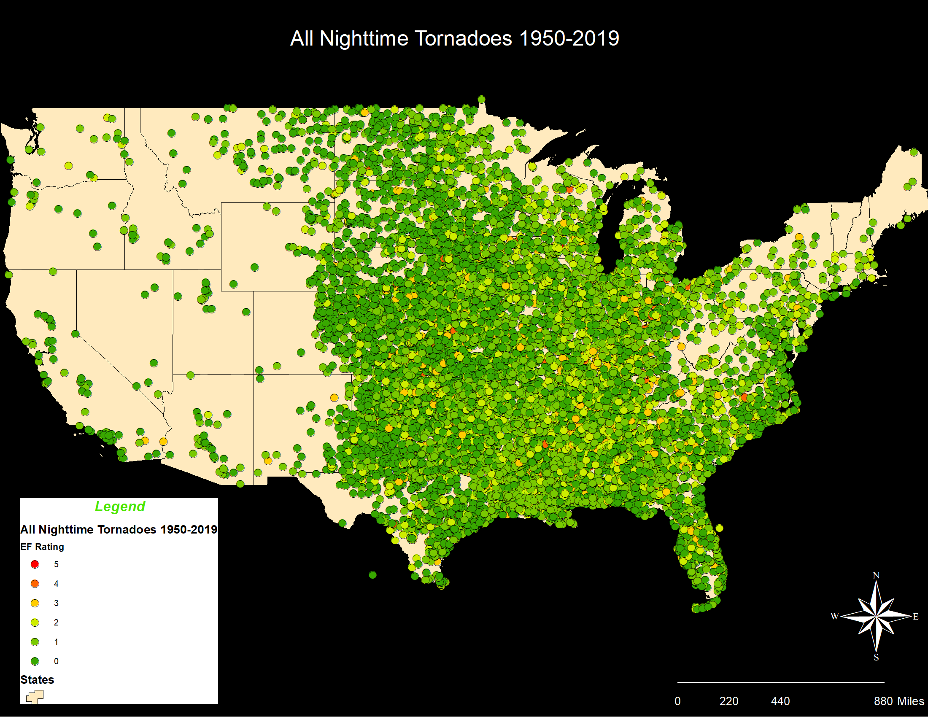

The map above shows all nocturnal tornadoes between 1950 and 2019. The tornadoes are symbolized by EF rating (EF0-EF5). Over the period of observation, 13,856 tornadoes occurred at night. For the purposes of this study, nocturnal tornadoes are defined as a tornado occurring between 18:00 and 06:00. There is no strong visual spatial relationship between nocturnal tornadoes.

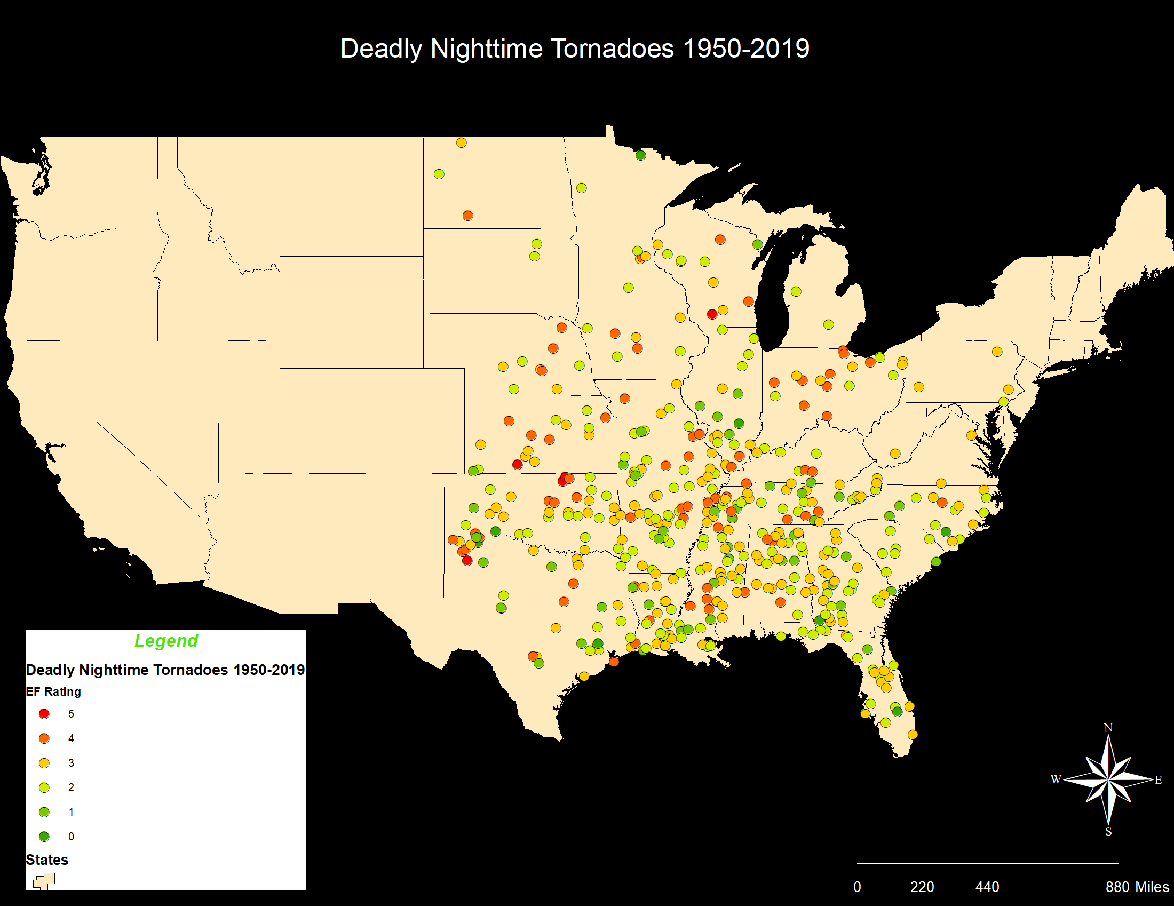

This map depicts nocturnal tornadoes that caused at least 1 fatality. Of the 13,856 tornadoes occurring at night, only 457 (3.3%) caused at least 1 fatality, amassing a total of 1,425 fatalities. One tornado, an EF5 on May 25, 1955 that struck at 22:00, resulted in 80 fatalities alone. Of those 457 resulting in at least 1 fatality, 231 caused exactly 1 fatality (50.5%). Only 26 of the 457 deadly nocturnal tornadoes accounted for 10 or more fatalities (5.6%). 97% (13,399) of nocturnal tornadoes over the period of observation accounted for zero fatalities.

Again, we do not see any clear spatial patterns for occurrence of nocturnal tornadoes. However, there does seem to be a clustering in western Tennessee stretching south through Mississippi. More analysis could be performed to determine if any demographic data can explain this cluster of particularly deadly nocturnal tornadoes.

**Spatial Regression**

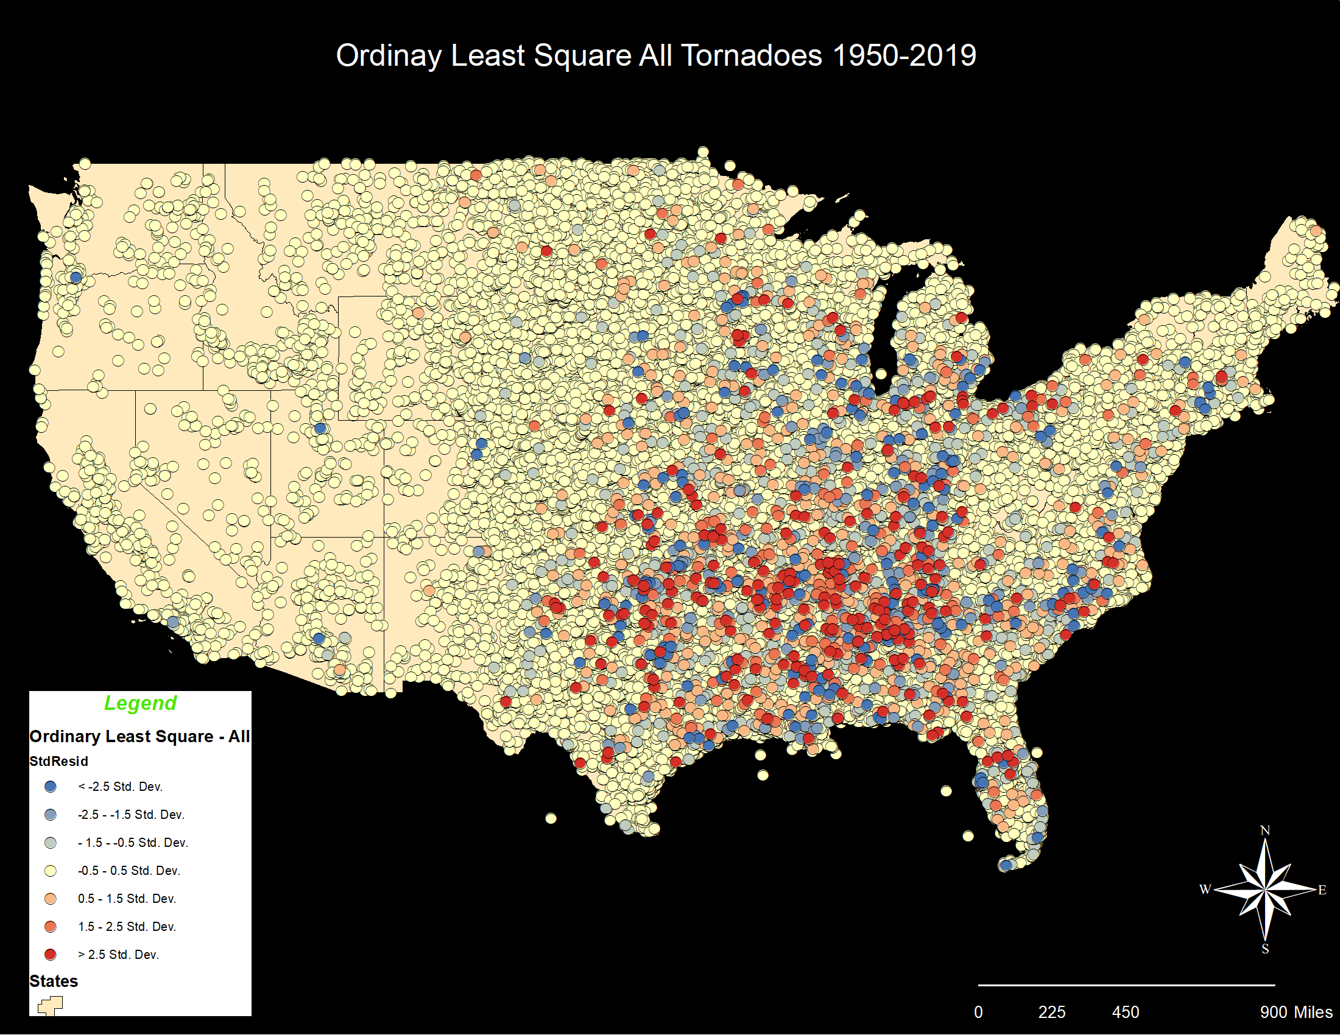

The map above displays the results of the Ordinary Least Square analysis run within ArcGIS. The dependent variable was set to fatalities (fat) while the exploratory variables were damage (loss) and injuries (inj).

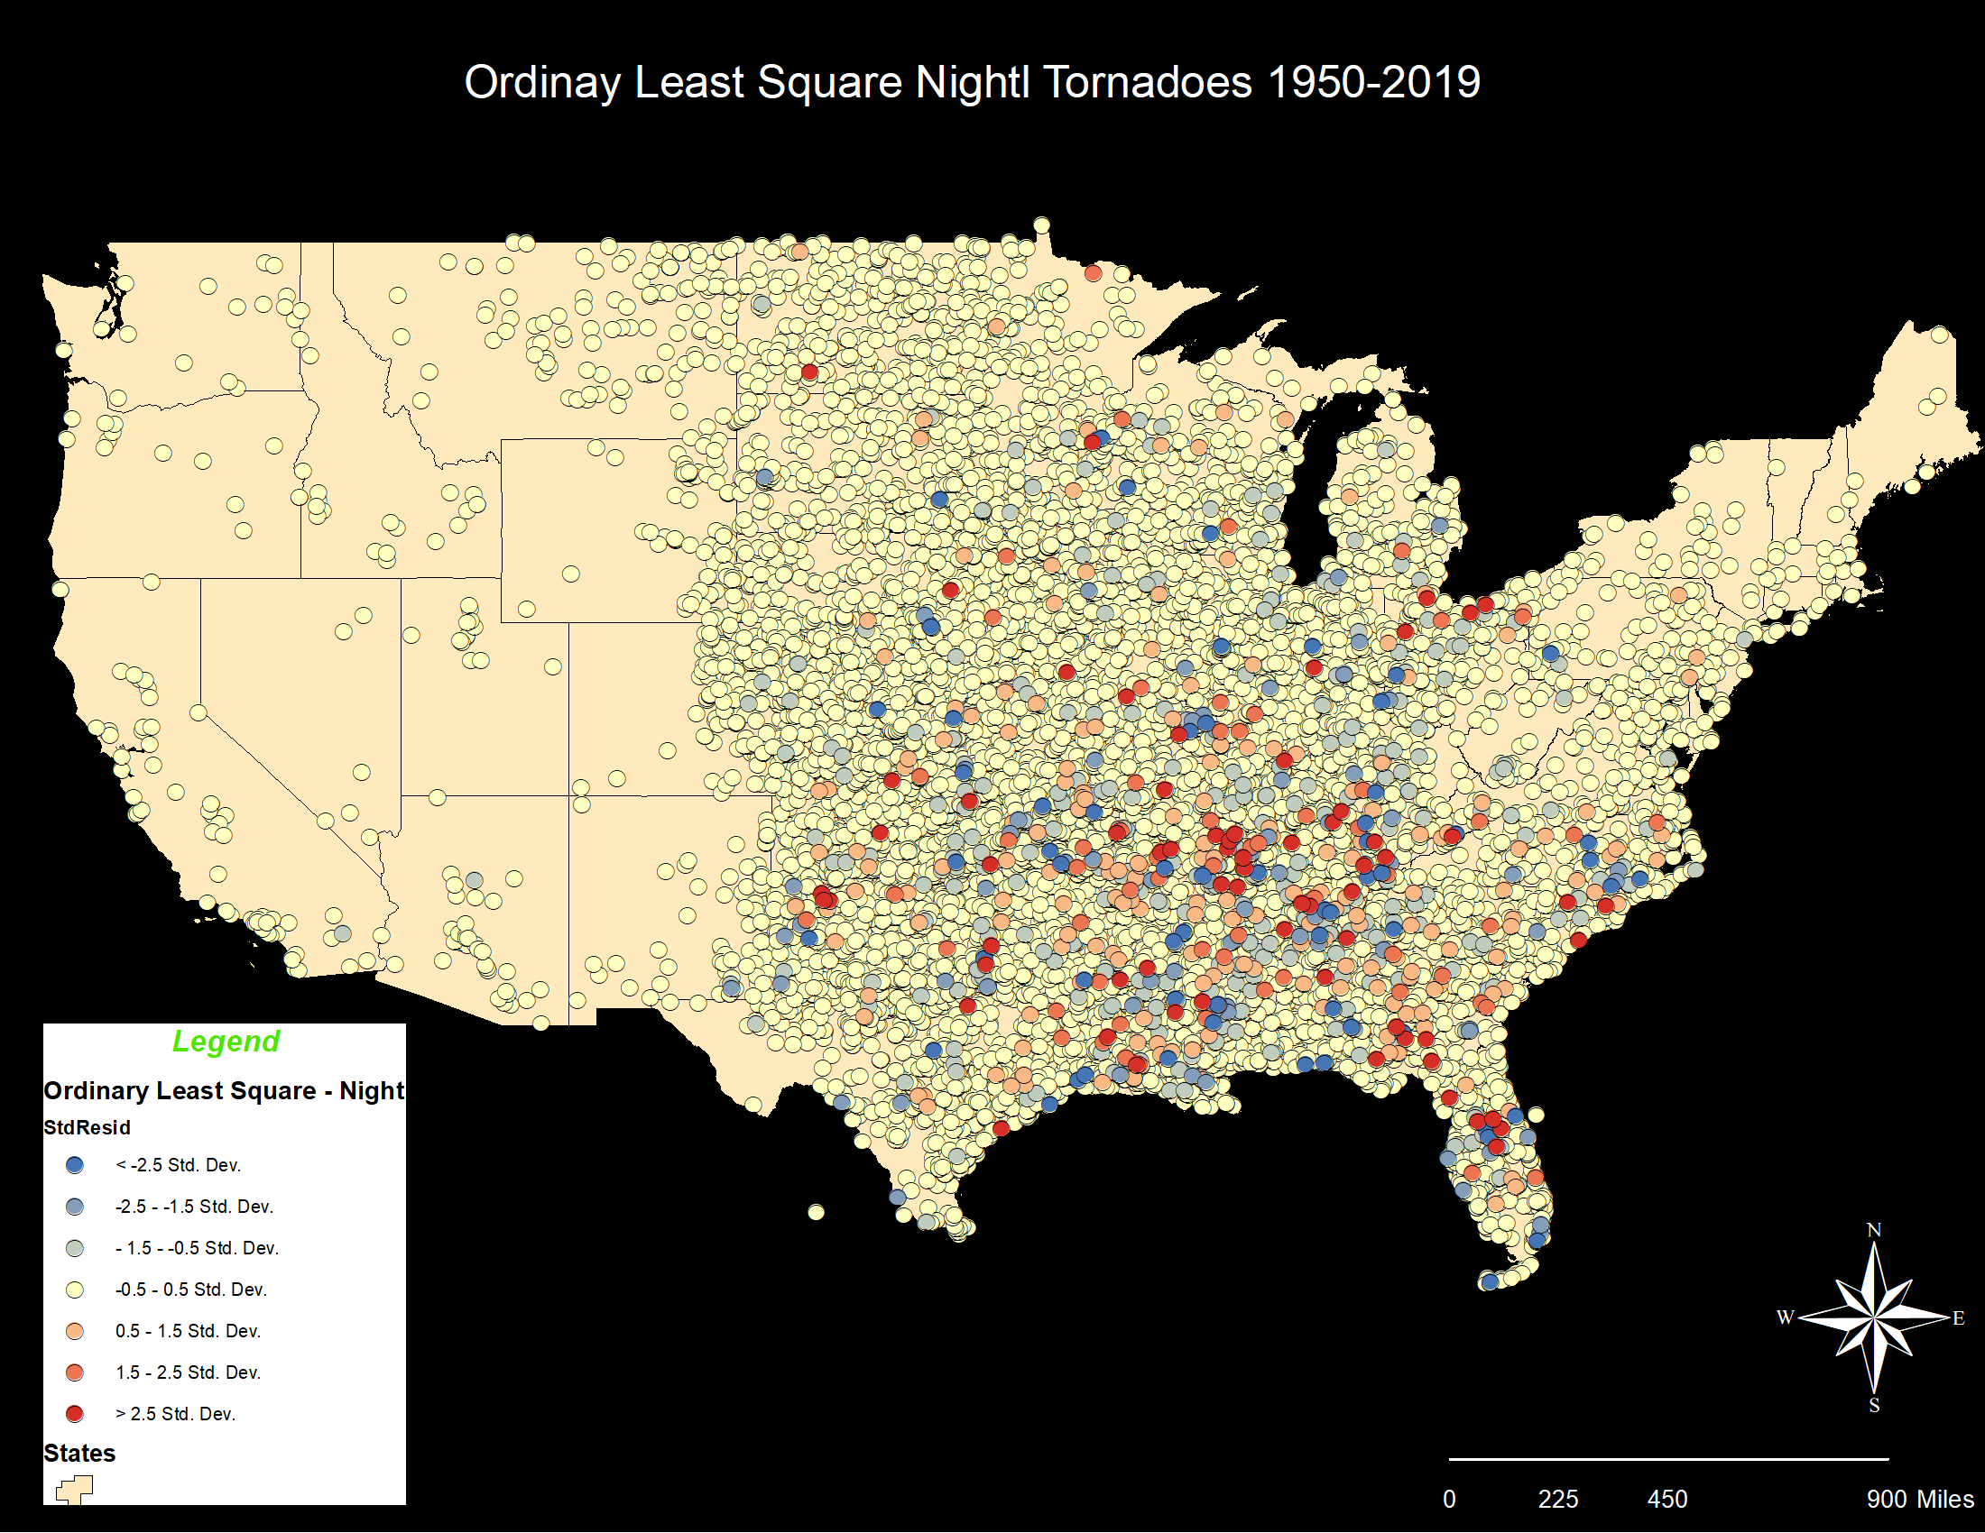

Additionally, the map above is another Ordinary Least Square analysis run with the same dependent and exploratory variables, with only nocturnal tornadoes.

I am not entirely sure how to interpret the results but have been reading more in the ArcGIS help pages (<https://desktop.arcgis.com/en/arcmap/latest/tools/spatial-statistics-toolbox/interpreting-ols-results.htm>).

**Nighttime Tornadoes and Vulnerability**

1. Ashley, W. S., Krmenec, A. J., & Schwantes, R. (2008). Vulnerability due to Nocturnal Tornadoes, Weather and Forecasting, 23(5), 795-807. Retrieved Jul 19, 2021, from [https://journals.ametsoc.org/view/journals/wefo/23/5/2008waf22221](https://journals.ametsoc.org/view/journals/wefo/23/5/2008waf2222132_1.xml)

Ashely, Krmenec & Schwantes analyzed human vulnerability to nocturnal tornadoes in the paper “Vulnerability to Nocturnal Tornadoes” (2008). Their study focused on tornadoes occurring from sunset to sunrise over the period from 1880 to 2007. The paper finds that nocturnal tornado events enhance human vulnerability for a number of reasons. Due to normal sleeping patterns, people are less likely to receive warnings during a nocturnal tornado event. Additionally, tornadoes are more difficult to see during the nighttime hours. Moreover, the public is less likely to be in safer locations, such schools or places of work which are reinforced steel structures, than at night and more prone to weaker building structures, such as mobile homes. Finally, and surprisingly, tornado warning sirens are deployed to mitigate tornado hazards during outdoor activities. Therefore, they are less effective at night when more people are inside of their homes. The study concludes that nocturnal tornado fatalities continue to increase during the last half century, while their daytime counterparts have seen a reduction in fatality rates. Moreover, they determine that nocturnal tornado fatality rates seem to be the primary driver for stalled declines in overall tornado fatality rates. They determine that factors such as increasing mobile home stock, expanding population and a growing elderly population are all additional variables driving the rates of fatalities due to nocturnal tornadoes. However, it is important to note that nocturnal tornado fatalities have been kept from rising rapidly during the observation period due to enhanced forecasting and technology.

1. Kis, A. K., & Straka, J. M. (2010). Nocturnal Tornado Climatology, Weather and Forecasting, 25(2), 545-561. Retrieved Jul 19, 2021, from [https://journals.ametsoc.org/view/journals/wefo/25/2/2009waf2222294_1.xm](https://journals.ametsoc.org/view/journals/wefo/25/2/2009waf2222294_1.xml)

In their paper, “Nocturnal Tornado Climatology” (2010), Kis and Straka discuss forecasting of tornadoes across the diurnal cycle. The study finds that conditions favorable for late afternoon tornado formation are in fact different from those found in nocturnal tornadoes. They found that certain conditions that are not conducive to tornadogenesis earlier in the day are found to be favorable for significant nocturnal tornado formation. The authors note that human vulnerability to nocturnal tornadoes is increasing in the United States, partly due to human reasons. However, they note that increasing forecasters understanding of conditions favorable for tornadogenesis during nighttime hours could lead to more accurate warnings disseminated to the public.

1. Mason, L. R., Ellis, K. N., Winchester, B., & Schexnayder, S. (2018). Tornado Warnings at Night: Who Gets the Message?, Weather, Climate, and Society, 10(3), 561-568. Retrieved Jul 19, 2021, from <https://journals.ametsoc.org/view/journals/wcas/10/3/wcas-d-17-0114_1.xml>

Mason et al. use survey data from a sampling of Tennessee residents to study the human responses to daytime and nighttime tornado warnings in their paper, “Tornado Warnings at Night: Who Gets the Message?” (2018). Using bivariate and logistic regression the authors compare day versus night tornado warning receipt. It was found that demographic and cognitive factors could help to predict daytime tornado warning receipt, the same did not hold true for nighttime warning receipt. The authors also note that local “tribal knowledge” played a role in how tornado warnings were received. They conclude that more research is needed to determine how to improve warning access at night in order to reduce nocturnal tornado fatalities.

**Spatial Trends**

1. Gensini, V.A., Brooks, H.E. Spatial trends in United States tornado frequency. *npj Clim Atmos Sci* **1,**38 (2018). <https://doi.org/10.1038/s41612-018-0048-2>

In the paper, “Spatial Trends in United States Tornado Frequency” (2018), Gensini and Brooks discuss the spatially varying temporal trends of tornado distribution. They note that annual frequency of tornado reports have remained relatively constant. However, since 1979, there have been negative tendencies of tornado occurrence in the central and southern portions of the Great Plains. Moreover, strong positive trends have been observed in the Midwest and Southeast US. Their research focuses on the environmental covariate approach to examine changes in tornado frequency. The results of the study suggest an eastward shift in tornado frequency, also known as Dixie Alley. Additionally, they found significant upward trends in tornado frequency in portions of the Southeast, Midwest and Northeast. However, they found no evidence of increased tornado frequency west of the 95th meridian. The authors note that previous research supports these findings. They point out that this shift in tornado distribution toward the Southeast puts an already vulnerable population at a much higher risk to tornado related disasters. It is made clear that more research is needed to determine the reasoning behind the shift in tornado distribution eastward.

1. Ashley, W. S. (2007). Spatial and Temporal Analysis of Tornado Fatalities in the United States: 1880–2005, Weather and Forecasting, 22(6), 1214-1228. Retrieved Jul 19, 2021, from [https://journals.ametsoc.org/view/journals/wefo/22/6/2007waf20070](https://journals.ametsoc.org/view/journals/wefo/22/6/2007waf2007004_1.xml)

Ashley analyzes region-specific vulnerabilities of killer tornadoes in the United States in his paper, “Spatial and Temporal Analysis of Tornado Fatalities in the United States: 1880–2005” (2007). The author found that most fatalities from tornadoes occur in the Southeast US, rather than the area traditionally known as Tornado Alley. Ashley’s study concludes that variables including mobile home, population density and frequency of nocturnal tornadoes, as well as physical and social vulnerabilities in the Southeast are the likely causes. Specifically the author notes that the average mobile home density in the region with most fatalities may be the key reason. Additionally, increases in population and migration patterns could increase risk and vulnerability to tornado hazards in the future. However, Ashley concludes that a more complete analysis is necessary to improve tornado mitigation efforts.

* The author notes incompleteness of data as a limiting factor in the study. This includes demographic and spatial data associated with historical tornado records. Ashley mentions the need for improvement in damage and casualty assessment. Finally, the recent adoption of the Enhanced Fujita scale complicates comparing prior tornadoes as determination of tornado rating criteria have changed.

1. Sutter, D., Simmons, K.M. Tornado fatalities and mobile homes in the United States. *Nat Hazards* **53,**125–137 (2010). <https://doi.org/10.1007/s11069-009-9416-x>

In their paper, “Tornado fatalities and mobile homes in the United States” (2010), Simmons and Sutter studied the possible reasons for high fatality rates in mobile homes during tornado events. The authors note that overall tornado fatalities have declined, but fatalities in mobile homes remained up to ten times higher than in permanent homes. A key finding is that while stronger tornadoes are more deadly in general, a large proportion of fatalities occur in mobile homes during weaker tornadoes. Additionally, the authors note that 54% of mobile home fatalities occurred in the Southeast US. Moreover, fatalities in mobile homes are especially likely to occur at night. The authors describe the relationship between nocturnal tornadoes, mobile homes and the Southeast US as a reason for the regional concentration of fatalities. In conclusion, the authors point out several possible options for mitigating the mobile home problem. First they note that most mobile home parks do not have suitable shelter for residents during tornado events. Additionally, building stronger, more stable mobile homes could reduce fatalities during weaker tornadoes. However, additional research should be conducted to determine the best and most viable mitigation plans.

**Tornado Risk**

1. Dixon, P. G., Mercer, A. E., Choi, J., & Allen, J. S. (2011). TORNADO RISK ANALYSIS: Is dixie alley an extension of tornado alley? Bulletin of the American Meteorological Society, 92(4), 433-441. Retrieved from <http://ezaccess.libraries.psu.edu/login?url=https://www-proquest-com.ezaccess.libraries.psu.edu/scholarly-journals/tornado-risk-analysis-is-dixie-alley-extension/docview/870326950/se-2?accountid=13158>

# Dixon et al. seek to determine if there is a significant region of elevated tornado risk outside Tornado Alley in their paper, “Tornado Risk Analysis: Is Dixie Alley an Extension of Tornado Alley?” (2011). The authors note that, as with many studies in tornado climatology, their study suffers with shortcomings in the tornado database. They note that to avoid these shortcomings, they avoid individual tornado events and instead focus on local tornado days. The authors conclude that it appears Dixie Alley is its own distinct region in terms of tornado activity, separate from the traditional Tornado Alley. They note that it is possible that Dixie Alley is separate from Tornado Alley by geographic features, such as elevated terrain and mountains. However, the authors found that when considering tornado risk, there is a lack of separation between the two “alleys”. It is suggested that rather than naming the regions geographically, it would be more appropriate to name them seasonally, when tornado risk is greater. In conclusion, the authors suggest that further studies using statistical analysis and density analyses should be conducted to determine seasonality of tornado risk in different regions of the country. This will help drive public preparedness for tornado threats.

1. Coleman, T. A., & Dixon, P. G. (2014). An objective analysis of tornado risk in the united states. Weather and Forecasting, 29(2), 366-376. Retrieved from <http://ezaccess.libraries.psu.edu/login?url=https://www-proquest-com.ezaccess.libraries.psu.edu/scholarly-journals/objective-analysis-tornado-risk-united-states/docview/1522788256/se-2?accountid=13158>

Coleman and Dixon focus on spatial tornado risk of significant tornadoes in their paper, “An Objective Analysis of Tornado Risk in the United States” (2014). Focusing on significant tornadoes differs from other tornado climatology studies. The reason the authors chose this approach is because reporting frequency for significant tornadoes has remained stable over the period of study, since 1973. The study used path lengths, rather than touchdown points or tornado days. The study concludes that the greatest risk to significant tornadoes is the Southeast US with the destruction potential index (DPI) highest in this region after analysis. The region with highest risk to people was found to extend from central Mississippi into northern Alabama. The authors conclude that this study and others have determined that the highest risk of tornadoes is an area clearly different from that covered by the media that most people are completely unaware to the risk in the region.