Cyclic Sequence Alignment
The Cyclic Sequence Alignment problem for a set of circular sequences consists of first finding the best possible rotation for each one of the circular sequences and then performing the alignment itself using any regular linear multiple sequence alignment algorithm.
Some examples of circular sequences include mitochondrial DNA, chloroplast DNA and some bacterial DNA, so finding an efficient solution for this problem has important applications. Some solutions using dynamic programming were proposed in the past but they only allow the alignment of 2 circular sequences and they are quadratic in both time and space.
First we need an efficient way to represent all the rotations of a circular string. This can be done in linear time and linear space by making some small changes in Ukkonen’s Online Suffix Tree Construction Algorithm. Namely, we change the right pointer of every new “open leaf” and also the interpretation of the suffix links at the end of leaves.
For a string S of size n, every time we create a new node/leaf at depth d for a character at position k of S, we set the right pointer of that leaf to k+(n-d-1), instead of ∞, as in Ukkonen’s original algorithm. This way, every leaf has a path label of the same size as the entire initial string S. When comparing the characters against the label of the node, if the label position k corresponds to a position beyond the end of string S (k>n), we set k to k-n. Using this new representation of open leaves, when there exists a suffix link connecting 2 leafs, they correspond to 2 consecutive rotations of the string S. The resulting tree has all the rotations of the initial string. We call it the “cyclic suffix tree”. (In fact, we need to build the tree for string SS because, e.g., the tree for string AAABA would not have the last rotation AAAAB. But the algorithm runs in O(2n), so it still remains linear.)
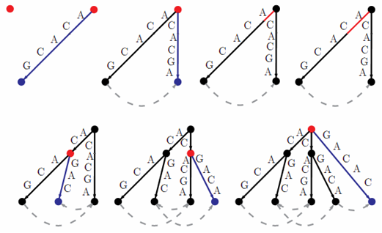
Image 1 – Example of the construction of the cyclic suffix tree for sequence ACACG. The current position in each step is marked in red and newly created nodes/leafs are marked in blue. For simplicity, only suffix links of leafs are represented in the image.
Now, the main idea to find the best rotation for each sequence is to find the largest common subsequence that occurs in all sequences but only once per sequence and use its position in each sequence to set the cutting point when performing the linearization of that sequence. (The subsequence must not occur more than once in each sequence because repetitions could lead to wrong alignments.)
This can be achieved by using a “cyclic generalized suffix tree”, the cyclic version of the generalized suffix tree. Every node of the generalized tree stores a bit array with the information of all the cyclic sequences that contain the path label of that node. Each node also maintains another bit array reflecting the existence or not (for each sequence) of a suffix link pointing at it. If a node does not have a suffix link pointing at it, that means that there isn’t any longer string that has that string (the path label of the node) has a suffix, so, the string can’t be further extended to the left.
The maximal unique common subsequence can then be found in linear time by doing a depth first search on the tree and keeping track of the node visited at the largest depth (right maximality) that matches all the next 3 conditions:
- all the sequence bits are set (common the all sequences)
- at least one of the suffix links existence bits is not set (left maximality)
- there is only one leaf of each sequence below that node (no repeats)
For example, for sequences CGGA, ATACG and GTGAC, whose tree is displayed in the image below, the algorithm would directly return string/block ACG as the maximal unique common subsequence, and the optimal rotations would be respectively:
ACGG
ACGAT
ACGTG

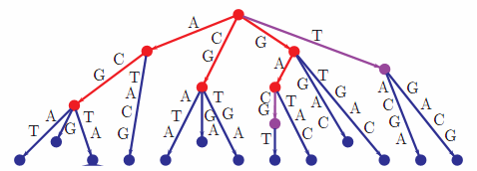
Image 2 – Generalized cyclic suffix tree for sequences CGGA, ATACG and GTGAC. Nodes belonging to all the sequences are marked in red, belonging to two of them in purple, and to only one in blue. For simplicity, no suffix links are shown.
The algorithm can be further extended by considering the largest chain of blocks (blocks that appear consecutively and in the same order in all the sequences) instead of only the largest block, as this would improve some alignments.
After this, by also considering chains of blocks that belong to only some of the sequences, a simple algorithm that could be implemented to perform the multiple sequence alignment could align these chains of blocks in a decreasing order given by the heuristic:
H(chain) = (sum of the lengths of all the blocks in this chain) x (number of seq.s that contain this chain)

