Cyclic Sequence Aligner
User Manual
(Version 1.0)

Introduction
The Cyclic Sequence Aligner tools allows to find the best possible rotation for a set of cyclic sequences that will be later aligned using a linear multiple sequence alignment algorithm. The best rotation found for each sequence will effectively improve the alignment of all the sequences.
This user manual will guide the user through all the steps from uploading the sequences to understanding the output, covering all the options and results in the process.

Main Page
The tool is available through an intuitive and easy to use web interface where the user can upload the cyclic sequences and set the visualization parameters.
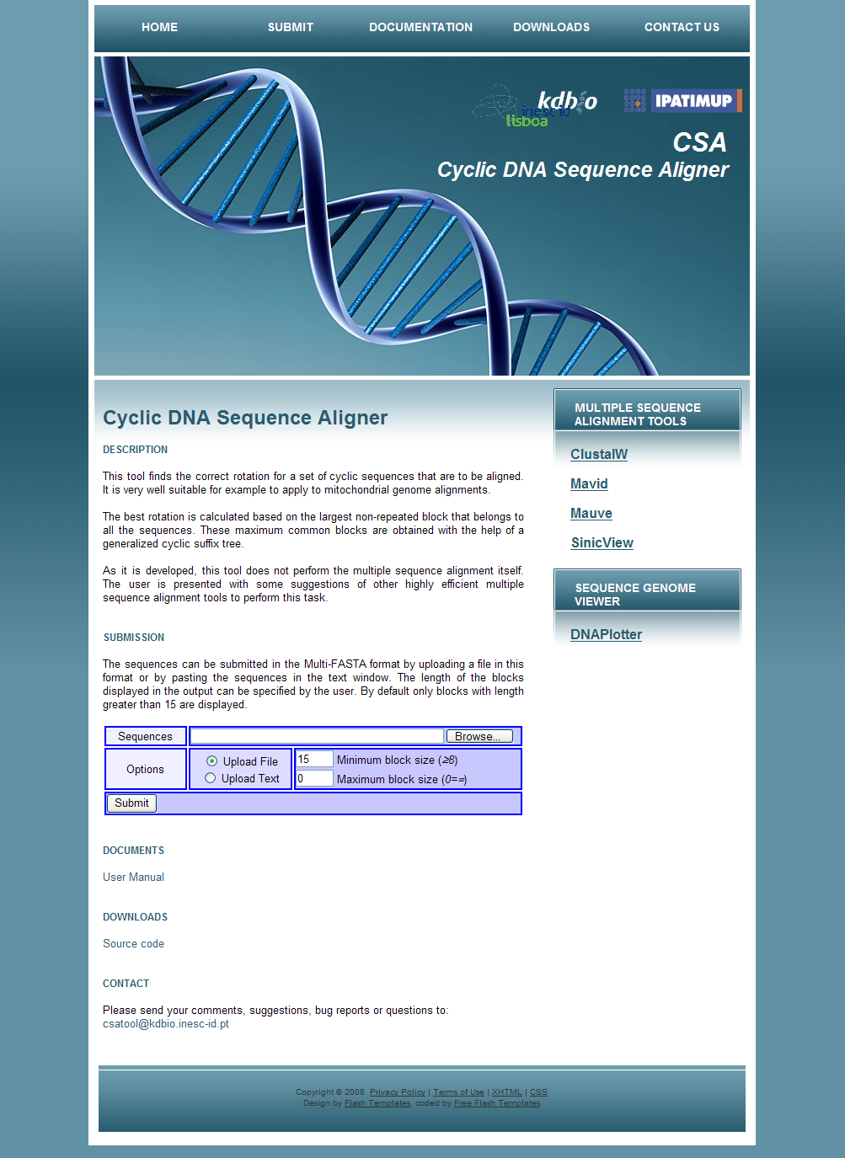
Uploading the Sequences
The submission form can be found in the “Submission” section at the middle of the main page. The sequences must be submitted all at once by storing the set in the Multi-FASTA format. There are two ways to upload the data:
- File upload: specify a file containing the data in this format.
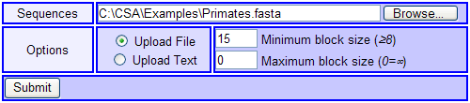
- Text upload: directly copy/paste the data into the text field.
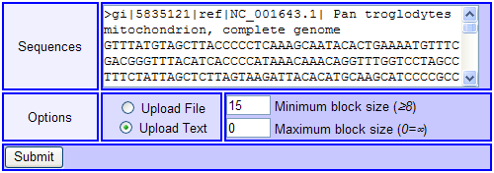
In current version, the maximum number of sequences that can be processed simultaneously is limited to 32. After inputting the sequences and setting the optional visualization parameters, pressing the “Submit” button will automatically upload the data and redirect the user to the results page.

Visualization Parameters
The user also has the possibility to specify the minimum and maximum lengths of the blocks that will be shown in the alignment map later in the results page.
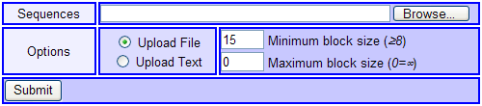
The minimum allowed length is 8. If no maximum length is required, the corresponding value should be set to 0. By default, the values are set to 15 and 0 respectively.

Results Page
This page shows the general output information and an alignment map of the blocks in all the sequences after their optimal rotation, as well as a table with all their lengths and positions, following the color code shown in the map.
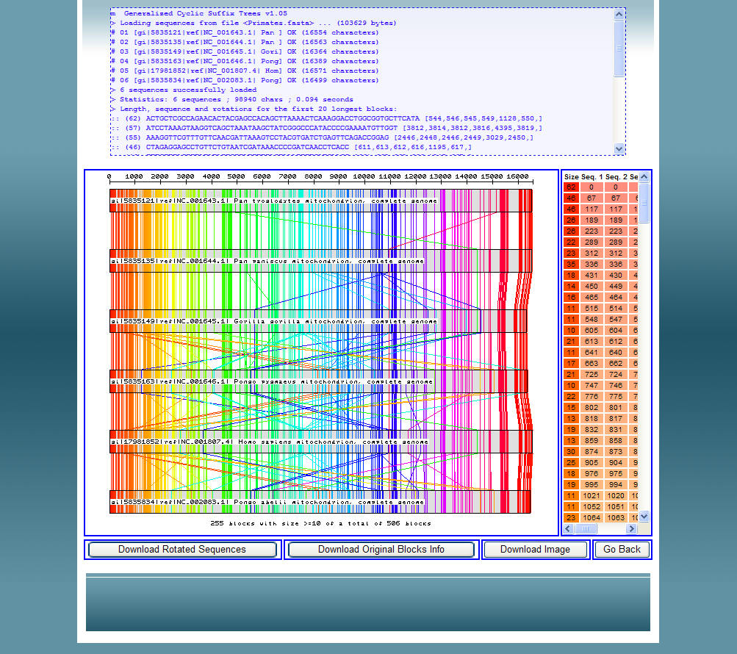
Output Information
Alignment Map
Positions Table
By right-clicking over a specific section of one of the sequences in the alignment map, the positions table automatically sorts its rows to reflect the correct order of the blocks inside that sequence and it automatically scrolls itself to show the information of the blocks from the selected region/sequence.
This page also gives the possibility to download the rotated sequences and information about the blocks:
- Download Rotated Sequences: returns a file in the Multi-FASTA format containing all the resulting sequences after the optimal rotation is applied to each one.
- Download Original Blocks Info: gives a plain text file where each line shows the size, nucleotide sequence and position on each original sequence (before the rotation) of each block.
- Download Image: transfers the image file of the displayed alignment map.
The “Go Back” button takes the user to the initial main page.
Understanding the Results
One important remark is that only the maximum blocks which occur in all the sequences and only once per sequence are considered for the results. The longest such block is used to set the optimal rotation of each sequence, so this block appears in the beginning of each rotated sequence. Beside this, the limits set in the visualization parameters are also taken into account when drawing the blocks in the alignment map.
The results page is divided into the following sections:
- Output Information: shows the general status and output messages resulting from the running of the tool, including size and description of each input sequence, running time, information about the 20 first longest blocks, and eventually any processing errors.
- Alignment Map: this image represents the relative location of the blocks inside each sequence. The blocks are marked using a gradient coloring to allow their easy detection between distinct sequences when translocations occur. All the represented sequences are already rotated. Note that only the blocks with lengths within the limits specified in the visualization parameters are shown. As already mentioned, this map is sensible to clicks.
- Positions Table: shows the size and position in each rotated sequence of all the blocks represented in the alignment map, following the same color scheme for each block in order to facilitate its identification in the image on the left.

Multiple Sequence Alignment
Although this feature is planned to be incorporated in a near future, this tool does not yet perform the multiple sequence alignment itself. In the meanwhile, some alternatives are presented.
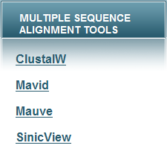
After retrieving the file containing all the optimally rotated sequences using the “Download Rotated Sequences” button, they can be aligned using any regular linear multiple sequence alignment tool. For this purpose, some links of very efficient such tools are presented in the main page.

Additional Information
Any additional questions, comments, bug reports or suggestions can be sent to the following e-mail address: csatool@kdbio.inesc-id.pt

