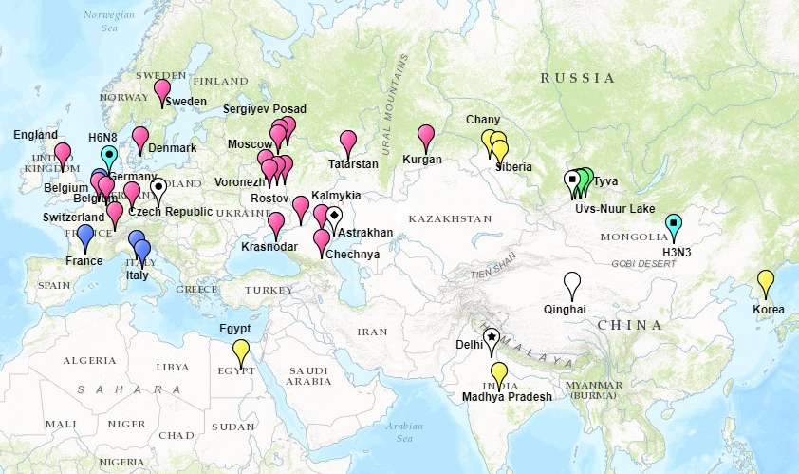Fig.1. Geographic distribution of HPAIV A(H5N8) strains, isolated in 2016-2017

Pink paddle – Base group, blue paddle - Mediterranean group, yellow paddle - Afro-Asian group, green paddle - Uvs Nuur group, white paddle – singletons: circle inside - A/chicken/Czech Republic/206-17_2/2017; square inside - A/great crested grebe/Uvs-Nuur Lake/341/2016; rhombus inside - A/chicken/Astrakhan/3131/2016; asterisk inside - A/duck/India/10CA01/2016. Light blue paddle – avian influenza viruses of other genotypes: circle inside - A/mallard duck/Netherlands/15/2011(H6N8); square inside - A/duck/Mongolia/129/2015(H3N3).