***RSYSLOG***

It offers high-performance, great security features and a modular design. While it started as a regular rsyslog, rsyslog has evolved into a kind of swiss army knife of logging, being able to accept inputs from a wide variety of sources, transform them, and output to the results to diverse destinations.

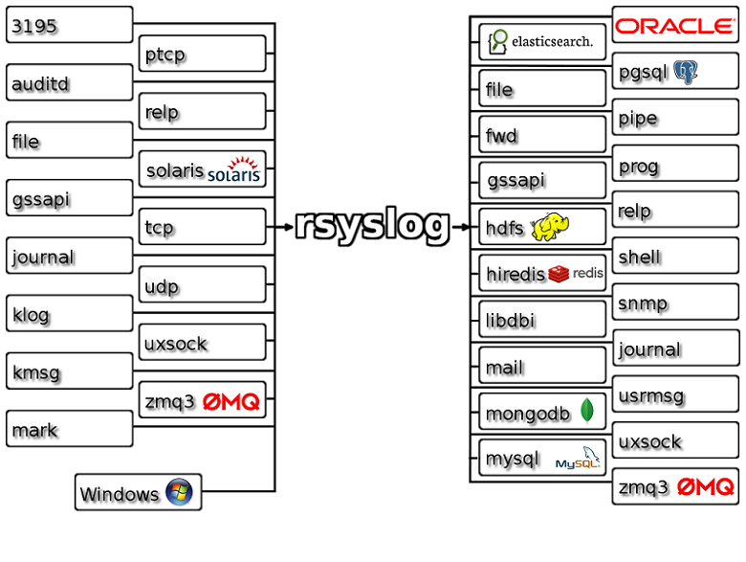RSYSLOG can deliver over one million messages per second to local destinations when limited processing is applied (based on v7, December 2013). Even with remote destinations and more elaborate processing the performance is usually considered "stunning"

Rsyslog is the default logging program on several Linux distributions including Debian and Red Hat based systems. Apart from implementing the syslog protocol, rsyslog adds additional features such as content-based filtering. This also uses TCP for transporting, and provides lot of configuration options.

***RSYSLOG:***

* Multi-threading
* TCP, SSL, TLS, RELP
* MySQL, PostgreSQL, Oracle, and more
* Filter any part of syslog message
* Fully configurable output format
* Suitable for enterprise-class relay chains

[www.rsyslog.com](http://www.rsyslog.com)

***Installation:***

Rsyslog comes as the default logging program in Debian Distribution and Red Hat based systems. If your system doesn’t have rsyslog, install it as shown below depending on your distro.

apt-get install rsyslog rsyslog-doc

(or)

yum install rsyslog rsyslog-doc

Rsyslog configurations are stored in /etc/ryslog.conf file and the files under /etc/rsyslog. d/ directory.

***What to do with rsyslog:***

Every Linux distribution have logging mechanism that records all the system activities. I will be setting a central logging server and configure rsyslog to record system logging activities.

**Rsyslog mailing list:**

Here is a link for the Rsyslog mailing list: <http://lists.adiscon.net/mailman/listinfo/rsyslog>

**Useful links:**

Rsyslog related libraries on GitHub: <https://github.com/rsyslog>

Rsyslog configurations: <http://www.thegeekstuff.com/2012/01/rsyslog-remote-logging>