1. The total number of Users (i.e. count of all users) in the system.

Answer

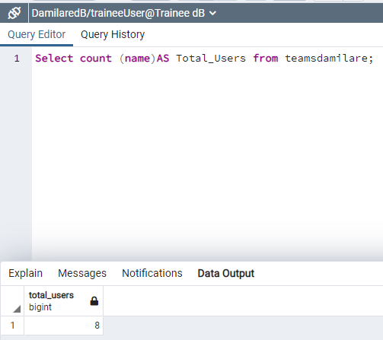

1. The total number of Users in the Accounting Department.

Answer;

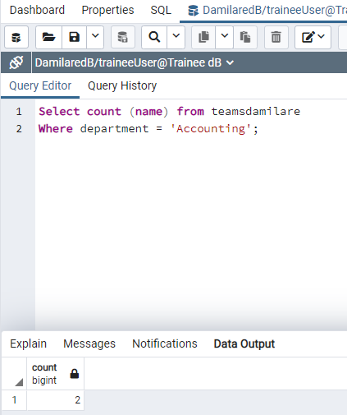

1. The total number of Users that have not activated their account.

Answer

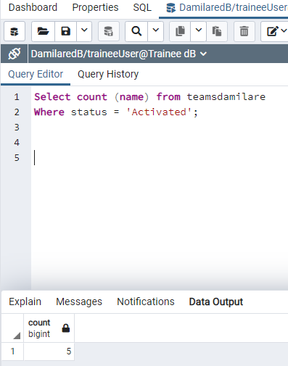

1. List the first 5 Users that registered for an account in the system.

Answer;

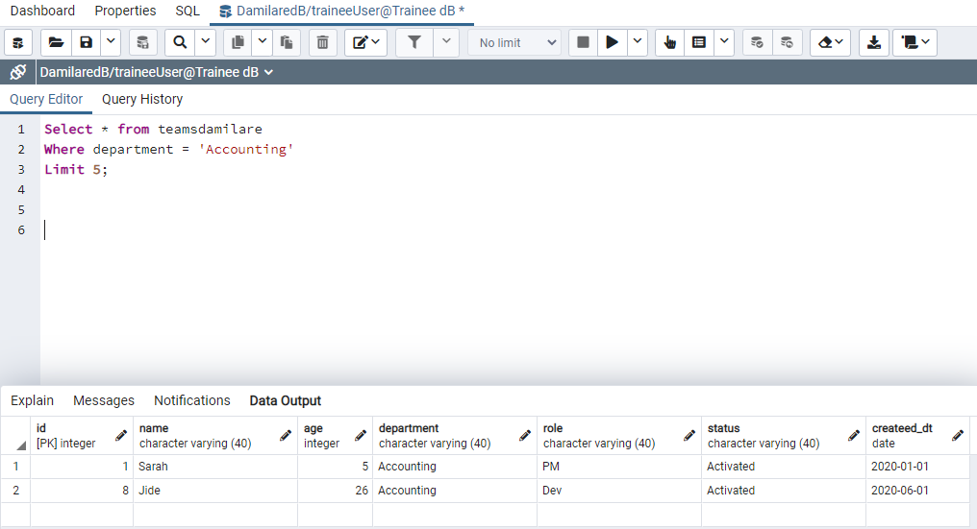

1. All Users whose age is greater than 18 but less than 26.

Answer;

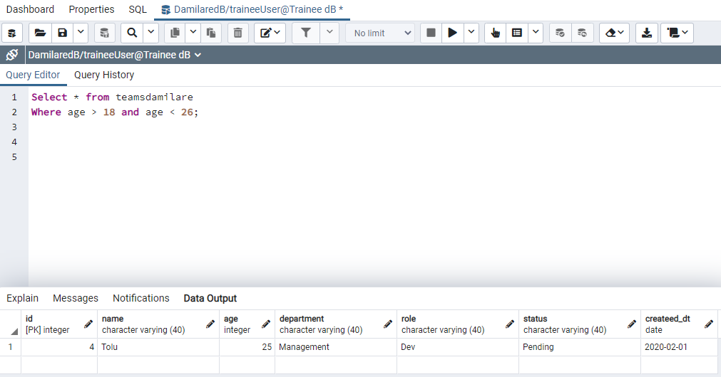

1. All Users that registered for an account last week Thursday.

Answer;

1. All Users that registered for an account between last week Saturday and this week Monday.

Answer

1. Query to Activate all pending Users in the system.

Answer

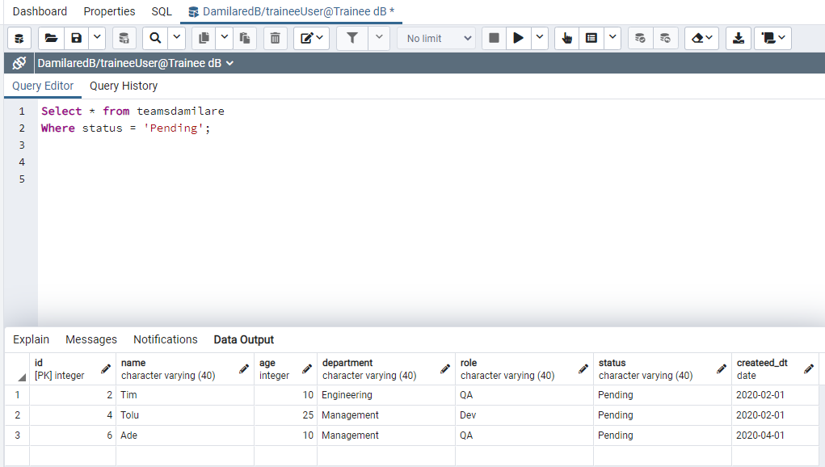

1. Query to Update the User whose name is Tim to Timothy.

Answer;

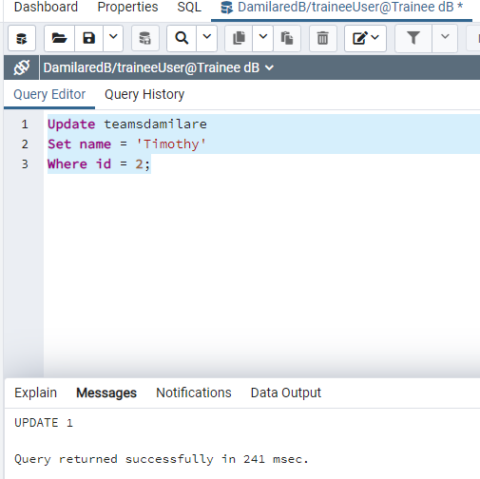

1. Total Number of Users in each Department. (I want this as a single query not in parts. Hint use group by or any clause - just 1 select query forthis).

Answer;

