Tips and tricks to configure environment and maintain my CDI development using Linux

Debugging:

Choose the Debian based version to download STM32CUBEIDE from ST website, during the installation process is recommendable decline the SEGGER package installation (and related), because my aim is using STLINK V2 interface based.

STLINK V2:

1 | 2 – TVCC, Connect 3,3V to Bluepill
7 – SWIO (TMS)
9 – SWCLK (TCK)
12 | 18 | 20 – NEG
19 – POS

PS: To use this debugger you must to connect at least 5 wires (1 more than generic interface)

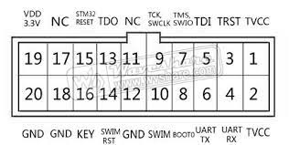

Follow this path to generate the *.hex file as output product:

- Project>Properties>Settings>Build Steps

And fill the field Post-build steps Command with:

arm-none-eabi-objcopy -O ihex ${ProjName}.elf ${ProjName}.hex

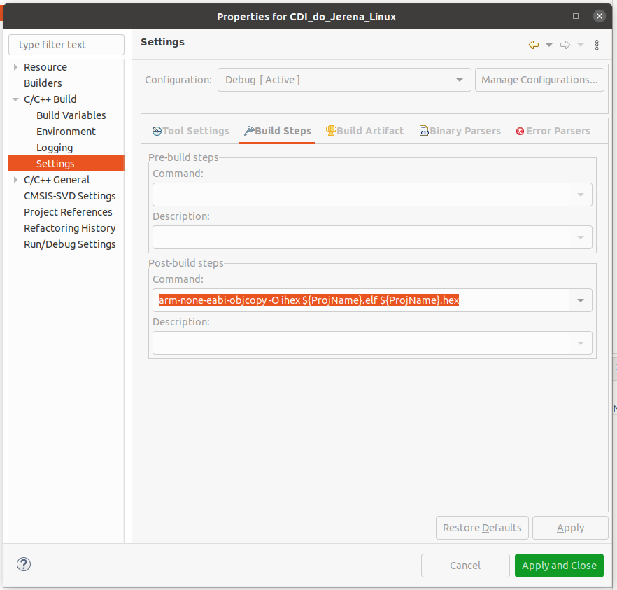

To configure STLINK V2 follow this:

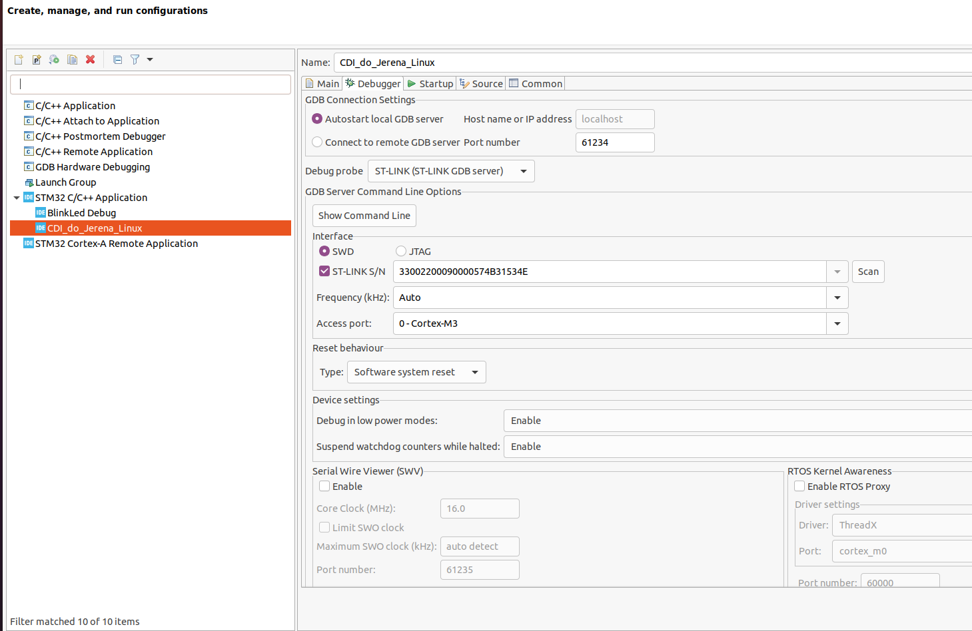

This is a function that I should invest some time, maybe can be useful:

https://www.youtube.com/watch?v=JqrUAzjJ0tw

