Hardware detail:

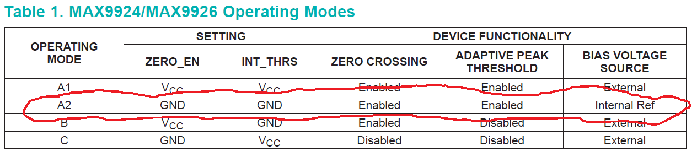

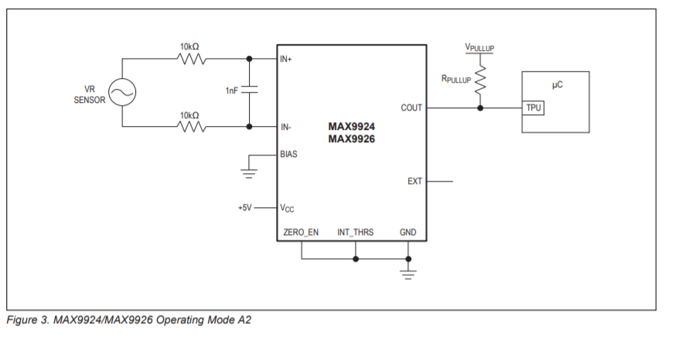

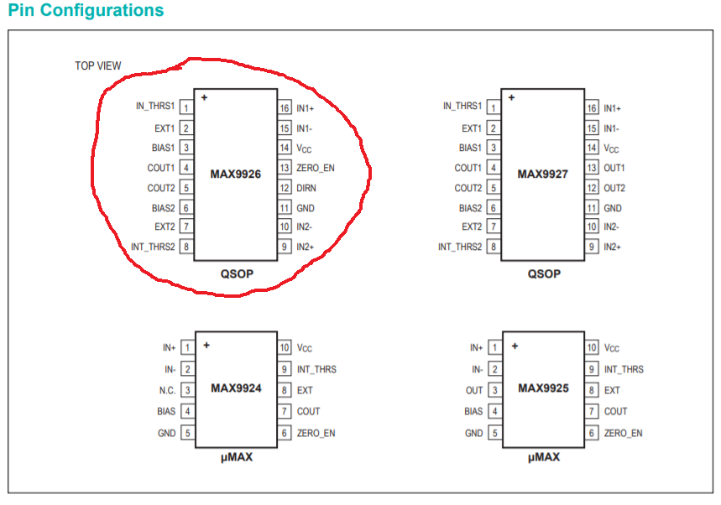

Circuit:

1 - +12V (Power Supply)

2- GND (Circuit)

3 - VRS1+

4 - VRS1-

5 - KEY

6 – TEMP

7 - HIGH_VOLTAGE (Ignition Coil)

8 - GROUND (Ignition Coil)

I need to decide If I populate the circuit or if I do not populate…

VRS2+

VRS2-

CAN_HIGH

CAN_LOW

INJECTOR

TPS_VCC

TPS_SIGNAL

TPS_GROUND

TEMP_SENSOR