**"Craniobot", a craniotomy robot for small rodents.**

This is a simple 3-axis high-prcision robot designed to perform craniotomies on small rodents. These small craniotomies are often needed for electrode implantation and neuroscience research.

**General Description**

This small 3-axis craniotomy robot consists of three ThorLabs 2.5 cm linear actuators, a 3D printed streotaxi alignment tool, a 3D printed drill holder, some mounting hardware, and a python GUI interface developed by Flavio JK da Silva and Mark Scatza. The 3D printed parts were designed using FreeCAD.  
The *.stl files as well as the FreeCAD files are available here in the PARTS folder. For software installation instruction see last section of this document.

**GUI interface**

Control of the robot is done using CraniobotGUI2.5.py. Drill_holes2.py and drill_craniotomy2.py are called by the GUI. Some ThorLabs control functions are included in the throlabs_apt_master folder. The RESOURCES folder contains GUI elements, logos, and graphics. After the skull is surgically exposed, The robot is pushed against the stereotaxic equipment to align the XY plane of the robot with the XY plane of the sterotaxic equipment. Then use the XYZ motion control buttons to move the drill to the rodent (0,0,0) point (the Bregma location) to establish a point of correspondence between the robot and rodent coordinates.

**RUNNING THE CRANIOBOT**

All necessary Craniobot software is on this GITHUB. To start run CaniobotGUI2.5.py All the commands you need to run the Caniobot are iconified on the screen.

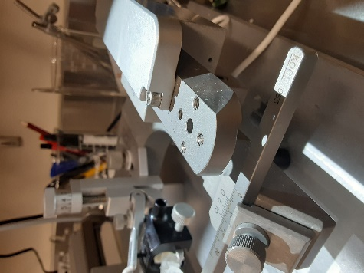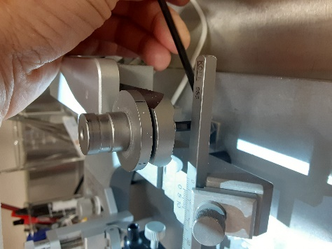

****Prepare the Stereotaxic Equipment:

1. To make room for the robot, remove Right Stereotaxic arm. Use Allen wrench to remove arm mounting disk.
2. Move right arm shuttle so it as far back as possible.

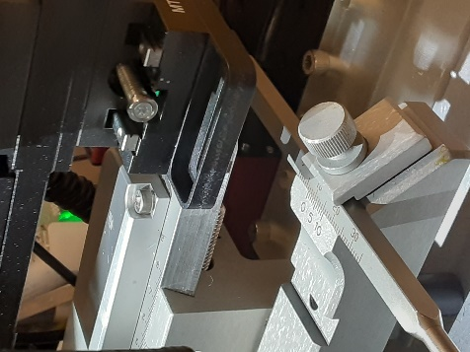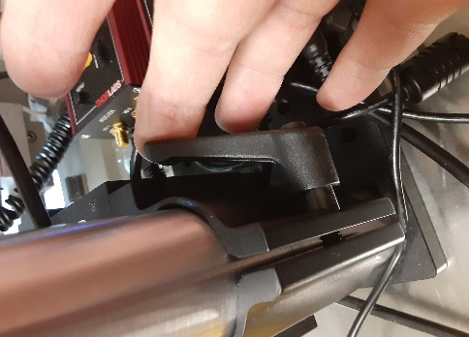

1. When Robot is in position, it will rest on the right arm support where the disk was previously located.
2. Note that you may have to adjust the height of the robot along its vertical support column.

Preparing the rat:

1. 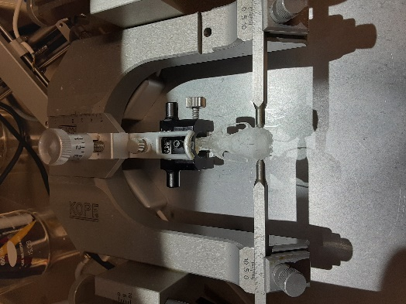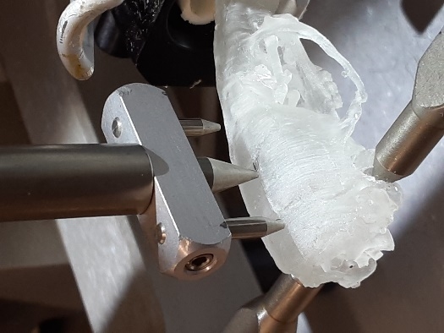Mark Bregma with black marker.

1. Use ear-bars to center rat onto stereotaxic equipment.
2. Using the trident stereotaxic leveling tool, be sure the rodent skull is level.

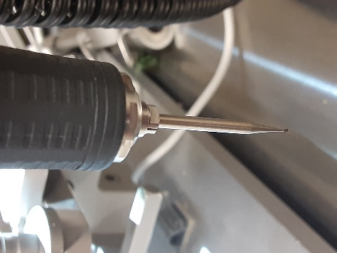

1. Insert drill bit into drill. Leave approx. 3 cm extending beyond the chuck. This is to increase the reach of the robot along the z-axis.
2. Start the Craniobot GUI program. Be sure all three motors are properly loaded.

If not, the robot was left in an unknown state. To correct this this problem. You may need to run the Thor Labs Kinesis Program, then Load and Unload all three motors. Note you may need to load the motors several times (up to three) to get all motors loaded.

1. Select Species. Currently only Rats or Mice are available (rat is default).

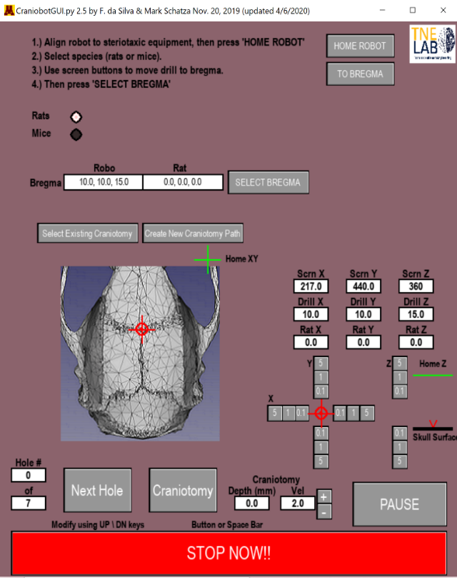

1. Align the Craniobot with the stereotaxic equipment.

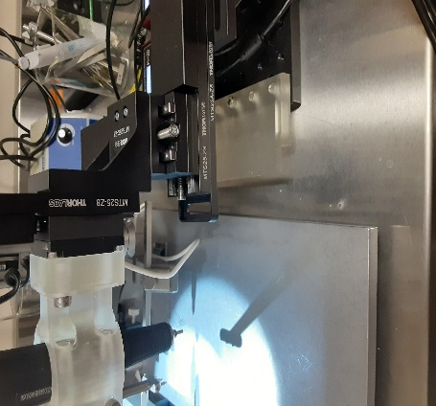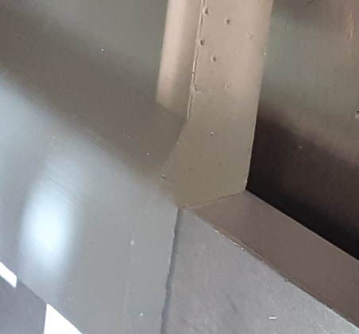

This is done by pushing the Craniobot snuggly against the right side of the stereotaxic equipment. Secure it in place. Taping it down to the table works fine for me. Remember the robot only has a 2.5 cm range of motion along each axis.  
It is therefore desirable that the tip of the drill is roughly at the bregma when the robot X,Y,Z is at approximately (12.5 , 12.5, 12.5). Though X,Y,Z = 10, 10, 10 is perfectly adequate for most surgeries.  
Best Practice: **Home the robot**. The use the XYZ buttons to move the robot to approximately X,Y,Z = 10, 10 , 10.  
**Move the entire robot assembly so that the drill is just above the Bregma.**

1. 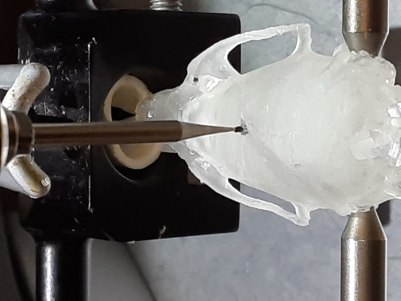When the robot assembly is aligned to the stereotaxic equipment and the robot is approximately in the middle of its working volume (~10, ~10, ~ 10), use the XYZ move buttons to touch the drill precisely to the Bregma.  
   Then press the SELECT BREGMA button. You should see a red circle and cross-hairs over the bregma graphic.

**Note: Make a note of the bregma coordinates, in case you ever need to restart.**

1. **Use GUI Z-axis button to raise drill 5mm**
2. Select an Existing Craniotomy or Create New Craniotomy Path.  
   Any pre-existing craniotomy path can be edited using the Craniotomy Designer stand alone application by pressing the Create New Craniotomy Path button.
3. **Be sure drill is ON and going in the FWD direction.**
4. CRANIOTOMY: Press Craniotomy button. One pass of the entire craniotomy path depicted in the screen graphics will be reproduced by the robot. Repeat. On each pass, the drill will cut the path 0.1 mm deeper. Continue pressing “Craniotomy” button after each pass is complete until through skull (approximately 10 passes). **NOTE: The craniobot assumes that the rodent skull is level. The robot will automatically go deeper when x-position > 4.5 mm on either direction of the Bregma to compensate for skull curvature.**
5. SCREW HOLES: Next press Next Hole Button to create screw holes. When the drill stops, used the Z axis motion control button to go deeper if necessary. When drilled to the depth you desire, press the Next Hole button to go to the next hole location

**USING THE CRANIOTOMY DESIGNER**

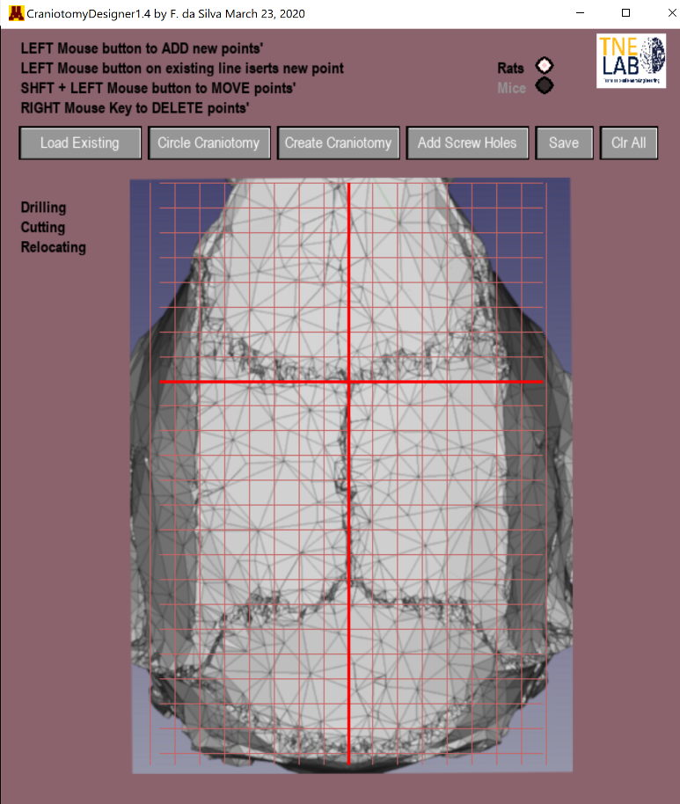The Craniotomy Designer is a separate, but fully integrated module that is used to design craniotomy paths for the Craniobot. It can be run as a stand-alone software, or called from the CraniobotGUI application. The GUI should be self explanatory. Click on the button icons to load an existing craniotomy path, create simple circular craniotomies, created complex arbitrary craniotomies, add screw-hole locations, save or clear the screen. As soon as the mouse is dragged over the window, the cursor location (in skull coordinates) appear next to it. Please see the included video for a quick tour: CraniotomyDesigner 1.4 by Flavio...

Making a circular craniotomy: When the circular craniotomy button is pressed, user input boxes appear on the left of the skull graphic. Click on the box, its  
outline will turn red, then type the desired values for the radius, and the X and Y offsets from the Bregma. As soon as the last value is entered, a path for the robot to follow will appear on the screen.

To add a point, simply select the create craniotomy button, then simply click anywhere on a blue line. Another point will be added.

To delete a point, left click on any point and it will disappear.

To Move an existing point, hold down the shift key while left clicking on a point, then move it to anywhere on the screen.

Making a craniotomy with an arbitrary path:  
To create an arbitrary path, simply click on the Create Craniotomy Button. Using the left mouse button, place points (in red) on the skull graphic. Multiple points will constitute a path along the X and Y axes for the robot to follow. When the path is complete, the resulting closed path will turn blue. Move points by simultaneously holding down the SHIFT key and left clicking on a point. Add points by clicking anywhere on an existing line.

Adding Screw Holes: Simply click on the Add Screw Holes button, then left click the mouse on any point on the skull. The robot will go to that point and drill along the Z-axis.

FINISHING IT UP: When happy with your design, simply press the Save button. All craniotomy patterns are stored in the CRANIOTOMY DESIGNS folder. Now simply run the craniotomy robot, and load your desired path.

**SOFTWARE INTALLATION GUIDE**

1. Install Python 3.7 or higher. I prefer to install it as stand alone. a. During installation, choose Custom installation. Them place your Python in new folder. I created one called  
   c:\python3.8.  
   b. Be sure to Install 64 bit version if your computer is 64 bit c. Be sure to add python to system path when asked.
2. Install pygame.  
   a. Type cmd in windows search bar at bottom left of screen b. In the pop-up command window, type: cd .. Enter, then cd .. Enter (yes, do it twice) c. Then cd c:\python3.8 (or whatever directory you used above) d. Then type: pip install pygame
3. Install numpy. Using CMD prompt as above in 2, type: pip install numpy
4. Install Thorlabs-apt. Using CMD prompt as above, type: pip install Thorlabs-apt
5. Install ThorLabs: <https://www.thorlabs.com/newgrouppage9.cfm?objectgroup_id=10285> a. Goto Kinessis Software tab, and press the Softwate Download button.  
   b. choose 64 bit if your computer is 64 bit.
6. Go to Github and clone the Thorlabs_apt depository. See <https://github.com/qpit/thorlabs_apt> a. In the download folder, extact all of the download. b. Then run the setup.py program using install as the only argument. c. That is, type: python setup.py install
7. Copy G:\Shared drives\TNEL - UMN\Project related material\craniobot\APT.dll into the Windows\System32 directory
8. Copy entire craniobot directory to your desktop. see G:\Shared drives\TNEL - UMN\Project related material\craniobot
9. Now you should be ready to use the craniobot application. NOTE: Be sure to exit Craniobot using Windows exit “X” on top right of window. If not, all motors will be locked out (that is, already in use). To fix this problem, run Thorlabs Kinesis software. Load all three motors. When all three alre loaded, unload all, then run Carniobot again.