* **Reactive arthritis** is characterized by a triad of **`{{c1::conjunctivitis}}`**, **`{{c2::urethritis}}`**, and **`{{c3::arthritis}}`**, with patients often also having `{{c4::diarrhea::GI}}`
  + &U+2800;
  + *- patients can also develop keratoderma blennorhagicum, diarrhea is often seen due to GI tract infection*   
    - "can't see, can't pee, can't climb a tree"; formerly known as Reiter syndrome  
    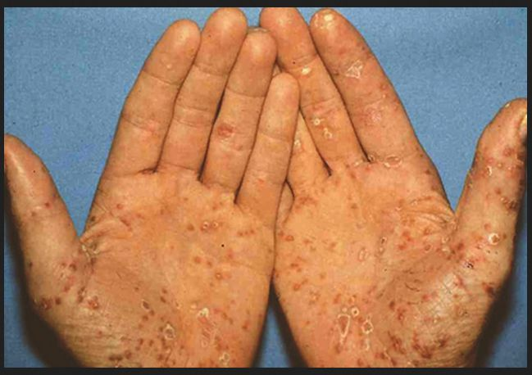
* **Reactive arthritis** classically arises in young adults after a(n) **`{{c1::GI}}` tract** or *`{{c2::Chlamydia trachomatis}}`* infection
  + *GI bugs include****: (ShY******Ch****i****CCS****)* ***Sh****igella,* ***Y****ersinia,* ***Ch****lamydia,* ***C****ampylobacter,* ***C****lostridium difficile,* ***S****almonella*
* Is **reactive arthritis** characterized by *sterile* or *septic* synovial fluid?  
  `{{c1::Sterile}}`
  + *~ 5,000 - 50,000 WBCs/mm3 but no bacteria present*
* *Chlamydia trachomatis* can cause **`{{c1::reactive arthritis (aka Reiter syndrome)}}`**, most commonly of the `{{c2::sacroiliac joint}}`
  + 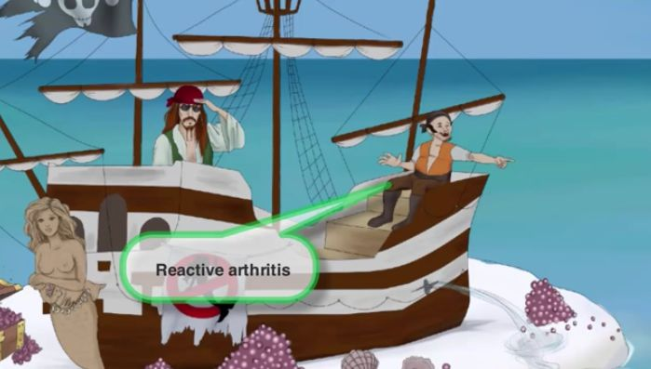  
    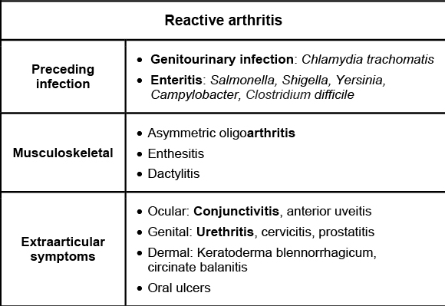
* *Chlamydia trachomatis* can cause **`{{c2::Reiter}}` syndrome**, which presents with the triad of `{{c3::uveitis/conjunctivitis}}`, `{{c4::urethritis}}`, and `{{c5::arthritis}}`
  + "can't see, can't pee, can't climb a tree"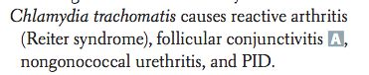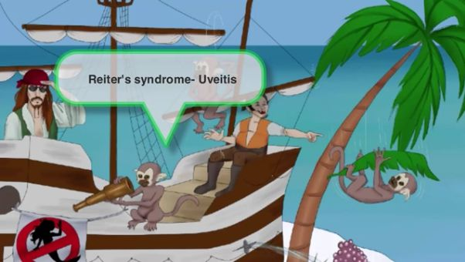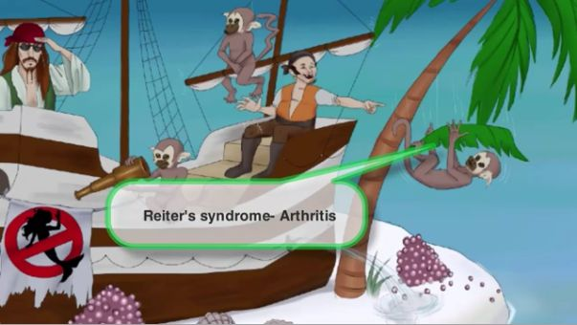
* *`{{c1::Campylobacteri jejuni}}`* is a curved bacteria that can cause **`{{c2::reactive arthritis}}`**, a spondyloarthropathy
  + aka Reiter syndrome (can't see, can't pee, can't climb a tree) -> uveitis, urethritis, arthritis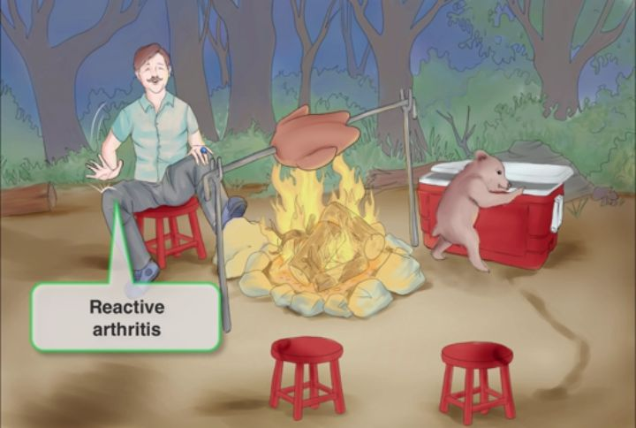
* Dermatological manifestations of **reactive arthritis** include `{{c1::hyperkeratotic vesicles}}` on the palms and soles (keratoderma blennorhagicum), and a serpiginous annular dermatitis of the `{{c2::glans penis}}` (circinate balanitis)
  + 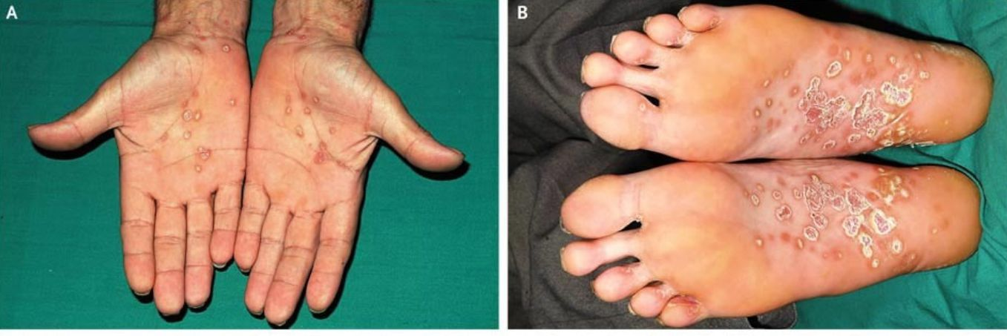  
    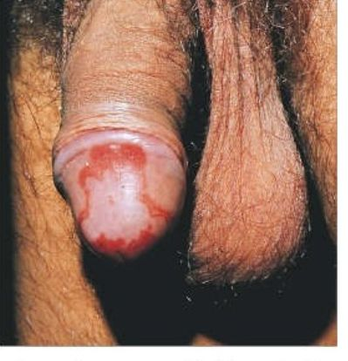
* **Reactive arthritis** may cause `{{c1::sacroiliitis}}` in about 20% of cases, resulting in axial pain in the lower back / buttocks region