MUR 1-0-1
- Turning on:
- Main switch on the right hand side gives power to the whole upper system (everything expect MIR).
- MIR can is powered on by pressing the blue button on the front right of the MIR
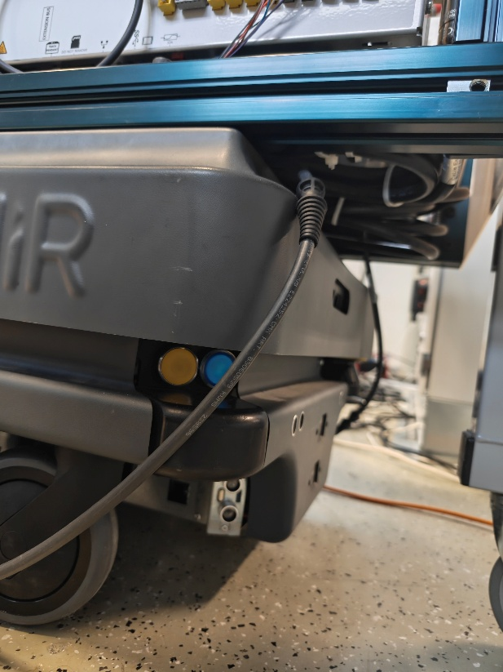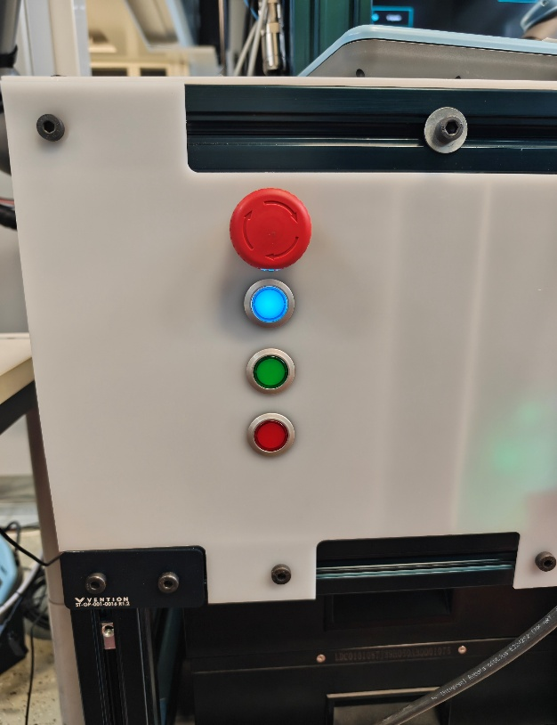
Figure 1, Blue starting button of MIR and lit blue reset button on the MUR to start MIR
- After pressing the lower blue button, MIR needs to be reset before accessing the UI. This is done by pressing another blinking blue button at the back of the upper system.

- Accessing systems:
- MIR200 can be accessed through MiR_R854 Wi-Fi (password mirex4you) and navigating to mir.com or optionally through the router RUT_D572_5G (password written to the router: g9K2JeHu)
- Commonly browsers complain about safety issues while accessing the web UI, but this must be just acknowledged and continue with advanced options.
- Username and password are default “admin”
- The UR5e cobots came with 2 pieces of AI acceleration kits, computers, that controls the cobot arms. Accessing these computers uses the default password “easybot”
- Safety plc can be accessed with Sick Flexi Soft with password FASTSAFE
- UR5e arms can be configured with the connected teach pendant and safety password of ”fastrobot” (Written behind the teach pendant)
- The router RUT50X can be accessed as well with the default ip-address 192.168.1.1 with the default credentials of admin + Mi0g9VBa (THE NEW PASSWORD IS “Fastlab2026” NO CAPS) (just when making this document the wifi connection cuts off quite often and doesn’t amaze with robustness, so this couldn’t be verified.)

- Turning off
- Main switch for upper system (Save your work before doing so)
- Same blue switch for MIR200 as starting. (Shutting down takes a while, be patient)

- Maintaining the system (Most important part)
- The MIR200 battery level must be kept in between 20-80%, the battery level must be monitored every week through MIR UI, as there is substantial leakage power even when powered off. (These batteries cost fortunes and therefore are important to keep alive)
- The batteries charge through the one hanging SUKO-cable which provides power for the entire system. Plugging the cable in starts charging the upper system by default, and the MIR200 charges by pressing the red switch on the lower left corner.
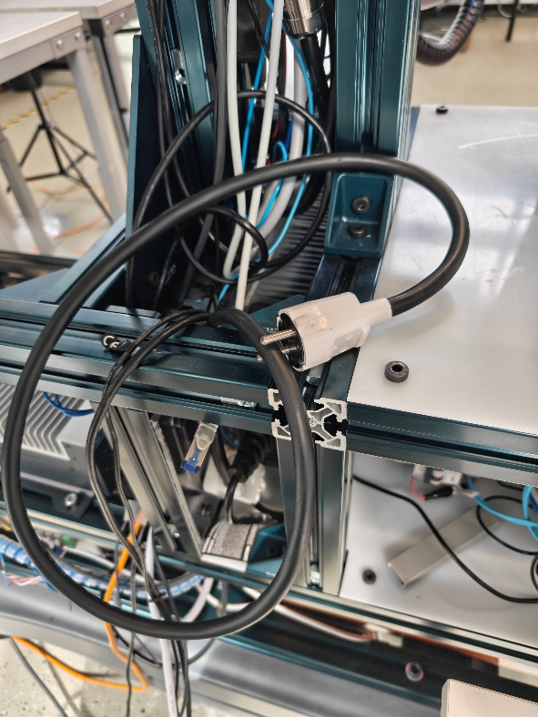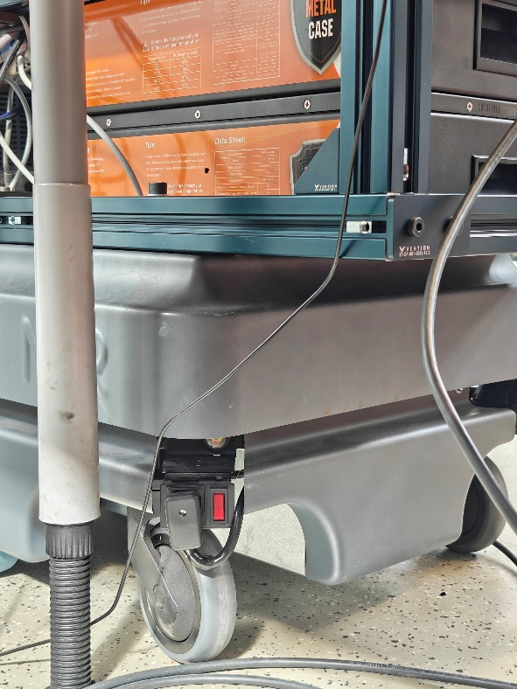
Figure 2, schuko-cable and the charging red switch of MIR
- As well as charging the system, the dual arms each axis must be moved every week. This can be done through the teach pendants.

