MIR SUITE
System Technical Documentation

Dual-arm mobile manipulation platform
MiR200 · 2× UR5e · BrainCo Revo1 · Orbbec Gemini · Nordbo
Tampere University (TUNI) / Fastlab

Version 1.0 — July 2026

Table of Contents
1. Background and Initial System State
2. Containerization Process
3. MiR Communication Bridge Integration
4. User Interface
5. Operating Guide
6. Technical Reference Manual
Appendices

1. Background and Initial System State
The MIR Suite project originated from work developed by Eemil, a laboratory researcher who implemented the original control system for the robotic platform. The system was distributed across three main repositories located in the otros_proyectos_eemil/ directory:
Project | Description | Main Content
pbd_system/ | Programming by Demonstration system | ROS workspace (~5 GB) with duo_ur packages, moveit_utils_pkg, contact_graspnet, SAM3 segmentation module and Tilix automation scripts
pandai_ark/ | Perception and navigation system | Initialization scripts, Polyscope extension modules and network utilities
Universal_Robots_ROS2_Driver/ | Official UR driver | Vendored source code of the official ROS 2 driver for Universal Robots arms

The original implementation required direct execution of all processes on the Jetson AGX Orin operating system, without isolation or containerization mechanisms. The ROS workspace was located at the absolute path ~/pbd_system/ros_ws/, with hardcoded dependencies and paths that prevented environment reproducibility on other machines.

1.1 Identified Limitations
Communication between the MiR200 mobile base and the ROS 2 environment was performed using the mir_raw.py script, which established a connection with the MiR internal rosbridge and republished all available topics (approximately 150). This behavior caused saturation of the DDS domain shared with the UR5e arm controllers.
- Unnecessary occupation of the DDS bus with diagnostic topics and internal MiR200 states
- Loss of critical messages from the UR5e controllers
- Error 9000 on the MiR200 (safety PLC activation and emergency stop) when transitioning to Running mode
- General system instability, particularly in the arm controllers
All processes —Python scripts, ROS nodes and Bash routines— ran directly on the host operating system without any container or virtual machine. The system lacked a unified graphical interface, requiring SSH connections and manual script execution for any robot operation.

1.2 Restructuring Objectives
Based on the analysis of identified limitations, the following objectives were defined:
- Containerization of all components using Docker to ensure isolation and reproducibility
- Reduction of DDS traffic through a selective bridge with the MiR200 base
- Development of a unified web graphical interface with authentication and access control mechanisms
- Implementation of a security policy based on the principle of least privilege
- Complete documentation of the architecture and operational procedures

2. Containerization Process

2.1 Component-Based Reorganization
As the first stage of the restructuring process, all source code was reorganized into a hierarchical component-based structure. Each robot subsystem was assigned to a specific directory within mir_suite/:
Directory | Component | Responsibility
UR/ | UR5e arms | ROS 2 driver, joint server, motion manager, action bridge
MiR/ | MiR200 mobile base | Selective communication bridge, scanner fusion, supervision mechanisms
PERIPHERAL/ | Peripherals | Orbbec Gemini 335Lg camera driver
ENDEFFECTOR/ | End effectors | BrainCo Revo1 hand control, touch sensor
UI/ | User interface | FastAPI backend, Svelte 5 frontend, Caddy TLS proxy, mDNS publication
BATTERY_MS/ | Battery/BMS | Research and documentation (phase 2)
HEAD_NECK/ | Motorized neck | Research and documentation (phase 2)
ROUTER_MODEM/ | Teltonika RUTX50 router | 5G connectivity configuration

2.2 Docker Service Architecture
The entire system was defined in a single docker-compose.yml file declaring 7 services. All containers use network_mode: host to share a common ROS 2 communication domain:
Service | Container | Profile | Function
caddy | mir_caddy | always | TLS/HTTP reverse proxy; sole LAN listening point
mdns | mir_mdns | always | Publication of mir-suite.local via avahi
mir_ui | mir_ui | always | FastAPI backend and compiled web UI; docker.sock access
camera | mir_camera | always | Orbbec driver (started on demand as a node)
mir | mir_mir | always | Selective MiR bridge, scanner fusion and supervision
ur_driver | mir_ur_driver | arms, full | UR driver, rosbridge, joint server, action bridge
ur_driver_sim | mir_ur_driver_sim | sim | Same image with simulated hardware for testing

Key architectural characteristics:
- Single ROS graph: all instances share ROS_DOMAIN_ID=75, resulting in approximately 41 topics visible from any container
- Shared /dev/shm: FastDDS requires shared memory between processes on the same host
- Docker profiles: arms (real hardware) and sim (simulation) selectable via --profile
- No container operates with elevated privileges: device access granted through specific cgroup rules
Note: /dev/shm must be explicitly shared. Without this configuration, topics appear listed but do not transmit data between containers. Symptom: "topic exists, zero messages".

2.3 Security Policy and Least Privilege
A policy of removing unnecessary privileges was applied to all containers. Instead of the privileged: true directive, only the minimum required permissions were granted:
Container | Previous privileges | Current privileges | Mechanism
mir_ur_driver | privileged: true | SYS_NICE + IPC_LOCK | cap_add + rtprio/memlock ulimits
mir_camera | privileged: true | c 189:* rmw | device_cgroup_rules + /dev/bus/usb
mir_mir | privileged: true | none additional | network_mode: host sufficient
mir_ui | privileged: true | docker.sock | exclusive docker socket mount

This modification was validated on real laboratory hardware. The UR5e arm controller operates correctly with SYS_NICE and IPC_LOCK for its real-time loop.

2.4 Network Infrastructure and Encryption
A two-tier Public Key Infrastructure (PKI) was implemented to ensure confidentiality of all web interface communications:
- Local root Certificate Authority with 10-year validity
- CA private key stored exclusively on the Jetson (mode 600, excluded from version control)
- Server certificate signed by the local CA with 825-day validity
- Subject Alternative Names: mir-suite.local, tunisite.local, lab.local, localhost, 192.168.1.75, 127.0.0.1
- mDNS publication of mir-suite.local via avahi
- Caddy proxy terminating TLS and routing traffic to uvicorn and rosbridge

3. MiR Communication Bridge Integration

3.1 DDS Domain Saturation Problem
The mir_raw.py script established a connection with the MiR200 internal rosbridge (192.168.1.14:9090) and republished all topics published by the mobile base into the local ROS 2 domain. The MiR200 exposes approximately 150 topics, including internal diagnostics, component states, odometry and raw sensor data.
This unnecessary traffic saturated the DDS domain shared with the UR5e arm controllers, causing Error 9000 on the MiR200 (safety PLC and emergency stop) and significant degradation in communication with the UR5e controllers.

3.2 Adopted Solution: Selective Topic Bridge
During analysis of this problem, a selective bridge implementation was identified in the fortis-uc1-tau (TK32) repository developed by Wael. This implementation solved the problem by transmitting only the essential topics for system operation. On July 10, 2026, this solution was integrated into the codebase, completely replacing mir_raw.py.
The implemented bridge (mir_bridge.py) uses the roslibpy library to connect to the MiR200 rosbridge and transmits exclusively the following topics:
Direction | Topics | Frequency | Purpose
MiR → ROS 2 (subscribe) | /f_scan | ~13 Hz | Front SICK laser scanner
MiR → ROS 2 (subscribe) | /b_scan | ~13 Hz | Rear SICK laser scanner
MiR → ROS 2 (subscribe) | /odom | 41 Hz | MiR200 base odometry
MiR → ROS 2 (subscribe) | /tf | - | Transforms (with map→odom filter)
MiR → ROS 2 (subscribe) | /tf_static | - | Static transforms
MiR → ROS 2 (subscribe) | /MC/battery_percentage | - | Battery status
ROS 2 → MiR (publish) | /cmd_vel | - | Base velocity (PLC-supervised)

The bridge deliberately filters the map→odom transform published by the MiR200, allowing a future local SLAM system to assume localization responsibility.

3.3 Supervision and Recovery Mechanisms
The mir container entrypoint manages the bridge lifecycle through multiple supervision layers:
Component | Function
Liveness check (mir_liveness.py) | Subscribes to /odom and updates a heartbeat file with each received message
Watchdog (mir_watchdog.sh) | Every 15s checks heartbeat; after 25s without activity, terminates the bridge process
Reconnection (mir_entrypoint.sh) | Exponential backoff loop (10s → 20s → 40s → 60s maximum)
Scanner fusion (scanners_merger.py) | Executed outside the reconnection loop, independent of MiR200 status

Implementation results: drastic reduction of DDS traffic (from approximately 150 topics to 7), verified system stability and absence of Error 9000 since production deployment.

4. User Interface
The unified graphical interface was developed to replace terminal-based operation. It consists of a FastAPI backend and a Svelte 5 frontend, communicating through an authenticated REST API and WebSockets for real-time telemetry.

4.1 Backend Architecture
The backend resides in a single file (UI/backend/main.py, 1604 lines) implementing all server logic via FastAPI, uvicorn, docker-py, httpx and WebSockets.
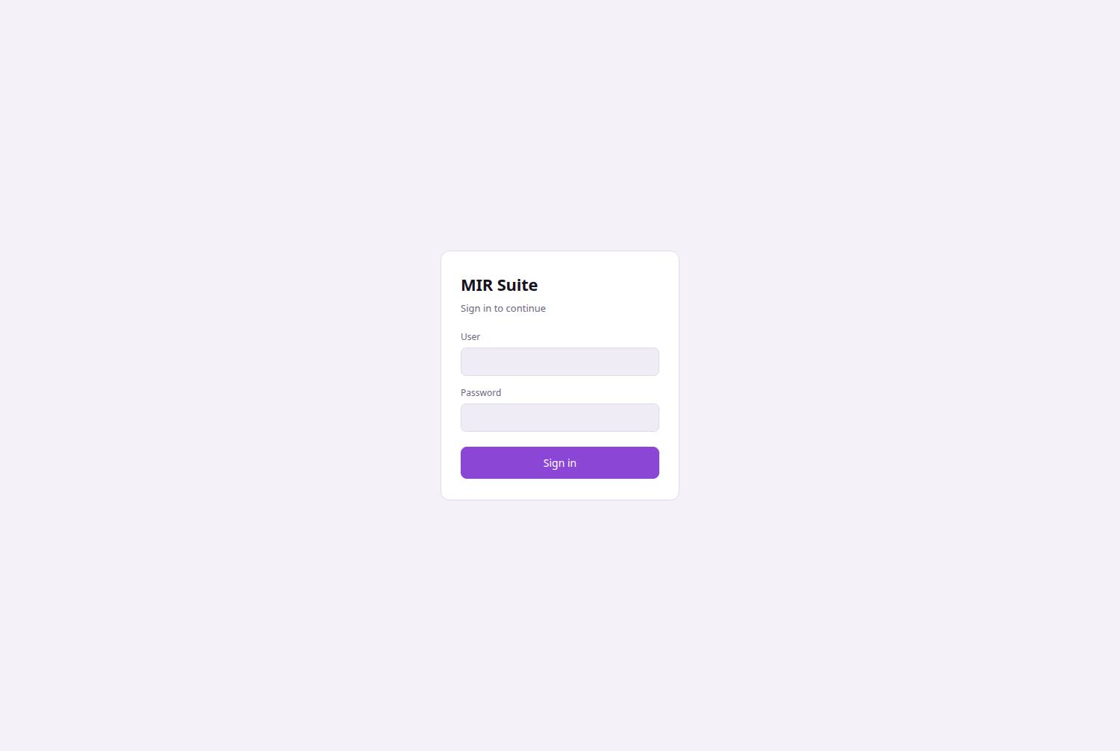
Login screen.

API Endpoints
Area | Route | Method | Purpose
Authentication | /api/login, /api/logout, /api/me | POST/POST/GET | Session management via tokens
Profile | /api/me/config, /api/me/apply | PUT/POST | Configuration and start saved nodes
Users | /api/users | GET/POST/PUT/DELETE | User management (administrators)
Containers | /api/containers | GET/POST | Docker Compose service control
Nodes | /api/nodes | GET/POST/GET | ROS node management and log query
System | /api/system | GET | Infrastructure process status
UR | /api/ur/status|start|stop|joints|move|payload|freedrive | GET/POST | UR driver control and telemetry
MiR | /api/mir/status | GET | Mobile base status via REST API
Force | /api/force | GET/POST | Nordbo force/torque sensors
Terminal | /api/term | WebSocket | Container Bash terminal (administrators only)

Backend security measures:
- Authentication tokens with 24-hour TTL stored in volatile memory
- Passwords protected via PBKDF2-SHA256 with 200,000 iterations
- Rate limiting: 8 consecutive failures result in a 300-second lockout
- Timing attack protection via dummy hash for non-existent users
- pkill pattern validation through restrictive regular expression
- can_control flag per user enabling or restricting control actions

4.2 Frontend Architecture
The frontend was developed with Svelte 5 and Vite, compiled and embedded in the backend Docker image. It consists of 12 Svelte components and 13 reactive stores:
Component | Route | Functionality
Overview.svelte | #/overview | Dashboard with status indicators, joints and force gauges
UrPanel.svelte | #/arms | Joint telemetry, motion controls and skills
SkillsPanel.svelte | #/arms | Skills execution (grasp, move)
ForcePanel.svelte | #/arms | Nordbo force sensor readings
MirPanel.svelte | #/mir | MiR200 base status
CameraPanel.svelte | #/camera | Live video stream via rosbridge
SystemView.svelte | #/system | Node, container and process manager
TerminalPanel.svelte | #/terminal | Container Bash terminal

4.3 Communication Flow
Data exchange between the browser and system follows this path:
Browser —— https/http ——> Caddy (:443/:80)
├── /rosbridge ——> rosbridge (localhost:9090, read-only)
└── other routes ——> uvicorn (localhost:8080)
│ FastAPI (main.py)
├── docker exec ——> container scripts
├── http ——> joint_server (localhost:9091)
├── http ——> MiR REST (192.168.1.14:80)
└── ws ——> Nordbo sensors (:2003)
Real-time telemetry reaches the browser via subscription through rosbridge. Commands never traverse rosbridge but are sent through the authenticated REST API.

4.4 Views Description
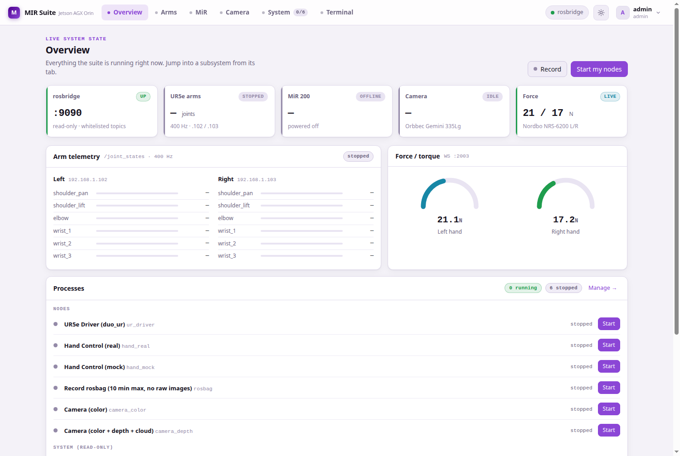
Overview: system status indicators.
The main view presents the overall system status: active containers, real-time bar graphs of both arm joints (400 Hz), Nordbo force sensor readings and the experimental data recording button.
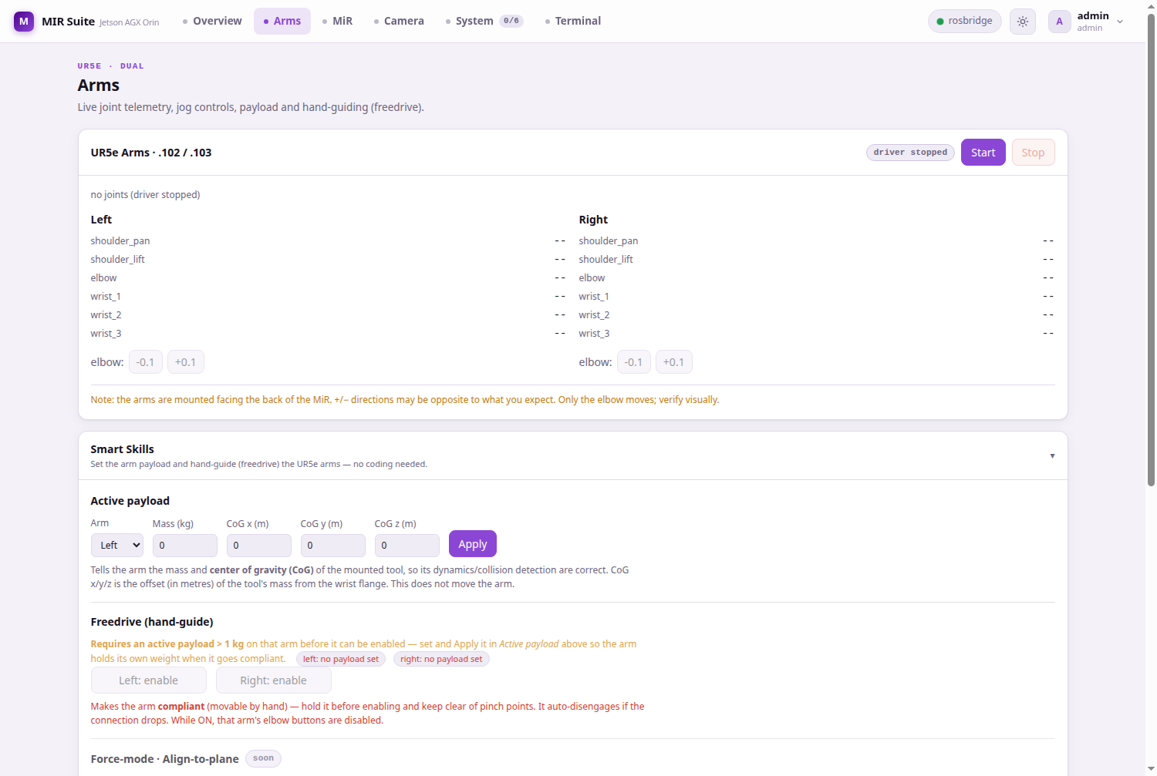
Arms: joint telemetry and motion controls.
The Arms panel allows monitoring each joint position, executing incremental movements, activating manual guidance mode, setting payload and running predefined skills.
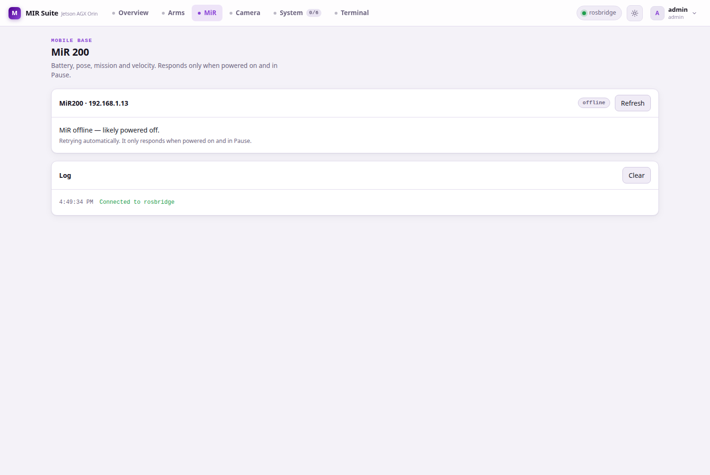
MiR: mobile base status.
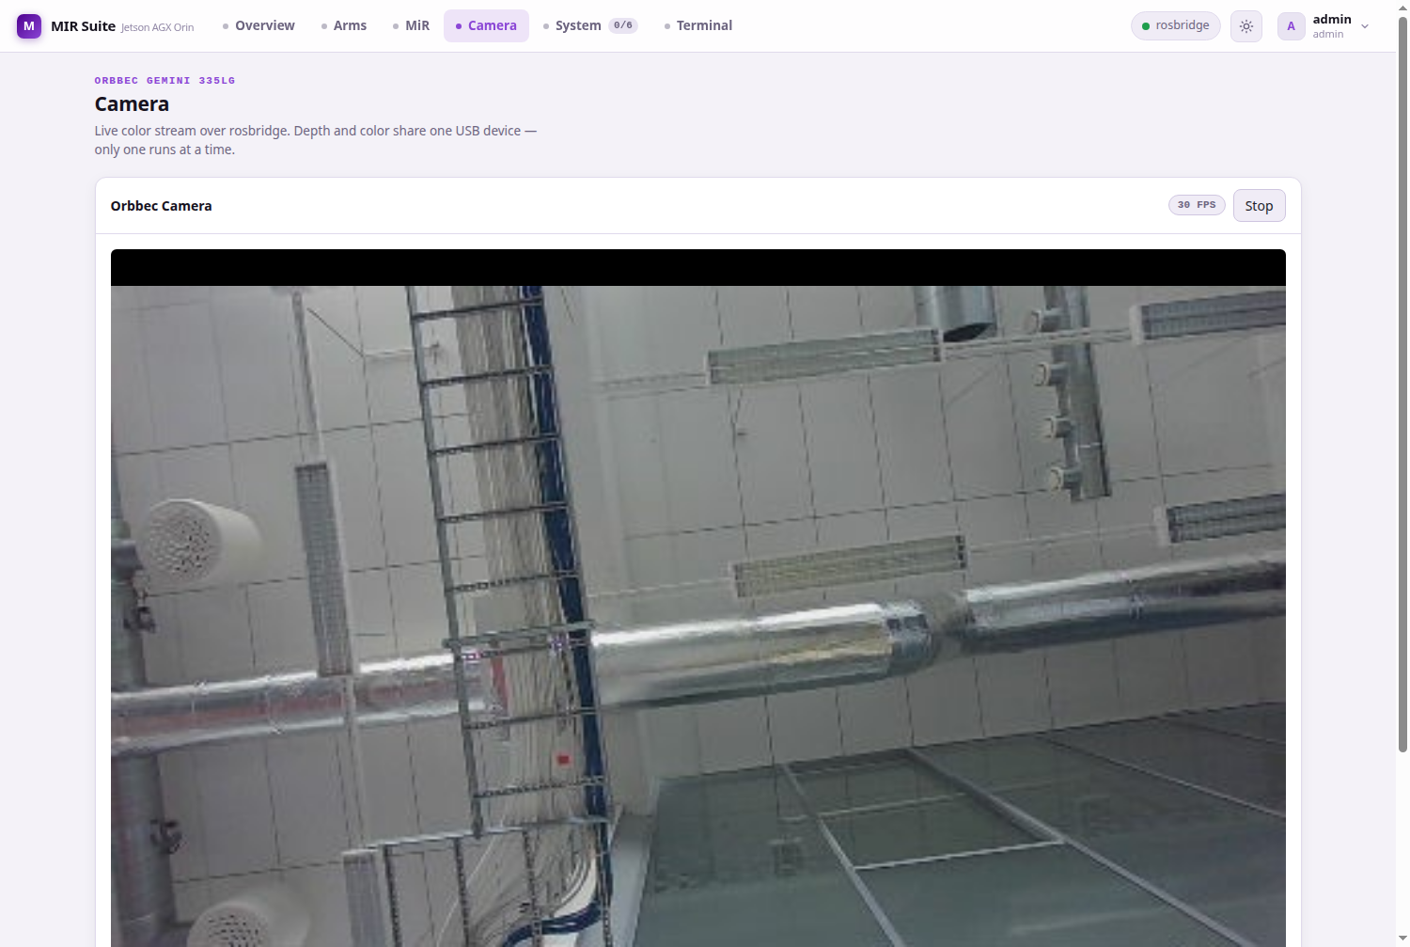
Camera: live video stream.
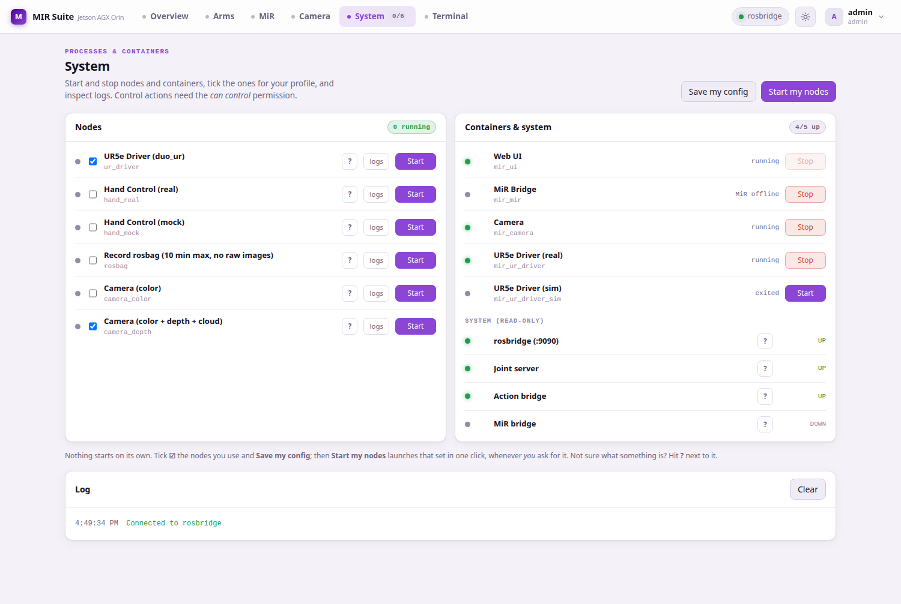
System: node and container manager.
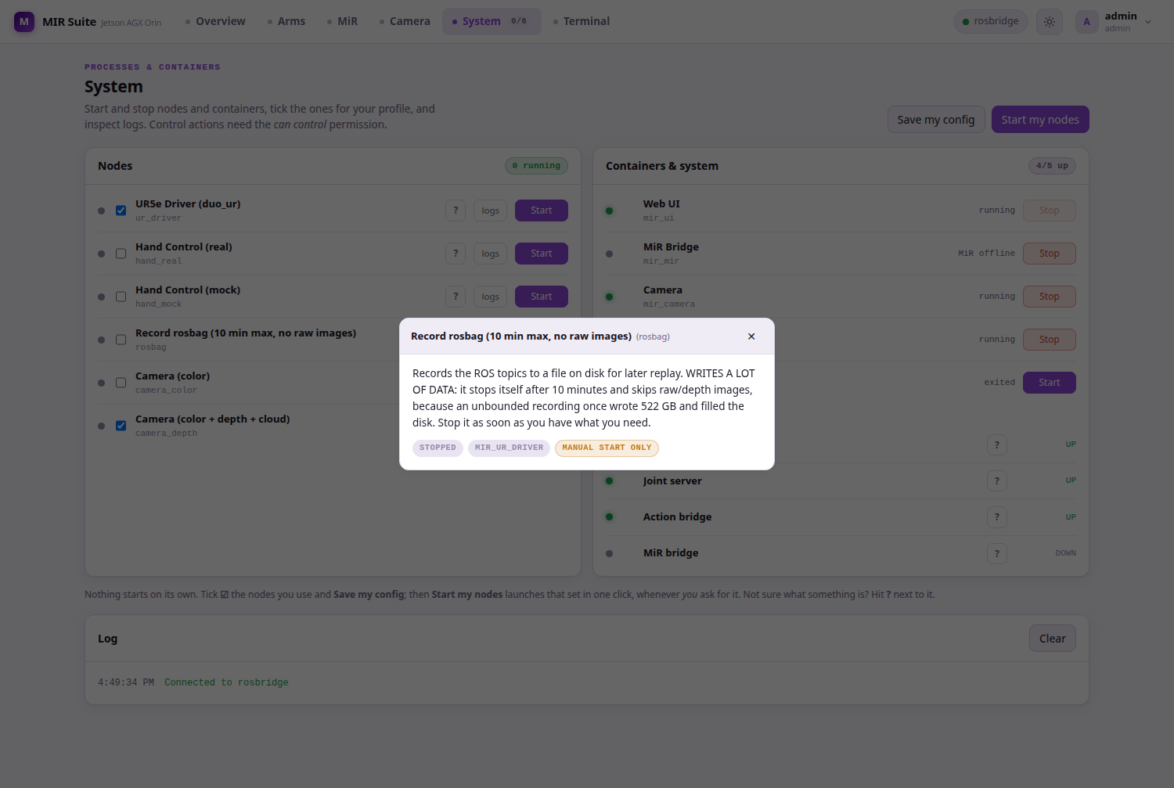
Rosbag node information.
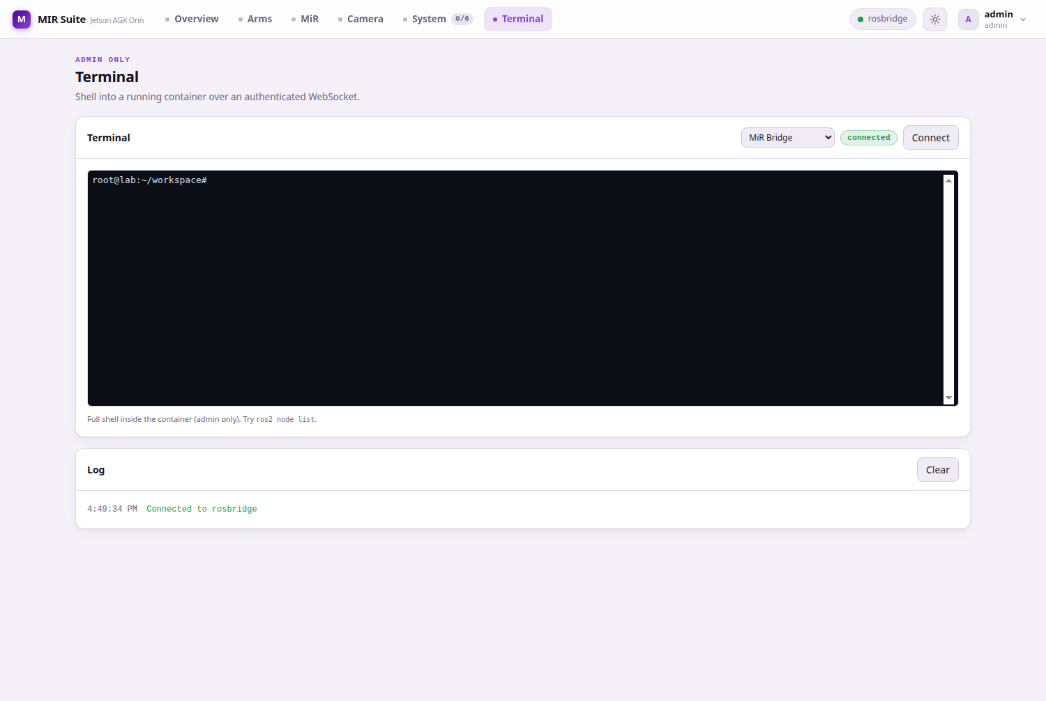
Web terminal in container.
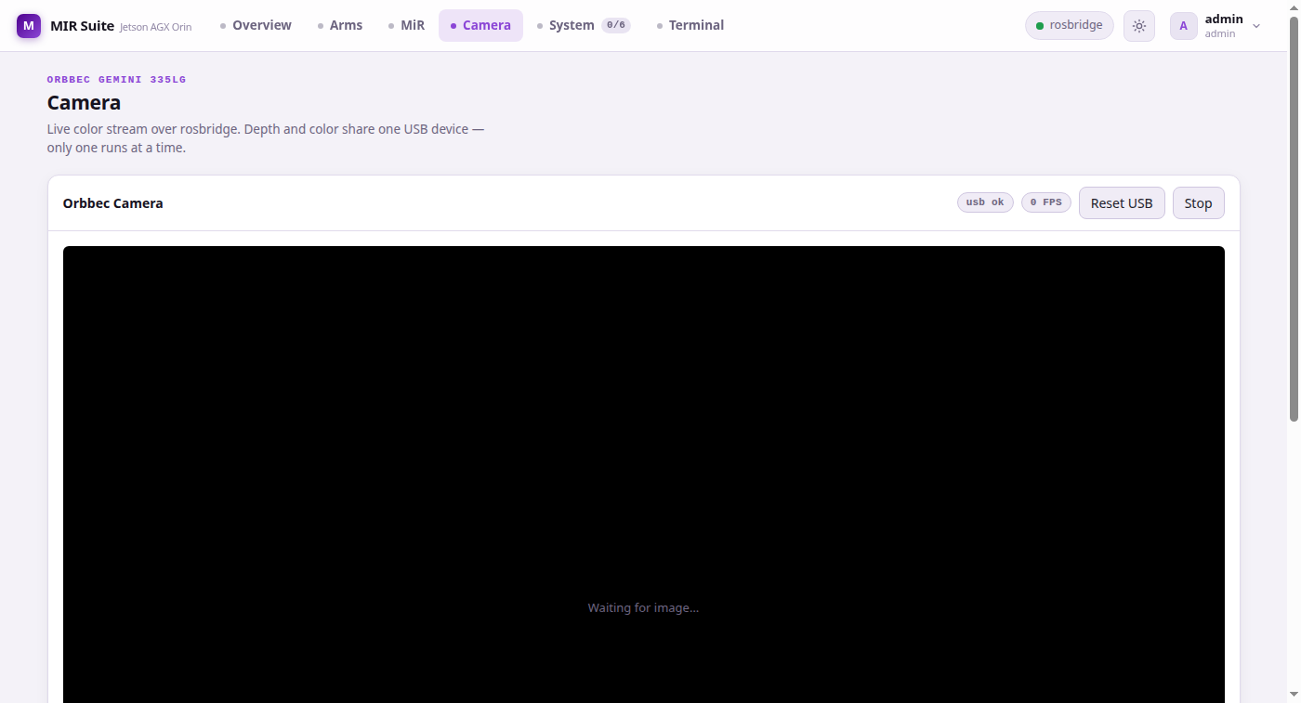
Camera USB management panel.

5. Operating Guide

5.1 System Access
The system is accessible from any device connected to the laboratory network:
URL | Description
http://192.168.1.75 | Unencrypted access from any device on the laboratory network
https://mir-suite.local | Encrypted access; requires installation of the laboratory CA

5.2 Startup Procedures
cd /home/lab/Desktop/MIR/mir_suite

docker compose up -d # Base services
docker compose --profile arms up -d # + real arms
docker compose --profile sim up -d # Simulation
docker compose down # Stop all
In the user interface, access System to start the required nodes. For the arms, power on the robots at their control panels; the system operates in headless mode without requiring the Play button.

5.3 UR5e Arm Control
Both UR5e arms (left: 192.168.1.102, right: 192.168.1.103) are controlled by a single ur_ros2_control_node instance. Key parameters: headless_mode=True, reverse_ip=192.168.1.75, tf_prefix left_/right_, state publication at 400 Hz.

5.4 Data Flow Verification
ros2 topic list | wc -l # ~41 topics
ros2 topic hz /odom # ~41 Hz with MiR200 powered on
ros2 topic hz /joint_states # ~400 Hz with UR driver active
ros2 topic hz /camera/color/image_raw/compressed # ~30 Hz

5.5 Software Update
git pull
docker restart mir_ui # Backend only
docker build --network=host -f UI/ui_image/Dockerfile -t mir_ui:latest .
docker compose up -d --force-recreate mir_ui

6. Technical Reference Manual
This chapter reproduces content from the MIR_SUITE_MANUAL.md technical manual, verified against the production system on July 13, 2026.

6.1 System Specifications
Component | Model | Address
Computer | NVIDIA Jetson AGX Orin (64 GB) | 192.168.1.75
Mobile base | MiR200 | 192.168.1.14
Left arm | Universal Robots UR5e | 192.168.1.102
Right arm | Universal Robots UR5e | 192.168.1.103
Hands | 2× BrainCo Revo1 | /dev/hand_L, /dev/hand_R
Camera | Orbbec Gemini 335Lg | /dev/bus/usb
Force/torque | 2× Nordbo NRS-6200 | .112 (left), .113 (right)
Router | Teltonika RUTX50 (5G) | 192.168.1.1

6.2 Jetson Ports
Port | Access | Service
80, 443 | LAN | Web UI + API + /rosbridge + /ca.crt
8080 | localhost | uvicorn (behind Caddy)
9090 | localhost | rosbridge (behind Caddy)
9091 | localhost | joint_server (arm telemetry)
50001–50004 | LAN | Left arm reverse interface
50011–50014 | LAN | Right arm reverse interface

6.3 Security
Measure | Detail
No privileged containers | Device access via cgroup rules
LAN surface = Caddy only | uvicorn, rosbridge and joint_server on localhost
Rosbridge read-only | Topic whitelist; services and actions denied
Authentication + can_control | Tokens with 24h TTL; per-user control flag
Command hardening | pkill pattern whitelist, per-node locks
TLS with private CA | Two-tier PKI; CA key never leaves the Jetson
Secrets out of git | .env, *.key, *.pem in .gitignore
Default passwords changed | admin/wael/pablo no longer use admin/wael/pablo; now Fastlab-2026/! (pbkdf2-sha256 hash, 200k iterations)
Terminal: mandatory second factor | Strong, unique SHELL_PASSWORD in config/.env; terminal is disabled on a default; constant-time comparison (hmac.compare_digest)

7. Recent Updates (2026-07-24)

7.1 Access Security
The default passwords of the three UI accounts (admin, wael, pablo) were changed from their factory values to Fastlab-2026/!. Profiles are stored hashed (pbkdf2-sha256, 200000 iterations) in UI/backend/data/profiles/*.yaml; config/.env was updated for any future re-seed.
The terminal second factor (SHELL_PASSWORD) is kept as a strong random value, distinct and independent from the login, stored only in config/.env.

7.2 Web Terminal Hardening
• The /api/term endpoint now requires a strong SHELL_PASSWORD: if the value is empty or a known default (fastlab2026, changeme, password, admin) the terminal is disabled and a warning is logged at boot.
• The password comparison uses hmac.compare_digest (constant time), preventing timing side-channel leaks.
• The Connect button now opens a modal dialog to enter the password (paste is reliable) instead of the old header field.
• Black-box verification (2026-07-24): no token, invalid token, non-admin user (wael/pablo), wrong password and a non-whitelisted container are all rejected before a shell opens. The only valid path is admin token + correct SHELL_PASSWORD + allowed container.

7.3 Emergency Stop and Arm Control
• Software E-STOP: /api/estop endpoint and a red button in the top bar; it actually cancels active action goals (stop_arm) on both arms and both hands, and disables freedrive.
• Wrist validation in MoveRequest (allow_wrist, default False) and a terminal exec_resize cap (max 200x200) to avoid Docker daemon hangs.

7.4 System Robustness
• Healthchecks on all six services (caddy, mdns, mir_ui, camera, mir, ur_driver/ur_driver_sim) and memory/CPU limits on every container.
• UR driver startup: verify that control ports 30002 and 30004 are open on 192.168.1.102 and 192.168.1.103 (ping alone is not enough) before starting the driver. If launched with the arms powered off, the node aborts (RTDE) and leaves a stale lock; the clean recovery is docker restart mir_ur_driver followed by a single Start from the UI.

Appendices

A. Repository Layout
mir_suite/
├── docker-compose.yml # 7 services
├── config/ # .env, tls/
├── UI/ # backend/, web/, caddy/, mdns/
├── UR/ # UR5e arms
├── MiR/ # MiR200 mobile base
├── PERIPHERAL/ # Orbbec camera
├── ENDEFFECTOR/ # BrainCo hands
├── BATTERY_MS/ # Battery (phase 2)
├── HEAD_NECK/ # Neck (phase 2)
├── ROUTER_MODEM/ # Teltonika router
├── documentation/ # This document
├── logs/ # Logs and rosbags
└── robot_workspace/ # Vendored ROS workspace

B. Environment Variables
Variable | Value | Description
ROS_DOMAIN_ID | 75 | Shared ROS 2 domain
MIR_IP | 192.168.1.14 | MiR200 IP address
LEFT_ARM_IP | 192.168.1.102 | Left UR5e arm
RIGHT_ARM_IP | 192.168.1.103 | Right UR5e arm
TOKEN_TTL | 86400 | Token TTL (24h)
NORDBO_LEFT_IP | 192.168.1.112 | Left Nordbo sensor
NORDBO_RIGHT_IP | 192.168.1.113 | Right Nordbo sensor
NORDBO_PORT | 2003 | Nordbo WebSocket port
UR_MAX_DELTA | 0.5 | Max jog delta (rad)
SHELL_PASSWORD | (secret) | Web terminal second factor; required and unique, distinct from login

C. Reference Commands
# Deployment
docker compose up -d
docker compose --profile arms up -d
docker compose down

# Logs
docker compose logs -f mir_ui
docker compose logs -f mir_mir
docker compose logs -f mir_ur_driver

# Container shell
docker exec -it mir_ur_driver bash
docker exec -it mir_mir bash
docker exec -it mir_camera bash

# ROS debug
ros2 topic list
ros2 topic hz /odom
ros2 topic hz /joint_states
ros2 control list_controllers

D. Architecture Diagram
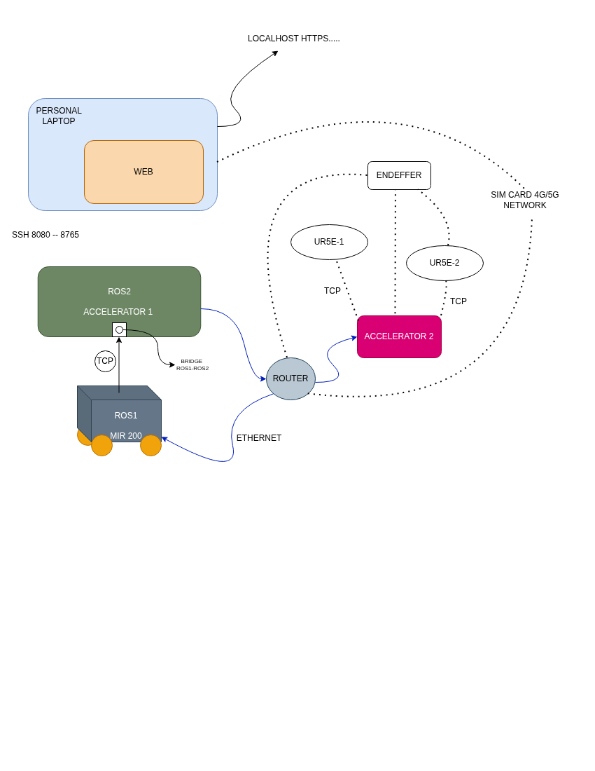

E. System Reference Table
Item | Value | Description
Jetson IP | 192.168.1.75 | Main computer
mDNS | mir-suite.local | Local network name
MiR200 | 192.168.1.14 | Mobile base
Left UR5e | 192.168.1.102 | Left arm
Right UR5e | 192.168.1.103 | Right arm
Left Nordbo | 192.168.1.112 | Left F/T sensor
Right Nordbo | 192.168.1.113 | Right F/T sensor
Router | 192.168.1.1 | Teltonika RUTX50
WiFi SSID | Robot_suite | 2.4 GHz, channel 11
REST API | http://192.168.1.75/api | FastAPI backend
Web UI | https://mir-suite.local | Graphical interface
Admin | admin, wael, pablo / Fastlab-2026/! | UI passwords (changed from default on 2026-07-24)
ROS_DOMAIN_ID | 75 | ROS 2 domain
Repository | github.com/fjmp-dev/TUNI-PROJECT | Branch: refactor/by-component

