MIR Suite - Technical Manual
Table of Contents

MIR Suite — Technical Manual
Mobile dual-arm manipulation platform · Tampere University (TUNI) / Fastlab
Document version | 1.0 — 13 July 2026
Repository | https://github.com/fjmp-dev/TUNI-PROJECT (branch refactor/by-component)
Audience | Industrial/robotics engineers developing on the platform
Status of facts | Every version number, IP, port and command in this manual was read from the running system on 2026-07-13, not copied from older documents.
[IMAGE HERE — cover photo] Full-body photo of the robot: MiR200 base with both UR5e arms and the sensor head visible, taken from ~3 m at slight angle so both arms and the base are in frame. Caption: “The platform: MiR200 mobile base carrying two UR5e arms, BrainCo hands, Orbbec camera and Nordbo F/T sensors, driven by an onboard Jetson AGX Orin.”

1. System overview and specifications
The MIR Suite is the software that turns a collection of robot hardware into one developable platform: a MiR200 mobile base, two Universal Robots UR5e arms, two BrainCo Revo1 dexterous hands, two Nordbo force/torque sensors and an Orbbec depth camera, all orchestrated by a single NVIDIA Jetson AGX Orin running Docker + ROS 2. Everything is operated from a web console served by the Jetson itself; no software needs to be installed on an operator’s machine.

1.1 Hardware
Component | Model | Interface | Address
Compute | NVIDIA Jetson AGX Orin (64 GB) | — | 192.168.1.75 (lan4)
Mobile base | MiR200 | WiFi → REST :80 + rosbridge :9090 | 192.168.1.14 (MIR_IP)
Left arm | Universal Robots UR5e | Ethernet, RTDE/primary | 192.168.1.102
Right arm | Universal Robots UR5e | Ethernet, RTDE/primary | 192.168.1.103
Hands | 2× BrainCo Revo1 (Stark) | USB-serial (FTDI) | /dev/hand_L, /dev/hand_R
Camera | Orbbec Gemini 335Lg (USB id 2bc5:080b) | USB 3 | /dev/bus/usb
Force/torque | 2× Nordbo NRS-6200 | Ethernet, WebSocket :2003 | .112 (left), .113 (right)
Router | Teltonika RUTX50 (5G) | — | 192.168.1.1
Two physical facts every developer must know:
- The arms are mounted facing the MiR’s back. This is intentional and must never be “corrected” in code, URDF or 3D views. A + jog can look inverted if you are standing at the MiR’s front.
- The MiR’s own safety PLC stays active underneath everything the suite does; its two SICK laser scanners enforce protective fields regardless of what we command.
[IMAGE HERE — arms orientation] Photo from the MiR’s side showing that the arms point toward the base’s rear (the side with the back laser). Caption: “The UR5e arms face the MiR’s back; keep this in mind when interpreting jog directions.”

1.2 Software stack (verified on the live system)
Layer | Component | Version
OS | Ubuntu 22.04.5 LTS, kernel 5.15.136-tegra | L4T R36.3.0 (JetPack 6)
Containers | Docker / Docker Compose | 28.3.3 / v2.39.1
ROS | ROS 2 Humble, ROS_DOMAIN_ID=75, FastDDS | —
UR driver | Universal_Robots_ROS2_Driver (vendored) + ur-client-library | 2.7.0
Motion planning | MoveIt 2 | 2.5.9
Web bridge | rosbridge-server | 2.0.5
MiR client | roslibpy (inside the MiR bridge) | 2.0.0
Backend | FastAPI / uvicorn / docker-py | 0.139.0 / 0.51.0 / 7.1.0
Frontend | Svelte 5 (runes) + Vite | 5.55.x / 5.4.x
TLS proxy | Caddy | 2.x (image caddy:2)
The ROS workspace (vendored external code: Eemil’s duo_ur arm packages, the UR driver, MoveIt configs, the Orbbec driver) lives in robot_workspace/ros_ws and is not committed to this repository — see documentation/EXTERNAL_PROJECTS.md. Treat it as read-only: suite-side changes are made through overlays (section 4.1).

2. Architecture

2.1 The seven containers
Everything runs as Docker Compose services (docker-compose.yml at the repo root), all with network_mode: host:
Service | Container | Profile | Role
caddy | mir_caddy | always on | TLS/plain reverse proxy; the only LAN-facing listener (:80, :443)
mdns | mir_mdns | always on | Publishes mir-suite.local → 192.168.1.75 via the host’s avahi
mir_ui | mir_ui | always on | FastAPI backend + the built web UI; talks to Docker via /var/run/docker.sock
camera | mir_camera | always on | Orbbec ROS 2 driver (started on demand as a node, see 5.3)
mir | mir_mir | always on | Selective MiR bridge + scanner merger + watchdog/liveness
ur_driver | mir_ur_driver | arms, full | UR driver, controllers, rosbridge, joint_server, action_bridge, hand node
ur_driver_sim | mir_ur_driver_sim | sim | Same image with mock hardware — test UI/flows without robots
None of the containers is privileged. Access is granted per device class instead: the camera container gets /dev/bus/usb plus cgroup rule c 189:* rmw (libusb); the UR container gets c 188:* (USB-serial hands) and SYS_NICE + IPC_LOCK with rtprio/memlock ulimits for the driver’s real-time loop.

2.2 One ROS graph, not seven
All ROS containers share ROS_DOMAIN_ID=75 on the host network, so there is a single ROS 2 graph. ros2 topic list returns the same ~41 topics from any container — the container you stand in decides where you look from, not what you see. To see what actually runs inside one container use ps aux | grep -E "python|ros"; to see who publishes a topic use ros2 topic info -v /scan.
Two DDS facts cost us real debugging days; they are load-bearing:
- /dev/shm must be shared. FastDDS uses shared memory between processes on the same host. Every ROS container therefore mounts the host /dev/shm (or /dev). Without it, discovery still works over UDP — topics list fine — but no data flows between containers. The symptom is “topic exists, zero messages”.
- Stale SHM segments wedge the graph. After hard kills (docker rm -f), leftover fastrtps_* files in /dev/shm can leave ros2 topic list empty or wedge the ros2_control service layer. Fix: stop the stack, then docker run --rm --network none -v /dev/shm:/shm --entrypoint bash mir_ui:latest -c 'rm -f /shm/fastrtps_* /shm/sem.fastrtps_*', then start again.

2.3 Request path
Browser ── https/http ──> Caddy (:443/:80, host)
├── /rosbridge ──> rosbridge (loopback :9090, read-only)
└── everything ──> uvicorn (loopback :8080)
│ FastAPI (main.py)
├── docker exec ──> node scripts in containers
├── http ──> joint_server (loopback :9091)
├── http ──> MiR REST (192.168.1.14:80)
└── ws ──> Nordbo sensors (:2003)
Live telemetry (camera frames, joint states) reaches the browser by subscribing through rosbridge. Commands never go through rosbridge — they go through the authenticated REST API, which executes inside the right container via docker exec. This split is what lets rosbridge be a read-only, whitelisted surface (section 8).

2.4 Build quirk (Jetson)
docker compose build fails on this Jetson because the kernel lacks the iptables raw table Docker’s default bridge networking wants during builds. Always build with host networking:
docker build --network=host -f UI/ui_image/Dockerfile -t mir_ui:latest .

3. Network

3.1 Topology
The Teltonika RUTX50 is the lab router: its 5G SIM (Elisa) provides internet, its LAN (192.168.1.0/24) is the robot network, and it broadcasts the WiFi SSID Robot_suite (2.4 GHz only, channel 11 — fixed there because channel 1 is saturated by eduroam). The Jetson additionally has a university-network uplink on lan1 (DHCP, currently 195.148.48.x) used for internet access (git, apt).
Device | IP | Notes
Teltonika RUTX50 | 192.168.1.1 | RutOS; admin UI on :80/:443
Jetson AGX Orin | 192.168.1.75 | static, port lan4; also mir-suite.local via mDNS
MiR200 | 192.168.1.14 | via Robot_suite WiFi; set in config/.env → MIR_IP
UR5e left / right | 192.168.1.102 / .103 | wired
Nordbo F/T left / right | 192.168.1.112 / .113 | wired, WebSocket :2003
[IMAGE HERE — router] Photo of the Teltonika RUTX50 with its WiFi/5G antennas as installed. Caption: “Teltonika RUTX50: LAN 192.168.1.0/24, SSID Robot_suite (2.4 GHz ch 11), internet over the Elisa 5G SIM.”
The MiR’s IP is assigned by the router’s DHCP; if the MiR ever changes address, update MIR_IP in config/.env and docker compose up -d mir mir_ui. (A DHCP reservation on the router is the pending permanent fix.)

3.2 Ports on the Jetson
Port | Bound to | What
80, 443 | LAN (Caddy) | Web UI + API + /rosbridge + /ca.crt
8080 | loopback only | uvicorn (behind Caddy)
9090 | loopback only | rosbridge (behind Caddy at /rosbridge)
9091 | loopback only | joint_server (arm telemetry for backend/mover)
50001–50004 | LAN | UR reverse interface, left arm (script/trajectory ports)
50011–50014 | LAN | UR reverse interface, right arm
The arms’ dashboard servers (:29999 on each robot) are disabled on both UR5e — recovery paths that would use them go through resend_robot_program instead.

4. Components

4.1 UR5e arms
Code: UR/ (suite side) + vendored robot_workspace/ros_ws/src/UR_arms/ (Eemil’s duo_ur, the UR ROS 2 driver, MoveIt config — do not edit; overlay instead, e.g. UR/duo_ur_launch_patch/ is bind-mounted read-only over the sim launch).
Both arms are driven by one ur_ros2_control_node in mir_ur_driver, launched by UR/ur_start/ur_start.sh (idempotent; killed by UR/ur_stop/ur_stop.sh). Key parameters, verified live: headless_mode=True (no pendant Play needed — the driver injects the External Control program over the primary interface), reverse_ip=192.168.1.75, per-arm reverse ports as in §3.2, tf_prefix left_/right_, joint states at 400 Hz.
Supporting processes in the same container:
Process | File | Role
joint_server | UR/joint_server/joint_server.py | Serves current joint positions on loopback :9091
joint_mover | UR/joint_mover/joint_mover.py | One-shot CLI: sends a single FollowJointTrajectory goal, then verifies motion against :9091
action_bridge | UR/action_bridge/action_bridge.py | Skills entry point (move_arm, open/close hand); clamps finger currents and velocities
rosbridge | patched launch in UR/rosbridge_hardening/ | Read-only topic whitelist for the browser
The move chain (what happens when you press a jog button in Arms):
UrPanel → POST /api/ur/move → backend _run_move (docker exec)
→ joint_mover.py → FollowJointTrajectory on /{arm}_joint_trajectory_controller
→ post-move check against joint_server :9091
If the arm did not actually move (the usual cause: the robot-side External Control program dropped its reverse-interface connection), the backend runs the recovery automatically: resend_robot_program → wait 3 s → re-activate the trajectory controller → retry. Per-request jog delta is capped by UR_MAX_DELTA=0.5 rad.
Logging caveat: the UR client library registers its log handler once per process, so all URCL lines are tagged with the first arm’s prefix (right_). “No left_ lines” does not mean the left arm is disconnected — diagnose per-arm via hardware component states, never via log tags.

4.2 MiR200 base
Code: MiR/. Two independent access paths:
- REST API v2.0.0 (http://192.168.1.14/api/v2.0.0/...) — status, battery, mode. Used by the backend for the MiR tile/tab. Auth is HTTP Basic with base64(user + ":" + sha256(password)).
- Selective ROS bridge (MiR/bridge_mir/mir_bridge.py, adopted from Wael’s fortis-uc1-tau TK32) — connects to the MiR’s own rosbridge (:9090 on the MiR) with roslibpy and republishes only the topics whitelisted in MiR/bridge_mir/topic_config.yaml:
Direction | Topics
→ MiR (publish) | /cmd_vel (direct base velocity; the MiR’s safety PLC still gates it)
← MiR (subscribe) | /f_scan, /b_scan (~13 Hz), /odom (41 Hz), /tf, /tf_static, /MC/battery_percentage
The bridge deliberately filters out the MiR’s map→odom TF so a future onboard SLAM can own localization. Its predecessor (mir_raw.py) republished every MiR topic and could saturate the shared DDS domain; if you find references to it in old documents, they are historical.
MiR/bridge_mir/scanners_merger.py fuses the two SICK scans into one 360° /scan (~12.5 Hz, frame base_footprint) — the input a future Nav2/SLAM stack expects.
Self-healing: the container entrypoint relaunches the bridge with backoff if the MiR is unreachable; mir_watchdog.sh kills a bridge that is “alive but mute” (no /odom for 25 s, with a 60 s startup grace) after probing whether the MiR side or our side is at fault; mir_liveness.py refreshes the heartbeat the watchdog reads. Do not hammer the MiR’s rosbridge with rapid reconnects — that wedges the MiR side (it needs its own restart to recover).
[IMAGE HERE — MiR rear] Photo of the MiR200 rear at ~1 m, crouching, showing the back laser scanner window and how the UR cables are routed above it. Caption: “Back SICK scanner. Anything inside its protective field (including dangling cables) puts the MiR in emergency stop; keep the window clean and the cables tied.”

4.3 Camera (Orbbec Gemini 335Lg)
Code: PERIPHERAL/camera_orbbec/. The driver runs inside mir_camera and is started on demand from the UI as one of two mutually exclusive nodes (single USB device): Camera (color) — 480×270 @ 30 fps compressed color, what the Camera tab shows — or Camera (color + depth + cloud) for perception work. The browser receives /camera/color/image_raw/compressed via rosbridge; measured ~30 Hz end-to-end.
The container is de-privileged: /dev/bus/usb + cgroup c 189:* rmw survives replugs (device number changes, bus tree doesn’t). If the camera hangs in a bad USB state, the node can reset it with the USBDEVFS_RESET ioctl — no extra capabilities needed. And it mounts /dev/shm explicitly; removing that mount reproduces the “topics visible, no frames” failure of §2.2.

4.4 Hands (BrainCo Revo1)
Code: ENDEFFECTOR/hand_control_node/hand_control_node.py, run inside the UR container (the hands’ FTDI adapters enumerate there via /dev/hand_L, /dev/hand_R udev symlinks, stable across replugs). It uses the official Python bc_stark_sdk (aarch64) — the C++ SDK is x86-only and was a dead end. Finger positions are clamped to [0,1000] (thumb 500) and close currents to [20,20,5,5,5,5] per finger, in both command paths (hand node and action_bridge), so no UI or skill request can exceed them. A --mock variant exercises the full UI path with no hardware.

4.5 Force/torque (Nordbo NRS-6200)
No ROS node — the sensors speak their own WebSocket protocol on :2003 ({"cmd":"START_TRANSMISSION"} starts the stream). The backend connects directly (NORDBO_LEFT_IP/NORDBO_RIGHT_IP, default .112/.113) and exposes /api/force plus per-side tare, connect, disconnect. The Arms tab shows live magnitudes.

5. Web UI
Code: UI/web/ (Svelte 5 + Vite, built into the mir_ui image at build time — UI changes require an image rebuild; backend main.py is bind-mounted and only needs docker restart mir_ui).

5.1 Views and routing
The active tab lives in the URL hash — reload keeps your tab, browser back/forward navigates, links can be bookmarked:
Route | View | Content
#/overview | Overview | Status tiles, live joint bars, force gauges, Record button, process list
#/arms | Arms | Joint telemetry + jog buttons, Skills, payload/freedrive, force panel
#/mir | MiR | Base status from the REST API (battery, state, position)
#/camera | Camera | Live color stream (30 fps) with node start/stop
#/system | System | Node launcher, containers, system processes, per-node logs
#/terminal | Terminal | Full bash inside a chosen container (admin only, ROS pre-sourced)
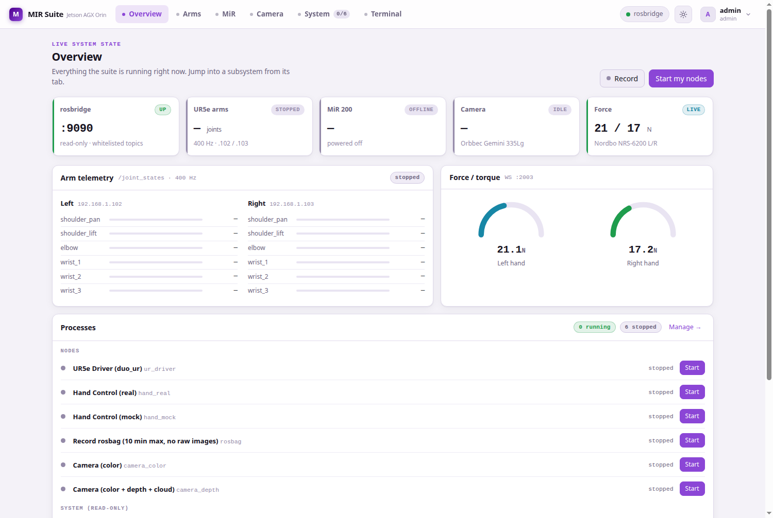 Overview: system state at a glance. The Record button starts/stops the bounded rosbag; the pulsing dot makes a running recording impossible to miss.
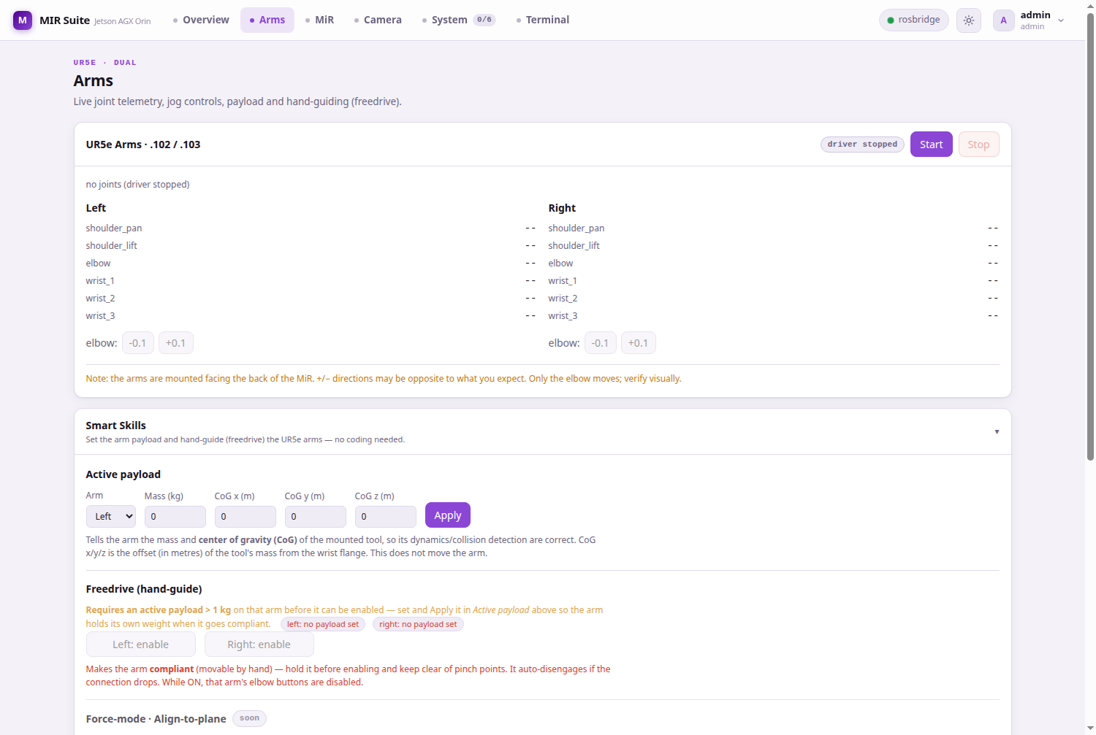 Arms: live joints at 400 Hz, jog controls, skills and force readings in one place.
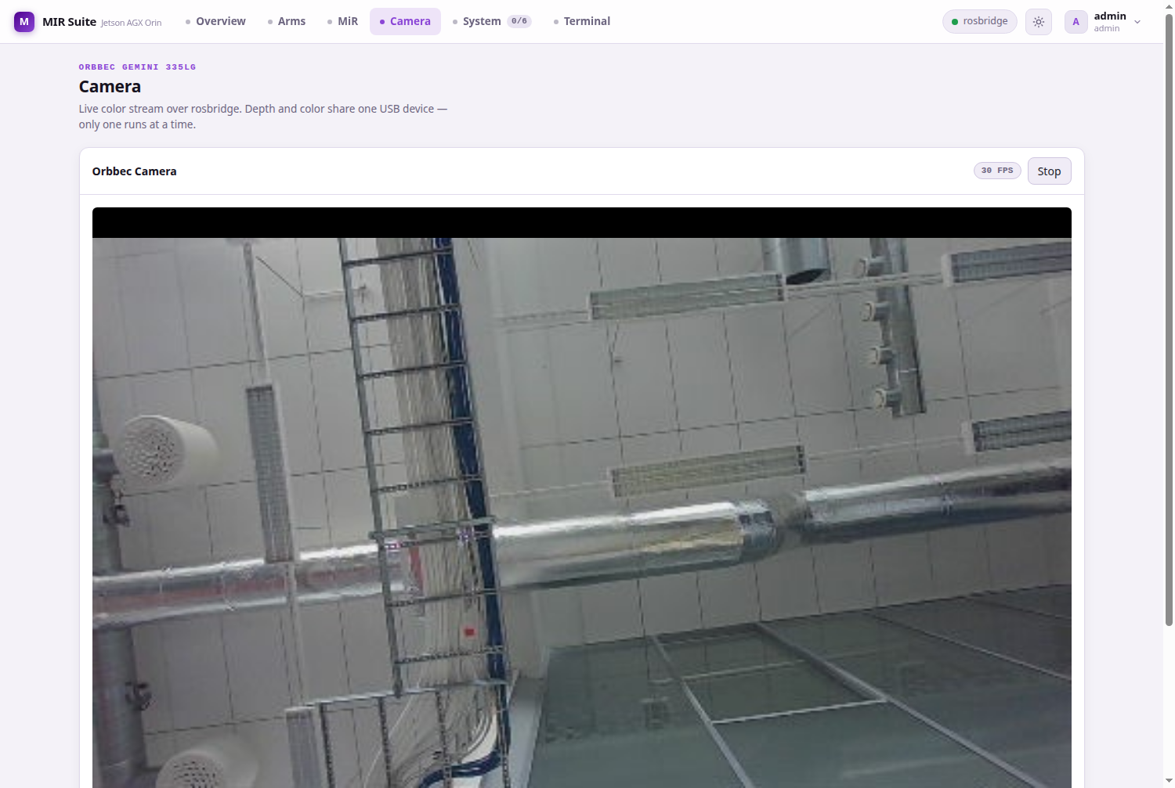 Camera: the live Orbbec stream over rosbridge, with the FPS chip confirming the real rate.

5.2 Users and permissions
Login is required for everything. Profiles are YAML files under UI/backend/data/profiles/ (passwords stored as PBKDF2-SHA256; the directory is git-ignored). Two roles: admin (everything, incl. Terminal and user management) and user. A user additionally needs the can_control flag to start/stop anything or move the robot — without it the UI is read-only and the backend rejects control calls regardless of what the UI shows. Session tokens (X-MIR-Token header) expire after TOKEN_TTL (24 h default).

5.3 Node launcher — nothing starts by itself
The System tab manages nodes (processes inside containers) via a data-driven registry (NODES in UI/backend/main.py): the UR driver, real/mock hand control, the two camera variants, and the rosbag recorder. Design rules, learned the hard way:
- Nothing auto-starts on login. A profile’s saved node list is a shortcut for the explicit Start my nodes button, not an autostart list. (Login used to auto-apply it; with rosbag saved in a profile, opening the web page silently started a recording that wrote 522 GB and filled the disk.)
- The rosbag recorder is bounded: hard 10-minute timeout, raw/depth image topics excluded, 2 GB file splits — ~600 MB per full run instead of unbounded gigabytes — and it is flagged no_autostart, so even a saved profile cannot launch it implicitly.
- Every node and system process has a “?” popup describing what it does, what hardware it needs, and what it costs, sourced from the same backend registry.
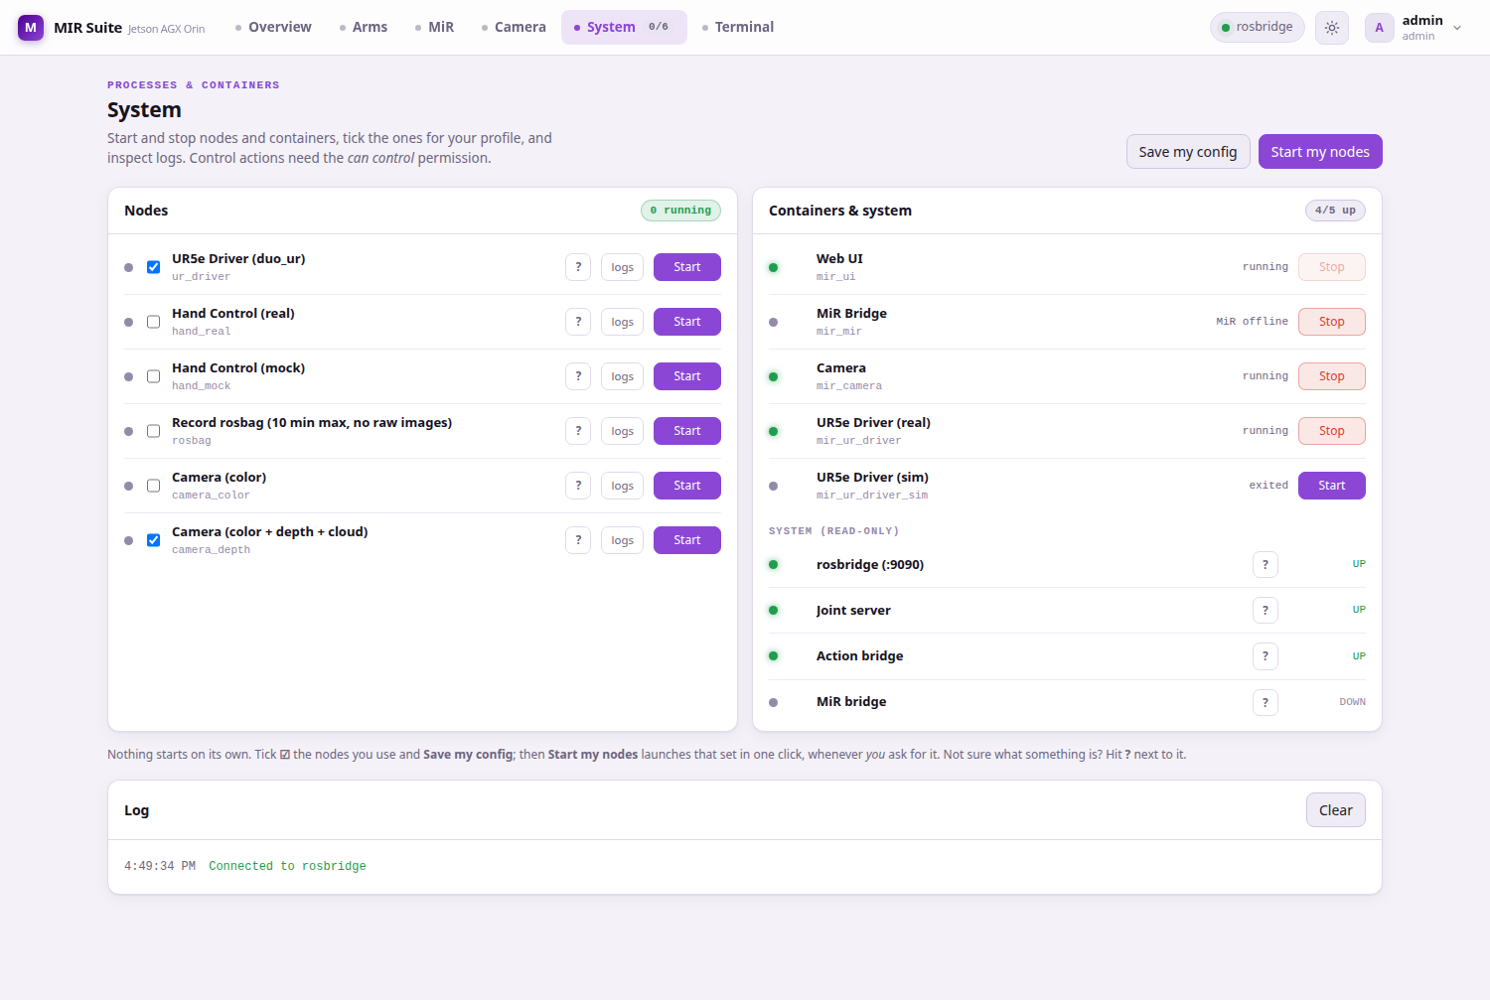 System: nodes on the left, containers and read-only system processes on the right.
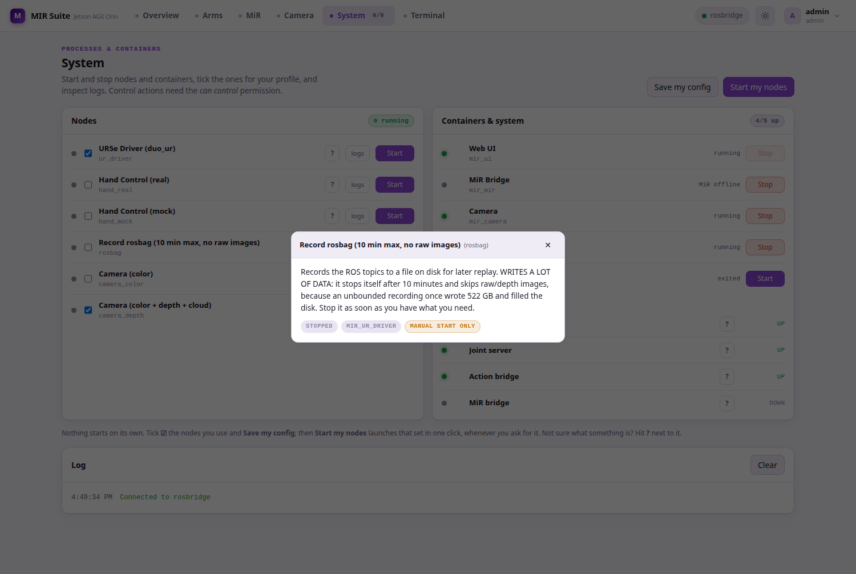 The “?” popup for the rosbag recorder — including why it is capped.

5.4 In-browser terminal (admin)
A full bash inside mir_ur_driver, mir_camera or mir_mir (xterm.js over /api/term). The shell sources ROS automatically, so ros2 ... works immediately.
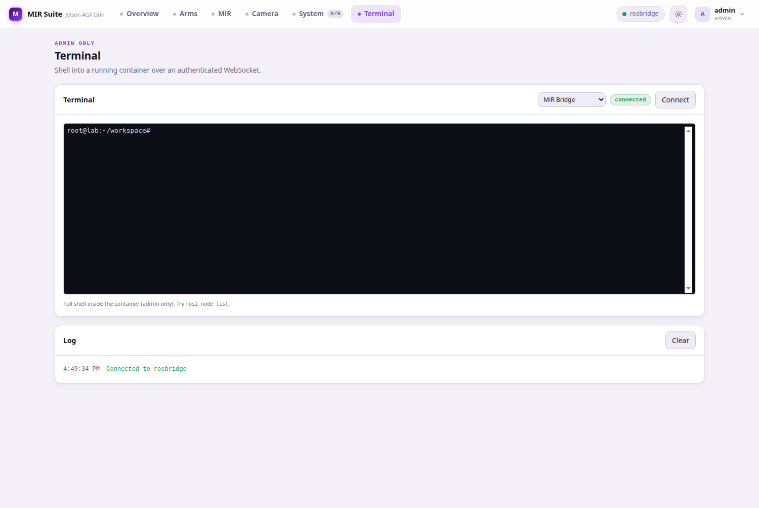 Terminal: a real shell in the chosen container, ROS environment pre-loaded.

6. Backend API reference
FastAPI app in UI/backend/main.py. All routes (except /api/login and /health) require the X-MIR-Token header; control routes additionally require can_control.
Area | Route | Method | Purpose
Auth | /api/login, /api/logout, /api/me | POST/POST/GET | Session; me returns profile + config
Profile | /api/me/config | PUT | Save node list + settings
Profile | /api/me/apply | POST | Start saved nodes (skips no_autostart ones)
Users | /api/users, /api/users/{u} | GET/POST/PUT/DELETE | Admin user management
Containers | /api/containers, /api/containers/{n}/start\|stop | GET/POST | Compose service control
Nodes | /api/nodes, /api/nodes/{id}/start\|stop\|logs | GET/POST/GET | Node launcher + logs
System | /api/system | GET | Read-only infra process status
UR | /api/ur/status\|start\|stop\|joints | GET/POST | Driver lifecycle + telemetry
UR | /api/ur/move, /api/ur/payload, /api/ur/freedrive | POST | Jog (with auto-recovery), payload, hand-guiding
MiR | /api/mir/status | GET | REST-derived base status
Force | /api/force, /api/force/{side}/tare\|connect\|disconnect | GET/POST | Nordbo sensors
Terminal | /api/term | WebSocket | Admin shell (token via query param)
Health | /health | GET | Liveness
Safety measures inside the backend worth knowing when extending it: pkill patterns are validated against a whitelist before execution (no shell injection through node definitions); per-node locks make start idempotent under double-clicks; the UR container identity comes from the UR_CONTAINER env var (no autodetection).

7. Operating guide
Every command below was executed on the real system while writing this manual.

7.1 Access
URL | When
http://192.168.1.75 | Works from any device on the lab network, no setup
https://mir-suite.local (or https://192.168.1.75) | Encrypted; requires installing the lab CA once per device
To get the green padlock: browse to http://192.168.1.75/ca.crt, install the downloaded certificate as a trusted authority (Firefox: Settings → Certificates → Authorities → Import; Windows: “Trusted Root Certification Authorities”; Android/iOS: the OS offers to install it — iOS also needs Settings → General → About → Certificate Trust Settings). On any Linux machine, config/tls/trust_ca.sh does all stores at once — note that browsers on Linux ignore the system store, and snap browsers keep their own NSS database; the script handles both. Restart the browser fully afterwards.
Plain HTTP is served by decision, so the team can always reach the UI: over :80 the login password and all robot commands travel unencrypted on the lab WiFi. Once the CA is installed on the machines that matter, re-enable the https redirect in UI/caddy/Caddyfile.
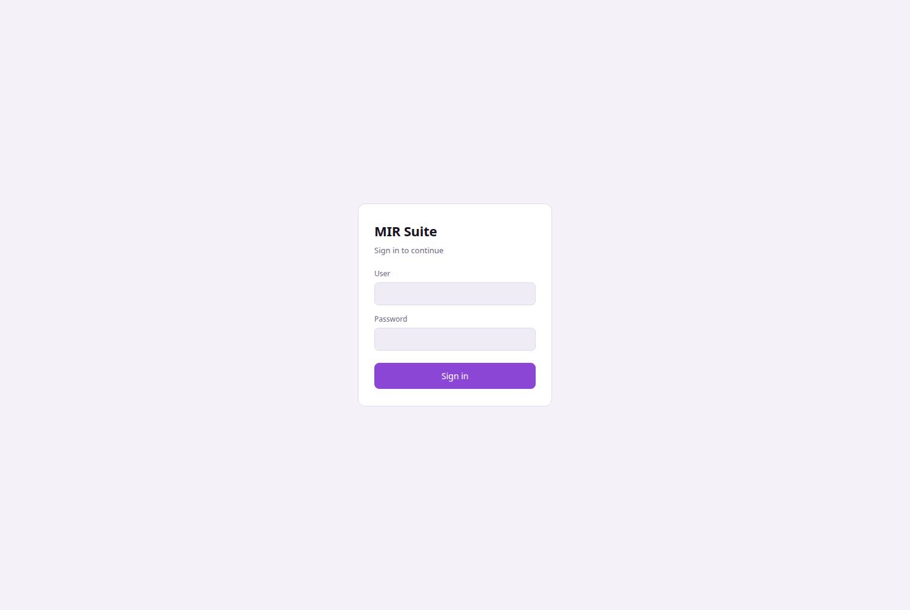 Sign in — profiles are personal; ask an admin for an account with the permissions you need.

7.2 Bring-up and shutdown
cd /home/lab/Desktop/MIR/mir_suite
docker compose up -d # caddy, mdns, mir_ui, camera, mir
docker compose --profile arms up -d # + the UR driver container
docker compose --profile sim up -d # (alternative) mock-hardware UR container
docker compose down # stop everything
Then in the UI: System → Start the nodes you need (UR driver, a camera variant), or set your profile once and use Start my nodes. Arms: power the robots on their pendants first; no Play needed — the suite runs them headless.
Rule of the lab: test in the sim profile before touching real hardware.
[IMAGE HERE — power & e-stop] Photo of the MiR’s blue power button and the red e-stop, labelled. Caption: “Clean MiR shutdown = hold the blue button ~3 s and wait for full power-off. The red switch is the emergency cut, not the off button.”

7.3 Verifying data flows (web Terminal or docker exec)
The ROS graph is shared, so these work from any of the three shell containers:
ros2 topic list | wc -l # ~41 topics; hundreds = something is flooding DDS
ros2 topic info -v /scan # who publishes / who listens
ros2 topic hz /camera/color/image_raw/compressed # ~30 Hz with a camera node running
ros2 topic hz /odom # ~41 Hz with the MiR powered on
ros2 topic hz /joint_states # ~400 Hz with the UR driver running
ros2 control list_controllers # only answers while the UR driver is up
A topic that lists but gives no hz output means the publisher is down (MiR off, camera stopped) — or, if the publisher is provably up in another container, the /dev/shm problem of §2.2.

7.4 Recording data
Overview → Record (or System → rosbag → Start). It stops itself after 10 minutes, skips raw image topics and splits files at 2 GB; bags land in logs/bag_<timestamp>/ (owned by root — delete via docker exec mir_camera rm -rf /var/log/mir/bag_<ts>). Stop it as soon as you have what you need; check disk headroom with df -h / before long recordings.

7.5 Updating the software
git pull
# backend only (main.py is bind-mounted):
docker restart mir_ui
# UI/frontend or Dockerfile changes (host networking is mandatory on this Jetson):
docker build --network=host -f UI/ui_image/Dockerfile -t mir_ui:latest .
docker compose up -d --force-recreate mir_ui

8. Security
The suite runs on a lab LAN, but “someone on the same WiFi” is exactly the attacker model that matters for a robot. What is in place, and what is consciously accepted:
Measure | Detail
No privileged containers | Device access via cgroup rules (c 188/c 189) + SYS_NICE/IPC_LOCK only where the RT loop needs it
LAN surface = Caddy only | uvicorn :8080, rosbridge :9090 and joint_server :9091 all bind loopback
rosbridge is read-only | Whitelist: the camera topic; services/actions deny-all. Commands must go through the authenticated REST API — there is no path to FollowJointTrajectory or /cmd_vel from the browser socket
Auth + can_control | Every actuation endpoint checks the per-user flag server-side; tokens expire (24 h)
Command hardening | pkill pattern whitelist, per-node start locks, hand current/position clamps, UR_MAX_DELTA
TLS with a private CA | Two-tier PKI (config/tls/gen_cert.sh): a 10-year lab root signs the 825-day server cert; reissuing the server cert never touches client trust stores. Root served at /ca.crt; ca.key never leaves the Jetson (mode 600, git-ignored)
Secrets out of git | .env, *.key, *.pem, UI/backend/data/ (password hashes) are git-ignored
Accepted risks, stated plainly: (1) plain HTTP on :80 exposes credentials and commands to the local network — a deliberate usability trade-off until the CA is deployed everywhere (§7.1); (2) factory/default passwords on lab equipment remain by the user’s decision; the backend logs a warning at boot while seed passwords are unchanged; (3) whoever holds ca.key can mint certificates any CA-trusting device would accept — install the lab CA only on machines that operate the robot.
SECURITY.md in the repo root is the living hardening log with the full history and verification steps of each measure.

9. Appendix

9.1 Repository layout
mir_suite/
├── docker-compose.yml # the 7 services
├── config/ # .env (MIR_IP, arm IPs, ports, TTLs), tls/ (CA + certs + scripts)
├── UI/ # caddy/, mdns/, backend/ (FastAPI), web/ (Svelte), ui_image/
├── UR/ # entrypoints, start/stop, joint_server/mover, action_bridge,
│ # rosbridge_hardening/, duo_ur_launch_patch/ (overlays)
├── MiR/ # bridge_mir/ (bridge + merger + topic_config.yaml),
│ # mir_entrypoint/, mir_watchdog/, mir_liveness/, mir_image/
├── PERIPHERAL/ # camera_orbbec/ (+ mics/speakers placeholders)
├── ENDEFFECTOR/ # hand_control_node/ (BrainCo Revo1)
├── BATTERY_MS/ HEAD_NECK/ ROUTER_MODEM/ # findings/docs per subsystem
├── documentation/ # THIS MANUAL (+ build_manual.sh, manual_images/)
├── logs/ # runtime logs + rosbags (git-ignored)
└── robot_workspace/ # vendored ROS workspace (git-ignored, read-only)

9.2 Environment variables (config/.env)
ROS_DOMAIN_ID=75, UI_PORT=8080, UI_BIND_HOST=127.0.0.1, MIR_IP=192.168.1.14, LEFT_ARM_IP=192.168.1.102, RIGHT_ARM_IP=192.168.1.103, TOKEN_TTL=86400, NORDBO_LEFT_IP/NORDBO_RIGHT_IP/NORDBO_PORT, seed-user passwords (change before production; the backend warns at boot while defaults are in use). Credential values live only in config/.env and are never committed.

9.3 Photo checklist (to complete this manual)
Shoot these in one pass and drop each into its [IMAGE HERE] box:
- Cover — full robot, ~3 m, slight angle (§ top).
- Arms orientation — side view showing arms facing the MiR’s rear (§1.1).
- Teltonika router with antennas (§3.1).
- MiR rear laser — crouched, ~1 m, scanner window + cable routing visible (§4.2).
- Power/e-stop buttons — blue power and red e-stop, close-up (§7.2).
- Optional: the Jetson mounted on the platform; a UR5e pendant showing Remote Control.

9.4 Related documents
- SECURITY.md — hardening log (current).
- documentation/PLAN_REFACTORIZACION.md — refactor status and phase-2 investigation notes.
- documentation/EXTERNAL_PROJECTS.md — the vendored external repos and how robot_workspace/ replaces them.
- Per-component docs: MiR/documentation/, UR/documentation/, ENDEFFECTOR/documentation/, BATTERY_MS/, HEAD_NECK/, ROUTER_MODEM/documentation/hallazgos.md.
- Every script folder has a README describing that script.
Build the Word version with documentation/build_manual.sh (regenerates MIR_SUITE_MANUAL.docx from this file).

