Mathematics used by the FourBarLinkage package
Referring to fig. 1 the four-bar linkage can be described by four vectors namely
Left rotating bar
Floating bar
Right rotating bar
Ground fixed bar
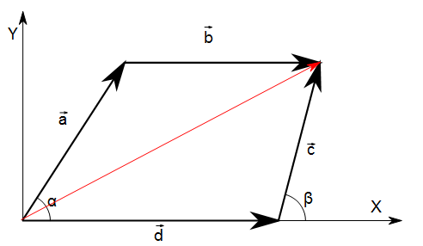fig. 1: Four-bar linkage geometry
Its configuration is completely defined by the anglesandformed by the rotating bars with positive direction of the X axis.
The linkage, though, has only one degree of freedom, therefore and not independent and the first aim of this document is to find a mapping .
The aforementioned vectors must satisfy the vector relation that can be solved with respect to the floating bar .
Considering that

this equation can be written as

where .
The modulus of is and squaring both sides of the equation yields .
Some elementary algebraic manipulations this equation yield

that cannot easily be solved with respect to angle therefore a numerical procedure is used by means of the fsolve() function in the octave language.
Actually fsolve() is a minimizer that numerically approximates to zero the function therefore the code is composed by the definition of the function to be minimized and the call to the minizer.
The solver is called in its simplest version, i.e. without the Jacobian as the numerical convergence in such kind of trigonometric functions is not a problem.
function y = f(beta)
global a b c d alpha;
y = a^2-b^2 +c^2 + d^2 - 2*a*d*cos(alpha) + 2*c*d*cos(beta) - 2*a*c*cos(alpha-beta);
endfunction
...
[beta, fval, info] = fsolve(@f, initialApprox);
...
So the algorithm solves numerically the equation for all the angles covered by the left rotating bar. The initial approximation of is fixed at for the first value of and as the values are incremented, the last is used as initial approximation for the following iteration.

Classification of the leverages
The rotating bars can rotate completely or oscillate in an angle range. The literature calls crank a bar that can rotate completely, rocker a bar that oscillates. The angle range of a rocker is always symmetrical in respect to the fixed ground bar (X axis in fig. 1).
The extreme conditions for both angles are summarized in fig. 2.
So the extreme conditions for the angles are the configurations that transform the four-bars into a triangle. Depending on the length of each bar, such triangles can be formed or not.
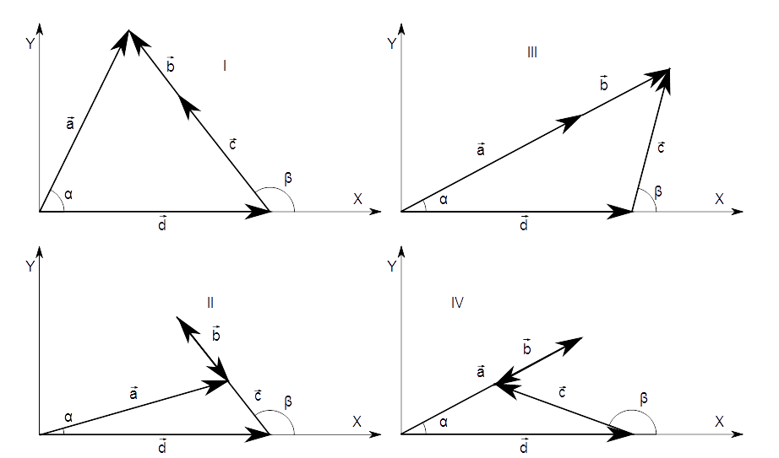fig. 2: Extreme conditions for the rotating bars.
The situation is the following.
 |  | Triangle sides
 | I | a | c-b | d
 | II | a | c+b | d
 | III | a+b | c | d
 | IV | a-b | c | d

For a triangle to exist, the sum of the length of two sides must be higher than the other side. Mathematically it can also be verified using the Heron's formula to compute the area of a triangle: if la, lb and lc is the length of each side and is the semi-perimeter, the area is . For a triangle to exist, the radicand of this equation must be positive.
The area is also used to compute the height of the triangle with respect to the ground side to compute the angle itself using the tan2() function.

Trajectory of the a point integral to the floating bar.
The trajectory of point integral to the rotating bars is a circumference. The floating bar, on the contrary, has a complex displacement and the points integral to it move following interesting trajectories. In order to compute them, the displacement of the floating bar must be known.
The angle of the floating bar can be computed with the following equations (ref. fig. 3)
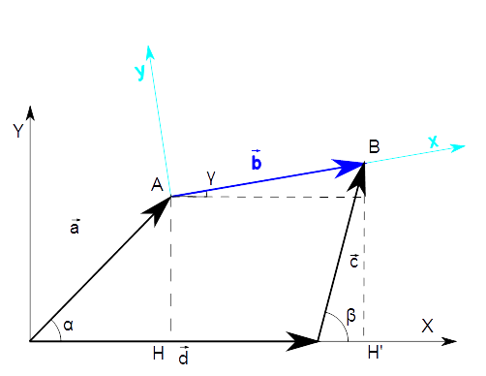fig. 3: System of coordinates integral to the floating bar.

therefore and evenutally
The (x,y) coordinate of the point on the moving reference is transformed in the absolute coordinates (X,Y) of the ground reference using basic matrix algebra.

By definition the modulus of a vector is positive, therefore the square root is taken with the positive determination only and squaring both sides of the equation is possible.
Octave is an open source language targeted at numerical computation which is designed to be compatible with Matlab.
https://en.wikipedia.org/wiki/Heron%27s_formula

