Coursework 1 of Biologically Inspired Computing

Black-Box Optimization
Genetic Algorithms and Neural Networks

by Francisco Mendonça
H00254547

Available on GitHub: https://github.com/fjpavm/BioInspiredCW1

Table of Contents
Introduction 1
Software Developed 2
General Genetic Algorithm 2
Initialize 2
Run 2
Parent Selection Strategies 3
Generational Selection Strategy 3
Neural Network Library 4
Vector Genetic Operators 4
New Individuals 4
Mutation 4
Crossover 5
Neural Network Genetic Operators 5
New Individuals 5
Mutation 5
Crossover 5
Genetic Algorithm Experiments 5
Population Size and Child Rate (version 1) 6
Results and Drawn Conclusions 7
Parent Selection Strategies 8
Results and Drawn Conclusions 8
Introducing an Alien 9
Results and Drawn Conclusions 10
Crossover Rate 11
Results and Drawn Conclusions 11
Improving Mutation 11
Results and Drawn Conclusions 11
Population Size and Child Rate (version 2) 12
Results and Drawn Conclusions 12
Neural Network Experiment 13
F1 separ 14
F6 lcon 14
F10 hcon 14
F15 multi 14
F20 multi2 14
Conclusions 14
Bibliography 16

Introduction
This coursework was divided into two parts. The first part encompassed most of the work required. For this reason the second part of the coursework was addressed first and used to inform the first part.
The first part of the coursework required us to train/evolve with a genetic algorithm a neural network to approximate black-box functions and then use a genetic algorithm on the trained network to optimized the approximated function.
The second part of the coursework required us to create a genetic algorithm and test its performance with differing parameters with the help of the COCO platform for black-box optimization [Hansel et al. 2016]
First we describe the software developed in python to implement a generic Genetic Algorithm, a minimal Neural Network and the genetic operators for continuous vectors and our minimal neural network.
We then go on to describe the devised experiments to tune the Genetic Algorithm along with their results.
We then describe the experiment using neural networks and how the knowledge gained from part 2 of the coursework was used to guide part 1.
Finally we attempt to draw some conclusions about Genetic algorithm parameter choices for differing functions and on the use of neural networks to replace the black-box functions

Software Developed
In this section we describe the software that was implemented in python. The code is available on Github (https://github.com/fjpavm/BioInspiredCW1).
We start with the general Genetic Algorithm, its parameters and operators. We then describe the minimal neural network library developed. Finally the implemented genetic operators for optimizing over continuous functions and over our neural network implementation are described.
All of the parts of the Genetic Algorithm that are not problem dependant where gathered in the file GeneticAlgorithm.py. The the genetic operators and random individual creation, that are problem dependant parts, were put into two files VectorGAOperators.py and NeuralNetGAOperators.py. The first file implements them for general multi-dimensional real-valued vectors. The second file implements them for our neural networks.
The Neural Network implementation is in the file NeuralNetwork.py

General Genetic Algorithm
The structure for this genetic algorithm was take from the class slide [Biologically Inspired Computing 2016 EA].
The generic algorithm is represented by the python class GeneticAlgorithm. It's structure was split into two parts: Initialize and Run.

Initialize
Implemented in the method initializePopulation of GeneticAlgorithm class. It utilizes a function to generate random individuals that must be provided and is problem dependant
Psedo-Code:
Discard all information of previous run
Until initial population number is reached
Create new individual and evaluate its fitness
Update best individual and add individual-fitness pair to population

Run
Implemented through methods run and advanceOneGeneration of GeneticAlgorithm class
The Run part goes through the Selection of parents, the Genetic Operators to create the children and the Population Update for each generation until some termination condition is met.
Depending on configuration the population update can keep the Best from last generation to the new generation (forcing elitism) and it can introduce a completely Alien random individual (that increases variability in the population). The idea of introducing completely random individual comes from localization particle filters where it is done to allow re-localization after kidnapping [Thrun, Burgard and Fox 2006]
It utilizes a Parent Selection Strategy and a Generational Selection Strategy that are both problem independent and can be provided at object creation or a default strategy will be used. It also utilizes Genetic Operators that are problem dependant. These are the Mutation and the Crossover. Only the Mutation needs to be provided for the algorithm to be able to run. If a crossover operator was provided Crossover is used to generate a child with probability equal to the crossoverRate parameter of the algorithm
Psedo-Code:
Until a termination condition is met
Select patentRate*populationSize Parents with Parent Selection Strategy
Create childRate*populationSize children with Genetic Operators
Update population with Best and Alien and the rest with Generational Selection Strategy
Update best individual found and increase generation by 1

Parent Selection Strategies
The implemented parent strategies where the ones described on the class slides [Biologically Inspired Computing 2016 EA]
-Roulette Wheel was modified to allow negative value fitness and implemented in a class called ProbabilisticFitnessSelection inspired by its description in the book Machine Learning [Mitchel 1997]
-Tournament Selection where the tournament size is configurable was implemented in the class called TournamentSelection
-Rank Based Selection where the bias is configurable (bias 1 is normal Rank Based Selection) is implemented in the class RankSelection

Generational Selection Strategy
The only implemented generational selection strategy was one based of elitism described in the slides [Biologically Inspired Computing 2016 EA]. The worst of the previous generation are replaced with the children and the best are kept for the next generation. This was implemented in the class ChildrenAndBestCurrent.

Neural Network Library
The Neural Networks where implemented a through matrix representation in the class NeuralNetwork by using the NumPy library.
The class constructor takes in the layer sizes (including input and output) and optional function vectors to use for the hidden layers. When no function vectors are present the sigmoid function is used.
The class is callable so a network can be used as a function in the python code. The weight matrices are accessible and settable directly through the getWeightMatrix and setWeightMatrix methods. Each weight can also be individually manipulated through the getWeight and setWeight methods. There are also methods to for manipulating the functions for the hidden layers. These are the getFunctionForNodeOnHiddenLayer and setFunctionForNodeOnHiddenLayer methods. Only two functions where implemented for use with the neural networks the sigmoid and a linear function (just lets the value through unaltered).
A method for performing a step of the stochastic back-propagation algorithm was also implemented in the backpropagate method.
The formulas and algorithmic knowledge from the book Machine Learning [Mitchel 1997] where instrumental in providing the knowledge for this implementation.

Vector Genetic Operators
The operators are gathered in a single class called VectorGAOperators and are separate methods of this class

New Individuals
The new individuals are created at random within configurable minimum and maximum values for each dimension. If no values are provided -5 and 5 are used for each dimension as it is the range used in COCO [Hansel et al. 2016]. The method that implements this is called createRandom

Mutation
Initially mutation was implemented as simply perturbing the current vector by one drawn from a normal distribution. Through the initial experiments it was seen that that was too random and so a deviationBase parameter was added so a the normal distribution could be multiplied by the deviation and become a zero mean Gaussian distribution with the given deviation. While trying to find a suitable deviation it became apparent that small deviations would lead to being able to achieve the targets but would slowdown the algorithm immensely. A random approach where the deviationBase was determined with equal probability to be raised to one of the values given by the deviationExponents parameter was devised. The method that implements this is called mutate

Crossover
The only crossover strategy implemented was the box crossover [Biologically Inspired Computing 2016 EA]. The method that implements this is called boxcrossover

Neural Network Genetic Operators
The operators are gathered in a single class called NeuralNetworkGAOperators and are separate methods of this class

New Individuals
The new individuals are created by createRandom. They are created with a random number of hidden layers (up to maxHiddenLayers provided on class construction), randomized hidden layer function vectors and matrices taken from a normal distribution with 0.1 standard deviation

Mutation
Mutation was implemented in the mutate method and associated sub methods: mutateBackpropagate, mutateWeights, mutateFunction and mutateNodes.
The mutate method manages the probabilities of each type of mutation and then calls the specific method.
The mutateBackpropagate method preforms a randomly sized back-propagation step based on a few of training samples. The mutateWeights method preforms a perturbation drawn from a normal distribution with random deviation to one of the weight matrices. The mutateFunction method mutates a hidden node so it uses a different function. Finally, the mutateNodes method adds or removes a node from one of the hidden layers.

Crossover
No crossover operator was developed due to the complexity of devising a crossover when the network can have different shapes

Genetic Algorithm Experiments
To have a baseline for our experiments the example experiment with the Pure Random Search algorithm was run and the data kept for future comparisons
Our experiments where based on an iterative approach to good value parameters. Our experimental conclusions will be based on the ability and speed of improving fitness for each configuration. Our first experiment was trying to determine the influence of the population size and the child rate on the ability and speed of improving fitness. Our second experiment was about determining the influence of the parent selection strategies. Our third was about determining the influence of Alien introduction. Our fourth was about the influence of crossover rate. Our fifth experiment was about establishing a mutation operation that would allow both large and small adjustments every generation. Our last experiment was a repeat of the first with the tweeks made from previous experimental results.
The data gathered from each set of parameters was put under the Results folder of the repository. Separated into sub folders based on the variance/deviation used for the mutation operator. The folder for the data was given the following name structure for experiments with just the Genetic Algorithm: GA followed by P PopulationSize C ChildRate P ParentRate 'R' or 'T' for Rank or Tournament selections and SelectionParameter (Bias for Rank Selection and tournament size for Tournament Selection). Some optional parameters are appended to the main formate. Crossover Rate is appended as C CrossoverRate, Alien inclusion is appended as 'Alien' and Best inclusion is appended as 'Best'

Population Size and Child Rate (version 1)
This experiment was performed with the mutation variance/deviation at value 1. The ParentRate was set to 20% of population (i.e. 0.2) and Tournament selection of size 2 was used. For the sake of swiftness we decided to try using only 5D and 10D functions for our initial tests. We initially planed to run through the combinations of population size values 50, 100, 250, 500 and child rate values 0.01, 0.25, 0.5, 0.75 and 0.99 but when we looked at the preliminary results abandoned it at child rate 0.5. The way will become apparent with the results presented and the conclusions drawn.

Results and Drawn Conclusions
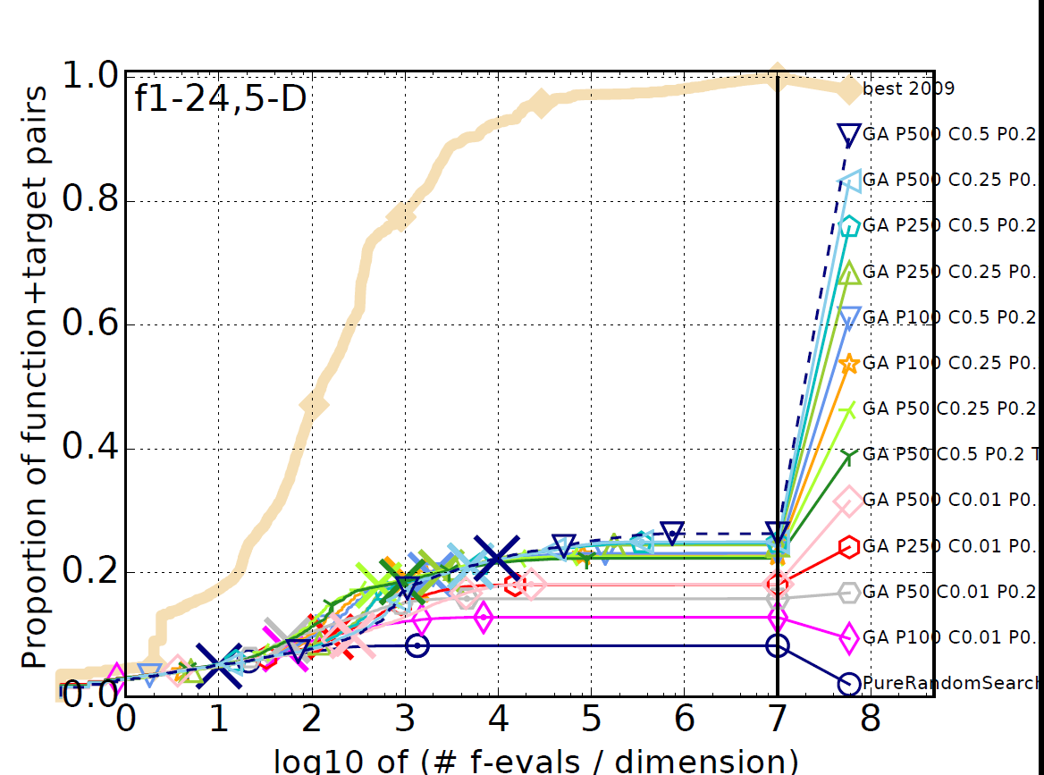
As we can see even for the 5D case the results are quite close to the random search. The major difference comes from the child rate when it is 0.01 and this can be explained by the fact that it is provides very little change so it quickly hits our 100 generations without change termination condition.
Δ fopt  f1 | 1e1  11 | 1e0  12 | 1e-1  12 | 1e-2  12 | 1e-3  12 | 1e-5  12 | 1e-7  12 | #succ  15/15
PureRandomSearch | 7.6 (12) | ∞ | ∞ | ∞ | ∞ | ∞ | ∞50 | 0/15
GA P100 C0.01 P0.2 T2 | 9.0 (11) | 77 (138) | ∞ | ∞ | ∞ | ∞ | ∞305 | 0/15
GA P100 C0.25 P0.2 T2 | 8.5 (9) | 43 (14) | 1252 (1457) | ∞ | ∞ | ∞ | ∞5250 | 0/15
GA P100 C0.5 P0.2 T2 | 6.9 (9) | 43 (21) | 970 (1163) | ∞ | ∞ | ∞ | ∞1e4 | 0/15
GA P250 C0.01 P0.2 T2 | 10 (15) | 327 (310) | ∞ | ∞ | ∞ | ∞ | ∞832 | 0/15
GA P250 C0.25 P0.2 T2 | 5.2 (7) | 87 (28) | 1267 (1147) | ∞ | ∞ | ∞ | ∞1e4 | 0/15
GA P250 C0.5 P0.2 T2 | 8.4 (5) | 87 (44) | 744 (540) | ∞ | ∞ | ∞ | ∞2e4 | 0/15
GA P50 C0.01 P0.2 T2 | 7.3 (3) | 38 (9) | ∞ | ∞ | ∞ | ∞ | ∞368 | 0/15
GA P50 C0.25 P0.2 T2 | 6.3 (5) | 27 (14) | 574 (546) | ∞ | ∞ | ∞ | ∞2741 | 0/15
GA P50 C0.5 P0.2 T2 | 5.1 (11) | 25 (14) | 858 (1494) | ∞ | ∞ | ∞ | ∞3800 | 0/15
GA P500 C0.01 P0.2 T2 | 10 (7) | 309 (210) | ∞ | ∞ | ∞ | ∞ | ∞1175 | 0/15
GA P500 C0.25 P0.2 T2 | 10 (9) | 109 (87) | 1000 (1204) | ∞ | ∞ | ∞ | ∞2e4 | 0/15
GA P500 C0.5 P0.2 T2 | 3.7 (3) | 163 (98) | 1048 (1037) | ∞ | ∞ | ∞ | ∞4e4 | 0/15
Even for the rather simple Sphere function only the minimum distance to target in the order of 0.1 what achieved. The target is considered achieved with 1e-8 distance to target.
These result point to either too big a variation from mutation making the selection pressure infective or not enough selection pressure. That brought us to our second experiment.

Parent Selection Strategies
For this experiment the mutation variance/deviation was reduced to 0.1 and only the 5D functions where used. The parent rate to 5% was reduced because it was originally determined to be a big cause of slowdown in the runtime and is closer to the low number of parents in the examples for steady state and generational approaches given in the slides [Biologically Inspired Computing 2016 EA]. Since the previous experiment gave very little clues as to the values to use for child rate and population size values from the mid range where chosen. Population size 100 and child rate 50% (half way between steady state and generational approach).
For the Parental Selection the following where tested:
-Tournament Selection with sizes 2, 5, 10 and 20
-Rank Selection with bias 0.5, 1, 2, 4

Results and Drawn Conclusions
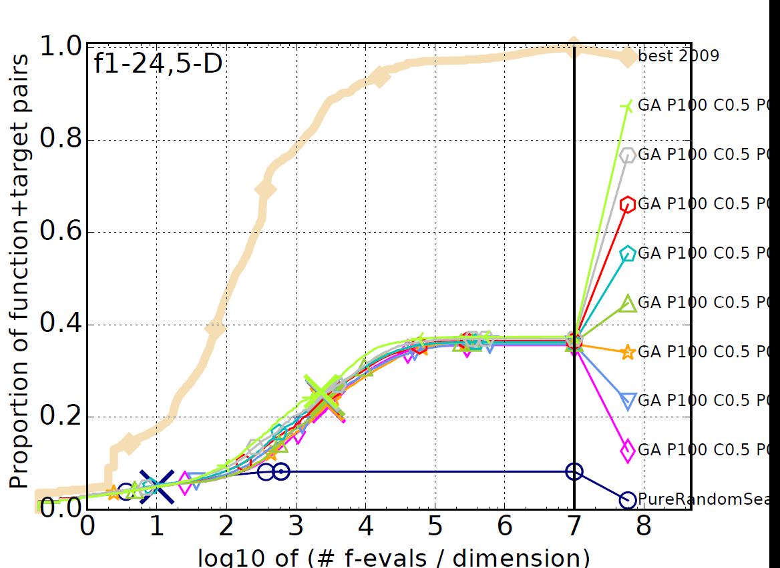
In this graph of the results over all noiseless functions we can again see very little difference between the strategies but we do see a marked increase in the results overall. Meaning that the reduction of the variance/deviation had a significant impact.

Δ fopt  f1 | 1e1  11 | 1e0  12 | 1e-1  12 | 1e-2  12 | 1e-3  12 | 1e-5  12 | 1e-7  12 | #succ  15/15
PureRandomSearch | 7.6 (13) | ∞ | ∞ | ∞ | ∞ | ∞ | ∞50 | 0/15
GA P100 C0.5 P0.05 R0.5 | 21 (13) | 177 (93) | 241 (117) | 283 (64) | 1854 (2138) | ∞ | ∞1e4 | 0/15
GA P100 C0.5 P0.05 R1 | 29 (33) | 159 (60) | 212 (50) | 263 (52) | 1331 (1879) | ∞ | ∞1e4 | 0/15
GA P100 C0.5 P0.05 R2 | 15 (16) | 107 (26) | 153 (52) | 182 (54) | 797 (245) | ∞ | ∞1e4 | 0/15
GA P100 C0.5 P0.05 R4 | 6.1 (18) | 83 (26) | 117 (37) | 140 (22) | 2146 (1258) | ∞ | ∞9250 | 0/15
GA P100 C0.5 P0.05 T2 | 23 (33) | 149 (42) | 203 (50) | 243 (42) | 2152 (3252) | ∞ | ∞1e4 | 0/15
GA P100 C0.5 P0.05 T5 | 14 (19) | 90 (43) | 123 (50) | 149 (55) | 860 (955) | ∞ | ∞9600 | 0/15
GA P100 C0.5 P0.05 T10 | 11 (18) | 68 (22) | 95 (25) | 114 (23) | 526 (884) | ∞ | ∞1e4 | 0/15
GA P100 C0.5 P0.05 T20 | 10 (10) | 54 (24) | 74 (37) | 93 (47) | 658 (435) | ∞ | ∞1e4 | 0/15

The above table shows the Expected Running Time for function 1. We show it here as a representative of what the best ones are for most of the functions. Overall Tournament Selection with size 20 is the one with the lowest ERTs for most functions with T10 and R4 being contenders in specific instances.

Introducing an Alien
For this experiment the variance was again reduced to 0.01. The remaining parameters where the same as in the previous experiment with T20 chosen for parent selection. Then we tested with and without Alien introduced each generation.

Results and Drawn Conclusions
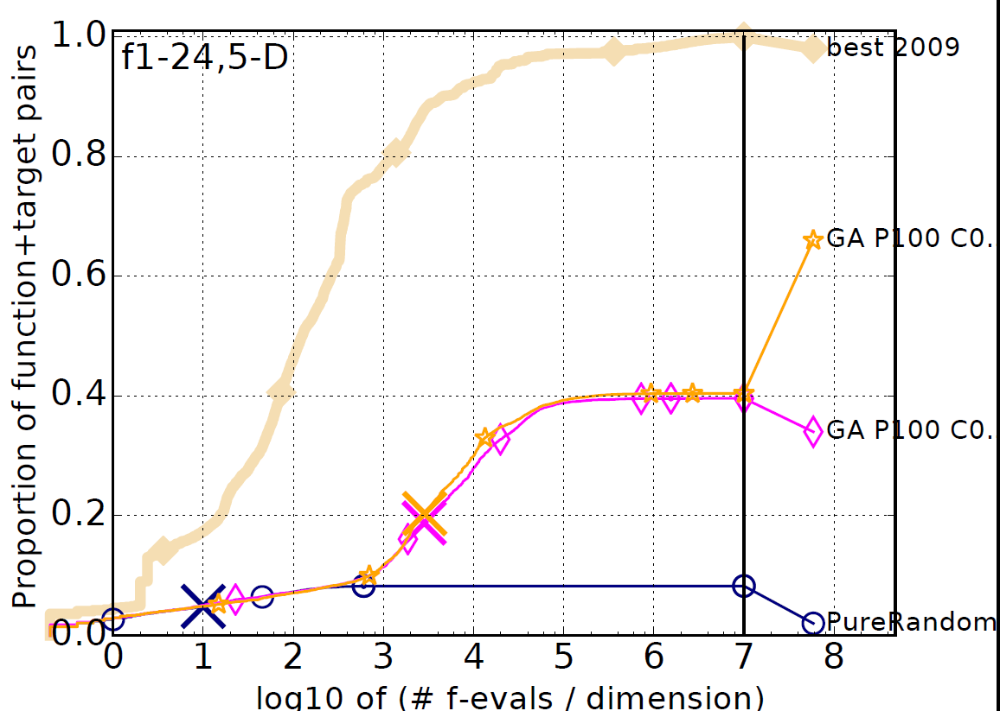
Overall the Alien introduction seems to be slightly better with the best improvements being in one of the sets of multi modal functions. (Theone with Alien is the yellow star)
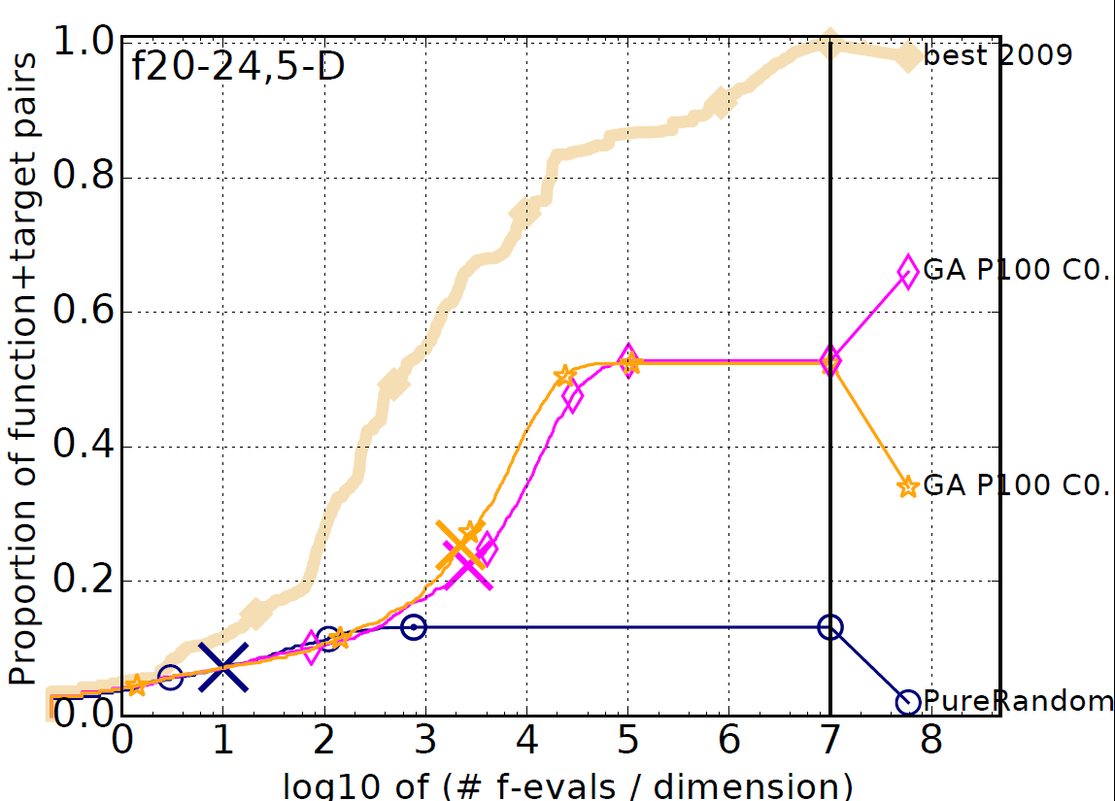

Crossover Rate
In this experiment we kept the previous parameters and the Alien inclusion and tested different crossover rates 0.05, 0.1, 0.25, 0.5, 0.75

Results and Drawn Conclusions
Unfortunately the results where highly variable from function to function. It would be cumbersome to report all the tables and graphs here. However there seemed to be a minor tendency towards 0.1 and 0.25 having good results.

Improving Mutation
All the previous parameters where maintained with crossover rate of 0.15. We tried an approach where the variance/deviation had a base of 0.01 with exponents 0, 0.5, 1, 2, 3 chosen randomly for each mutation and compared it to the previous best with the same parameters.

Results and Drawn Conclusions
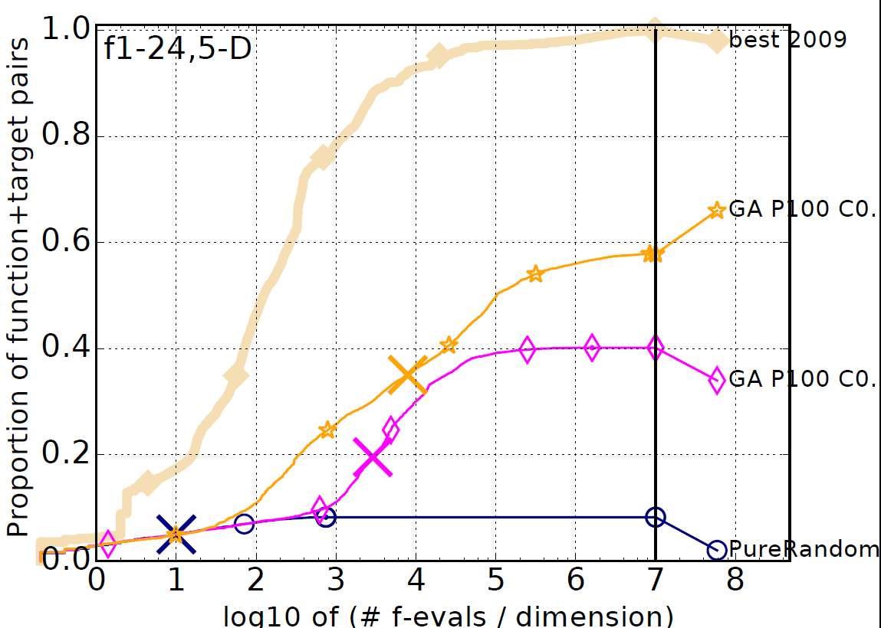
A marked improvement can be seen both in the initial speed and the overall achieved results.

Population Size and Child Rate (version 2)
In this experiment we used the random variance method along with the parameters that we have been selecting and retried our initial experiment. This time we used child rates of 0.1, 0.25, 0.5, 0.75, 0.9 and population sizes 100, 250, 500 over 2D, 10D and 40D to get a sense of the influence of the dimension on these parameters choice.

Results and Drawn Conclusions
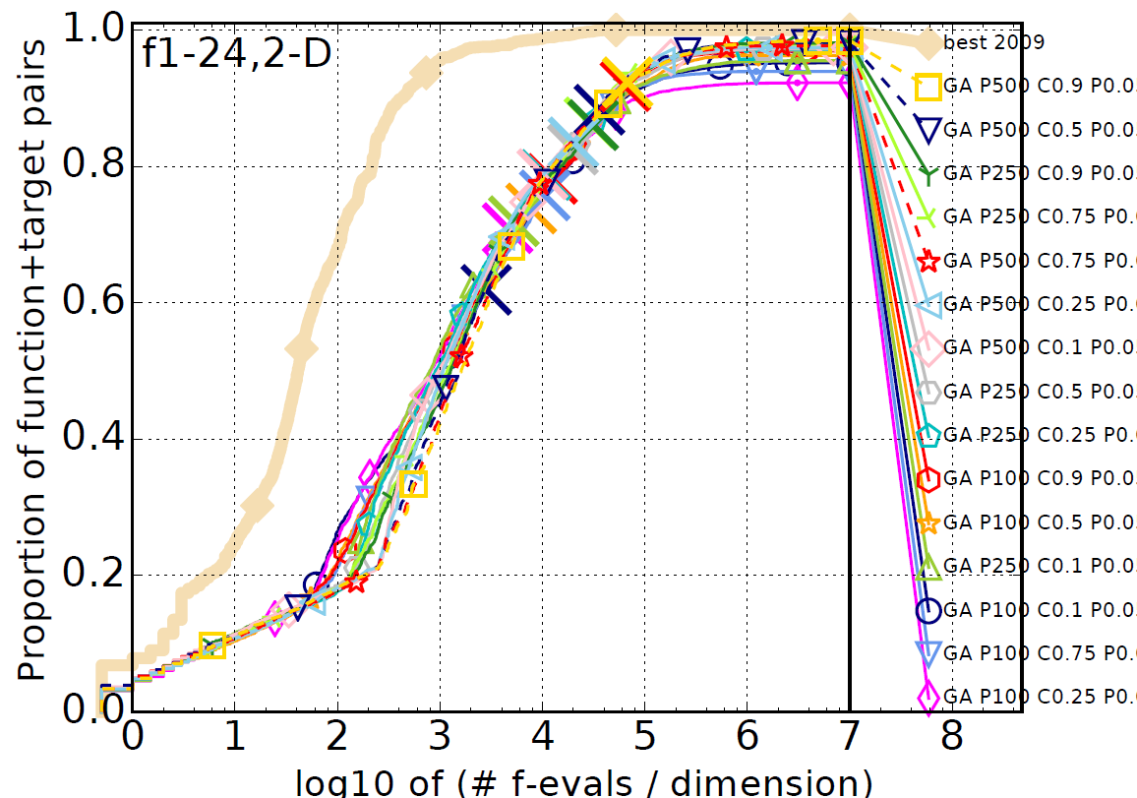
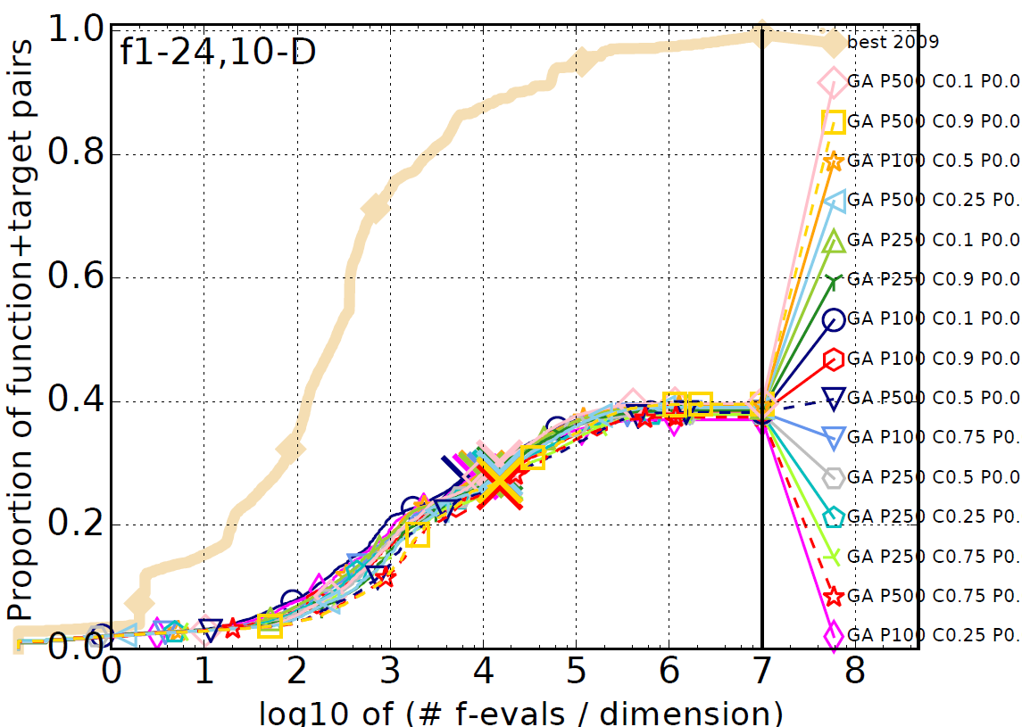
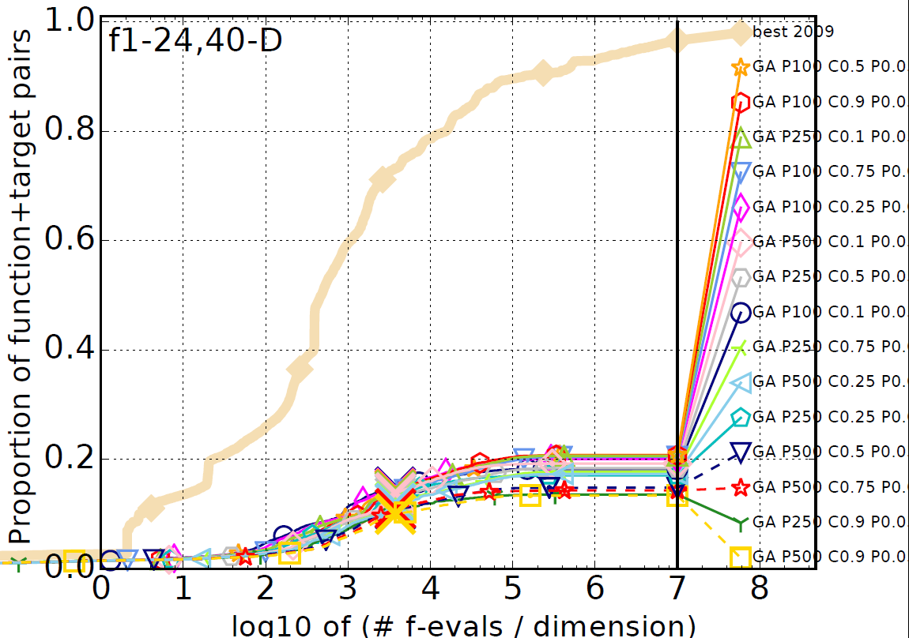
The results are all very close as in previous experiments. For the 2D case the higher populations seem to have a slight advantage as they do in the 10D case. As for the 40D case the tendency seems to reverse. This is probably indicates that in a huge search space with comparatively very limited budget a small population gives an earlier start on the optimization part and has higher pressure using the same tournament size achieving slightly better results early on.

Neural Network Experiment
Given the time intensive nature of genetic algorithm optimization and especially given the implementation was made in python a full training and then using of neural networks to reproduce even one of the parameter sets of the previous experiments would be more than time would allow. Only a single experiment was performed where a neural network was “trained” with a GA algorithm for one single 2D function from each function class: f1 for separ, f6 for lcon, f10 for hcon, f15 for multi and f20 for multi2.
The GA was configured with parameters derived from the earlier experiments: population size 500, parent rate 5%, child rate 15%, tournament size 20. Given the poor results for 40D a much higher budget of 10000 generation maximum was used.
The fitness function was based on the quadratic error from 500 random samples of the functions.
The result files with the full matrices, and functions can be found in the github repository under Results\NeuralNets. Here we will just report the layer sizes and the quadratic error for the training set and an equally sized testing set and draw conclusions from those.

F1 separ
test error value: 25.7784799131
training error value: 21.594915274320478
layer sizes:[2, 4, 4, 1]
This was the only function where the training network seems to more or less manage to follow the function

F6 lcon
test error value: 1017113032.73
training error value: 1083757371.655787
layer sizes:[2, 4, 4, 4, 1]
This like all the following results seems to fall far short of the desired function approximation.

F10 hcon
test error value: 1.31629462557e+14
training error value: 155148346777851.7
layer sizes:[2, 1]

F15 multi
test error value: 554826.814839
training error value: 407041.7447616186
layer sizes:[2, 4, 1]

F20 multi2
test error value: 150794077.614
training error value: 53969100.45436498
layer sizes:[2, 4, 4, 1]

Conclusions
The biggest conclusion that can be taken from the Genetic Algorithm experiments is that the mutate function has a huge impact on achievability and speed of convergence to the target. The remaining parameters hover important seem to pale in comparison in he differences that could be observed throughout the experiments.
As for the Neural Network experiment several things where very apparent from sizes of the layers and the appalling results overall. All the networks that had hidden layers converged to have the maximum size that was allowed for them. This can be explained by the fact that removing a node causes a much bigger change that adding a node with small weights attached. Most of the hidden layer functions ended up with a linear function even though that could never achieve the final desired result simply because changing a sigmoid to a linear function quickly raises the final value range.
So, in conclusion, the designed set-up for the Neural Network part of the assignment was not conducive to good results and the extreme time frames for running these algorithms in a standard CPU made the iterations over the code very time consuming to test out. If designing a Genetic Algorithm for Neural Networks with changing structure it makes very little sense to use exclusively a the genetic algorithm to evolve completely weights when back propagation is a proven way to get good results much quicker. A hybrid GA where after each mutation the back propagations training is run to finalise the mutation would be much more likely to evolve reasonable networks in shorter time.

Bibliography
Biologically Inspired Computing. (2016). Evolutionary Algorithms: Details, Encoding, Operators available: https://vision.hw.ac.uk/bbcswebdav/pid-2324478-dt-content-rid-2116861_2/courses/F21BC_2016-2017/02_BIC_ealec3%282%29.pdf
Hansen,N., Auger,A., Mersmann,O., Tušar,T., Brockhoff,D.. (2016). 'COCO: A Platform for Comparing Continuous Optimizers in a Black-Box Setting'. ArXiv e-prints arXiv:1603.08785
Mitchel,T. . (1997). Machine Learning. McGraw-Hill
Thrun,S., Burgard,W., Fox,D.. (2006). Probabilistic Robotics. The MIT Press

