(I’m not going to do Assignment 2)

**Final Project Proposal**

Carpool Assistant

This project helps those who want to earn money in carpool and those who want to take a carpool to somewhere.

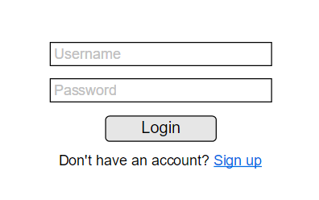Phase 1. Sign up & Login

Users login with usernames and passwords. They can also sign up new accounts if they don’t have any account. The information “username” will be kept in a session.

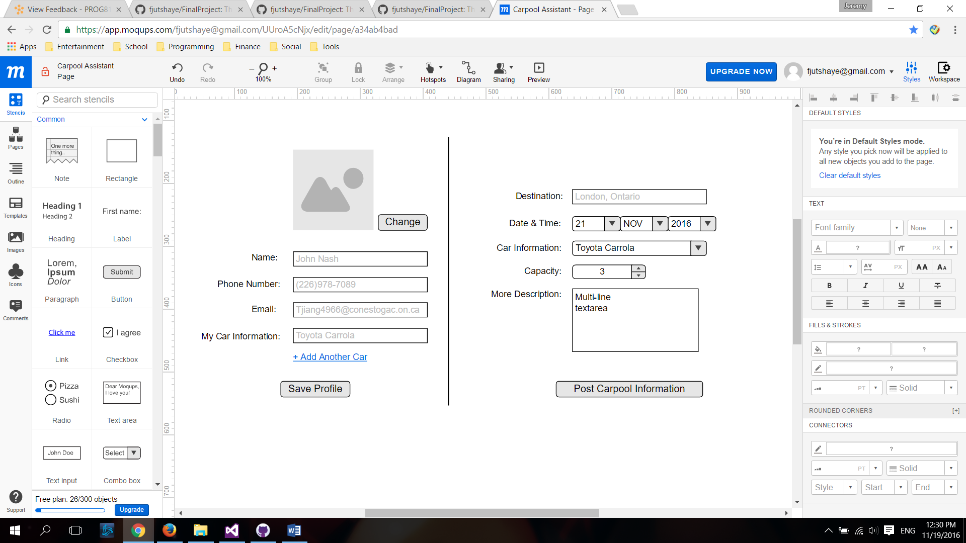Phase 2. Update Profile and Post My Carpool Resource

A profile contains:

1. *Name
2. *Phone Number
3. *Email Address
4. Profile Picture
5. Car Information

(* means mandatory)

Users update their profiles.

Users submit their willing of sharing their can to earn some.

A unit of information contains:

1. *Destination
2. *Date and Time
3. *Car Information
4. *Driver’s Profile
5. *Capability Left
6. Complement Description

Phase 3. Submit Carpool Requests & View Available Resources

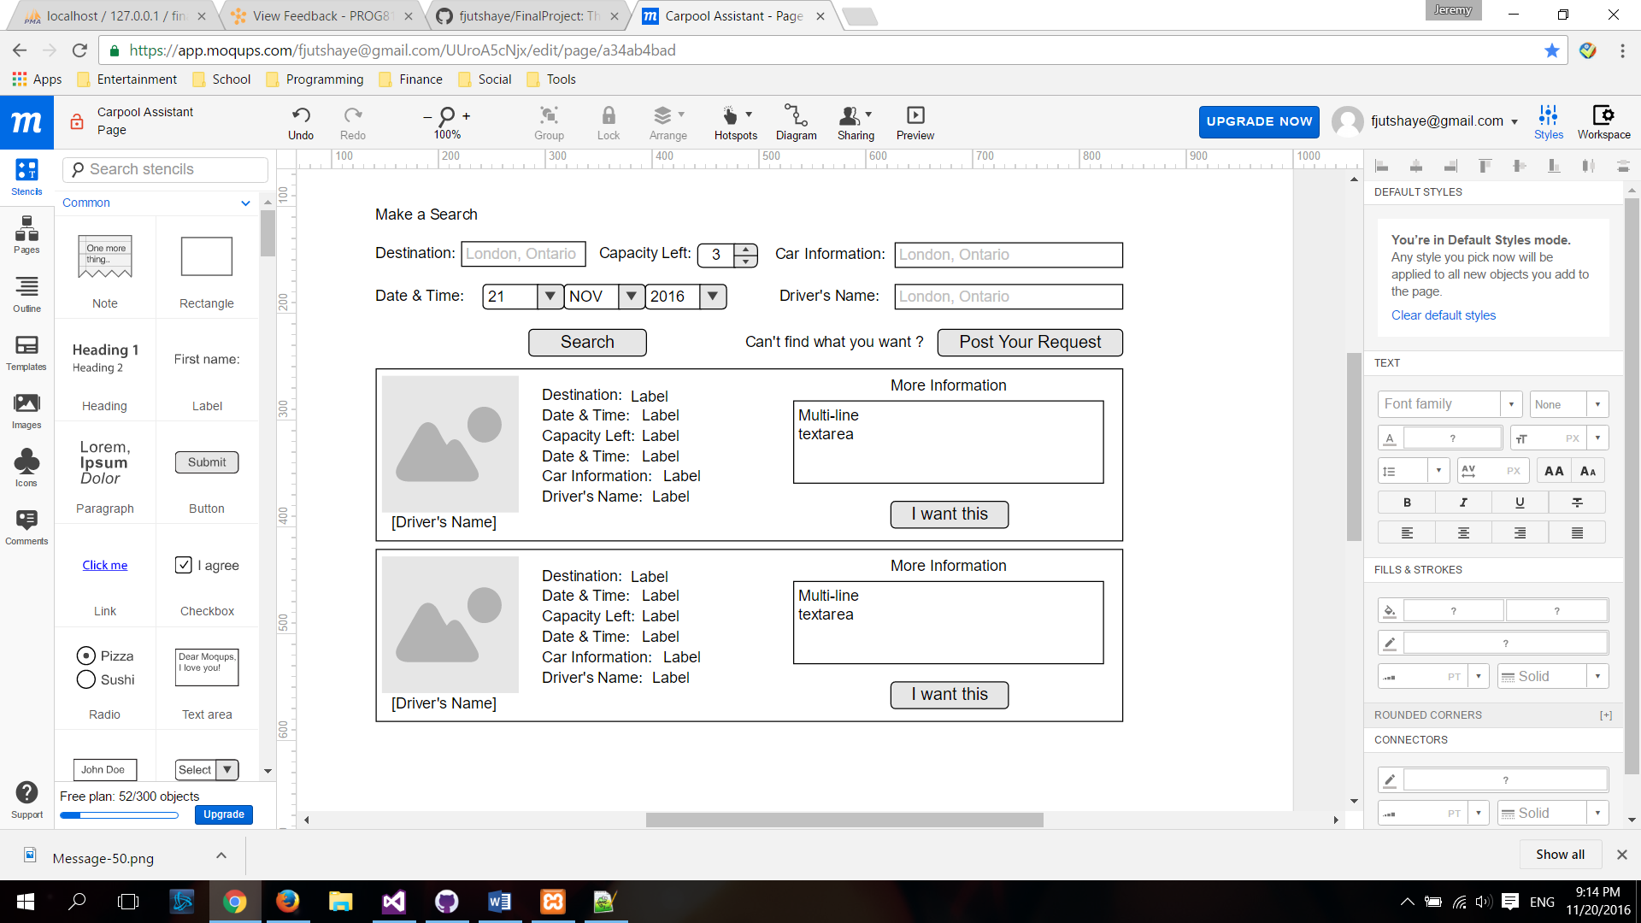

Users who want to be passengers can submit their need of taking a ride.

A unit of request contains:

1. *Destination
2. *Date and Time
3. *Passenger’s Profile
4. *The Number of Passenger(s).
5. *Price
6. Complement Description

Also, they can search existed available carpool resources by:

1. Date and time
2. Destination
3. Price
4. Capability Left
5. Car Information
6. Driver’s Name

Phase 4. Notify Driver with Request, Accept Requests and Notify Passengers

(This function doesn’t have a certain visual interface. Users check their email in their own mailboxes.)

If a passenger books a carpool, the driver will be notified by an email. The driver can accept or reject the request. The passenger will receive an confirmation email.