**Bar Chart - viewers per game:**

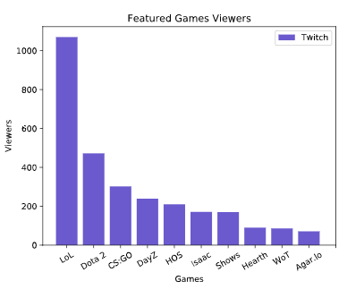

**Pie Chart – viewers nationality:**

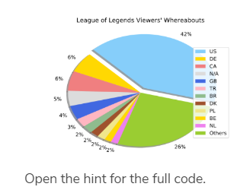

**Line Chart- US viewers at different hours:**

