Problem 3: Empirical Performance Testing

A.

**Comparison between PRM and RRT(default setting)**

|  |  |  |
| --- | --- | --- |
| PRM |  |  |
| C:\Users\smili\AppData\Local\Microsoft\Windows\INetCache\Content.Word\prm01.png | C:\Users\smili\AppData\Local\Microsoft\Windows\INetCache\Content.Word\prm02.png | C:\Users\smili\AppData\Local\Microsoft\Windows\INetCache\Content.Word\prm03.png |
| RRT |  |  |
| C:\Users\smili\AppData\Local\Microsoft\Windows\INetCache\Content.Word\rrt01.png | C:\Users\smili\AppData\Local\Microsoft\Windows\INetCache\Content.Word\rrt02.png | C:\Users\smili\AppData\Local\Microsoft\Windows\INetCache\Content.Word\rrt03.png |

**Comparison for different knns for PRM**: Connection Threshold = 0.1 (obstacle radius = 0.36)

|  |  |  |
| --- | --- | --- |
| Knn = 1 | C:\Users\smili\AppData\Local\Microsoft\Windows\INetCache\Content.Word\knn1.png | [Too long, unable to obtain a successful path within reasonable time] |
| Knn = 2 | C:\Users\smili\AppData\Local\Microsoft\Windows\INetCache\Content.Word\knn2.png | [0.130159139633, 0.118903875351, 0.0972120761871, 0.0923070907593, 0.156420946121, 0.128278970718, 0.125301122665, 0.175091981888, 0.156027078629, 0.120491027832, 0.120626926422, 0.142296075821, 0.0907251834869, 0.156124830246, 0.110499858856, 0.135986089706, 0.185766935349, 0.16702413559, 0.103992938995, 0.111259937286] |
|  | | |
| Knn = 20 | C:\Users\smili\AppData\Local\Microsoft\Windows\INetCache\Content.Word\knn20.png | [0.143523931503, 0.151234149933, 0.150932788849, 0.16851401329, 0.125816106796, 0.150538921356, 0.0989298820496, 0.0913228988647, 0.118329048157, 0.127609014511, 0.108587026596, 0.167919158936, 0.122192144394, 0.200456142426, 0.0935111045837, 0.11268901825, 0.198260068893, 0.142157077789,  0.133938074112, 0.170228004456] |
|  | | |
| Knn = 60 | C:\Users\smili\AppData\Local\Microsoft\Windows\INetCache\Content.Word\knn60.png | [0.0771520137787,0.161941051483, 0.131823062897, 0.169919013977, 0.185908079147, 0.149682998657, 0.211441993713, 0.155369997025,  0.153607845306, 0.108218193054, 0.173654079437, 0.166096925735,  0.115972995758, 0.123878002167,  0.143290996552, 0.137388944626,  0.110648155212, 0.146234989166,  0.160201072693, 0.0642998218536] |
|  | | |
| Knn = 95 | C:\Users\smili\AppData\Local\Microsoft\Windows\INetCache\Content.Word\knn95.png | [0.163717746735, 0.186847925186, 0.132453203201, 0.108211040497, 0.138588905334, 0.147310018539, 0.139370203018, 0.199523925781, 0.168343067169, 0.159296035767, 0.0869829654694, 0.0647170543671, 0.133009910583, 0.121901035309, 0.122754812241, 0.138145208359, 0.175776004791, 0.124979972839, 0.199604034424, 0.0698258876801] |
|  | | |



When knn is one, the planner is unable to finish the planning task. For any other value in the range of 2-100, the planning time is not affected by the knn parameters, as shown in the plot. No obvious difference in path is observed. The variability is shown in the histogram of the total time cost for planning.

**Different connection thresholds for PRM**: knn = 10 (obstacle radius = 0.36)

|  |  |  |
| --- | --- | --- |
| CT = 0.01 | C:\Users\smili\AppData\Local\Microsoft\Windows\INetCache\Content.Word\ct0.01prm.png | [0.0685811042786, 0.063159942627, 0.0621571540833, 0.0622320175171, 0.0588600635529, 0.0676119327545, 0.0529780387878, 0.0422670841217, 0.0587050914764, 0.0561339855194, 0.0630421638489, 0.0774290561676, 0.0683701038361, 0.0543971061707, 0.0598368644714, 0.063441991806, 0.0590190887451, 0.054792881012] |
|  | | |
| CT = 0.05 | C:\Users\smili\AppData\Local\Microsoft\Windows\INetCache\Content.Word\ct0.05prm.png | [0.0580620765686, 0.0526850223541, 0.0526249408722, 0.080531835556, 0.0686650276184, 0.0660061836243, 0.0653948783875, 0.0566031932831, 0.0477659702301, 0.0829420089722, 0.0629420280457, 0.063766002655, 0.0648770332336, 0.0527341365814, 0.0556561946869, 0.0871911048889, 0.0726978778839, 0.0537850856781, 0.0672509670258, 0.057718038559] |
|  | | |
| CT = 0.2 | C:\Users\smili\AppData\Local\Microsoft\Windows\INetCache\Content.Word\ct0.2prm.png | [0.0571851730347, 0.0564148426056, 0.0701529979706, 0.0672359466553, 0.0627529621124, 0.0591430664062, 0.0622568130493, 0.0642249584198, 0.0542690753937, 0.0544707775116, 0.0491108894348, 0.0471761226654, 0.0671398639679, 0.0652358531952, 0.0602509975433, 0.0591080188751, 0.0772299766541, 0.0487909317017, 0.0645749568939, 0.0655989646912] |
|  | | |
| CT = 0.7 | C:\Users\smili\AppData\Local\Microsoft\Windows\INetCache\Content.Word\ct0.7prm.png | [0.0766208171844, 0.0517990589142, 0.0661399364471, 0.0513050556183, 0.0600719451904, 0.0588698387146, 0.0748839378357, 0.0586700439453, 0.0487048625946, 0.0593960285187, 0.0692639350891, 0.0605161190033, 0.0470979213715, 0.0545098781586, 0.0589530467987, 0.0614409446716, 0.0480968952179, 0.0541138648987, 0.052875995636, 0.0567100048065] |
|  | | |
| CT = 0.98 | C:\Users\smili\AppData\Local\Microsoft\Windows\INetCache\Content.Word\ct0.98prm.png | [0.0513517856598, 0.0469801425934, 0.0758898258209, 0.0621960163116, 0.0541889667511, 0.0679979324341, 0.0551819801331, 0.0539238452911, 0.0452978610992, 0.069267988205, 0.0519449710846, 0.0584959983826, 0.0468938350677, 0.0608849525452, 0.0729961395264, 0.0469892024994, 0.063579082489, 0.0648679733276, 0.058874130249, 0.0624928474426] |
|  | | |



As shown in the plot, the connection threshold does not affect the planning time for PRM. For the solution path, no apparent difference is observed. The variability is shown in the histogram of the total time cost for planning.

**Comparison among different connection thresholds for RRT**: perturbation radius = 0.25

(obstacle radius = 0.36)

|  |  |  |
| --- | --- | --- |
| CT = 0.01 | C:\Users\smili\AppData\Local\Microsoft\Windows\INetCache\Content.Word\ct0.01rrt.png | [0.4735455513, 0.687798500061, 0.369745969772, 2.21894526482, 1.17689347267, 0.812784194946, 0.50426864624, 0.613251447678, 0.634234905243, 0.820456266403, 0.758734226227, 1.00165653229, 0.798441648483, 0.570843935013, 0.358913183212, 0.977999210358, 1.09668540955, 1.55438327789, 0.638239145279, 0.464031934738] |
|  | | |
| CT = 0.05 | C:\Users\smili\AppData\Local\Microsoft\Windows\INetCache\Content.Word\ct0.05rrt.png | [0.199958324432, 0.146220684052, 0.164295434952, 0.13677072525, 0.174894571304, 0.111487150192, 0.179087162018, 0.178929805756, 0.260138511658, 0.150110006332, 0.137303829193, 0.165966272354, 0.148153066635, 0.270800352097, 0.113164186478, 0.136445999146, 0.223494768143, 0.140440225601, 0.172428846359, 0.126969099045] |
|  | | |
| CT = 0.20 | C:\Users\smili\AppData\Local\Microsoft\Windows\INetCache\Content.Word\ct0.20rrt.png | [0.0428738594055, 0.0569560527802, 0.0881509780884, 0.0530338287354, 0.0446000099182, 0.04518699646, 0.0455820560455, 0.0515749454498, 0.0652508735657, 0.0485239028931, 0.108167886734, 0.0634708404541, 0.0747528076172, 0.0819621086121, 0.0670840740204, 0.0660839080811, 0.0605800151825, 0.0485739707947, 0.0405790805817, 0.0959000587463] |
|  | | |
| CT = 0.70 | C:\Users\smili\AppData\Local\Microsoft\Windows\INetCache\Content.Word\ct0.70rrt.png | [0.0201790332794, 0.052994966507, 0.0279009342194, 0.0416929721832, 0.0414741039276, 0.049211025238, 0.0324339866638, 0.0360288619995, 0.0376579761505, 0.0286781787872, 0.0427582263947, 0.0381968021393, 0.0493137836456, 0.0298738479614, 0.036789894104, 0.0401601791382, 0.0284278392792, 0.0427241325378, 0.0482921600342, 0.0505142211914] |
|  | | |
| CT = 0.98 | C:\Users\smili\AppData\Local\Microsoft\Windows\INetCache\Content.Word\ct0.98rrt.png | [0.0382511615753, 0.0504810810089, 0.0285618305206, 0.0494599342346, 0.0396418571472, 0.0289659500122, 0.0266401767731, 0.0441930294037, 0.0303390026093, 0.0266890525818, 0.0345199108124, 0.0379219055176, 0.0403978824615, 0.0358328819275, 0.0345590114594, 0.035364151001, 0.0373010635376, 0.0298101902008, 0.0242388248444, 0.0546901226044] |
|  | | |



The planning time decreases when connection threshold value is increased. Significantly more milestones are created to build the path when the connection threshold value is small. The variability is shown in the histogram of the total time cost for planning.

**Comparison among different perturbation threshold for RRT**: connection threshold = 0.05

(obstacle radius = 0.36)

|  |  |  |
| --- | --- | --- |
| PT = 0.01 | C:\Users\smili\AppData\Local\Microsoft\Windows\INetCache\Content.Word\pt0.01rrt.png | [0.320586681366, 0.404224157333, 0.471855401993, 0.367873430252, 0.330770492554, 0.430208444595, 0.456031560898, 0.459489822388, 0.337475061417, 0.340339899063, 0.421815156937, 0.466417312622, 0.375227451324, 0.490842819214, 0.354751586914, 0.37659239769, 0.350960493088, 0.27469420433, 0.38450217247, 0.376793861389] |
|  | | |
| PT = 0.05 | C:\Users\smili\AppData\Local\Microsoft\Windows\INetCache\Content.Word\pt0.05rrt.png | [0.175454378128, 0.140776872635, 0.175675392151, 0.123573303223, 0.128358602524, 0.179686069489, 0.127663135529, 0.144820451736, 0.127466201782, 0.0944819450378, 0.28266453743, 0.120318889618, 0.119228363037, 0.216327667236, 0.133766889572, 0.102006673813, 0.132454872131, 0.14062166214, 0.184136390686, 0.186259508133] |
|  | | |
| PT = 0.20 | C:\Users\smili\AppData\Local\Microsoft\Windows\INetCache\Content.Word\pt0.20rrt.png | [0.104744911194, 0.113498687744, 0.15596818924, 0.148200035095, 0.14870595932, 0.109042167664, 0.119592189789, 0.130785703659, 0.182546138763, 0.098757982254, 0.1341817379, 0.199413776398, 0.144286394119, 0.128643035889, 0.0819761753082, 0.171290636063, 0.143237113953, 0.142205953598, 0.106782197952, 0.261681079865] |
|  | | |
| PT = 0.70 | C:\Users\smili\AppData\Local\Microsoft\Windows\INetCache\Content.Word\pt0.70rrt.png | [0.197145938873, 0.188620328903, 0.131361961365, 0.266441345215, 0.180012226105, 0.115720748901, 0.15513253212, 0.148788690567, 0.174214839935, 0.117901802063, 0.110232591629, 0.266558170319, 0.144176959991, 0.172546863556, 0.198064804077, 0.103394031525, 0.213378667831, 0.178475141525, 0.18424987793, 0.184772968292] |
|  | | |
| PT = 0.98 | C:\Users\smili\AppData\Local\Microsoft\Windows\INetCache\Content.Word\pt0.98rrt.png | [0.137812137604, 0.153540849686, 0.142822742462, 0.231309890747, 0.140761852264, 0.138429164886, 0.129332780838, 0.155167341232, 0.176432609558, 0.119510173798, 0.163200616837, 0.12192940712, 0.125533819199, 0.0945980548859, 0.111264944077, 0.127802371979, 0.120436191559, 0.155075550079, 0.127015113831, 0.181436061859] |
|  | | |



When the perturbation value is between 0.01 – 0.1, the planning time decreases significantly as the perturbation radius is increased. However, after 0.1, there is no obvious planning time difference as the perturbation radius is increased. For the path, when perturbation radius is in the range of 0.01 – 0.1, significantly more millstones are created to complete the planning task. However, when the perturbation value is larger than 0.1, there is no apparent difference for the number of the millstones created nor the shape of the planning path. The variability is shown in the histogram of the total time cost for planning.

**Comparison for different obstacle radius:**

|  |  |  |  |
| --- | --- | --- | --- |
| **PRM(knn = 2, CT = 0.30)** | | | |
| R = 0.36 |  |  |  |
| R = 0.30 |  |  |  |
| R = 0.25 |  |  |  |
| R = 0.20 | C:\Users\smili\AppData\Local\Microsoft\Windows\INetCache\Content.Word\prm02001.png | C:\Users\smili\AppData\Local\Microsoft\Windows\INetCache\Content.Word\prm02002.png | C:\Users\smili\AppData\Local\Microsoft\Windows\INetCache\Content.Word\prm02003.png |

|  |  |  |  |
| --- | --- | --- | --- |
| **RRT(CT = 0.05, PR = 0.20)** | | | |
| R = 0.36 | C:\Users\smili\AppData\Local\Microsoft\Windows\INetCache\Content.Word\rrt03503.png | C:\Users\smili\AppData\Local\Microsoft\Windows\INetCache\Content.Word\rrt03502.png | C:\Users\smili\AppData\Local\Microsoft\Windows\INetCache\Content.Word\rrt03501.png |
| R = 0.30 | C:\Users\smili\AppData\Local\Microsoft\Windows\INetCache\Content.Word\rrt03003.png | C:\Users\smili\AppData\Local\Microsoft\Windows\INetCache\Content.Word\rrt03002.png | C:\Users\smili\AppData\Local\Microsoft\Windows\INetCache\Content.Word\rrt03001.png |
| R = 0.25 | C:\Users\smili\AppData\Local\Microsoft\Windows\INetCache\Content.Word\rrt02503.png | C:\Users\smili\AppData\Local\Microsoft\Windows\INetCache\Content.Word\rrt02502.png | C:\Users\smili\AppData\Local\Microsoft\Windows\INetCache\Content.Word\rrt02501.png |
| R = 0.20 | C:\Users\smili\AppData\Local\Microsoft\Windows\INetCache\Content.Word\rrt02003.png | C:\Users\smili\AppData\Local\Microsoft\Windows\INetCache\Content.Word\rrt02002.png | C:\Users\smili\AppData\Local\Microsoft\Windows\INetCache\Content.Word\rrt02001.png |

It can be observed that RRT creates more milestones for planning than PRM does no matter what the obstacle radius is.

For both RRT and PRM, their planning time does not change significantly when the obstacle radius changes.

RRT grows road map from starting point and goal simultaneously until the road maps meet at some point. Therefore, as it is shown by the sample images for the planning results. RRT road map has much more branches than PRM. In contrast, PRM samples on the free space and connect the sampled locations into road map, and determine the path from starting point to the goal, therefore less branches appear. RRT also needs to create more milestones to complete the planning task than PRM. As a result, path from PRM needs to visit less milestones than the path from RRT needs.

Suggest planner and parameters:

RRT(CT = 0.98, PR = 0.1, bidirectional = True)

B

Setting of the failure case:

Start: (0.06,0.5) r = 0.05

Goal: (0.94,0.5) r =0.05

Obstacle: [Circle(0.5,0.701,0.2), Circle(0.5,0.3,0.1)]

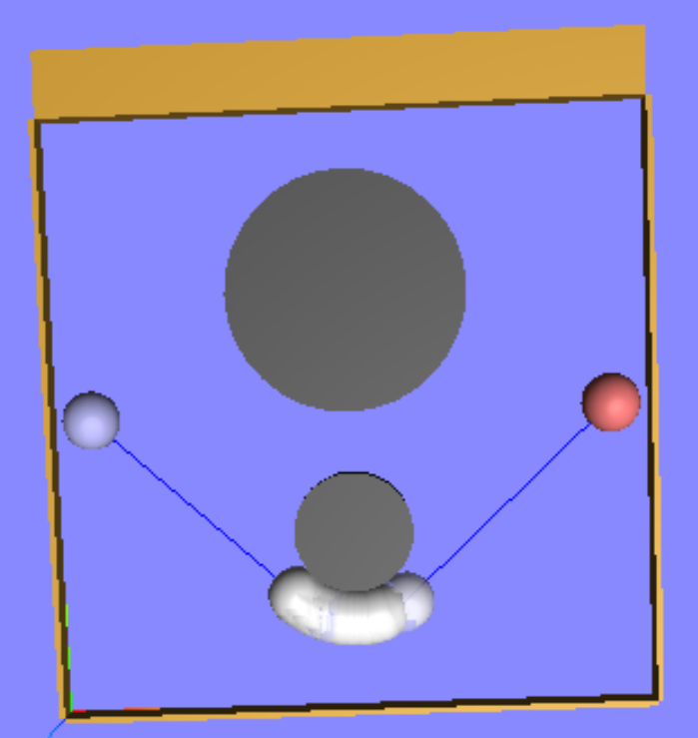

As shown, the distance between two circle is slightly larger than the diameter of the robot:

It is possible for the robot to go through the gap and have a shorter path, while the PRM:

MotionPlan.setOptions(type="prm",knn=10,connectionThreshold=0.1,shortcut=True)

Fails to do so.

RRT*: MotionPlan.setOptions(type="rrt*",connectionThreshold=0.1,perturbationRadius=0.25)

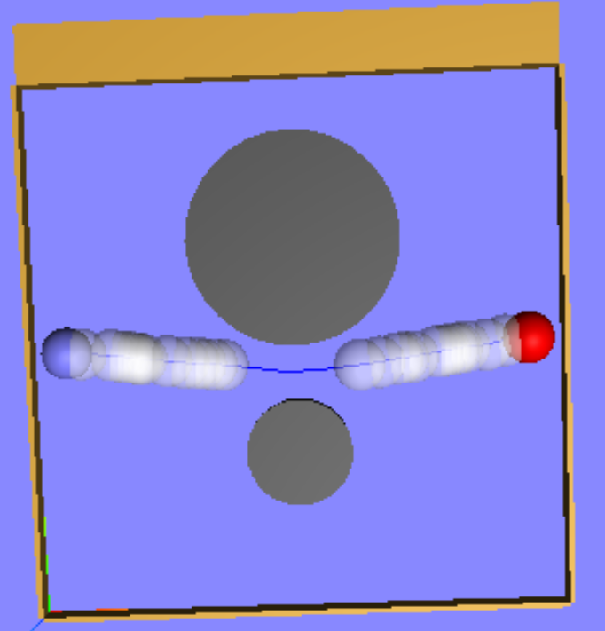

FMM: MotionPlan.setOptions(type="fmm*")

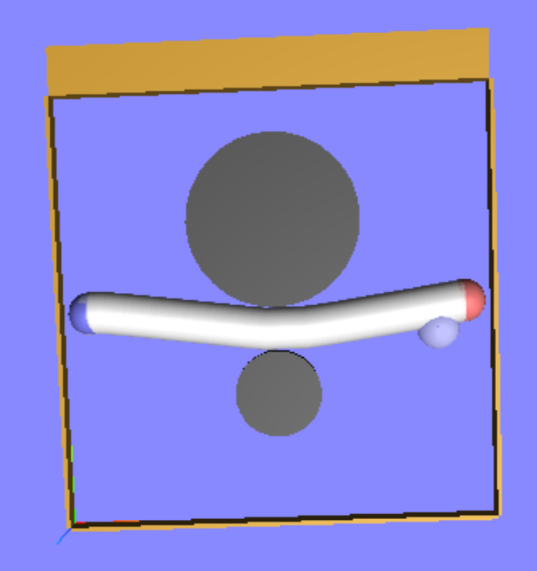

RRT random restart: MotionPlan.setOptions(type="rrt",connectionThreshold=0.2,perturbationRadius=0.01,bidirectional=True,restart=True,shortcut=True) with different attempt on parameters setting, such as decrease connection threshold and perturbation radius, it still fails

