1. Kalman Filter with Position Sensor

1: As shown in the code.

2:

From the problem description:

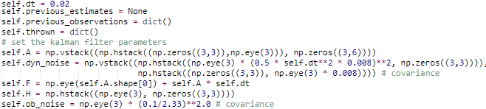

The dynamic noise is assumed based on the empirical testing results.

For velocity initialization, it is assumed that the velocity on x and y are constant and on z direction it is only affected by gravity. With this assumption, the coefficient of the fitted line using the first 10 position reading from the sensor are used for initialization.

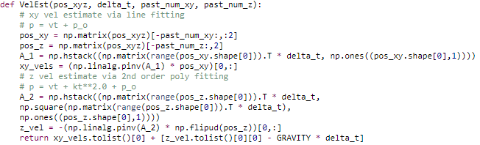

And it is assumed that when the following condition is satisfied that a ball is judged to be kicked.



1. This model works better than the using the position sensor, as the error in the position reading is very large compare to the 0.5 pixel reading standard deviation. And from the result, the landing position prediction from the camera sensor is more stable and accurate than the result from the position sensor.