**What We Do: Business Process Re-Engineering**

**Introduction**

Business Process Re-engineering (BPR) is a management strategy aimed at improving organizational performance by re-designing and optimizing business processes. BPR is a systematic and radical approach to change, focused on transforming and streamlining core business processes to achieve dramatic improvements in quality, efficiency, and customer satisfaction.

Business Process Re-engineering (BPR) is a strategic approach to improve an organization’s performance by rethinking and redesigning its business processes. The goal of BPR is to achieve significant improvement in parameters like cost, quality, service, and speed.

**Key Activities in Business Process Re-Engineering**

1. **Identify Processes:**This step involves identifying processes for re-engineering that require the most improvement and will offer the greatest benefit from re-engineering.
2. **Understand Existing Processes:**Conduct a thorough analysis of current processes to identify inefficiencies and bottlenecks.
3. **Define Objectives:**Set clear and specific goals for the re-engineering process such as cost reduction, faster service, improved quality, and many more.
4. **Form a Cross-Functional Team:**Form a team of members from various departments to bring diverse expertise to the re-engineering process.
5. **Redesign Processes:**Rethink and redesign processes from the ground up, focusing on eliminating non-value-adding activities.
6. **Implement Changes:**Execute new process designs and ensure that all necessary resources are available to facilitate a smooth transition.
7. **Monitor and Optimize:**Continuously track the performance of re-engineered processes and make changes as needed to ensure that they meet the desired outcomes.

**Benefits of BPR**

Here are some key benefits that can significantly impact organizational performance and efficiency:

1. **Increased Efficiency:**It aims to streamline processes, reduce cycle times, and eliminate redundancies, leading to improved operational efficiency.
2. **Cost Reduction:**Organizations can lower operational costs by optimizing processes and reducing costs.
3. **Improved Quality:**Redesigned processes include built-in quality checks, resulting in higher quality outputs and fewer errors.
4. **Improved Customer Satisfaction:**It focuses on improving overall customer satisfaction by aligning the processes with customer needs.
5. **Employee Empowerment:**Involving employees in process redesign leads to a more motivated workforce.
6. **Improved Financial Performance:**BPR can lead to improved financial performance through cost savings, better resource utilization, and increased revenues.
7. **Continuous Improvement:** It encourages an environment of continuous improvement, enabling organizations to be more adaptable to market changes.

**Tools and Techniques**

* **Process Mapping Tools**: Visio, BPMN software.
* **Data Analysis**: Excel, Tableau, Power BI.
* **Automation Platforms**: Robotic Process Automation (RPA), workflow management systems.
* **Methodologies**: Lean, Six Sigma, Agile.

**Our Approach**

Our approach is using the DMAIC methodology of the lean six sigma

What is DMAIC?

Define, Measure, Analyze, Improve, and Control is a DMAIC acronym. The process includes five phases: defining the problem, improving the activity, identifying the opportunities for improvement, setting project goals, and meeting the needs of the customer (internal and external).

* Define:
* During this phase, we select the most critical and impactful opportunities for improvement. This phase is also about mapping the process, focus, scope, and the ultimate goal as well as understanding how the problem affects all stakeholders
* Measure:
* The Measure phase is where baselines are drawn to assess the performance of a given process.
* Analyze:
* In this phase, your goal is to identify and test the underlying causes of problems to make sure that improvement takes place from deep down where the problems stem from.
* Improve
* With the analysis done and the data in front of you, now is the time to start making the improvements
* Control
* After changes are in place and are successfully addressing the problems to improve your operations, it’s time to bring the process under control to ensure its long-term effectiveness.

**References :**

**Our Deliverables**

* Comprehensive process maps and documentation.
* Detailed analysis reports highlighting inefficiencies and opportunities.
* Actionable recommendations and redesigns for workflows.
* Implementation of recommended automation

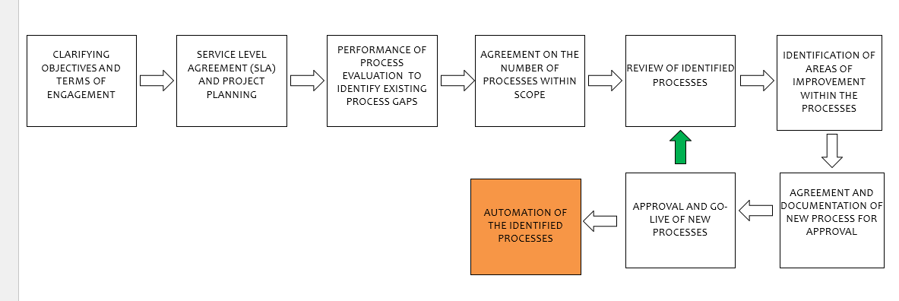

**Conclusion**

In summary, BPR can be a powerful tool for organizations seeking to transform their business processes and improve performance. However, the costs, resistance to change, risk of failure, disruption to operations, and focus on short-term goals are all potential disadvantages that organizations should carefully consider before embarking on a BPR initiative.

**References**

1. <https://www.geeksforgeeks.org/introduction-to-business-process-re-engineering/>
2. [**https://www.simplilearn.com/dmaic-process-article#:~:text=Define%2C%20Measure%2C%20Analyze%2C%20Improve,customer%20(internal%20and%20external)**](https://www.simplilearn.com/dmaic-process-article#:~:text=Define%2C%20Measure%2C%20Analyze%2C%20Improve,customer%20(internal%20and%20external))**.**

* ([Steve Tanner](https://www.simplilearn.com/authors/steve-tanner), Page 3 , Aug 13, 2024 )