# Installing Jupyter Notebook:

To install Jupyter notebooks:

* If you have the pip package manager, you can just use the command pip install jupyter
* If you don’t have this, the following guide will be helpful in installing jupyter notebooks <https://docs.jupyter.org/en/latest/install/notebook-classic.html>

# Starting Jupyter Notebook

* In the terminal, navigate to the directory you would like to open in jupyter notebook.
* Then if you run the command jupyter notebook in your terminal, it should start.
* To access this notebook, copy and paste (or CTRL + click) the URL (that is printed once the previous step is run) into your browser, it should look something like this, where I have underlined the links in blue.

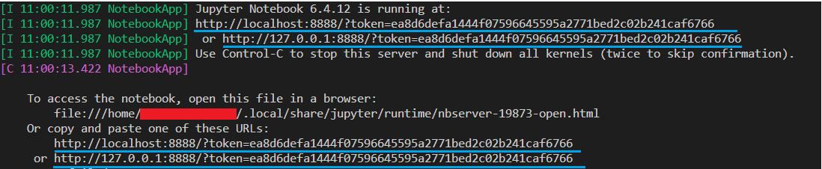

* When you want to stop the notebook, just use the keyboard shortcut Ctrl + C in your terminal

# Using a Jupyter Notebook

Once you have started up the jupyter notebook and you have it open in your browser, you will see a screen like below:

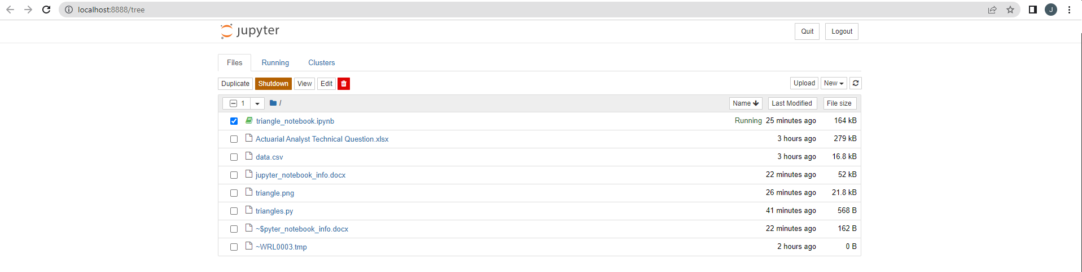

To create a notebook, go to the home page and select “New”. From there, select “Python 3 (ipykernel)”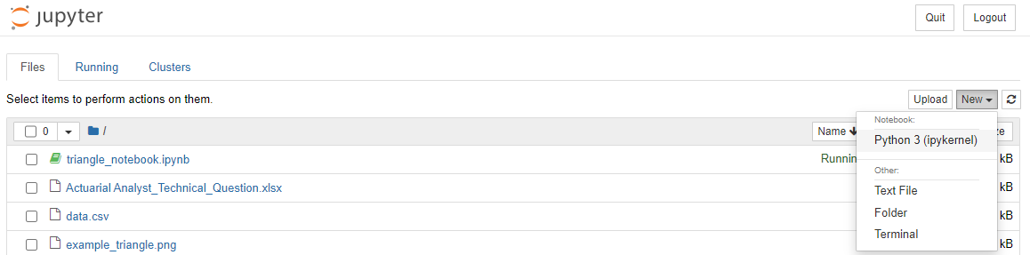

Then double click on the file you want to open.

Jupyter notebooks allow you to have blocks of code. To run a block of code, select it and then click the “Run” button at the top of the screen 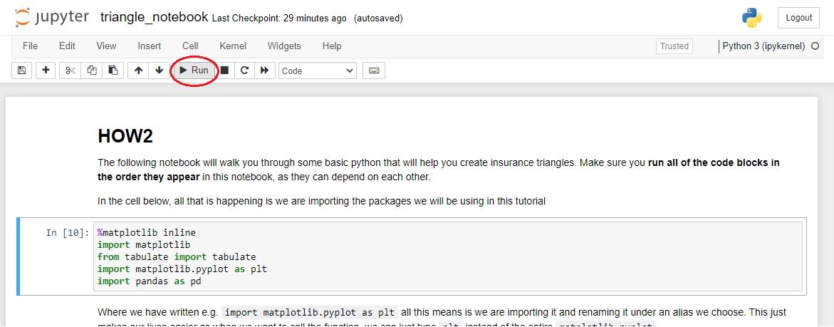

If you want to start the notebook again, you will find it useful to remove all of the cell outputs. To do this, open the cell dropdown, go to “All Output” and select “Clear”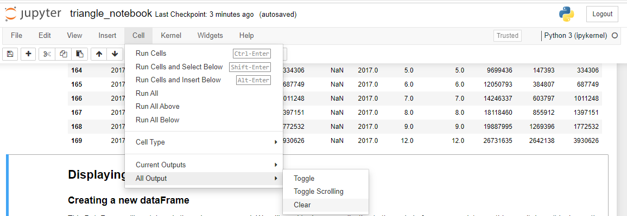

# Possible errors and solutions

* If you try and open jupyter notebooks, but when you copy the link into your browser the page loads forever, try restarting jupyter notebooks and running with the command jupyter notebook --no-browser instead
  + Another possible solution would be running jupyter lab instead
  + If neither of those solutions worked, another way is to try and set it so that jupyter notebooks will automatically open in browser. The following link may be helpful: <https://stackoverflow.com/questions/55756151/how-to-set-jupyter-notebook-to-open-on-browser-automatically>
* If you get the following error, you need to install the required modules on your machine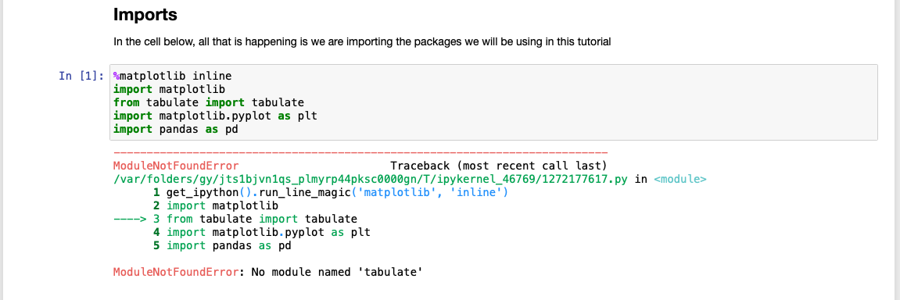

If you are on Linux, you can install pandas and matplotlib with the following terminal commands:

* For Pandas: sudo apt-get install python3-pandas
* For Matplotlib: sudo apt-get install python3-matplotlib

If you are on Windows or Mac, use the following guide to install matplotlib:

<https://pythonguides.com/how-to-install-matplotlib-python/>

If you are on Windows or Mac, use the following guide to install pandas:

<https://sparkbyexamples.com/pandas/install-python-pandas-on-windows-linux-mac-os/>