T.C.

UNIVERSITY OF AKDENIZ



FACULTY OF ENGINEERING

DEPARTMENT OF ELECTRICAL AND ELECTRONICS ENGINEERING

ANALOG COMMUNICATION

Hayri Sinan SÜRMELİHİNDİ

Ali Bera KURUNÇ

Hakan ÖZDABAK

Fahri Kaan USLU

Prof. Dr. Selçuk HELHEL

2022

ANTALYA

**Introduction**

In this study, the fundamentals of communication tools were examined and the stages for building transmitter and receiver circuits were evaluated for wireless communication. After explaining the stages, an FM transmitter and receiver circuit was built and necessary calculations were made.

The main problem that arises from the development of people among themselves is this: How is communication provided to distant points? Various methods have been tried since ancient times to solve this problem. The main ones are smoke, pigeon, letter, telegraph and so on. methods have been developed. With Maxwell's 4 basic mathematical equations, human beings have learned to dominate electromagnetic waves and rolled up their sleeves to use them for their benefit. In response to this, communication over long distances for very short periods was made possible using electromagnetic waves.

Amplitude, Phase, and Frequency modulations were developed using electromagnetic waves. Frequency, that is, the FM modulation method used in this circuit, has been preferred due to its higher SNR ratio and less data loss.

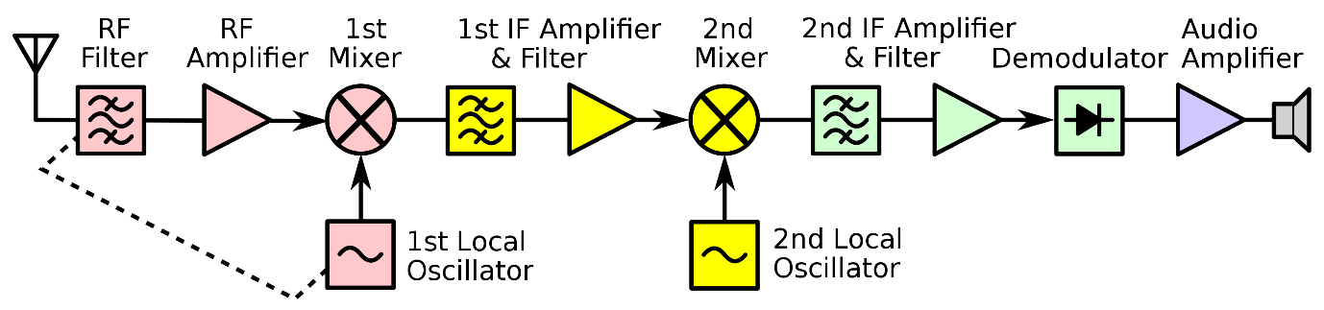

**Figure-1 Illustration of a Radio Transmitter**

In Figure-1 above, a typical radio transmitter design is illustrated. The carrier signal is applied to the phase modulator. The Voice signal is increased by an amplifier and directed so that frequency would be limited and high levels of deviations are prevented.

**Modulation and FM Modulation**

Modulation is a method of combining an information signal and a carrier signal, used in transceiver systems in the field of communication. Since the transmission of low-frequency waves is both financially expensive and physically difficult, any modulation technique is used to ensure that the high-frequency signal carries the low-frequency signal. However, restoring the modulated signal on the transmitter side is also very important for the correct reception of the data. Thus, reversing the modulation process of the signal is also called demodulation. As we mentioned before, there are several types of modulation techniques and the FM modulation technique was preferred in this project.

FM modulation is just one of the modulation types used in communication technology. In this technique, the high-frequency signal, that is, the carrier signal is a sine function. In the transmitter, the frequency of the sine signal is changed depending on the information signal, and the transport is provided. In the receiver, on the other hand, the information packet is reached by providing demodulation.

Just as there are different modulation techniques, there are also different techniques for generating FM signals. Two techniques are mentioned, one of which is indirect production and the other is direct production. In the indirect generation method, the information signal is applied to the phase modulator by passing an integrator circuit, but since the frequency will be lower than desired, the signal must be passed through the frequency multiplier. In the direct generation method, the modulator is an oscillator that produces only the carrier signal. By using the varactor and the capacitor in the oscillator, the frequency of the signal produced by the oscillator is also changed by the varying capacitance of the varactor.

**FM Transmitter**

Worldwide, the FM frequency range is expressed in the radio wave spectrum between 87.5 MHz and 108.0 MHz, which is classified as Very-High-Frequency and Ultra-High-Frequency (also named VHF and UHF) areas. Some serious calculations have been made below to send a 256-bit size and 30x30 pixel resolution (single letter) image.

Pixel amount of one letter:

**30 *30 = 900**

Size of one pixel:

**Log2(256) = 8 bit, 900 * 8 = 7200 bits**

Let’s assume that the frame rate is 24 fps and desired SNR value is 10dB;

**24 * 7200 = 172800 bps**

**C = B * log2(1+SNR), 172800 = B * log2(1+10)**

**B = 49950 Hz**

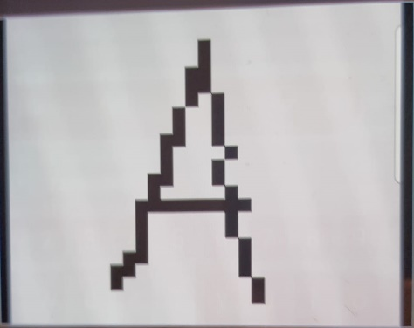

**Figure-2 The letter transmitted in this study.**

According to the calculations done above, at 50KHz bandwidth with the help of the transmitter circuit, microwaves can transmit a letter or any image that has a size of 256 bit and 30x30 pixel resolution (which equals 900 pixels).

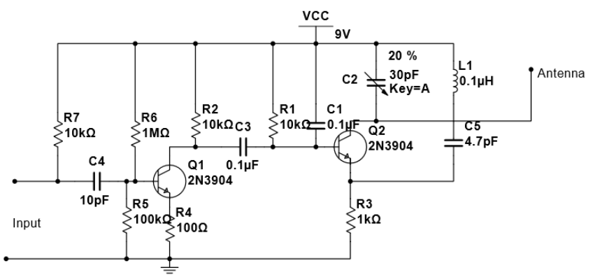

**Figure-3 FM transmitter that is used in this project.**

**FM Receiver**

In this circuit, as in the whole world, the FM receiver is designed to receive data in the frequency range of 88-108 MHz. However, the transmitted signal becomes extremely attenuated until it reaches the receiver circuit, as the microwave signals lose energy in the air and encounter various obstacles. Therefore, to recover the signal, a power amplifier must be used to increase the signal level to the desired levels.

In addition to the previously mentioned microwaves losing energy in the air, another problem is that these signals are mixed with thousands of transmission signals in the air which can cause noise and/or data breaches, and these mixed signals can be picked up by any receiving circuit, and antenna. Therefore, the receiver circuit must have filters that acquire the original message signals and block other noises to pass through.

The circuit in Figure-4 is designed to receive signals from the transmitter circuit used in this project. In this circuit, the Varactor is used to set the matching frequency of the receiver to any desired frequency in the range of 88-108 MHz. As a power amplifier, an op-amp called LM386 is used to amplify the attenuated audio signals. Capacitors C3, C10, and resistor R3 are used as band-pass filters to pass desired signals and suppress unwanted signals.

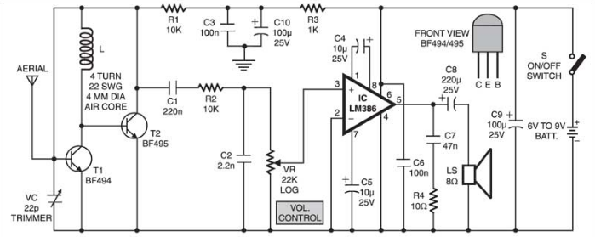

**Figure-4 FM receiver that is used in this project.**

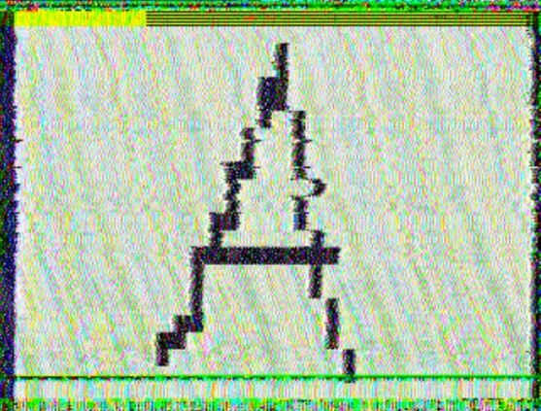

**Figure-5 The letter received in this study.**

**Encountered Problems and Their Solutions**

There were some problems encountered in the project. Some of these problems were impedance control problems and problems with winding the coil.

Impedance control is important for the control of the energy flow in the circuit and the control of the power distribution in the circuit. Under the influence of a magnetic field, impedance represents both energy and power dissipation. At the high-frequency range, any differences in the length of the current's flow path make that path act like capacitance or inductance. The impedance problem caused by the length of the legs also prevents obtaining the desired sound intensity at the circuit output, since maximum power transfer cannot be achieved. To recover from these effects and achieve impedance control, we must reduce the length of the current path and keep the legs of the circuit elements short. At the same time, if we design the circuit and place it on the PCB by printing, the legs of the circuit elements will not be longer than necessary and there will be no impedance problem in the circuit due to their ideal location.

About the coil problems, the required dimensions for the coil were calculated according to the formula, and the coil required for the circuit was wound. However, since the winding process was done by hand instead of using a machine, a sensitive winding could not be done and the required inductance value of 0.1 uH could not be obtained clearly. For this reason, the winding was repeated several times, but still, a qualitatively sufficient winding was not made and caused interference problems. Both circuits have been completed and tested to see if the circuits work properly. As a result of the tests, it was determined that the circuits were working, but it was observed that there was interference and the sound output was insufficient.

**Antenna**

To receive the transmitted signal from the transmitter, we need a device that helps us capture the modulated waves. These devices are called antennas and are systems that continue to propagate in space, capture modulated or unmodulated waves, and transmit them within the transmission line after capturing them. Antennas can be found in various structures, some of them can be classified as isotropic antenna, dipole antenna, monopole antenna, yagi antenna, and microstrip antenna. The antenna we use in this project is just a cable. While making the calculations of this cable, that is the antenna, the following formulas were used and the calculations were added below.

Quarter Wave Physical Antenna Length (meters);

**Length = [(300 / f (MHz)) * 0.95] / 4**

If we consider the frequency at 100 MHz;

**[(300 / 100 (MHz)) * 0.95] / 4 = 0.7125 Meters  
0.7125 (mt) ≈ 72 (cm)**

A 75-centimeter-long wire was used to more easily reach the desired frequency range by accepting the 72-centimeter result as the minimum value.

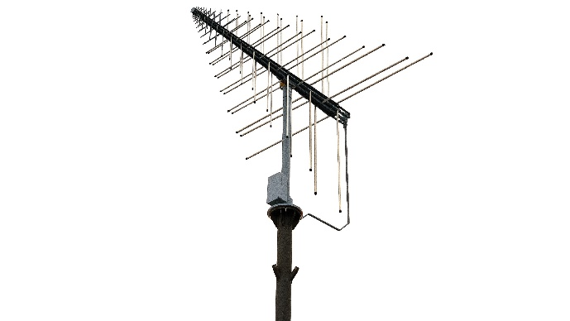

**Figure-6 R&S®HL007A2 Crossed Log-Periodic Antenna.**

**Conclusion**

The main goal was to send a 30x30 pixel image from the transmitter side to the receiver side. That was successfully done via FM circuits. The channel capacity is calculated as min 50kHz. Also, LM386 has been used to get a strong signal to the receiver side.

To able to obtain the message signal a filter was needed which can reduce noise as well as interference at the transceiver side. It has been solved by using a bandpass filter.

On the receiver circuit side, the varactor should be held constant to be able to get the signal which was sent by the transmitter circuit. Because of some noise and interference frequency of the circuit was needed to change with the help of the varactor and matched with the frequency of the receiver circuit.

**REFERENCES**

Frenzel L., “Principles of Electronic Communication Systems”, McGraw Hill, 2016

Couch L., “Digital and Analog Communication Systems”, Pearson, 2013

Lathi B, “Modern Digital and Analog Communication Systems”, Oxford Press, 2010

JunezRiyaz. “How to Make FM Transmitter”. Retrieved: May 27, 2022, from <https://www.instructables.com/How-to-Make-FM-Transmitter/>.

Tech Maker. “Make FM Receiver Easily”. Retrieved: May 27, 2022, from <https://electronicsprojectshub.com/fm-receiver-circuit/>

Rohde&Schwarz. “R&S®HL007A2 crossed log-periodic antenna”.

Retrieved: May 27, 2022, from <https://www.rohde-schwarz.com/tr/products/aerospace-defense-security/directional-stationary/rs-hl007a2-crossed-log-periodic-antenna_63493-9057.html>

Wikipedia. “Double-conversion superheterodyne receiver block diagram”.

Retrieved: May 27, 2022, from <https://en.m.wikipedia.org/wiki/File:Double-conversion_superheterodyne_receiver_block_diagram.svg>