Measured powers of units are shown in Figure which is below. Power loss and efficiencies are shown in Table 1.

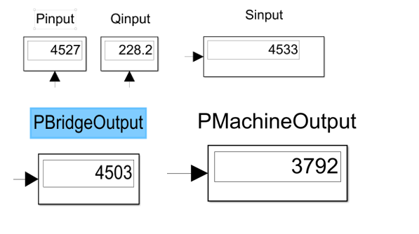

Figure Power

Table Efficiencies

|  |  |  |
| --- | --- | --- |
| **Unit** | **Power(W)** | **Efficiency (%)** |
| Input | 4527 | 100 |
| Output of Bridge | 4503 | 99 |
| Output of Machine | 3792 | 84 |

Armature resistance and bridge on resistance lead the loss of power. Bridge on resistance is 20 mΩ and armature resistance is 10Ω so, armature resistance leads more power loss.