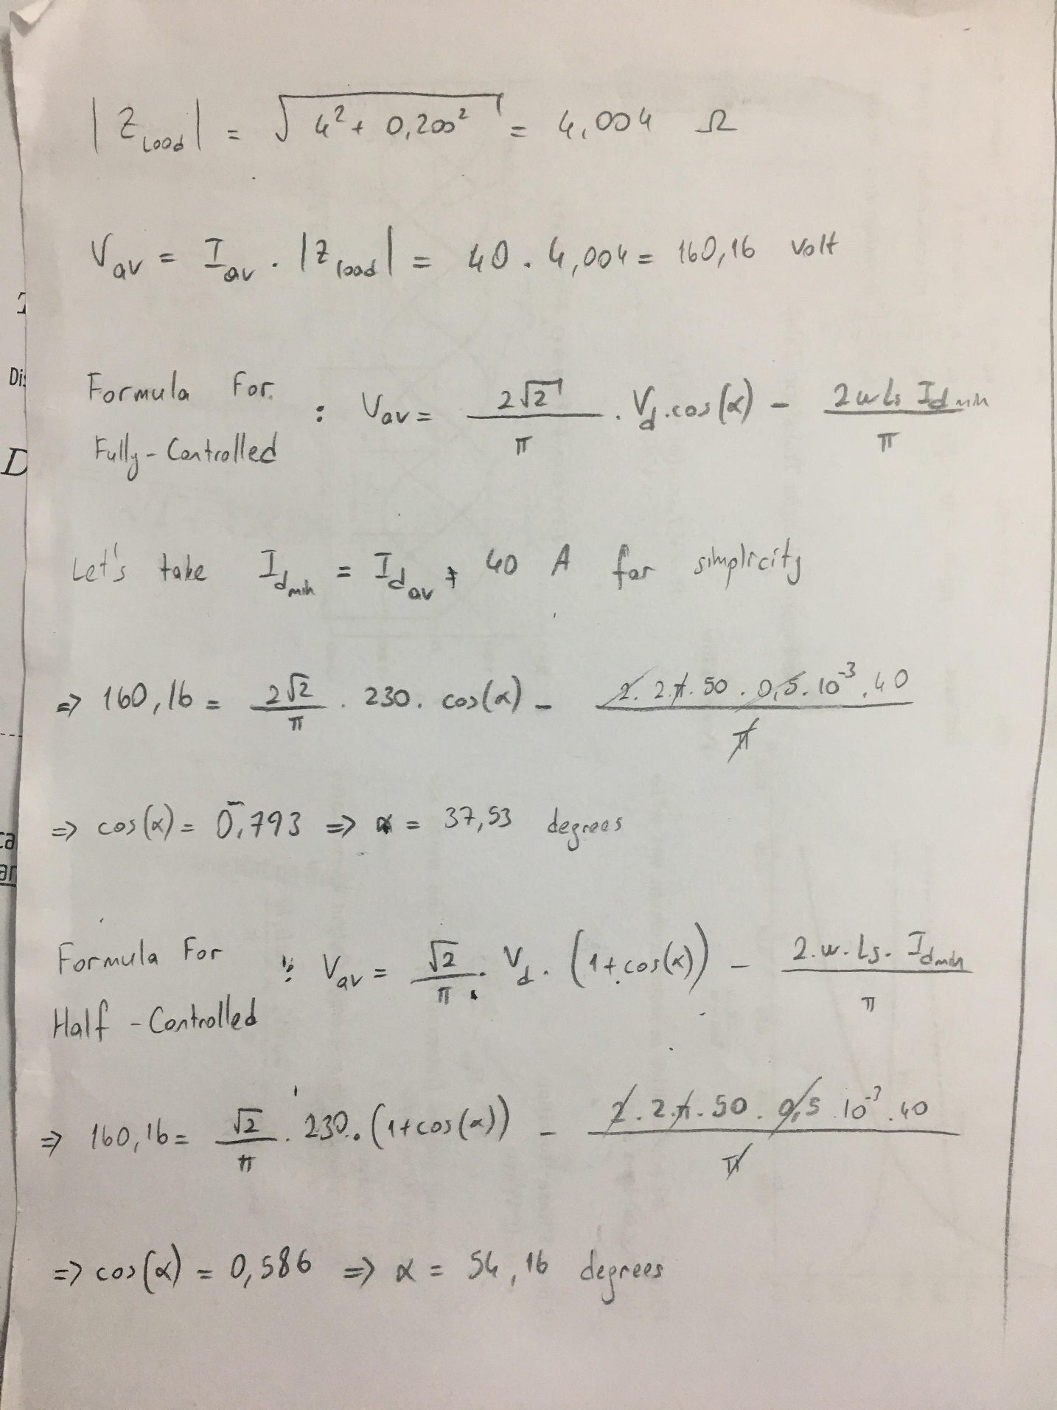

Figure Analytical Calculation of the Firing Angles

* 1. The difference between the topologies, output voltage cannot be negative in half-controlled rectifier. However, output voltage can be negative in fully-controlled. Because of that, average output voltage of the half-controlled rectifier is higher than fully-controlled one in same case. Moreover, negative output voltage is a big disadvantage of the fully-controlled rectifier because some loads are sensitive to negative voltage.

The similarities of these are that if thyristors are fired at the same time for both cases, starting of the output voltage is same.