Keynote

Time: September 16, 2026 - 9:30 to 10:30

Chair: Blerina Spahiu

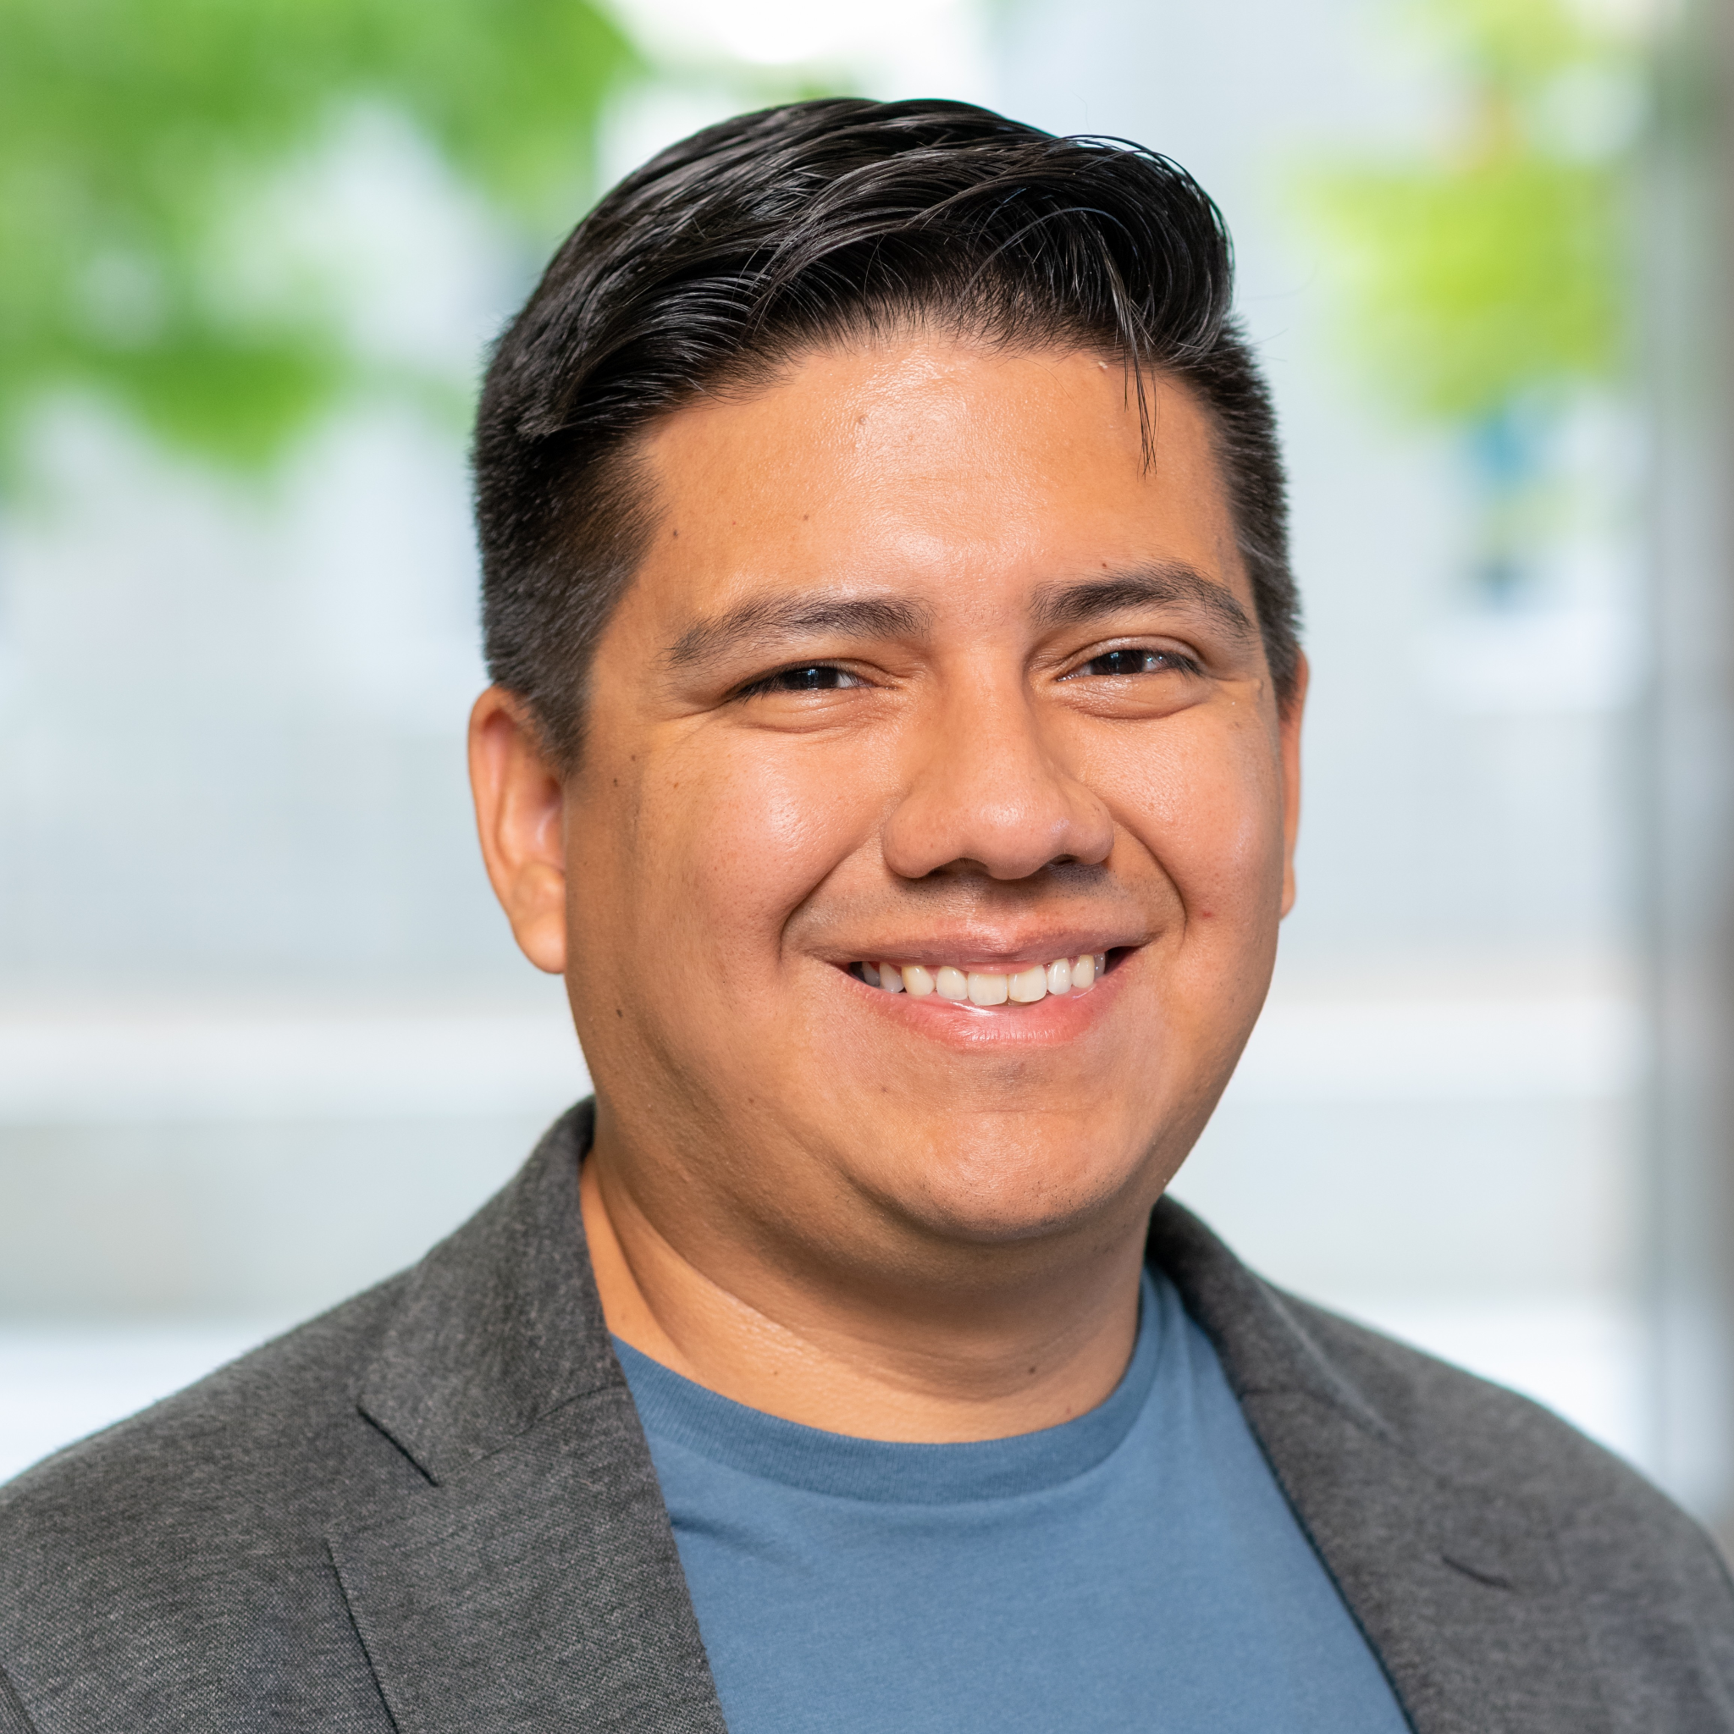  Juan Sequeda Ph.D.  Principal Data Strategist & Researcher at ServiceNow  (Keynote Speaker) | Juan Sequeda  is a Principal Data Strategist at ServiceNow, joining through the acquisition of data.world and previously the acquisition of Capsenta, a spin-off from his doctoral research. Juan’s research and industry work has been on the intersection of data and AI, with the goal to reliably create knowledge from inscrutable data, specifically designing and building knowledge graphs for enterprise data and metadata management. Juan serves as a strategic and innovation bridge across Product, Engineering, Marketing, Sales, and Customer, ensuring technical insights are aligned with business value.  Juan Sequeda is a Principal Data Strategist at ServiceNow, joining through the acquisition of data.world and previously the acquisition of Capsenta, a spin-off from his PhD in Computer Science from The University of Texas at Austin. Juan’s research and industry work has been on the intersection of data and AI, with the goal to reliably create knowledge from inscrutable data, specifically designing and building knowledge graphs for enterprise data and metadata management. Juan serves as a strategic and innovation bridge across Product, Engineering, Marketing, Sales, and Customer, ensuring technical insights are aligned with business value.  - google scholar

Title: Scar Tissue: 20 Lessons from 20 Years of Building Ontologies and Knowledge Graphs
Abstract: TBD

