CS650 · ARTIFICIAL INTELLIGENCE · WEEK 13
Chapter 19 Lecture Pamphlet
Learning from Examples — The Full, Illustrated Guide
This pamphlet is a detailed, illustrated companion to the Chapter 19 lecture — written to be read on its own, with no slides required. It goes further than the deck: every idea gets a plain-language explanation, a worked example, and a hand-drawn diagram. Two running examples carry through the whole chapter: the textbook's own restaurant-waiting problem, and Northgate General Hospital, where Dr. James Okafor and Nurse Priya Mehta screen patients like Maria Santos for appendicitis risk.
Look for the shaded callout boxes for the “don't forget this” ideas, the navy formula boxes for the exact math (always paired with a plain-English line underneath), and a captioned figure next to every major concept.

In This Pamphlet
- 19.1 – 19.2 Forms of Learning & Supervised Learning
- 19.3 Learning Decision Trees
- 19.4 – 19.5 Model Selection, Optimization & Theory
- 19.6 Linear Regression and Classification
- 19.7 Nonparametric Models
- 19.8 Ensemble Learning
- 19.9 Developing Machine Learning Systems

19.1 – 19.2 Forms of Learning & Supervised Learning
Think about how a brand-new nurse gets good at their job. Nobody hands them a rulebook that covers every possible patient who might walk through the door. Instead, they see case after case, and slowly they build a feel for the patterns — this combination of symptoms usually means that. That is exactly what we are teaching a computer to do in this chapter. Every agent we've built so far this semester acted on knowledge we handed it directly: a search heuristic we wrote, a set of logical rules we typed in, a probability table we specified by hand. Machine learning asks a different question: can the computer build its own sense of the patterns just by watching examples go by?
There are two very human reasons we'd want a machine to learn rather than just programming it correctly from the start. First, nobody can anticipate every future situation — a maze-solving robot has to learn the layout of each brand-new maze it's dropped into; a hospital's triage system has to keep adapting as new illnesses and new patient populations appear. Second, for some skills, nobody could write the rule down even if they tried. You recognize your best friend's face instantly and effortlessly, but you couldn't write step-by-step instructions for exactly how you do it. That gap — between “I can do it” and “I can explain exactly how” — is precisely where machine learning steps in.

What Exactly Can Be Learned?
Almost any part of how an agent behaves can be improved with practice, the same way almost any human skill can. Recall the seven components of an agent from earlier in the course: a direct mapping from conditions to actions; a way of inferring what's going on in the world from raw sensor input; knowledge of how the world evolves and what actions do; a sense of how desirable different world-states are (utility); a sense of how good individual actions look (action-values); explicit goals; and the problem-generator/critic/learning machinery that ties it all together. Every single one of these can be learned rather than hand-programmed.
A self-driving car is a good running example. Every time a human driver brakes, the car can learn a condition-action rule for when to brake (component 1). By watching thousands of labeled camera images, it learns to recognize a pedestrian or a stop sign (component 2). By trying actions and observing results — braking hard on a wet road behaves differently than on dry pavement — it learns the effects of its own actions (component 3). And when passengers complain about being jostled by sudden stops, it can learn a piece of its own utility function (component 4). None of this required a programmer to sit down and write “if wet road and speed > 40, brake with force X” by hand.

Three Kinds of Feedback, Three Kinds of Learning
Everything in machine learning sorts into three buckets, and the sorting question is simple: does someone tell you the right answer while you're learning, or not?
Supervised learning is like studying with flashcards that have the answer printed on the back. The agent observes input-output pairs and learns a function that maps from one to the other. At Northgate General Hospital, the “front of the card” is a patient's symptoms and lab values, and the “back of the card” is the confirmed diagnosis, usually established later through surgery or biopsy. This entire chapter is about this kind of learning.
Unsupervised learning has no answer key at all. It's like sorting a messy junk drawer into piles with nobody telling you the categories — you just notice that certain things seem to belong together. The most common unsupervised task is clustering: a computer vision system shown millions of random internet photos can identify a large cluster of similar images that any English speaker would call “cats,” without ever being told that word or shown a single labeled example.
Reinforcement learning is like learning a video game purely by trial and error. The agent only finds out, at the end of a chess game, that it won (a reward) or lost (a punishment) — and it has to work out for itself which of its earlier moves actually deserved the credit or the blame, then adjust its future behavior to chase more reward. We'll meet unsupervised and reinforcement learning properly in later chapters; this whole chapter lives entirely in the flashcard world of supervised learning.

The Formal Supervised Learning Task
Given (x₁,y₁), (x₂,y₂), …, (xₙ,yₙ) where y = f(x), discover h that approximates f.
In plain terms: given a stack of (situation, correct answer) pairs, guess a rule that predicts the answer for a new situation.
Here's the formal definition, translated into plain terms. We're handed a stack of (situation, correct answer) pairs — flashcards, essentially — and our job is to guess a rule, called a hypothesis and written h, that would have produced those same correct answers, and that we hope also works on flashcards we haven't seen yet. The correct answer on each card is called the ground truth. h is drawn from a hypothesis space, written H — the entire universe of rules we're willing to consider. That might be the set of all straight lines, the set of all decision trees, or something else entirely; the choice of H is one of the most important decisions in the whole process.
A hypothesis that gets every single practice card right is called consistent — sounds impressive, but here is the crucial idea for the entire chapter, and it's exactly like studying for a real exam: the true measure of how good your rule is has nothing to do with how well it does on the practice questions you already have the answers to. It's about generalization: how well it does on a test set — brand-new questions where nobody's shown it the answer key in advance. A hospital model that perfectly reconstructs every past diagnosis but gets the next patient wrong is as useless as a student who memorized last year's exact exam but can't answer this year's questions on the same topic.
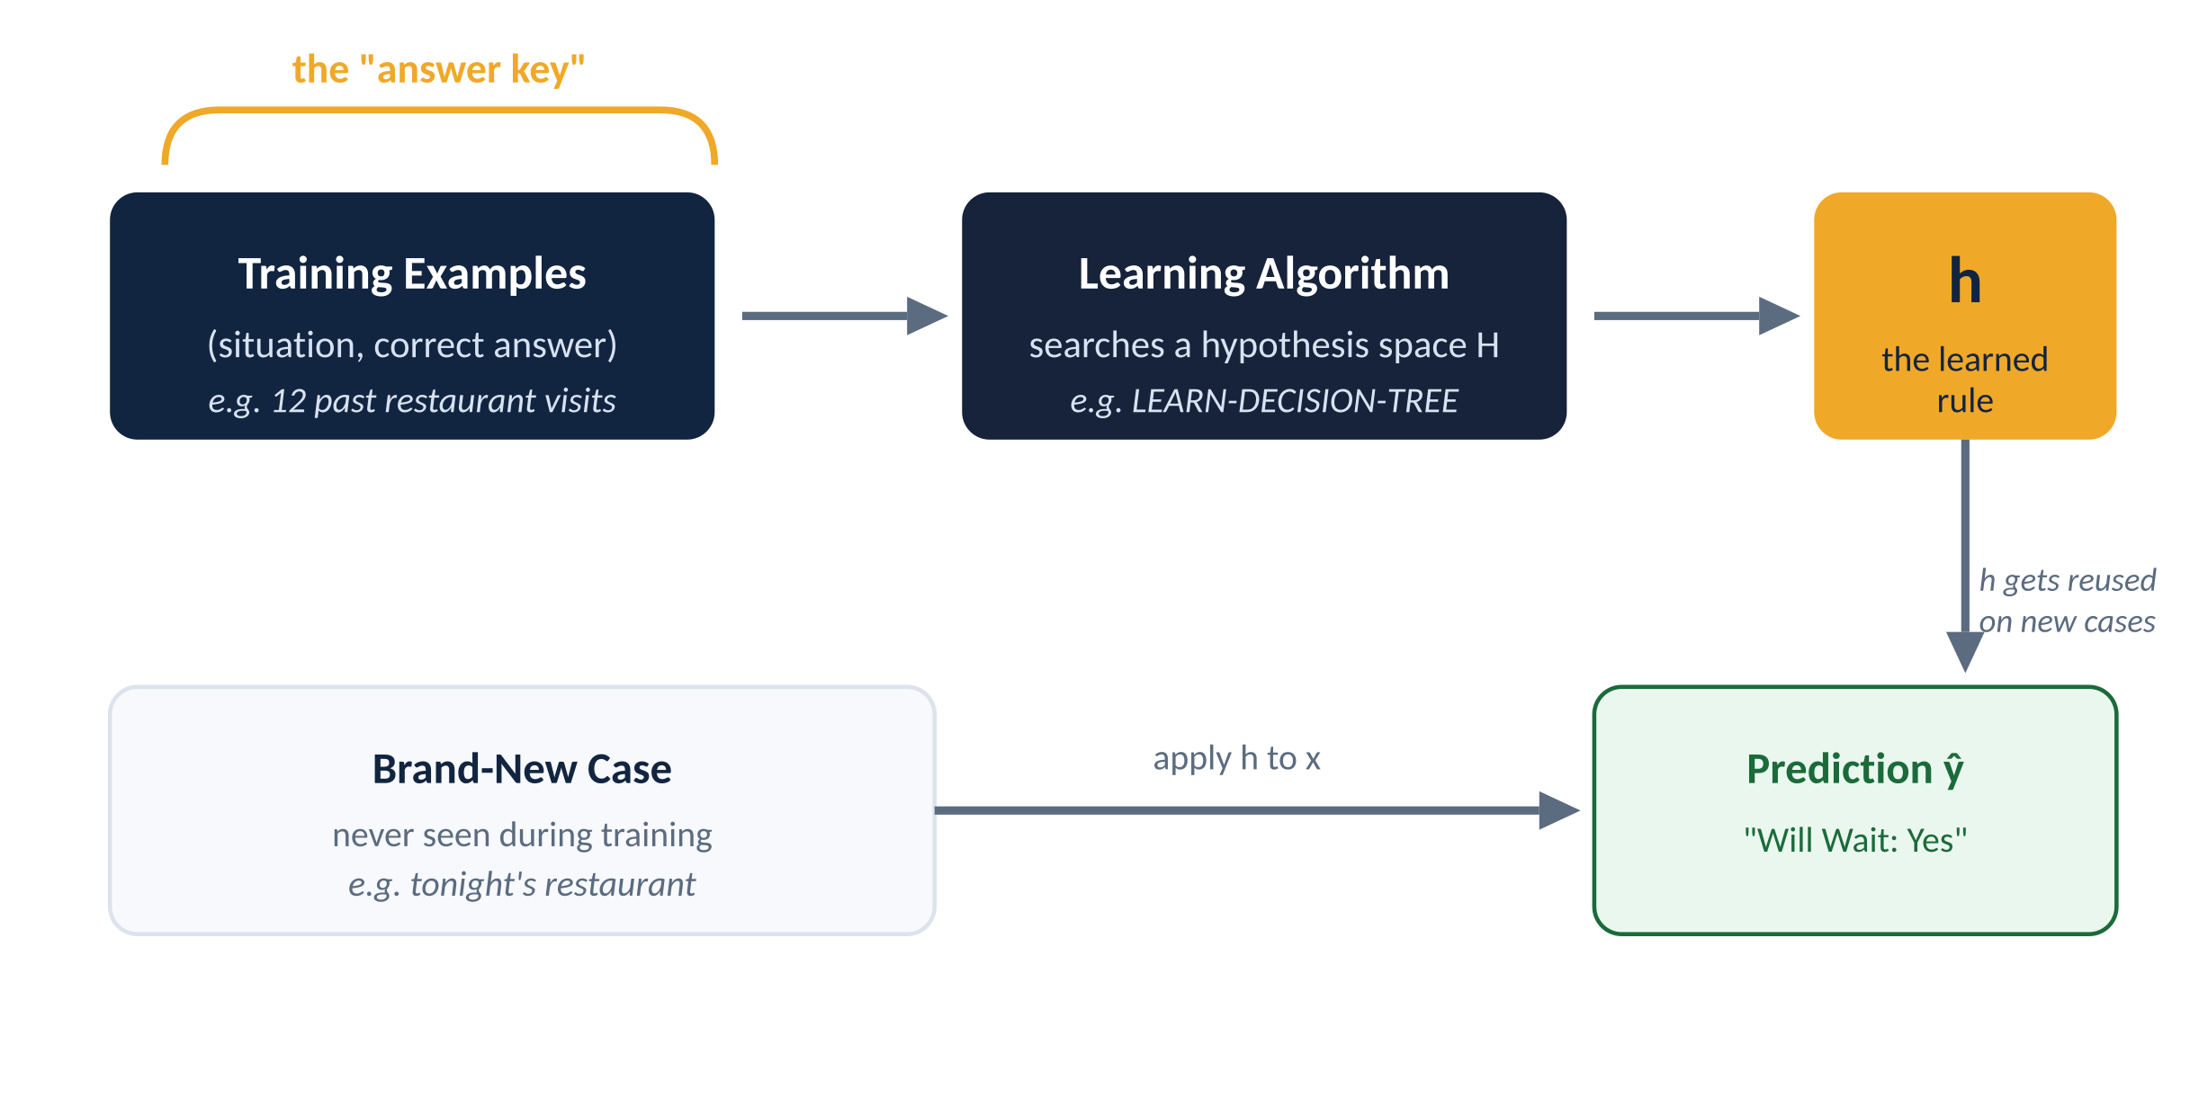
Figure 1. The supervised learning loop: an answer key trains an algorithm, which produces a hypothesis h that gets reused on brand-new cases.

Four Ways to Guess the Same Data — Two Batches
This is one of the most important pictures in the whole chapter. Imagine the exact same underlying pattern, but you collect two slightly different batches of 13 data points from it — the way two different weeks of restaurant visits would look slightly different even if diners's true preferences never changed.
The diagram below shows both batches — Dataset A on top, Dataset B below, with arrows showing what changed. A straight line and the gentle wave barely move between batches — stable. The wild curve (red) fits both datasets perfectly, but produces a completely different-looking curve on the second batch. That IS the variance problem: getting every practice question right means nothing if the rule collapses the moment the data shifts slightly.
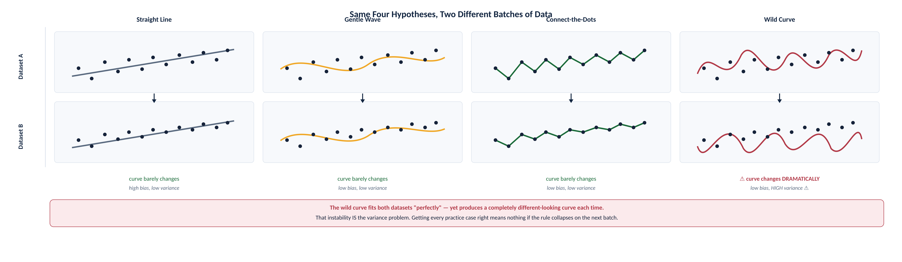
Figure 2. Figure 2. BEFORE/AFTER (Dataset A → Dataset B): same four hypothesis spaces, two slightly different data batches. Shift arrows reveal which curves stay stable (line, wave) and which collapse (wild curve — high variance ⚠).

Two Everyday Words: Bias and Variance
Bias is like a stubborn friend who always gives the same kind of advice regardless of the situation — sometimes right, but structurally blind to anything unusual. A straight-line hypothesis space has strong bias: it can only ever represent straight-line patterns, no matter what the data actually looks like. We say a hypothesis is underfitting when it fails to find a pattern that's genuinely there.
Variance is like a friend whose advice completely changes every time you ask, even when almost nothing about your situation changed — unpredictable, and hard to trust. The wild curve from the four-hypotheses picture has high variance: small changes in exactly which data you happened to collect translate into wildly different guesses. We say a hypothesis is overfitting when it pays too much attention to the particular data set it was trained on, at the cost of performing poorly on new data.
There's usually a real tradeoff between the two. Albert Einstein put it memorably in 1933: “the supreme goal of all theory is to make the irreducible basic elements as simple and as few as possible.” That idea traces back even further, to the 14th-century English philosopher William of Ockham, and we still call it Ockham's Razor in his honor: don't invent more explanation than the data actually requires. Figuring out exactly how “simple” something is turns out to be genuinely difficult in practice — we'll sharpen this idea considerably in Sections 19.3 and 19.4.

The Restaurant Waiting Problem
Here is the running example we'll use for the rest of this chapter, deliberately chosen because anyone can picture it: deciding whether to wait for a table at a restaurant. The output, called WillWait, is a simple yes or no. The input is a vector of ten everyday facts about the situation:
- Alternate — is there a suitable alternative restaurant nearby?
- Bar — does the restaurant have a comfortable bar area to wait in?
- Fri/Sat — is it a Friday or Saturday?
- Hungry — are we hungry right now?
- Patrons — None, Some, or Full
- Price — $, $$, or $$$
- Raining — is it raining outside?
- Reservation — did we make a reservation?
- Type — French, Italian, Thai, or burger
- WaitEstimate — 0–10, 10–30, 30–60, or over 60 minutes
Multiply out every possible combination of these ten facts and you get 9,216 distinct situations — but the textbook only supplies one person's actual dining history for twelve of them. That gap, twelve known situations against over nine thousand unknown ones, is the essence of induction. Every single learning method in this chapter is, at bottom, a disciplined way of making that guess responsibly.

The Real Test
• A hypothesis that gets every practice example right is called consistent — but that alone proves nothing.
• The only real measure is generalization: how well h does on a test set it has never seen.
• Bias = a hypothesis space's built-in blind spot. Variance = how much the guess swings between different training sets. Ockham's Razor: prefer the simplest hypothesis that still fits.

19.3 Learning Decision Trees
A decision tree is genuinely just a flowchart, no more mysterious than that — the exact kind of checklist a triage nurse might mentally run through. Start at the top, answer one question about the situation, follow the arrow for your answer, repeat, and eventually you land on a decision. Following the restaurant flowchart, if the restaurant is packed and the wait is short, you follow those two arrows and land on “yes, we'll wait.”
Here's why this simple idea is actually powerful: any such flowchart can be rewritten as one big logical sentence — “wait if (packed AND short wait) OR (empty AND we're hungry) OR …” — one clause for every path through the tree that ends in “yes.” That means decision trees aren't some limited toy representation; they can capture literally any yes/no rule expressible in plain logic. A lot of real-world “how-to” manuals, like car-repair guides, are basically decision trees already, which is part of why humans find this representation so naturally easy to follow.
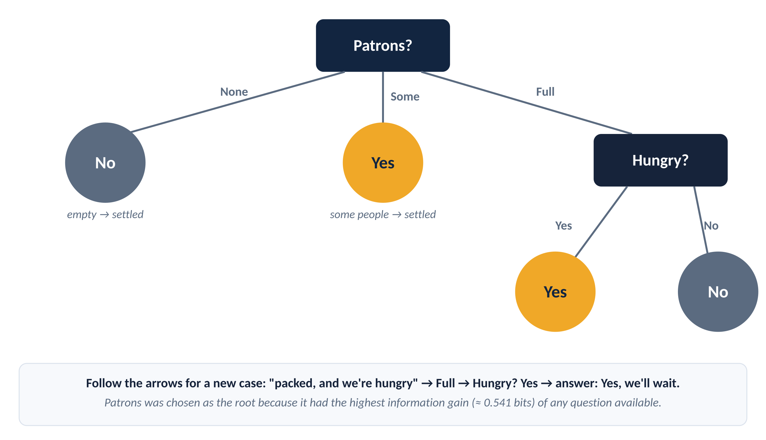
Figure 3. The decision tree LEARN-DECISION-TREE induces from the 12-example restaurant training set.

Good for Some Questions, Bad for Others
Flowcharts are wonderful for a lot of real problems, but not everything. Anything shaped like “majority rules” — true whenever more than half the facts are true — needs an absurdly huge flowchart to represent, and so does anything shaped like “true only when an even number of facts are true.” Geometrically, every question in a flowchart slices the world along one fact at a time, so it naturally draws boxy, straight-edged regions. A genuinely diagonal boundary — the kind you'd get if risk depended smoothly on two things added together — needs a staircase of tiny boxes to even approximate well, the way you'd need a lot of small Lego bricks to approximate a smooth curved wall.
Is there some representation that's great at literally everything? No. With just twenty yes/no facts, the number of possible rules is so astronomically large — more than 10^300,000 — that no small, tidy representation could capture them all. This is a gentle preview of a theme we'll meet again in Section 19.5: there's a real tradeoff between how expressive a representation is and how practical it is to actually search through.

The Tree-Growing Recipe
The LEARN-DECISION-TREE algorithm adopts a greedy, divide-and-conquer strategy: always test the single most important attribute first, then recursively solve the smaller sub-problems defined by each possible answer. There are exactly four cases to handle at every step, and each one is worth understanding on its own, because they show up constantly in practice.
If there's nobody left to ask for this particular branch, just go with whatever answer was most common among similar cases we do have — we simply never observed this exact combination before. If everyone remaining already agrees on the answer, we're done, no need to ask more questions. If we've run out of facts to ask about but people still disagree — same situation, different outcomes — that's just noise or an unmeasured factor, and the best we can do is go with the majority. Otherwise, the interesting case: we pick whichever single fact does the best job of separating the yes's from the no's, ask about it, and repeat this entire process separately within each possible answer to that question.
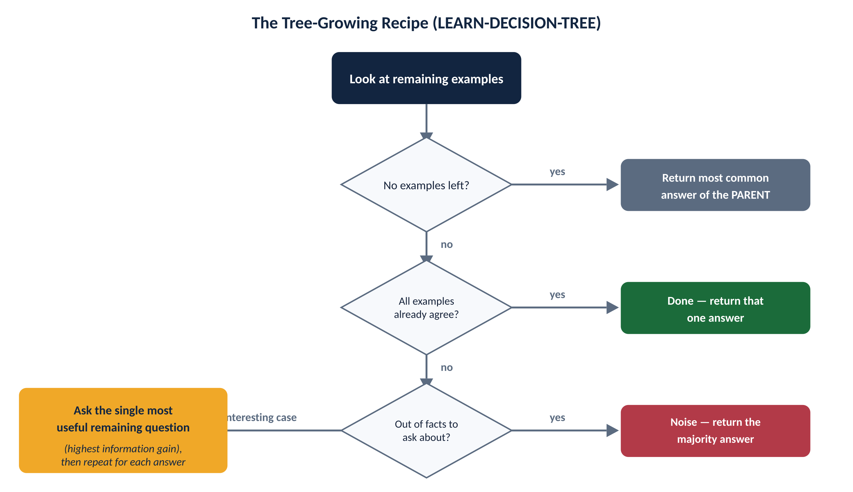
Figure 4. The four cases the tree-growing recipe checks at every single step, in order.

FORMAL NOTATION · LEARN-DECISION-TREE(examples, attributes, parent_examples)
if examples is empty: return PLURALITY-VALUE(parent_examples)
else if all examples have the same classification: return that classification
else if attributes is empty: return PLURALITY-VALUE(examples)
else:
A ← argmax_{a in attributes} IMPORTANCE(a, examples)
tree ← new decision tree with root test A
for each value v of A:
exs ← { e : e ∈ examples and e.A = v }
subtree ← LEARN-DECISION-TREE(exs, attributes − A, examples)
add a branch to tree labeled (A = v) leading to subtree
return tree
IMPORTANCE(a, examples) = Gain(a). Complexity: choosing the best attribute at one node costs O(|examples| · |attributes|); across a tree of depth d this is O(|examples| · |attributes| · d) in the worst case — fine for the restaurant data, but why real implementations (e.g. scikit-learn's DecisionTreeClassifier) pre-sort continuous features rather than re-scanning them at every split.

⌘ IN PRACTICE sklearn.tree.DecisionTreeClassifier(criterion='entropy') — criterion='gini' is the (faster, similar) default instead of information gain.

Some Questions Are Just More Useful Than Others
Before the formula, build the gut feeling with a concrete comparison. Ask “what type of food is it” first, and you split diners into French, Italian, Thai, and burger — but every single one of those four groups still has exactly the same fifty-fifty split between people who waited and people who didn't. It's like trying to guess whether someone likes pizza by asking their favorite color — technically a question, but it tells you nothing useful.
Ask “how packed is it” first instead, and you get three groups: empty, some people, packed. The empty group is entirely “no,” the some-people group is entirely “yes” — both fully settled after just one question! Only the packed group still has a mix of answers, and it turns out asking “are we hungry” works well specifically within that leftover group.

Entropy: A Number for Suspense
H(V) = −∑ P(vₖ) log₂ P(vₖ)
Entropy measures how much suspense (uncertainty) remains about a random outcome.
Entropy sounds intimidating, but think of it simply as a number for suspense — how curious should you still be about the outcome? A coin you know is rigged to always land heads has zero suspense: no uncertainty at all, you already know how it ends. A perfectly fair coin is maximum suspense for a two-outcome situation, and we call that exactly 1 bit. A coin that lands heads 99% of the time has very little suspense left — you're already almost certain — which comes out to only about 0.08 bits.
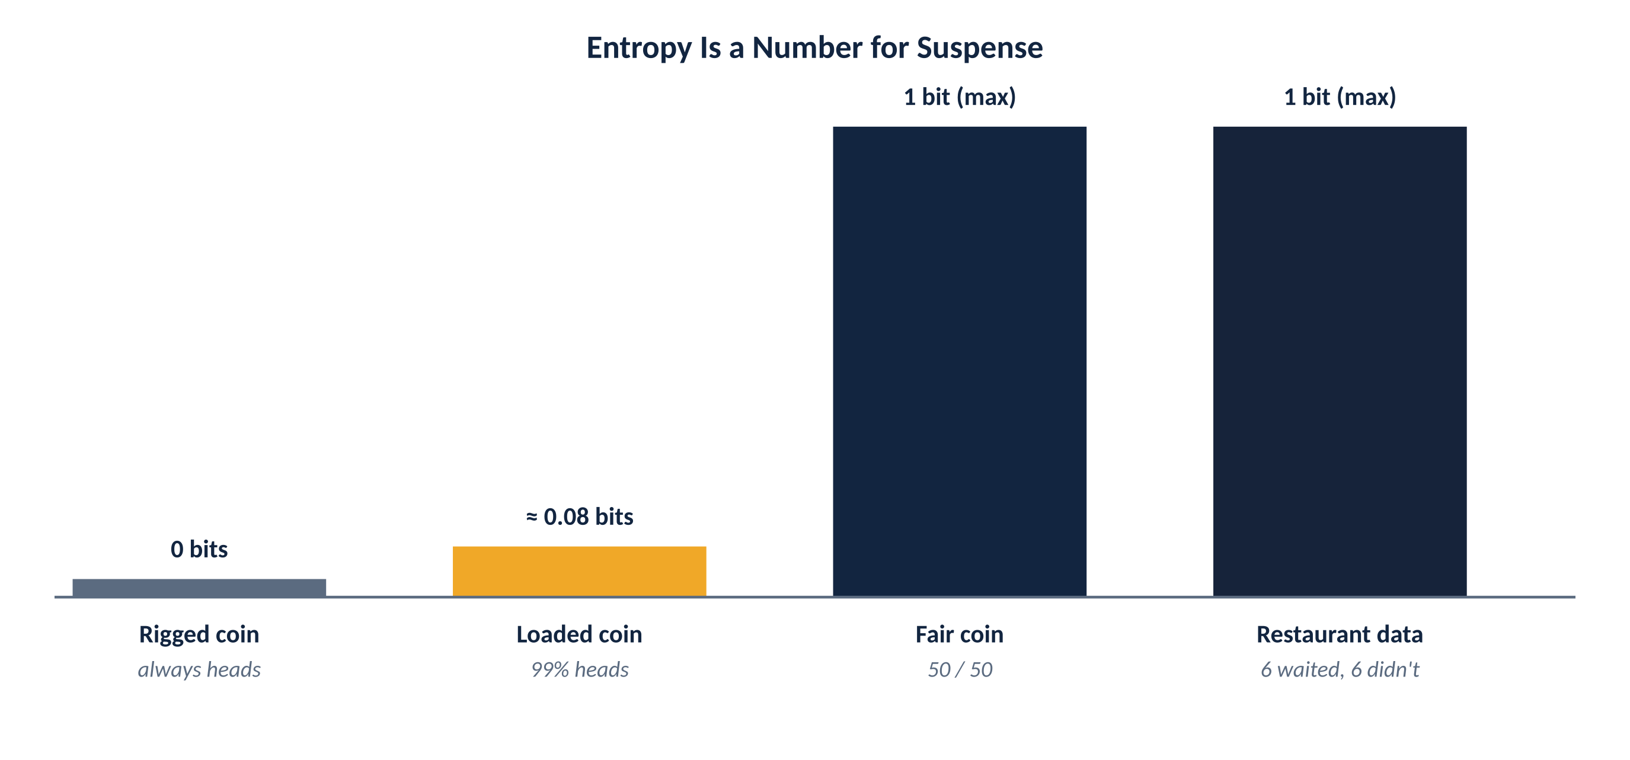
Figure 5. Suspense, in bits: a rigged coin has none; a fair coin has the most possible for a two-outcome guess.
Apply that same idea to our restaurant data: six people waited, six people didn't, a perfectly even split, so the suspense is at its maximum, exactly 1 bit, before we've asked a single question. Every question we ask in the decision tree is really just an attempt to reduce that suspense as much as possible, as quickly as possible — and that's precisely what information gain measures directly.

Information Gain: Picking the Most Useful Question
Gain(A) = B(p/(p+n)) − Remainder(A)
Information gain is the expected reduction in entropy from testing attribute A — exactly the “most useful question” rule from a good round of Twenty Questions.
Split the examples by some fact, add up how much suspense is left in each resulting group weighted by how big that group is (that's the Remainder), and subtract it from the suspense we started with. That difference is the gain. Plug in the restaurant numbers: for how-packed-is-it, the empty group and the some-people group both have zero suspense left — completely settled — and only the packed group still has any real uncertainty, giving a gain of about 0.541 bits. For what-type-of-food, every one of the four groups still has exactly the original fifty-fifty suspense, so the gain works out to precisely zero — mathematically confirming what we already sensed.
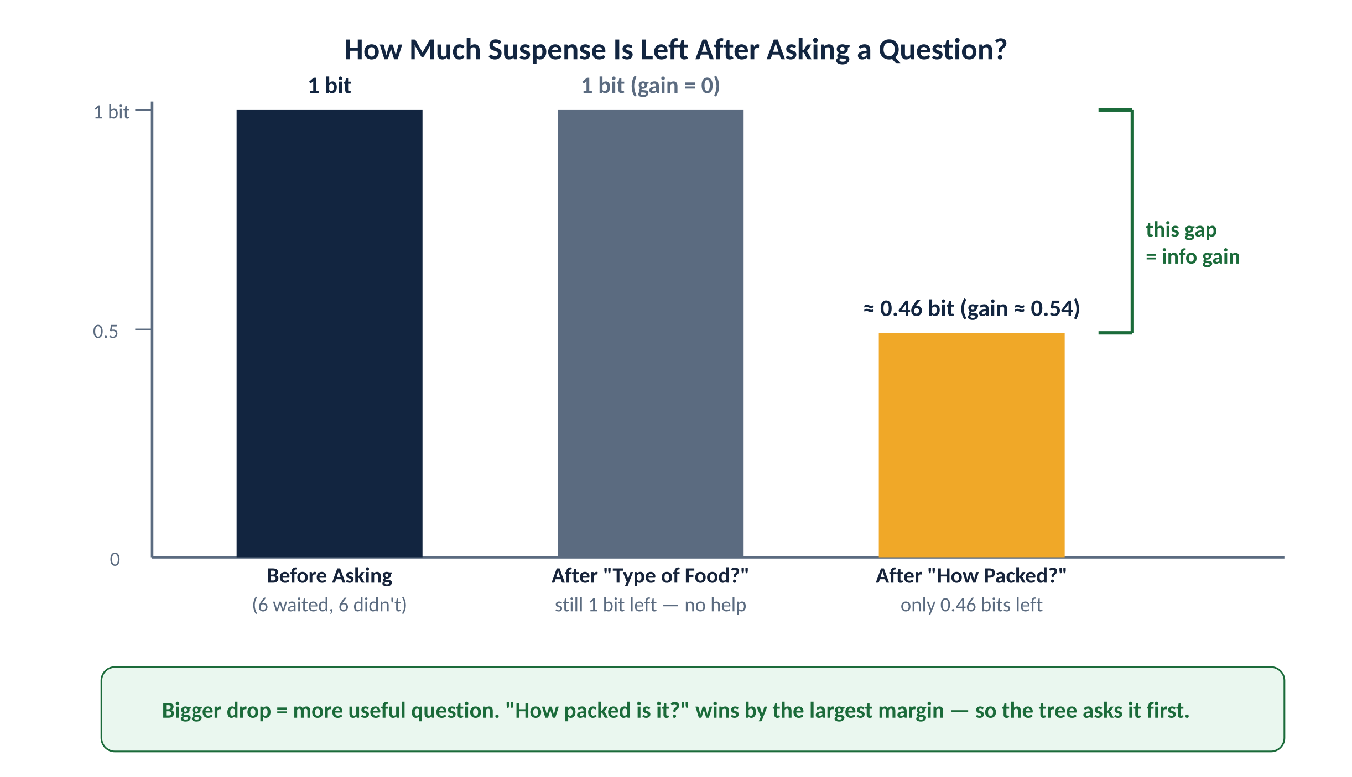
Figure 6. “How packed is it?” removes far more suspense than “what type of food?” — exactly what the information-gain arithmetic confirms.
How-packed-is-it turns out to have the biggest gain of any question available, exactly matching our earlier intuition, which is exactly why the tree-growing recipe picks it first as the root. Run the whole recipe on the twelve restaurant examples and the resulting tree only ever asks about how-packed-it-is, are-we-hungry, what-type-of-food, and is-it-the-weekend. It never bothers asking about rain or reservations, because it doesn't need to — and it even stumbles onto a genuinely new pattern nobody told it: this particular diner will wait for Thai food specifically on weekends. That's real induction happening, not memorization.

How Do We Know the Flowchart Is Actually Good?
Getting every practice question right proves nothing on its own. We measure something called a learning curve — sometimes nicknamed a “happy graph” because it usually climbs — which plots accuracy on brand-new cases as training-set size grows. On 100 restaurant-style examples, the curve climbs to about 95% correct on brand-new cases, and it still looks like it's climbing, suggesting more practice would help even further. Overfitting gets more likely the more facts you're tracking, and less likely the more real examples you have: a flowchart with room for a hundred questions has vastly more room to accidentally memorize coincidences than one with room for only five.

Pruning: Trimming Back a Flowchart That Got Too Fussy
Δ = ∑ₖ [(pₖ−p̂ₖ)²/p̂ₖ + (nₖ−n̂ₖ)²/n̂ₖ]
A statistical significance (χ²) test: a bigger deviation Δ from a boring, even split is stronger evidence a question genuinely mattered.
Pruning starts with the full, possibly-too-fussy flowchart, then works backward: at any question whose children are all leaves, ask whether it's actually telling us something real, or whether we just got fooled by a coincidence in a small batch of examples. We check this with a genuine statistical test, like an editor cutting a clever-sounding sentence that doesn't actually add meaning. We start by assuming the question is useless, work out what a boring, even split would look like under that assumption, and measure how far the real data deviates from that boring expectation. For the restaurant data's “type of food” question (four values, three degrees of freedom), that gap turns out to be small enough that we conclude it genuinely was useless — exactly matching what the information-gain arithmetic already told us — so we prune that whole branch away.
One important warning: don't stop growing the tree early just because no single question looks helpful at some point (called early stopping). That misses situations, like an even-or-odd pattern (XOR), where no single fact helps on its own, but two facts together reveal a lot. Grow the whole tree first, then go back and trim — never stop early.
⌘ IN PRACTICE sklearn's DecisionTreeClassifier(ccp_alpha=…) implements cost-complexity pruning — a regularization-flavored cousin of χ² pruning; grid-search ccp_alpha with cross_val_score to pick it, same idea as Section 19.4.
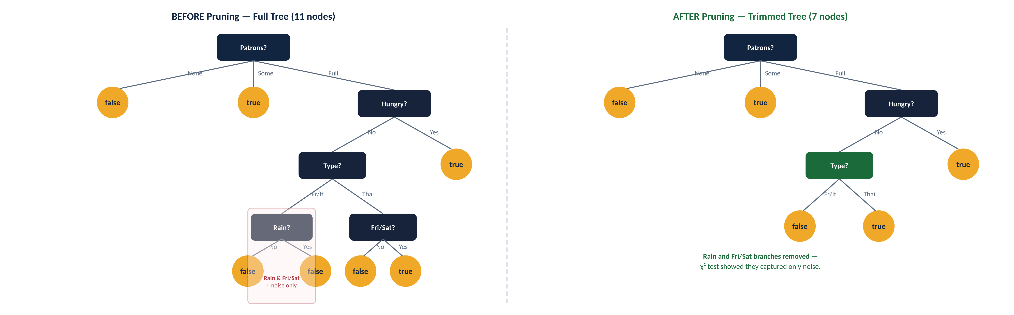
Figure 7. BEFORE/AFTER: Full 11-node tree (left) vs trimmed 7-node tree (right). The Rain and Fri/Sat branches failed the χ² test — they were detecting noise, not real patterns.

Making Flowcharts Work in the Real, Messy World
Real-world flowcharts need to handle a few more messy situations. For continuous measurements like weight or wait time, we ask a threshold question — “over 160 pounds, yes or no?” — rather than one branch per exact value, which would be useless. For facts with tons of possible categories, like zip code, we need to be careful too, since you can end up with an almost-useless branch for nearly every single example. And when we want to predict a number rather than a yes/no — a house's selling price, say — we use a regression tree, where each branch ends not with a flat answer but with a small formula. The umbrella name for both classification and regression trees together is CART.
Decision trees do have a real weak spot worth naming honestly: they can be unstable, meaning one single new example can completely change the very first question the tree asks, and cascade through the whole thing. That's exactly the problem random forests, in Section 19.8, are designed to fix.

Quick Recap: The Whole Recipe in Four Lines
• Compute entropy (suspense) for the current set of examples.
• For each remaining fact, compute information gain — how much that fact would reduce the suspense.
• Ask about the fact with the highest gain; repeat separately within each answer.
• Once the full tree is grown, prune back any branch whose gain doesn't survive a statistical significance check.

19.4 – 19.5 Model Selection, Optimization & Theory
If you're only ever going to build one single model, a simple practice-versus-exam split is enough. But real projects almost always compare several candidate models, or fiddle with several dials on the same model — called hyperparameters, meaning the model's own settings (like how aggressively to prune a tree), as opposed to the specific flowchart it lands on. Here's a sneaky trap: if you try one dial setting, peek at your final-exam score, try a different setting, peek again, no individual guess technically cheated — but you, the person running the experiment, quietly did cheat, just by repeatedly checking the answer key.
The fix is to keep three genuinely separate piles: a training set you actually study from, a validation (“dev”) set you use to decide between candidates and tune the dials, and a test set, locked away completely untouched until you're totally finished experimenting, for one final, honest number.

K-Fold Cross-Validation
What if you simply don't have enough data to carve out three genuinely separate piles? K-fold cross-validation squeezes more honest information out of limited data. Split the data into, say, five equal chunks, then run five separate rounds, each time practicing on four chunks and quizzing yourself on the one you held back, rotating which chunk gets held back each round. Average all five quiz scores together, and you get a far steadier, more trustworthy estimate than any single lucky or unlucky split would give you. Five and ten chunks are popular choices — reliable, at the cost of five to ten times the work. The extreme version, where you hold back just one single example at a time, is called leave-one-out cross-validation (LOOCV). One thing this doesn't replace: you still need a genuinely separate, untouched test set at the very end.
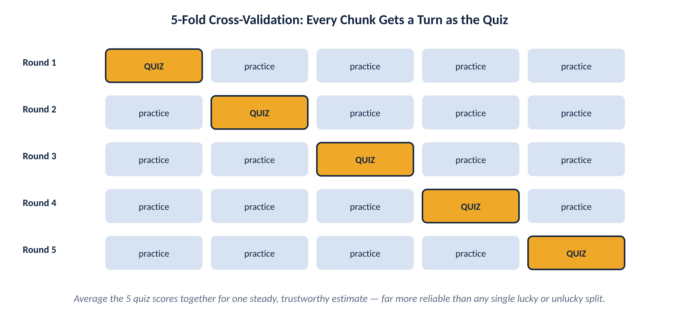
Figure 8. Five rounds, five different quiz chunks — every example serves as both practice and quiz material at some point.

FORMAL NOTATION · CROSS-VALIDATION(Learner, size, examples, k) returns an error rate
N ← number of examples
errs ← 0
for i = 1 to k:
validation_set ← examples[(i−1)×N/k : i×N/k]
training_set ← examples − validation_set
h ← Learner(size, training_set)
errs ← errs + ERROR-RATE(h, validation_set)
return errs / k
MODEL-SELECTION calls this once per candidate size/hyperparameter, keeps a running array err[size], and stops once err starts rising significantly — exactly the U-shaped curve in Figure 8.

⌘ IN PRACTICE sklearn.model_selection.cross_val_score(model, X, y, cv=5) or GridSearchCV(model, param_grid, cv=5) automate exactly this loop.

Picking the Right Amount of Complexity
The basic strategy: try models of increasing complexity, and pick whichever does best on your quiz set, not your practice set. For decision trees on the restaurant problem, you get a classic U-shape: quiz performance improves as the tree grows to a good size (around 7 questions), then gets worse again as it starts memorizing coincidences instead of real patterns. But here's a genuine surprise worth remembering: for some very flexible model types — big neural networks, forests of trees, boosted committees — quiz score keeps improving even long after the model has already gotten every practice example perfectly right. Why the difference? It seems to come down to what a model does with “extra room” once it's already gotten everything right. Some model types use that room almost randomly; others keep finding genuinely useful new patterns with it. Keep that exception in your back pocket — it matters again in Section 19.8.
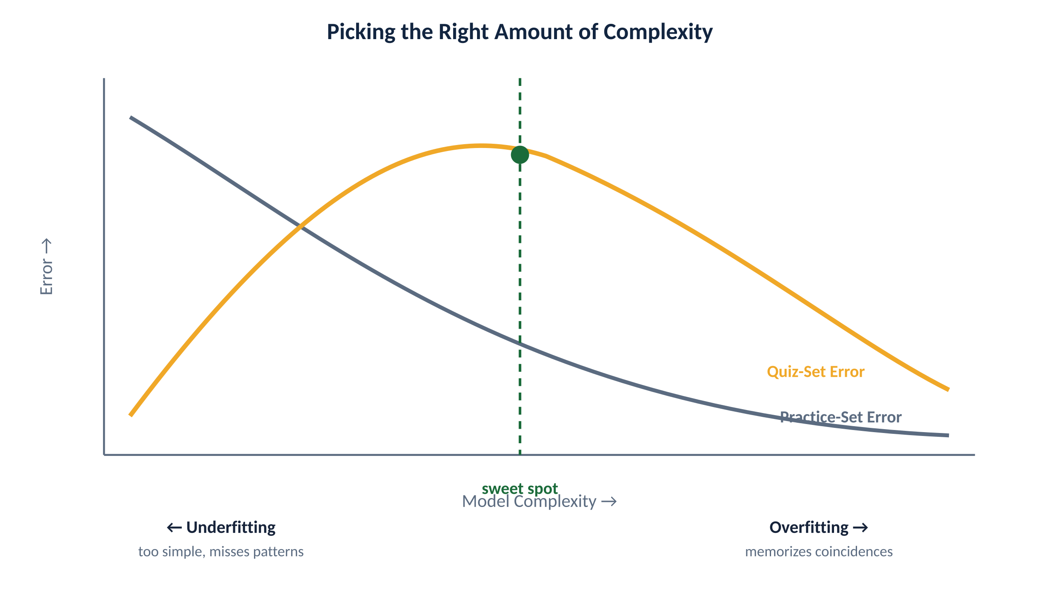
Figure 9. The classic dip-then-rise pattern: quiz-set error falls, hits a sweet spot, then rises again as the model starts memorizing coincidences.

Not All Wrong Answers Are Equally Bad
Minimizing mistakes (the fraction of wrong answers) is a fine starting point, but it quietly assumes every mistake costs the same, which is often unfair — the same way a doctor wouldn't treat “missed a serious illness” and “ordered one unnecessary test” as equally bad. We formalize this with a scoring rule, called a loss function: how-far-off (L₁), how-far-off-squared (L₂), or simple right-or-wrong (0/1 loss). At Northgate, missing a real appendicitis case is far more costly than a false alarm that leads to an extra hour of observation, and a well-designed scoring rule should say so explicitly — exactly like the textbook's own spam-filter example, where letting real spam through is treated as ten times worse than a false alarm.

Regularization: Building In a Preference for Simplicity
Cost(h) = EmpLoss(h) + λ · Complexity(h)
Total cost combines how wrong you were with how fancy your guess is — a built-in preference for simplicity.
Regularization bakes a penalty for fanciness directly into the scoring itself, rather than trying out several sizes and checking each against a quiz set. Lambda is a dial that says how much to penalize complexity — like a strict editor's threshold for cutting a clever-sounding but unnecessary sentence. For decision trees, the χ² pruning test is really this same idea in disguise. For curve-fitting, a natural fanciness score is how large the curve's coefficients are — keeping them small steers us away from wildly wiggly curves. We'll make this completely concrete with real numbers in Section 19.6.
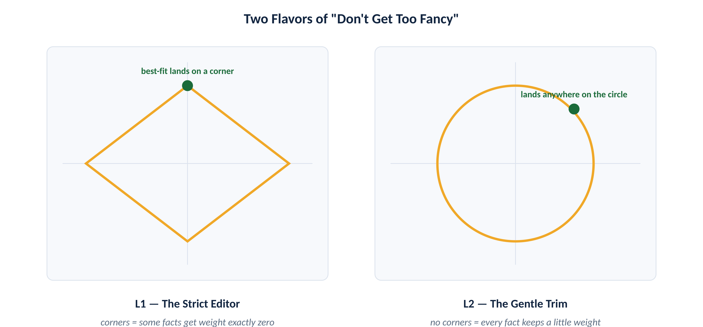
Figure 10. L1's diamond has corners sitting exactly on the axes, so the best fit often lands on one — zeroing out a weight entirely. L2's circle has no corners, so it rarely does.
⌘ IN PRACTICE sklearn.linear_model.Lasso (L1), Ridge (L2), and ElasticNet (both, blended by l1_ratio) implement exactly this. LogisticRegression(penalty='l1'|'l2', C=…) does the classification version — note C is the inverse of λ.

Searching for the Best Dial Settings
When there are several dials to tune at once, trying things one at a time isn't enough. Grid search tries every combination on a grid — fine for one or two dials. Random search tries random combinations instead, and often works surprisingly well with several dials or continuous ones. Bayesian optimization treats “which dial settings work best” as its own learning problem, balancing safe bets against novel ones. Population-based training trains a whole batch of models at once with different settings, then lets the successful settings “breed” into the next batch, borrowed from how evolution works.

PAC Learning — a Real, Calculable Guarantee
N ≥ (1/ε)·[ln(1/δ) + ln|H|]
The number of examples needed for a probably-approximately-correct guarantee, given tolerance ε, confidence 1−δ, and hypothesis space size |H|.
How do we know a learned rule is close to the truth, when we don't even know what the truth actually is? Think of a food inspector who can't possibly taste every dish a restaurant serves, but who can sample enough dishes to become genuinely, statistically confident about the whole kitchen. PAC learning (“probably approximately correct”) formalizes exactly that idea: a badly wrong rule has some real chance of accidentally looking right on a handful of examples purely by luck, but the more examples in a row it would have to accidentally get right, the smaller that lucky-streak chance shrinks — exponentially fast. This gives us a concrete, calculable formula for how many examples we need before we can trust a rule that's survived that many tests.
Here's the catch: if you allow literally any possible yes/no rule as a candidate, the haystack of candidates is so enormous that PAC-learning it would require seeing almost every possible situation — defeating the whole point. There are three ways out: bring real-world common sense to bear before you start; prefer simple, tidy explanations (Ockham's Razor again, now with real math behind it); or restrict yourself in advance to a smaller, sensible family of rules.
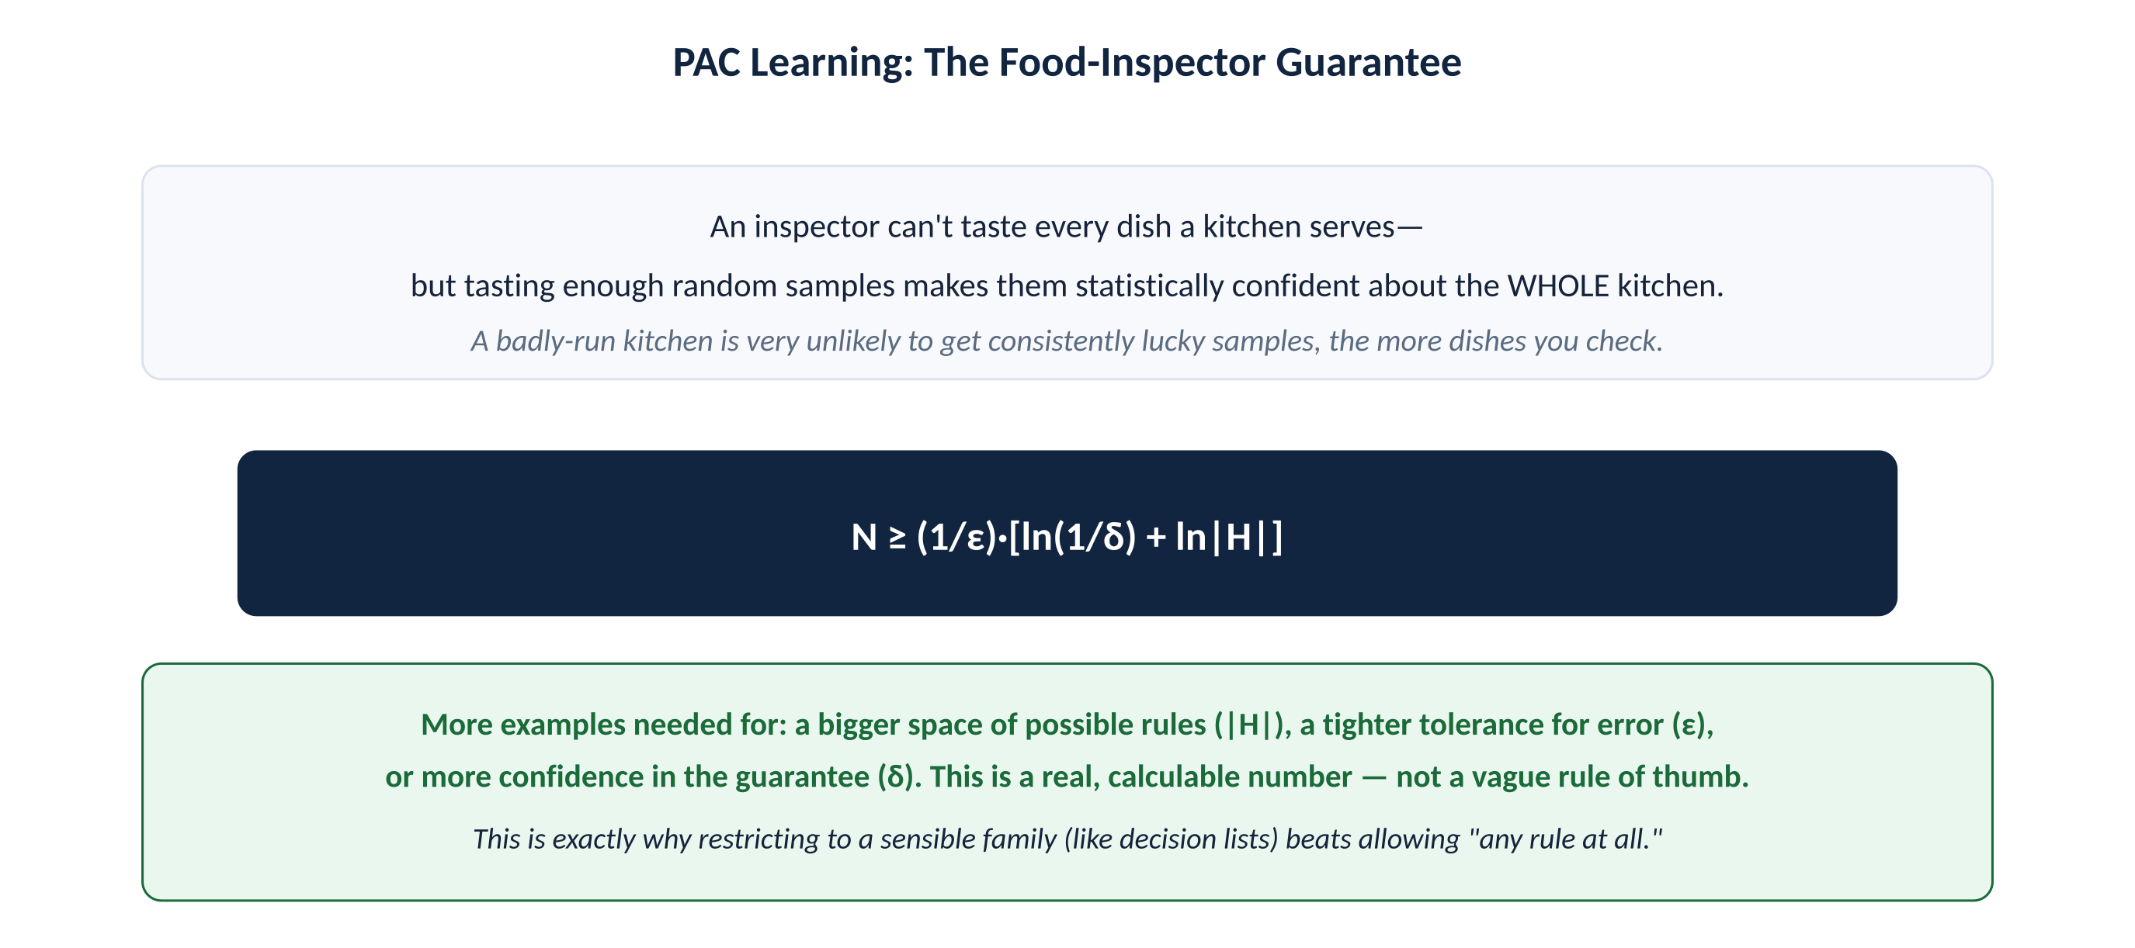
Figure 11. The PAC bound: more examples are needed for a bigger hypothesis space, a tighter error tolerance, or a stronger confidence guarantee.

FORMAL NOTATION · The Two Formal Assumptions Behind the Guarantee
Stationarity: P(Eⱼ) = P(Eⱼ₊₁) = P(Eⱼ₊₂) = …
i.i.d.: examples are independent and identically distributed
“i.i.d.” (independent and identically distributed) is the standard term you'll see in every ML paper for “future examples behave statistically like past ones, and don't influence each other.” It's the formal name for the assumption the food-inspector analogy is quietly leaning on.

A Sensible, Restricted Family: Decision Lists
WillWait ⇔ (Patrons=Some) ∨ (Patrons=Full ∧ Fri/Sat)
A decision list: a short, numbered list of if-this-then-that rules, checked top to bottom.
A decision list is just a short numbered list of simple rules, checked in order top to bottom, stopping at the first one that applies. Restrict each rule to mentioning only a handful of facts, and the whole family stays small enough to be genuinely learnable from a reasonable number of examples — exactly what makes it PAC-learnable, unlike “any rule at all.” The learning recipe is refreshingly simple: repeatedly find any short rule that perfectly explains some chunk of the remaining examples, add it to the list, and move on to what's left. Run this on the restaurant data and it does slightly worse than the full decision tree, but both comfortably clear 90% accuracy after 100 examples.

FORMAL NOTATION · DECISION-LIST-LEARNING(examples) returns a decision list, or failure
if examples is empty: return the trivial decision list "No"
t ← a test matching a nonempty subset examples_t of examples
such that members of examples_t are all positive or all negative
if there is no such t: return failure
o ← Yes if examples_t are positive, else No
return a decision list with initial test t, outcome o,
and remaining tests = DECISION-LIST-LEARNING(examples − examples_t)

Sample Complexity in Practice
• Bigger hypothesis space, or a stricter error tolerance, means needing more examples — and the relationship is exact, not a guess.
• Restricting to a sensible family (like k-DL decision lists) is what makes the required number of examples grow reasonably (polynomially) instead of explosively.

19.6 Linear Regression and Classification
We now set flowcharts aside and pick up an idea that's centuries old: drawing the best-fit straight line through a scatter of points.

Fitting a Straight Line Through the Data
h_w(x) = w₁x + w₀ Loss(h_w) = ∑(yⱼ − h_w(xⱼ))²
Fitting a line means finding the weights that minimize the total squared miss across every data point.
A straight-line guess is exactly what it sounds like: predicted value equals some slope (w₁) times the input, plus a starting point (w₀). Fitting a line to data means finding the weights that minimize the total “miss” across every data point, squaring each miss so big misses count extra — the same intuition as a golf score that punishes a bad hole more than a slightly-off one. Because that total-miss score forms a smooth bowl shape with exactly one lowest point — not a bumpy hillside with multiple dips — basic algebra hands us the exact best answer directly, no trial and error required. For a real example from the textbook, Berkeley, CA house prices against square footage in 2009, the best-fit line comes out to about $246,000 plus roughly 23 cents per extra square foot.
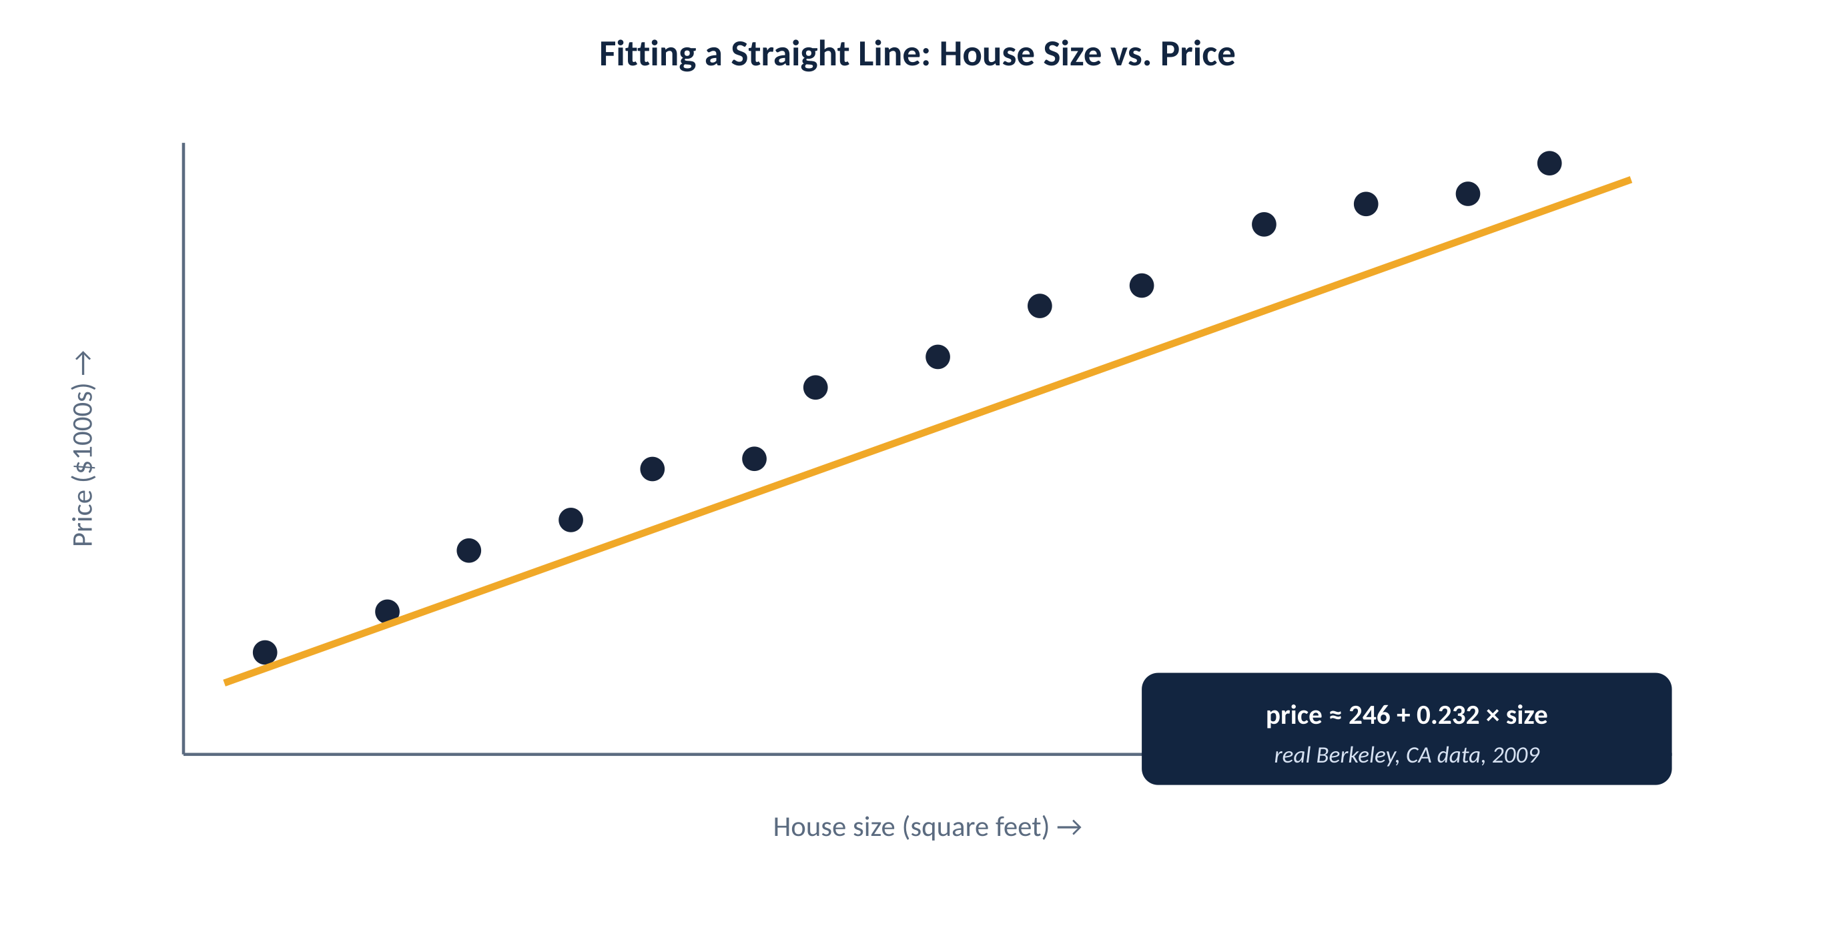
Figure 12. Real house-price data from Berkeley, CA (2009) with its best-fit line — the line that minimizes total squared miss across every point.

FORMAL NOTATION · Closed-Form Solution (Univariate)
w₁ = [N·∑xⱼyⱼ − (∑xⱼ)(∑yⱼ)] / [N·∑xⱼ² − (∑xⱼ)²]
w₀ = [∑yⱼ − w₁·∑xⱼ] / N
Set ∂Loss/∂w₀ = 0 and ∂Loss/∂w₁ = 0 and solve the resulting 2×2 linear system — this is exactly where these two closed forms come from.

⌘ IN PRACTICE sklearn.linear_model.LinearRegression() solves the closed form directly (via the normal equation / SVD) rather than iterating — no learning rate to tune, since there's no local-minima risk for plain least squares.

Gradient Descent: Walking Downhill in the Fog
wᵢ ← wᵢ − α ∂Loss(w)/∂wᵢ
α is the learning rate — how big a step to take downhill each time.
Gradient descent is exactly like walking downhill in thick fog: you can't see the bottom of the valley from where you're standing, but you can feel which direction slopes downward right under your feet, take a small step that way, and repeat. That's the whole idea: nudge each dial a little in whatever direction currently reduces the total miss, and keep doing that until you stop improving.
Batch gradient descent checks every single data point before each step — careful and guaranteed to work, but slow if there's a huge pile of data. Stochastic gradient descent (SGD) checks just one random example per step — much faster, great for a live, ever-changing stream of data. In practice we usually split the difference with minibatch SGD, checking a small batch each time (say 100 of 10,000 examples), which cuts the work per step by a hundred while needing only about ten times more steps overall — a clear net win.
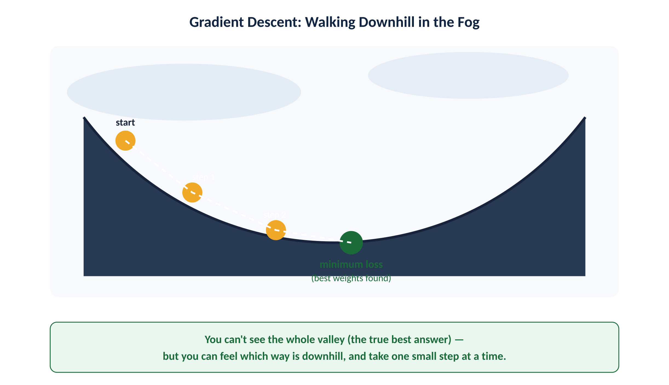
Figure 13. Gradient descent: you can't see the whole valley, but you can feel which way is downhill and take one step at a time.

FORMAL NOTATION · Cost Per Step
Batch: O(N · n) per step (N examples, n features) — one full pass every step
Minibatch: O(m · n) per step (m ≪ N) — the standard choice in practice
Stochastic: O(n) per step — noisiest, but cheapest and adapts online
This is why SGD variants (not plain batch descent) train almost every large-scale model in practice, including the neural networks in Chapter 22.

⌘ IN PRACTICE sklearn.linear_model.SGDRegressor / SGDClassifier expose the learning rate, batch behavior, and regularization directly; most other sklearn estimators hide the optimizer and just solve the closed form or use LBFGS internally.
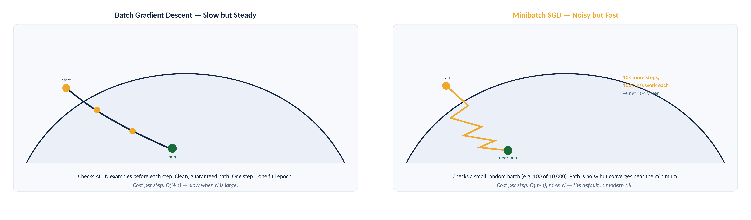
Figure 14. BEFORE/AFTER: Batch gradient descent (left) takes a smooth, clean path to the minimum but checks all N examples per step. Minibatch SGD (right) zigzags noisily but arrives 10x faster — the standard choice in modern ML.

What If There Are Several Facts, Not Just One?
predicted value = w₁·fact₁ + w₂·fact₂ + … + baseline
Multivariable regression: the same walking-downhill trick, just nudging every weight at once.
Stretching this to handle several facts at once turns out to be almost anticlimactic: the predicted value is just each fact multiplied by its own importance weight, all added together, plus a baseline. The walking-downhill trick barely changes — at each step, nudge every weight a little, all at once. There's also a tidy algebra shortcut (the normal equation) for those who'd rather solve it directly. But there's a genuinely new risk worth knowing: with lots of facts, some completely irrelevant one can look useful purely by coincidence — a kind of overfitting that can sneak into even a simple straight-line model. That's exactly why regularization (L1's “strict editor” vs. L2's “gentle trim,” from Section 19.4) matters here too.

FORMAL NOTATION · The Normal Equation (Matrix Form)
h_w(x) = w·x = wᵀx (x₀ ≡ 1 folds in the intercept)
w* = (XᵀX)⁻¹ Xᵀ y (XᵀX)⁻¹Xᵀ is the pseudoinverse of X
X is the data matrix (one row per example, one column per feature). Computing this directly costs O(n³ + n²N) for n features and N examples — fine for dozens of features, why we switch to gradient descent once n or N gets large.

Turning a Line Into a Yes/No Decision
wᵢ ← wᵢ + α (y − h_w(x)) · xᵢ
The perceptron learning rule — nudge weights only on a mistake; correct predictions leave w unchanged.
A straight line can classify just as naturally as it can predict a number: draw a dividing line through the data, and whichever side a new case falls on tells you the guess. This is called the perceptron. It's guaranteed to find a perfect dividing line — but only if the yes's and no's can actually be cleanly separated by a straight line in the first place. When real, messy data can't be cleanly separated, this simple rule can flail forever, hitting a good-enough answer occasionally but never settling on it. The fix: gradually take smaller and smaller steps over time, like slowing your car down as you get close to parking rather than always braking at full force.

A Dimmer Switch Instead of an On/Off Light
Logistic(z) = 1 / (1 + e⁻ᶻ) h_w(x) = Logistic(w·x)
The sigmoid function softens a hard yes/no into a smooth confidence between 0 and 1.
The plain on/off perceptron has real problems: it's twitchy to train, and it always announces total, unwavering confidence — a flat yes or no — even for cases sitting right on the fence. Logistic regression fixes both by replacing the on/off switch with a dimmer switch: a smooth, gradual confidence level between 0% and 100%. Fifty percent right at the boundary, closer to certain the further you are from it. That's directly useful at Northgate: instead of a flat yes-or-no on appendicitis, this kind of model hands Dr. Okafor an actual confidence level to weigh against everything else he knows. It behaves far more sensibly than the plain on/off version on messy, real-world data — which is exactly why it's one of the most widely used tools in medicine, credit scoring, and public health.
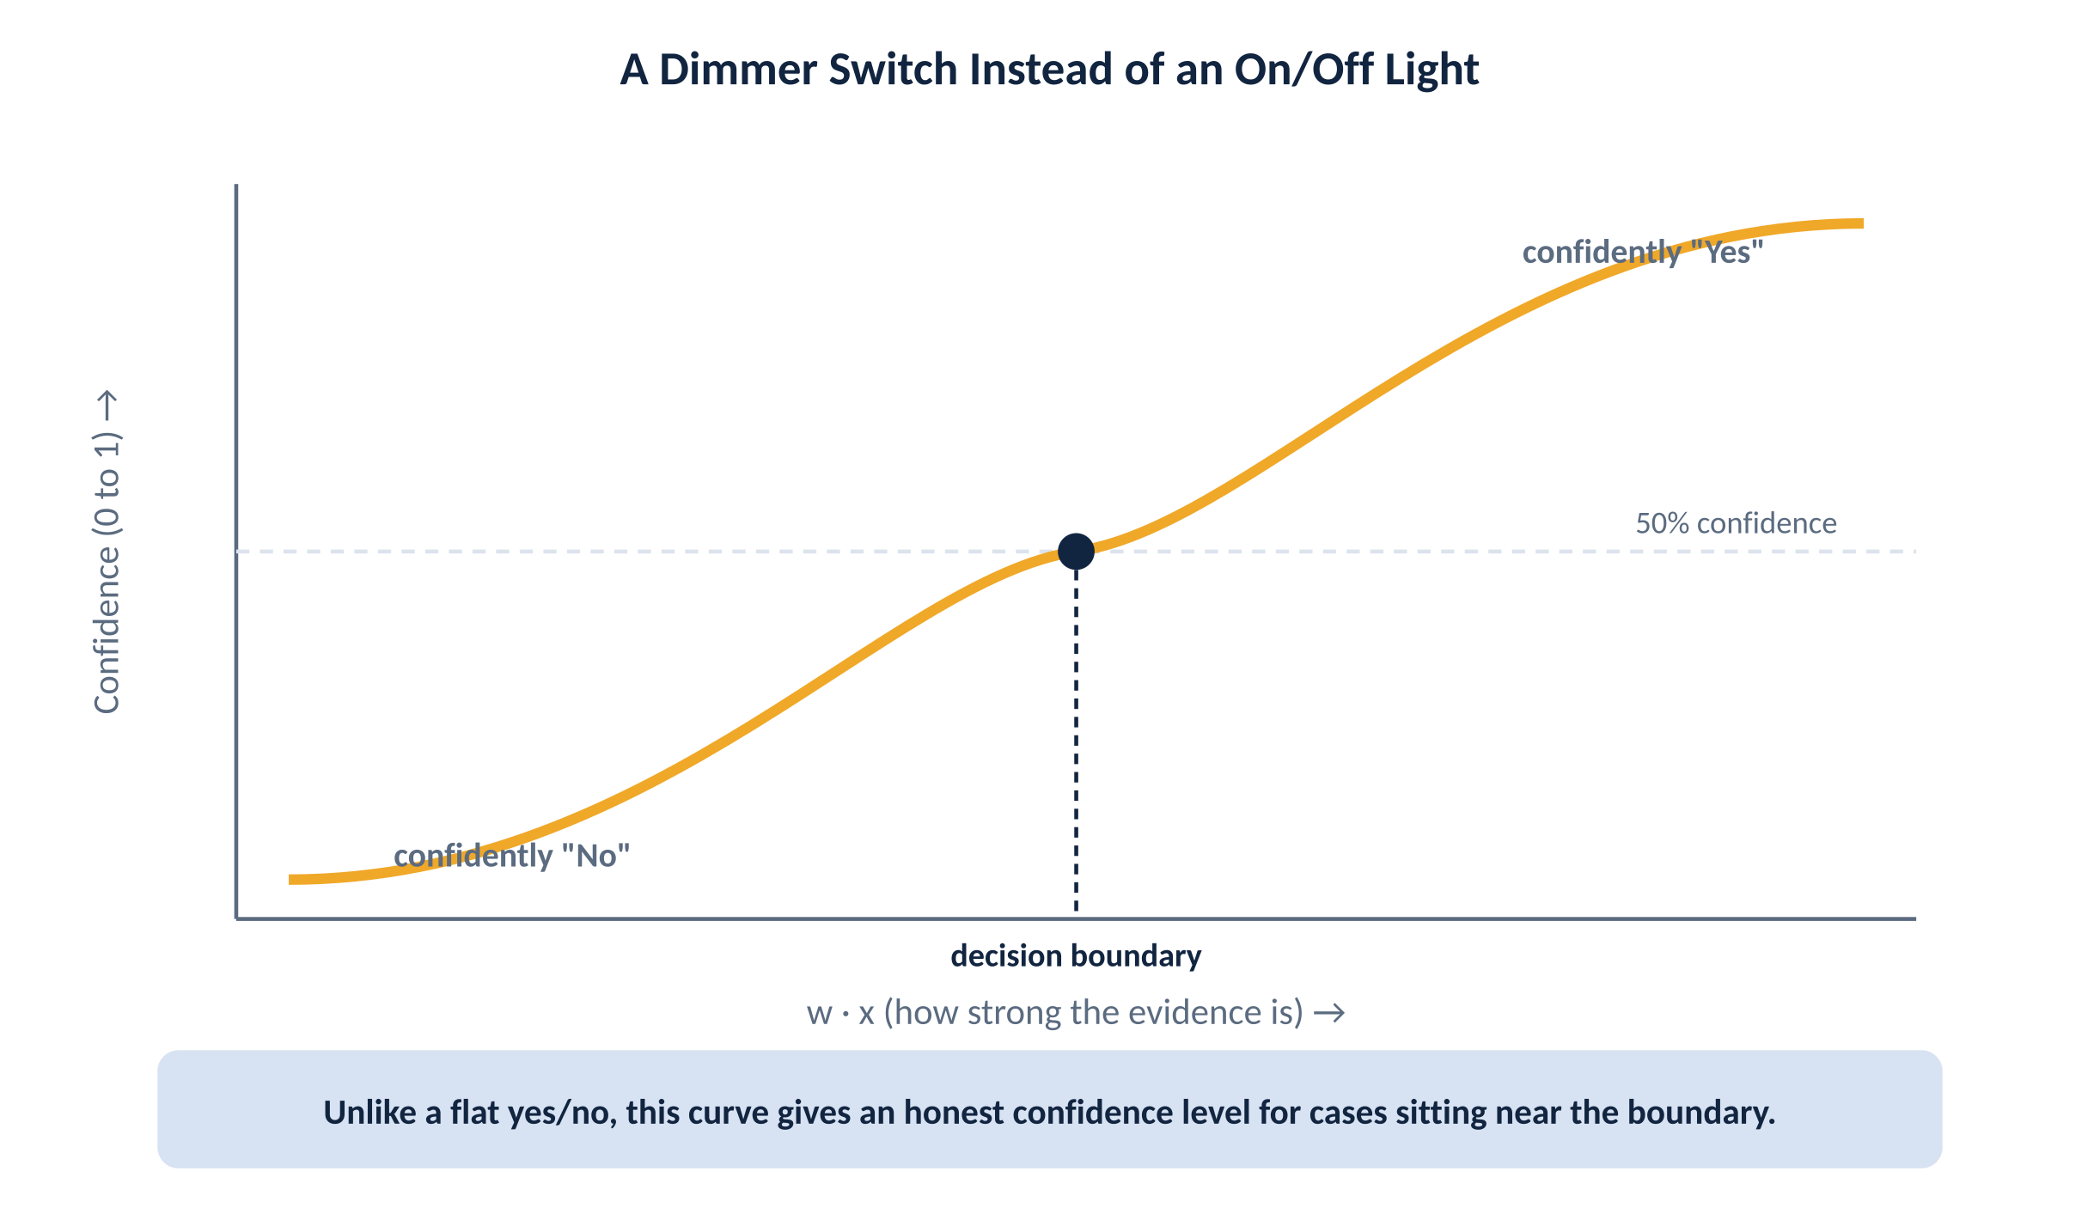
Figure 15. Logistic regression softens the hard yes/no line into a smooth confidence level between 0% and 100%.

FORMAL NOTATION · The Gradient (via the Chain Rule)
g'(z) = g(z)(1 − g(z)) (the logistic function's convenient derivative)
wᵢ ← wᵢ + α (y − h_w(x)) · h_w(x)(1−h_w(x)) · xᵢ
Same update shape as the perceptron rule, with one extra factor — h(x)(1−h(x)) — coming straight out of differentiating the sigmoid. This is the update your autograd library computes automatically.

⌘ IN PRACTICE sklearn.linear_model.LogisticRegression() — despite the name, this is a classifier, not a regressor; predict_proba(x) returns the sigmoid confidence directly, predict(x) applies the 0.5 threshold for you.
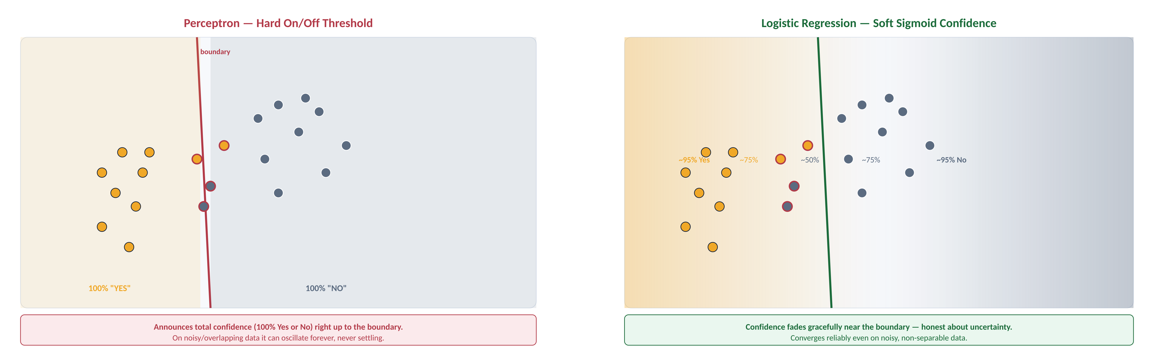
Figure 16. BEFORE/AFTER: Perceptron (left) draws a hard boundary and announces 100% confidence everywhere — and flails on noisy overlapping data. Logistic regression (right) gives a gradient of confidence that fades honestly near the boundary.

Which Should I Reach For?
• One input, want a simple explainable formula → straight-line regression, solved exactly with algebra.
• Many inputs, or no closed-form shortcut → gradient descent, walking downhill one small step at a time.
• Yes/no answer, and you want honest confidence levels, not just a flat guess → logistic regression.

19.7 Nonparametric Models
Every method so far boils training data down into a small, fixed-size summary, and then the original data can be thrown away — a parametric approach. This section takes the opposite philosophy: keep every example around, and let the effective complexity of the model grow along with how much data you actually have.

“Who Does This Most Resemble?”
The most basic just-keep-everything idea is exact lookup: store every past case, and if a new case exactly matches one you've seen, return that answer — which fails constantly, since almost no new case will be an exact match. k-nearest-neighbors (k-NN) improves this: find the handful of most similar past cases, measuring similarity in some sensible fact-by-fact way, and for a yes/no decision, go with whatever the majority of them decided — like asking a small panel of similar past patients what actually happened to them. For predicting a number, average what those similar cases turned out to be instead of voting.
Compare against just the single most similar case, and you're at the mercy of one weird outlier. Compare against five, and that noise mostly washes out; compare against far too many, and you start blurring together cases that genuinely aren't similar anymore. Exactly the same practice-quiz trick from Section 19.4 tells you the right number to compare against.
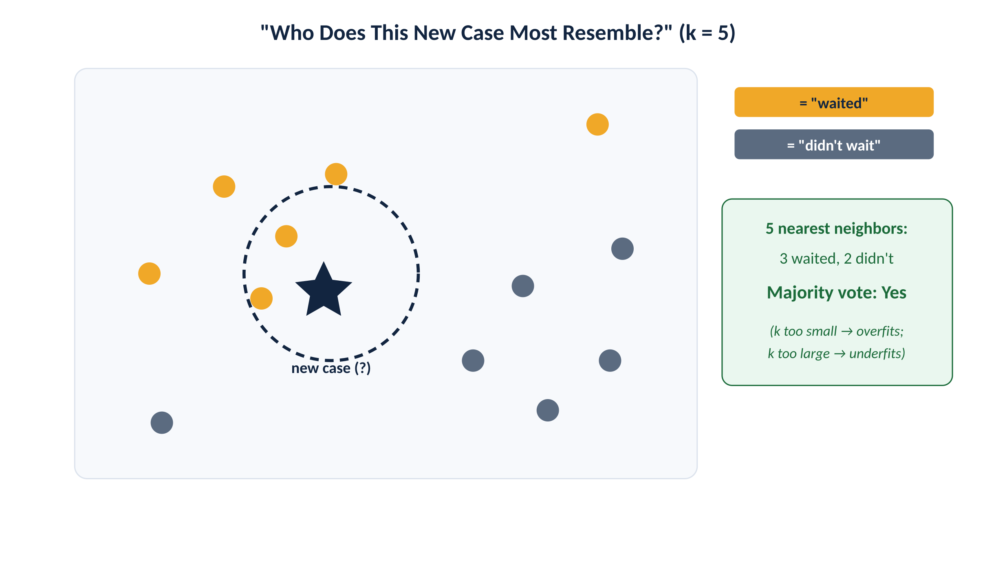
Figure 17. k-nearest-neighbors: find the 5 most similar past cases and take their majority vote.

FORMAL NOTATION · Minkowski Distance (Lₚ norm)
Lₚ(xⱼ, x_q) = ( ∑ᵢ |xⱼ,ᵢ − x_q,ᵢ|ᵖ )^(1/p)
p = 2 → Euclidean distance p = 1 → Manhattan distance
Brute-force prediction costs O(N·n) per query (N stored examples, n features) — the reason production systems use KD-trees or ball trees (O(log N) average, low dimensions) or approximate nearest-neighbor libraries like FAISS/Annoy at scale (high dimensions, where KD-trees degrade toward brute force — the “curse of dimensionality”).

⌘ IN PRACTICE sklearn.neighbors.KNeighborsClassifier(n_neighbors=5, weights='distance') — weights='distance' has closer neighbors vote more heavily, a common refinement over the plain majority vote described above.
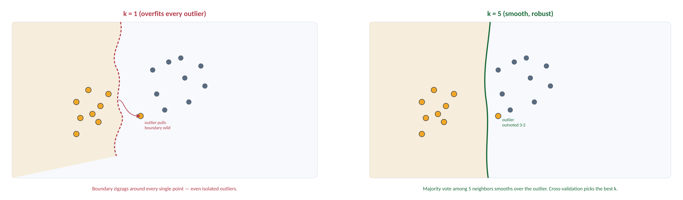
Figure 18. BEFORE/AFTER: k=1 (left) overfits every outlier, creating a jagged boundary; k=5 (right) smooths it out. The same cross-validation trick from Section 19.4 picks the best k.

Bending a Straight Line Into a Curved One
One more idea worth knowing: rather than just any straight dividing line that happens to separate two groups, a support vector machine (SVM) finds the one with the widest possible “safety margin” on both sides — like parking exactly in the center of a parking space. Real data is almost never perfectly tidy, so the soft-margin classifier allows a few exceptions to sit on the wrong side, with a penalty proportional to how far out of place they are. The truly clever trick, called kernelization, mathematically “lifts” the data into a richer, higher-dimensional view where a straight line actually can separate things cleanly — without ever literally computing that richer view directly. That's how a method built entirely on straight lines underneath can still draw genuinely curved boundaries in the original, everyday view of the data.

FORMAL NOTATION · Common Kernels
Linear: K(xᵢ,xⱼ) = xᵢ·xⱼ
Polynomial: K(xᵢ,xⱼ) = (xᵢ·xⱼ + c)^d
RBF: K(xᵢ,xⱼ) = exp(−γ‖xᵢ−xⱼ‖²) (Gaussian — the default in practice)
Training an SVM by the classic quadratic-programming formulation scales roughly O(N²) to O(N³) in the number of examples — excellent accuracy on small-to-medium N, but why SVMs are rarely reached for once N runs into the millions (gradient-based methods scale much better there).

⌘ IN PRACTICE sklearn.svm.SVC(kernel='rbf', C=…, gamma=…) — C trades margin width against margin violations (small C = wider margin, more tolerance for misclassified points).

Choosing k, and When Nonparametric Models Shine
• Too small a k (like k=1) overfits to individual outliers; too large a k underfits and blurs together dissimilar cases.
• Nonparametric methods shine with lots of data and not much prior sense of the right formula — they let the data speak for itself.
• Downside: they usually give you a function h that's more expensive to run at prediction time, since it has to compare against stored examples.

19.8 Ensemble Learning
There are two genuinely distinct reasons a committee of models tends to beat a single expert model. First, a committee can simply see more: one straight dividing line can only ever separate the world one simple way, but combine three of them with an “all three must agree” rule, and you can carve out a triangular region that no single line could ever draw alone — at only three times the cost. Second, a committee cancels out noise: imagine five independent doctors, each individually right 75% of the time on their own. Put them to a majority vote and, if their mistakes are genuinely independent, the group is right 89% of the time; with 17 such doctors, 99%. Real models share some of the same blind spots, so it's never quite this perfect — but even partly-independent members still help a lot.
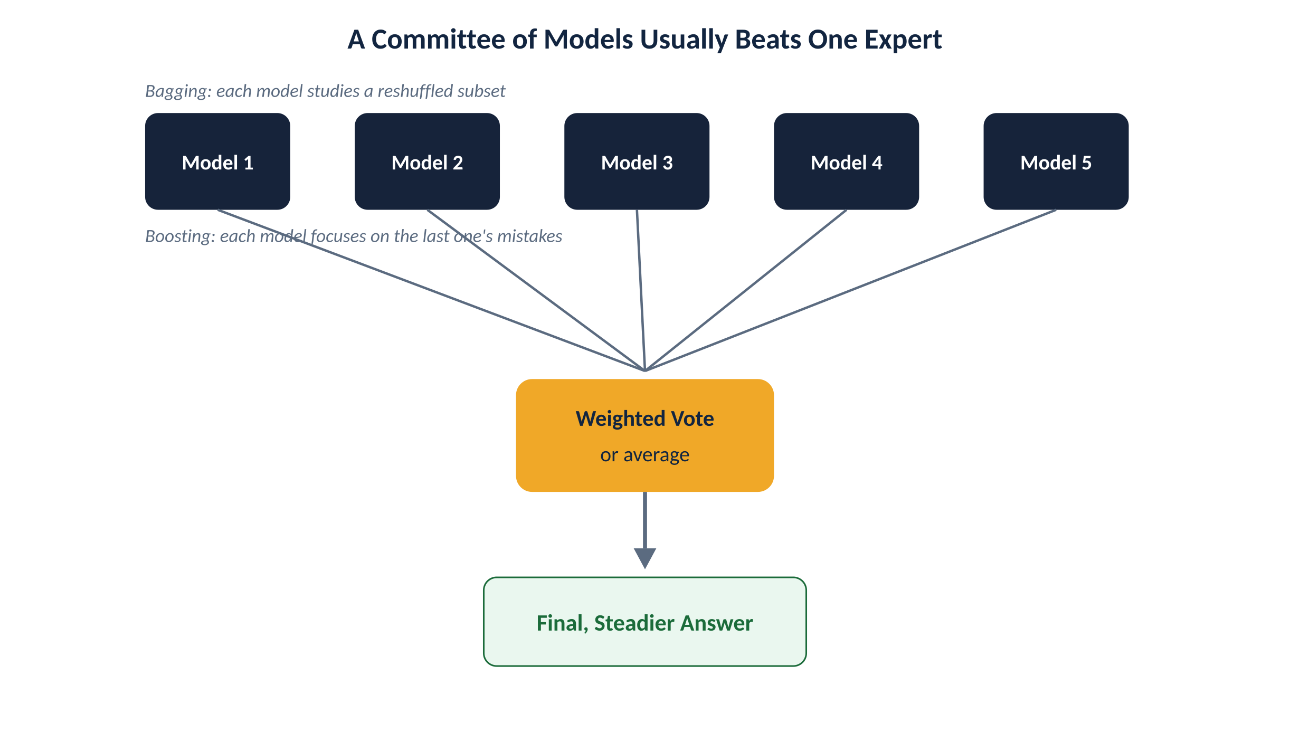
Figure 19. Bagging trains members on reshuffled data in parallel; boosting trains members sequentially, each one focused on the previous one's mistakes.

Bagging and Random Forests
Bagging (short for bootstrap aggregating) generates several distinct training sets by sampling with replacement from the original data — like handing several groups of students the same pool of practice questions, but letting each group study a randomly reshuffled, overlapping subset. Combine their final answers by majority vote (classification) or averaging (regression). This is especially useful for decision trees, since a single tree is famously unstable.
Random forests push this further with a second, independent source of randomness: at every question in every tree, only let it consider a random handful of facts rather than all of them. This stops every tree from converging on the exact same first question. A nice bonus: you get a free built-in practice-quiz, called the out-of-bag error, using only the trees that happened to skip a given example during their own training.
It's been mathematically proven (Breiman, 2001) that, in almost every case, adding more trees to a random forest only ever helps or holds steady — it never starts actively hurting, unlike a single overgrown flowchart. Random forests were the most popular approach among winners of major data-science competitions from 2011 through 2014, and remain a strong, reliable default today across finance, mechanical diagnostics, and medicine.
⌘ IN PRACTICE sklearn.ensemble.BaggingClassifier(base_estimator=…, n_estimators=…) for plain bagging; RandomForestClassifier(n_estimators=100, max_features='sqrt', oob_score=True) for random forests — oob_score=True gives you the out-of-bag error for free.
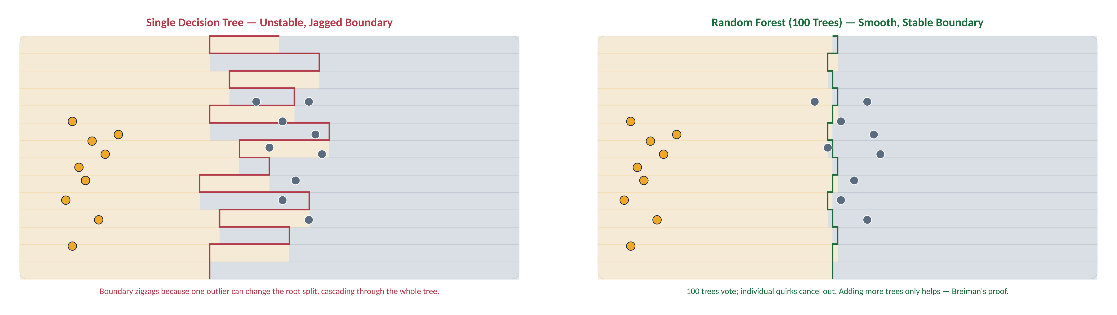
Figure 20. BEFORE/AFTER: Single decision tree (left) draws a jagged, unstable boundary that overreacts to individual outliers. Random forest of 100 trees (right) smooths this into a reliable boundary — individual quirks cancel out.

Stacking: A Committee of Genuinely Different Experts
Bagging combines many copies of the same kind of model. Stacking instead combines genuinely different kinds of models — say a curve-fitter, a dimmer-switch classifier, and a flowchart — all trained on the same practice data. Using held-out validation data, you add each expert's guesses as extra columns, and train one final “manager” model whose whole job is deciding how much to trust each underlying expert. It might learn a simple weighted average, or something more nuanced, like trusting the flowchart more specifically when the wait time is long. This is a favorite technique among winning teams in real data-science competitions, since everyone can perfect their own expert model independently before combining at the end.
⌘ IN PRACTICE sklearn.ensemble.StackingClassifier(estimators=[('svm',…),('tree',…)], final_estimator=LogisticRegression()).

Boosting: Learning From Your Own Mistakes, on Repeat
h(x) = ∑ᵢ zᵢ hᵢ(x)
The final ensemble is a weighted vote, where more accurate models earn more say.
Boosting works like a good tutor: quiz the student, notice which specific problems they got wrong, and focus the very next study session heavily on exactly those problems. Concretely: start with every practice example weighted equally, train one simple model, then bump up the weight on whatever it got wrong and lower the weight on whatever it got right. Train the next model on this reweighted set, and repeat. This has to happen one round at a time, unlike bagging.
Here's a remarkable, provable guarantee behind the AdaBoost algorithm: even if each individual model is only barely better than a coin flip (a weak learner), boosting enough of them together can drive practice-set mistakes all the way down to zero, regardless of how weak any single model in the committee is on its own.
On the restaurant data, a single simple rule (just one question, called a decision stump) gets only 81% accuracy alone. Boost five of them together and accuracy jumps to 93%. By around twenty stumps, the committee gets a perfect 100% on the practice set. Here's the genuine surprise: real-world accuracy keeps climbing well past that point — rising from 95% at 20 stumps to 98% around 137 stumps, before eventually settling back down. Ordinary common sense (“don't add complexity you don't need”) would predict this should hurt, not help. One explanation: extra committee members let the group become more confident right near the boundary between yes and no, and that added confidence pays off on brand-new cases.
Gradient boosting is a smoother cousin: instead of just reweighting wrong examples, each new model chases the specific gap between the right answers and the committee's current best guess. It powers a huge share of industrial-scale models and competition-winning entries today (the popular XGBoost package implements it).

FORMAL NOTATION · ADABOOST(examples, L, K) returns a hypothesis
w ← vector of N example weights, initially all 1/N
for k = 1 to K:
h[k] ← L(examples, w)
error ← ∑ⱼ w[j] for j misclassified by h[k]
if error > 1/2: break
error ← min(error, 1−ε)
for j: if h[k](xⱼ) = yⱼ: w[j] ← w[j] · error/(1−error) // shrink correct ones
w ← NORMALIZE(w)
z[k] ← ½ log((1−error)/error) // this model's vote weight
return the function x → ∑ᵢ zᵢ hᵢ(x)
Notice what actually happens on a mistake: nothing is directly increased. Only correctly-classified weights get multiplied down by error/(1−error) < 1, and then NORMALIZE rescales everything back to sum to 1 — which relatively inflates the misclassified examples' share. zᵢ is large (confident vote) when error is small, and approaches 0 as error approaches ½ (a coin-flip model earns almost no vote).

⌘ IN PRACTICE sklearn.ensemble.AdaBoostClassifier(n_estimators=50) and GradientBoostingClassifier(learning_rate=0.1, n_estimators=100) implement these directly; xgboost.XGBClassifier / lightgbm.LGBMClassifier are the industrial-strength gradient-boosting libraries referenced in the text.

Four Recipes at a Glance
• Bagging: many copies of one model, resampled data, combined by vote or average.
• Random forests: bagging plus randomly limiting which facts each tree may consider.
• Stacking: genuinely different model types, combined by a trained manager model.
• Boosting: models trained sequentially, each one focused on the last one's mistakes.

19.9 Developing Machine Learning Systems
The math is only half the job. This section is deliberately practical: how do real machine learning projects actually get built, from figuring out the right question to ask, through collecting and cleaning data, choosing and explaining a model, all the way to keeping a live system healthy after it ships.
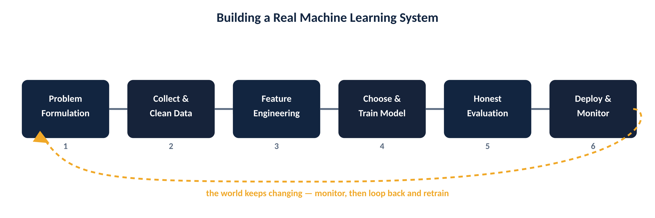
Figure 21. Building a real system is a loop, not a straight line — monitoring after deployment feeds back into retraining.

Get the Question Right Before You Touch Any Model
Before writing a single line of model code, get painfully specific. “Help patients understand their risk” is too vague to build against; “predict, from vitals and labs, the chance a patient needs urgent surgical evaluation” is specific enough to actually engineer toward. Your scoring rule is usually only a stand-in for your real goal, not identical to it — predicting labels correctly is a proxy for the actual goal of better outcomes. Even the “answer key” itself might be wrong sometimes: patient charts, like any real-world records, can have honest mistakes and inconsistencies baked in, and a careful project plans for that.

Data: Where It Comes From, and Healthy Skepticism About It
For every column of data, know exactly what it means, where it came from, and its history (data provenance) — a well-organized pipeline matters more than which fancy method you pick. Watch for lopsided data: a fraud data set with ten million ordinary transactions and a thousand fraudulent ones lets a model that always guesses “ordinary” claim 99.99% accuracy while being completely useless. Fixes include showing the model more of the rare cases, fewer of the boring ones, or penalizing a missed rare case more heavily. Watch for outliers too — curve-fitting methods get thrown badly off by them, while flowchart-style methods handle them more gracefully.

Choosing the Right Facts to Feed the Model
Pedro Domingos put it plainly: “easily the most important factor is the features used,” not the fancy method itself. Bucketing turns an exact number into a handful of ranges (our own WaitEstimate categories already do this). One-hot encoding turns a category like sunny/cloudy/rainy into three separate yes/no facts. And genuine common sense lets you invent brand-new facts — a plain calendar date becomes far more useful once you note whether it's a weekend or holiday. At Northgate, a derived fact like “hours since symptoms started” often carries more signal than any single raw number.

Grading a Classifier Honestly
A single “percent correct” number can hide a lot. A false alarm means flagging something normal as the thing you're hunting for. There's always a tradeoff between false alarms and missed real cases. An ROC curve plots every possible tradeoff point at once; the AUC boils that whole chart down to one summary number. A full confusion matrix — showing exactly which categories get confused with which other categories — reveals things a single accuracy score never could, like “appendicitis” specifically getting confused with “stomach flu” more often than you'd want.
⌘ IN PRACTICE sklearn.metrics: confusion_matrix(), roc_curve(), roc_auc_score(), and classification_report() (precision/recall/F1 per class) are the standard first calls after any classifier finishes training.

Two Different Flavors of “I Trust This”
A model is interpretable if you can look directly at the model itself and understand why it landed on a particular answer — flowcharts and straight-line models are naturally like this. A model is explainable if some separate, after-the-fact process can explain a specific decision in plain terms, even when the underlying model genuinely is a black box, like a complex neural network. Both matter, and some regulations (like the EU's GDPR) legally require certain systems to provide explanations, no matter what's running underneath.

Shipping It, Watching It, and Keeping It Healthy
Real users will bring situations your testing never covered — you need ongoing, live monitoring, not just a one-time report card. The world itself keeps shifting (nonstationarity): spammers change tactics the moment a filter starts catching them. A practical health checklist covers four areas: data and facts (every feature pulling its weight, privacy respected); building the model (reviewed by someone else, dials tuned, checked across every important group); the plumbing behind it (reproducible, canary-tested, quick rollback); and ongoing health checks (alerts for staleness, slowness, or worsening predictions).

Before You Trust Any Model
• Can you state the problem specifically enough that a stranger could build against it?
• Do you know exactly where every column of your data came from, and has anyone checked it for bias or errors?
• Have you graded it with more than one number (a confusion matrix, not just accuracy)?
• Do you have a plan for what happens after launch, when the world inevitably starts to shift?

Glossary: Analogy → Formal Term
Use this table to translate every analogy in this pamphlet into the vocabulary you'll see in papers, textbooks, and job interviews.

Analogy Used Here | Formal Term | Definition
The answer key / flashcards | Training set / labels | The (x, y) input-output pairs a supervised algorithm learns from.
A guessed rule | Hypothesis (h), drawn from hypothesis space H | A candidate function mapping inputs to outputs; H is the full set of candidates considered.
Getting every practice question right | Consistent hypothesis | h(xⱼ) = yⱼ for every training example — zero training error.
Doing well on the real exam | Generalization | Performance on a held-out test set, drawn from the same distribution but never seen during training.
A stubborn friend, same advice every time | Bias | Error from a hypothesis space too restrictive to represent the true pattern.
A friend whose advice keeps changing | Variance | Sensitivity of the learned hypothesis to which particular training set was sampled.
Suspense | Entropy, H(V) | −∑ P(vₖ) log₂ P(vₖ) — expected number of bits needed to communicate the outcome of V.
How much a question narrows things down | Information gain, Gain(A) | B(p/(p+n)) − Remainder(A) — expected reduction in entropy from testing attribute A.
Trimming a too-fussy flowchart | Decision tree pruning (χ² pruning) | Removing splits whose deviation from an even split isn't statistically significant.
Three piles: study, practice-quiz, real exam | Training set / validation (dev) set / test set | Disjoint data splits used to fit parameters, select hyperparameters, and report final unbiased performance.
Rotating which chunk is the quiz | k-fold cross-validation | Partition data into k folds; train on k−1, validate on the held-out fold, average over all k rotations.
A strict editor who cuts whole sentences | L1 (Lasso) regularization | Penalty ∑|wᵢ| — tends to drive some weights to exactly zero (sparse solutions).
A gentle editor who trims a little everywhere | L2 (Ridge) regularization | Penalty ∑wᵢ² — shrinks all weights smoothly, rarely to exactly zero.
A food inspector sampling dishes | PAC (probably approximately correct) learning | A hypothesis is approximately correct (error ≤ ε) with probability at least 1−δ, given enough i.i.d. samples.
Future looks statistically like the past | Stationarity assumption / i.i.d. | Examples are independent and identically distributed — drawn from one fixed, unchanging distribution.
Walking downhill in the fog | Gradient descent | Iteratively updating parameters in the direction of steepest decrease of the loss function.
A dimmer switch instead of on/off | Logistic (sigmoid) function | 1/(1+e⁻ᶻ) — maps any real number to a smooth value between 0 and 1.
Who does this most resemble? | k-nearest-neighbors (k-NN) | A nonparametric method that predicts using the majority vote (or average) of the k closest stored examples.
Lifting data into a richer view | Kernel trick / kernelization | Implicitly mapping inputs into a higher-dimensional feature space so a linear separator can be nonlinear in the original space.
A committee of models | Ensemble learning | Combining multiple base models' predictions (by vote, average, or a trained meta-model) to reduce bias and/or variance.
Reshuffled study groups | Bagging (bootstrap aggregating) | Training multiple models on bootstrap-resampled versions of the training set and averaging/voting their outputs.
A tutor who re-quizzes your mistakes | Boosting (AdaBoost) | Sequentially training models on reweighted data that emphasizes previous models' errors, then combining by weighted vote.
I can see why | Interpretability | The ability to inspect a model directly and understand why it produced a given output.
Someone explained it to me afterward | Explainability | A separate process (e.g., LIME) that produces a plausible explanation for a model's output without requiring the model itself to be transparent.

Practice Problems (with Worked Solutions)
Six problems that rehearse the exact arithmetic and reasoning covered in this pamphlet — try each one before reading the solution.

Problem 1
A new attribute, Reservation, splits the 12 restaurant examples into a Yes-branch (5 positive, 2 negative) and a No-branch (1 positive, 4 negative). Compute Gain(Reservation) and state whether it beats Patrons (Gain ≈ 0.541 bits).
SOLUTION
B(p/(p+n)) for the whole set = B(6/12) = B(0.5) = 1 bit.
Yes-branch: 5 pos, 2 neg → B(5/7) ≈ B(0.714) ≈ 0.863 bits, weight 7/12.
No-branch: 1 pos, 4 neg → B(1/5) = B(0.2) ≈ 0.722 bits, weight 5/12.
Remainder = (7/12)(0.863) + (5/12)(0.722) ≈ 0.504 + 0.301 = 0.805 bits.
Gain(Reservation) = 1 − 0.805 = 0.195 bits — positive, but well below Patrons' 0.541 bits, so Patrons still wins the root.

Problem 2
How many training examples N does PAC theory require for ε = 0.1, δ = 0.05, and a hypothesis space of size |H| = 1,000?
SOLUTION
N ≥ (1/ε)·[ln(1/δ) + ln|H|]
N ≥ (1/0.1)·[ln(1/0.05) + ln(1000)]
N ≥ 10 × [ln(20) + ln(1000)]
N ≥ 10 × [2.996 + 6.908]
N ≥ 10 × 9.904 = 99.04 — round up to 100 examples.

Problem 3
Starting from w₀ = 0, w₁ = 0, take one batch gradient descent step for univariate linear regression on the single example (x, y) = (2, 3), using learning rate α = 0.1.
SOLUTION
h_w(x) = w₁x + w₀ = 0.
Update rules: w₀ ← w₀ + α(y − h_w(x)); w₁ ← w₁ + α(y − h_w(x))×x.
y − h_w(x) = 3 − 0 = 3.
w₀ ← 0 + 0.1(3) = 0.3
w₁ ← 0 + 0.1(3)(2) = 0.6
After one step, h_w(x) = 0.6x + 0.3 — already much closer to passing through (2, 3): h_w(2) = 1.5.

Problem 4
A 5-NN query returns neighbors at distances 1.0, 1.2, 2.5, 2.6, 3.0 with labels Yes, Yes, No, No, No. What's the plain-majority prediction? What changes if k = 3? What if the vote is instead weighted by 1/distance?
SOLUTION
Plain majority at k=5: 2 Yes vs 3 No → predict No.
At k=3 (three closest: 1.0 Yes, 1.2 Yes, 2.5 No): 2 Yes vs 1 No → predict Yes — shrinking k changed the answer, showing why k is a hyperparameter to tune via cross-validation, not guess.
Distance-weighted (weight = 1/distance): Yes gets 1/1.0 + 1/1.2 ≈ 1.833; No gets 1/2.5 + 1/2.6 + 1/3.0 ≈ 1.185 → predict Yes — the two close neighbors outweigh three distant ones.

Problem 5
In one round of AdaBoost, a weak learner has weighted error = 0.3. Compute its vote weight zₖ, and the multiplier applied to correctly-classified examples' weights before renormalizing.
SOLUTION
zₖ = ½ · log((1 − error)/error) = ½ · log(0.7/0.3) = ½ · log(2.333) ≈ ½ · 0.368 (natural log) ≈ 0.184.
Multiplier for correctly-classified examples: error/(1−error) = 0.3/0.7 ≈ 0.429 — their weight shrinks to about 43% of its old value, before the whole vector is renormalized to sum to 1 (which relatively boosts the misclassified examples).

Problem 6
A decision tree's training-set error keeps falling as you add nodes: 30%, 18%, 9%, 3%, 0%, 0%. Its validation-set error is: 32%, 20%, 14%, 12%, 17%, 24%. Which tree size should MODEL-SELECTION pick, and why?
SOLUTION
Pick the size with the lowest validation error, not the lowest training error. Reading down the validation column (32, 20, 14, 12, 17, 24), the minimum is 12%, at the 4th size — even though training error keeps improving all the way to 0% afterward. Sizes 5 and 6 are overfitting: training error is flat at 0% while validation error is rising, the U-shaped curve from Figure 8.

Chapter 19 in One Paragraph
Learning takes many forms; supervised learning means guessing a rule from an answer key and honestly checking it on fresh cases. Decision trees, grown with entropy and information gain, represent any yes/no rule and get trimmed back with pruning. Cross-validation, loss functions, and regularization keep model comparisons honest; PAC theory gives a real, calculable answer for how many examples are enough. Linear and logistic regression, trained by gradient descent, predict numbers and classify; nonparametric methods like k-NN let large data sets speak for themselves. Ensembles — bagging, random forests, stacking, boosting — combine many so-so models into one reliable one. And none of it matters without disciplined data practice, honest evaluation, real explainability, and ongoing monitoring once a system is live.

