**Report on the Neural Network Model**

Aim: Develop a Model for nonprofit foundation for AlphaSoup that can help to select the applicants for funding with the best chance of success in their ventures.

Tools applied: Machine learning and neural networks

Data used: CSV containing more than 34,000 organizations that have received funding from Alphabet Soup over the years.

Steps/Considerations

1. The feature(s) variables for the mode

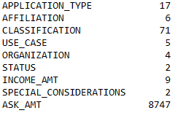

Model 1

Model 2

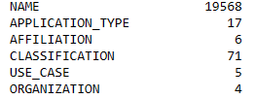





1. The target(s) variables for the mode



Model 1



Model 2

1. Cutoff value for binning

Model 1 APPLICATION TYPE: <500

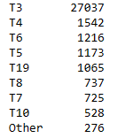

CLASSIFICATION: <1000

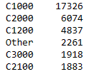

Model 2 NAME: <10

Other 21022

PARENT BOOSTER USA INC 1260

TOPS CLUB INC 765

UNITED STATES BOWLING CONGRESS INC 700

WASHINGTON STATE UNIVERSITY 492

...

CASCADE 4-H FOUNDATION 10

FREE & ACCEPTED MASONS OF WASHINGTON 10

NEW MEXICO GARDEN CLUBS INC 10

NATIONAL ASSOCIATION OF HISPANIC NURSES 10

UNION OF CALIFORNIA STATE WORKERS 10

CLASSIFICATION: class_to_replace = list(class_counts[class_counts < 1000].index)

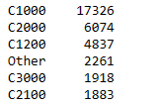

APPLICATION TYPE: < 500

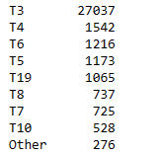

1. The number of input features and hidden nodes for each layer

Model 1

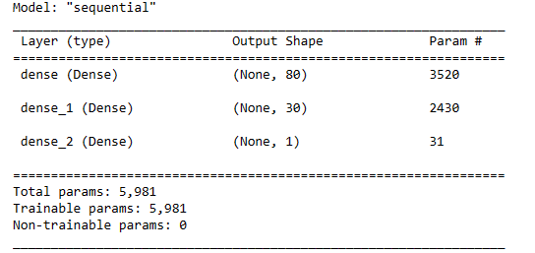

Model 2

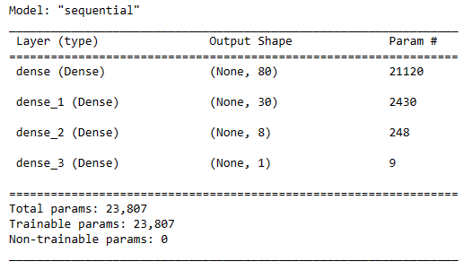

1. Train and Model /Evaluate the model using the test data

Model 1

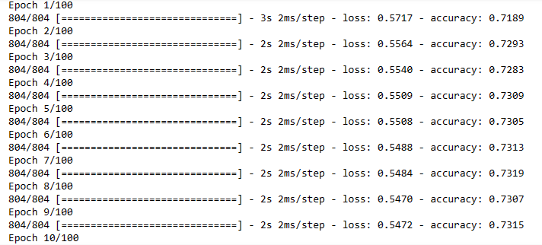



Model 2

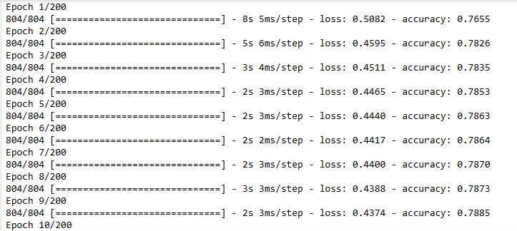



Conclusion

Model performance can be improved through vigorous review of target and feature variables. Besides, optimizing the hidden nodes and layers along with selecting proper activation function have significant effect on Model accuracy.