**Summary of Analytical Report**

The final analysis of the data considered the following major indicators as school performance measurement.

* Math and reading scores of students from grade 9th to 12th
* Schools budget: total amount allocated every year to run the school
* School spending: the total amount the schools utilized from the allocated budget
* School size: how big the school size for the suitability of schools environment for the students
* School type: charter school against public district schools

Binning is a useful skill in Pandas and use it to better group and distill information. It helps the analysis in the following ways:

* The Pandas qcut function bins data into an equal distributions of items
* The Pandas cut function allows you to define your own ranges of data
* Binning your data allows you to both get a better understanding of the distribution of your data as well as creating logical categories based on other abstractions

Analysis Result

Applying binning skill, the final data analysis results are shown below:

Result 1:

Figure Scores by School Spending

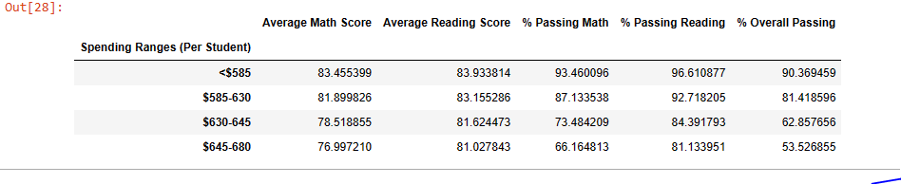

As per the result schools that have lesser spending ranges (per student) scores better math and reading scores as well as in overall passing result.

Result 2:

Figure Scores by School Size

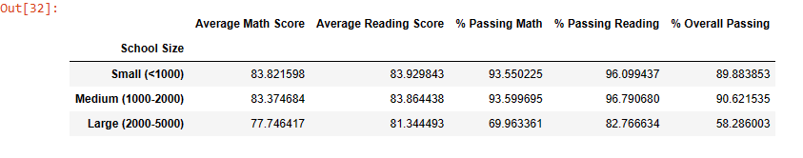

As per the result, schools that have smaller school size perform better in students results than the larger once.

Result 3

Figure Scores by School Type

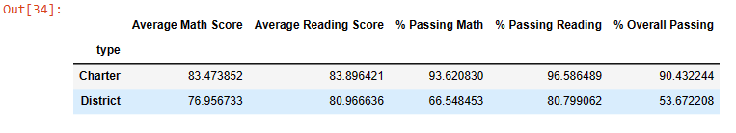

The result shows Carter schools score perform better than District school in students’ results.