**To what extent is the growth of nestling blue tits (*Cyanistes caeruleus*) influenced by competition with siblings?**

**Project - *Same data, different analysts: variation in effect sizes due to analytical decisions in ecology and evolutionary biology***

**Data analysis**

Two main approaches were used to analyze the data. In the first approach, I conducted analyses at the population level; i.e., nests were considered sampling units. More specifically, I tested how the number of live chicks in the nest (a proxy for the competition with siblings) influenced the average and the coefficient of variance (CV) of chick's mass (proxy for growth) at day 14, and the proportion of chicks that survived to leave the nest. The average and CV of chick's mass at day 14 were modeled using linear regressions. The proportion of chicks that survived to leave the nest was modeled using generalized linear models (binomial distribution). Since chick's mass and survivorship can be influenced by other variables, I decided to compare the results of each model with an equivalent model version containing potential cofounding variables (area, lay date, and whether the nest was manipulated or not).

In the second approach, analyses were conducted at the individual level. Here, I explored how clutch size and number of live chicks in the nest affected chick's mass at day 14 (a proxy for growth) and chick's survival to the first breeding season. For this analysis, I used only nests that were manipulated. This was necessary to separate the effects of clutch size and the competition with other life chicks (accessed via direct manipulation 🡪 net hearing manipulation). Clutch size reflects exploitative competition at early life stages when the resources of the mother are divided into different eggs. On the other hand, the number of live chicks in the nest (here manipulated experimentally) is related to interference competition for food that is brought to the nest by the father. I used linear mixed models to model chick's mass at day 14 and Binomial generalized linear mixed models to model chick's survival to the first breeding season. In both cases, clutch size and the number of live chicks in the nest were considered exploratory variables whereas rear nest box ID was considered a random variable. The inclusion of the random variable (rear nest box ID) was necessary to deal with the lack of independence between sample units (in this case, chicks). Similar to approach 1, I compared results of each model with an equivalent model version containing potential cofounding variables (rear area, lay date, and whether the chick was reared in the nest in which it hatched or had been moved by an experimenter to another nest).

A list with all models created can be found in table 1. All analyses were developed using the R programming language (R Core Team 2020) in Jupyter Notebook (Kluyver et al. 2016). Linear regressions and generalized linear models were conducted in the R package stats (R Core Team 2020). Linear mixed models and generalized linear mixed models were conducted in the package lme4 (Bates et al. 2015).

**Results and main conclusions**

*Population-level*

The number of live chicks in the nests had a negative relationship with average chick’s mass (F= 97.45, DF=1-351, p<0.001, R²=0.22; Figure 1a) and the proportion of chicks that survived to leave the nest (z= -2.01, DF= 1-351, p=0.04, R²=0.02, Figure 1c). These results were consistent after accounting for the effect of co-variables (average chick’s mass: t=-11.64, DF= 1-341, p<0.001; chick’s survivorship: t=-2.32, DF=1-341, p=0.02, Figure 1b, d). The CV of chick’s mass was positively associated with the number of live chicks in the nests (F= 42.96, DF=1-351, R2=0.11, p<0.001; Figure 1e) and this result was consistent when compared to models with co-variables (t=6.98, DF=1-341, p<0.001; Figure 1f).

These results indicate that competition with siblings has a significant effect on the growth (average and variation) and survivorship of nestling blue tits. These effects were still significant after accounting for potential confounding variables related to environmental conditions and experimental manipulation. However, it should be highlighted that the relationship among the variables is usually weak, especially for growth variance and survivorship.

*Individual-level*

Chicks’ mass was negatively associated with clutch size (Chisq=169.84, DF=1, P<0.001, model’s R2m=0.14, Figure 2a) and with the net hearing manipulation (Chisq=18.45, DF=1, P<0.001, model’s R2m=0.14, Figure 2c). These results were consistent after accounting for co-variables (chick’s mass: Chisq=171.69, DF=1, P<0.001, Figure 2b, hearing manipulation: Chisq=21.82, DF=1, P<0.001, Figure 2d). On the other hand, chicks’ survivorship was positively and marginally associated with clutch size (z= 1.91, P=0.06, Theoretical R2m of the model=0.03, Figure 3a), but this relationship was non-significant in models containing co-variables (z=-1, P=0.32, Figure 3b). The chicks’ survivorship was negatively associated with the net hearing manipulation (z=-3.32, P<0.001, Theoretical R2m of the model= 0.03, Figure 3c) and this relationship was also consistent after accounting for co-variables (z=-3.68, P<0.001, Figure 3d).

The results at the individual level also suggest that competition with siblings (either in terms of the number of eggs or life chicks) has a detrimental effect on the mass of chicks. Again, models were related to high levels of uncertainty, indicating the importance of other environmental variables. On the other hand, clutch size had a non-consistent relationship with chick's survivorship that changed according to the model used. This inconsistence is likely related to the inclusion of the co-variable "hatch_nest_LD", which describes the date of the first egg was laid ('lay date') in the clutch from which the chick hatched (April 1 = 1). Clutch size varies according to a seasonal (environmental) gradient. Clutch sizes were larger during the Spring than during the Summer (Figure 4a). Interestingly, chicks survivorship was also higher during Spring (Figure 4b). In this sense, birds are probably nesting during the most favorable period of the year. After controlling for this seasonal gradient, clutch size returns to its expected negative relationship with survivorship, however, this relationship seems weak and non-significant.

**References**

Bates D, Maechler M, Bolker B, Walker S. 2015. Fitting linear mixed-effects models using lme4. Journal of Statistical Software, 67(1), 1-48. doi:10.18637/jss.v067.i01.

Kluyver et al. 2016. Jupyter Notebooks -- a publishing format for reproducible computational workflows. Loizides F. & Schmidt B. (eds), Positioning and power in academic publishing: players, agents and agendas. IOS Press. pp. 87-90.

R Core Team 2020. R: A language and environment for statistical computing. R Foundation for Statistical Computing, Vienna. Retrieved from <https://www.r-project.org/>.

|  |  |  |  |  |
| --- | --- | --- | --- | --- |
| **Approach** | **Model type** | **Response variable** | **Exploratory variables** | **Co-variables** |
| Pop | LR | day_14_weight_Mean | rear_Cs_at_start_of_rearing |  |
| LR | day_14_weight_Mean | rear_Cs_at_start_of_rearing | rear_area + rear_nest_LD_Mean + Treatment |
| LR | day_14_weight_CV | rear_Cs_at_start_of_rearing |  |
| LR | day_14_weight_CV | rear_Cs_at_start_of_rearing | rear_area + rear_nest_LD_Mean + Treatment |
| GLM | n_chicks_fledged_from_nest/ rear_Cs_at_start_of_rearing | rear_Cs_at_start_of_rearing |  |
| GLM | n_chicks_fledged_from_nest/ rear_Cs_at_start_of_rearing | rear_Cs_at_start_of_rearing | rear_area + rear_nest_LD_Mean + Treatment |
| Ind | LMM | day_14_weight | hatch_nest_CS + net_rearing_manipulation |  |
| LMM | day_14_weight | hatch_nest_CS + net_rearing_manipulation | rear_area + rear_nest_LD + home_or_away |
| GLMM | chick_survival_to_first_breed_season | hatch_nest_CS + net_rearing_manipulation |  |
| GLMM | chick_survival_to_first_breed_season | hatch_nest_CS + net_rearing_manipulation | rear_area + rear_nest_LD + home_or_away |

**Table 1. List of the models built for this study.**

Figure 1. Marginal effects of the number of chicks in the nest on average chick’s mass (a, b), proportion of chicks that survived to leave the nest (c, d), and coefficient of variation of chick’s mass (e, f).

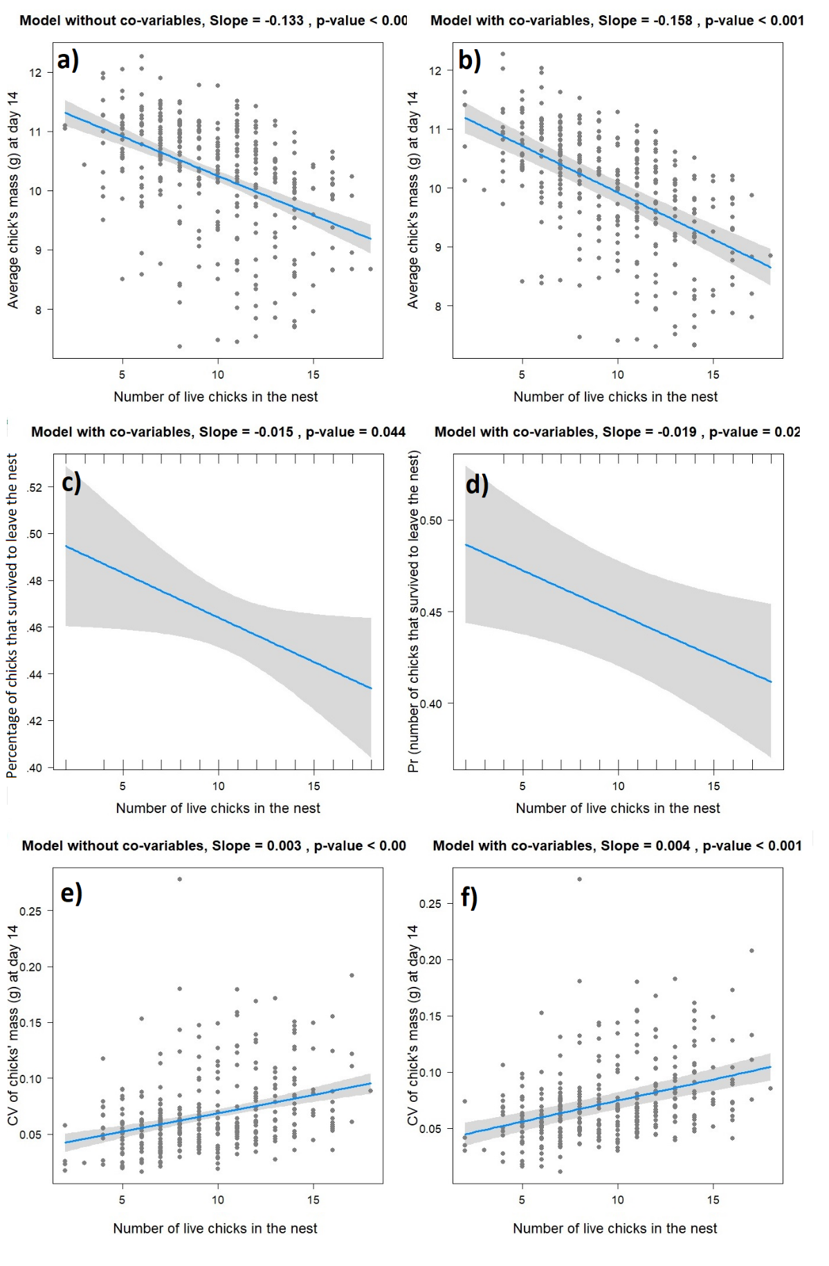

**Figure 2.** Marginal effect of clutch size (a, b) and net rearing manipulation (b, c) on chick’s mass.

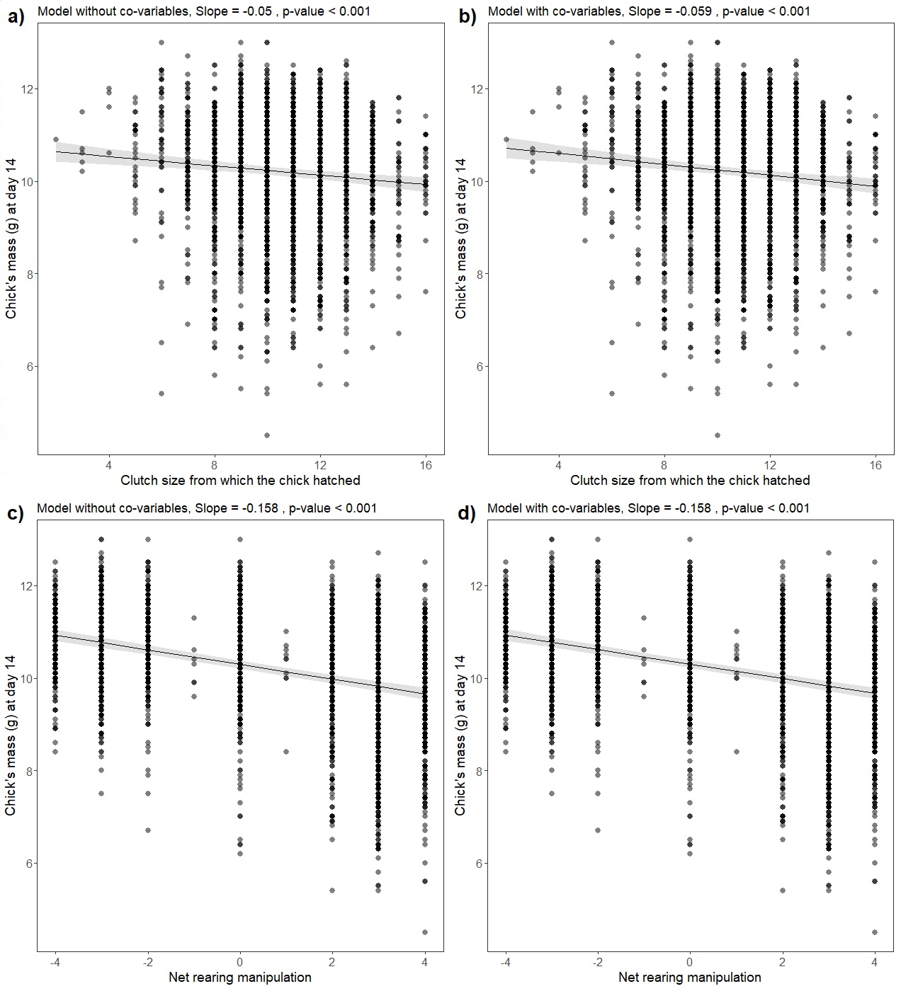

Figure 3. Marginal effect of clutch size (a, b) and net rearing (b, c) on the probability of chick’s survival

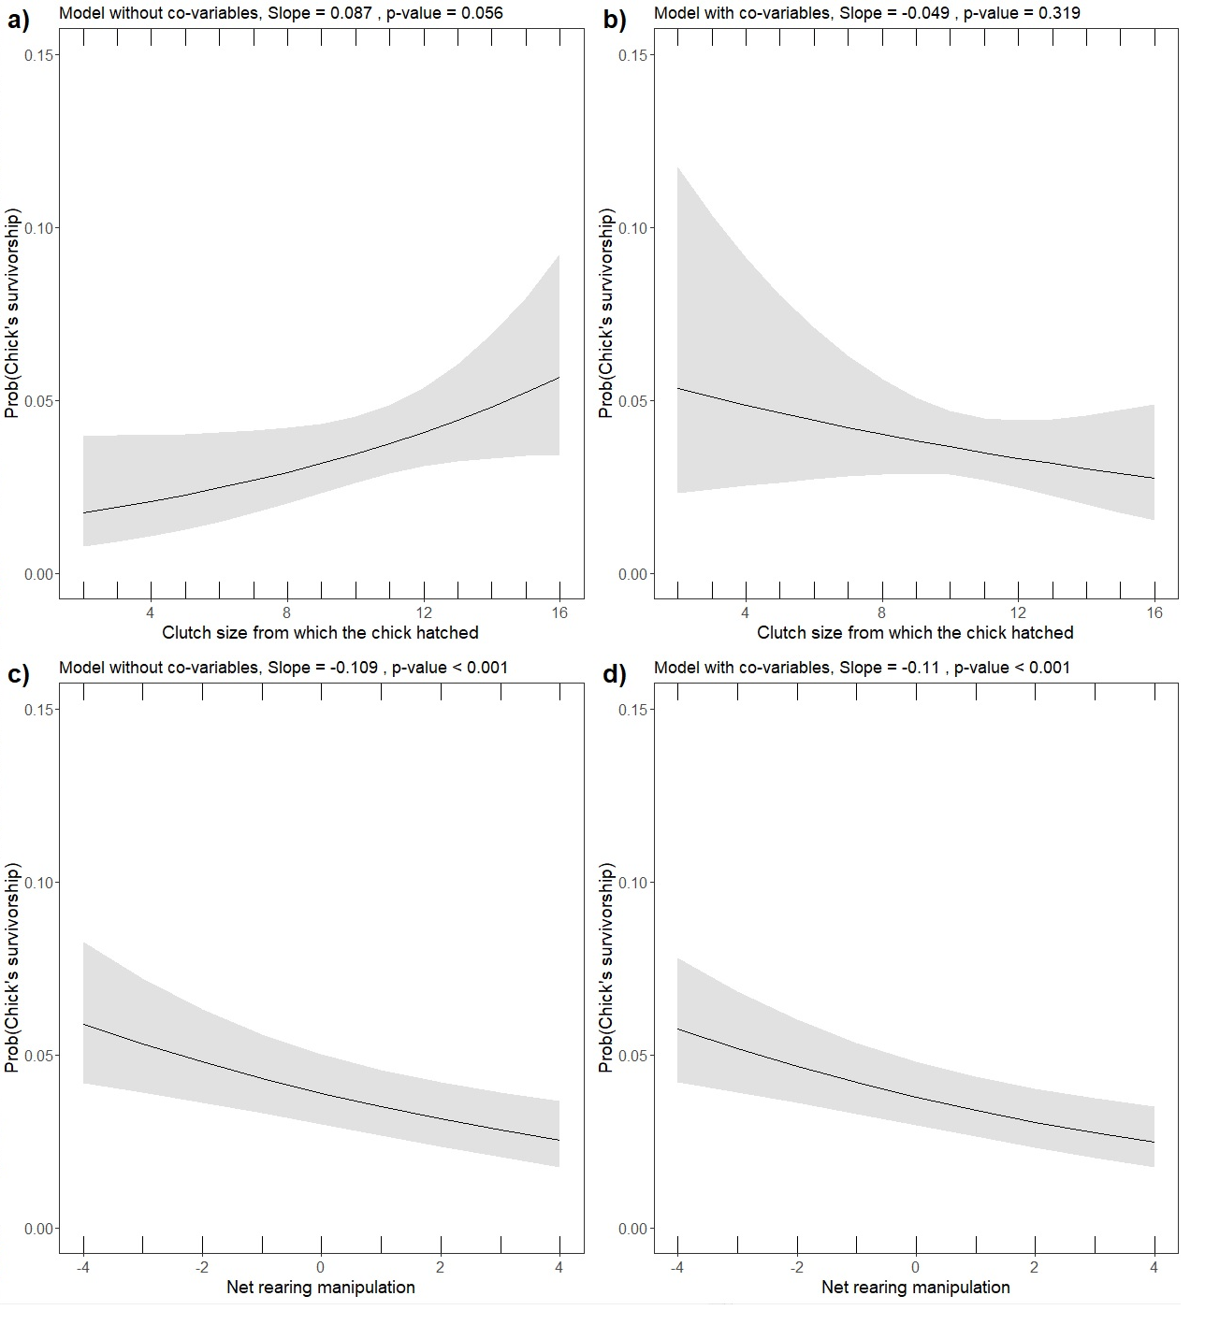

Figure 4. Relationship between lay date and clutch size (a) and the marginal effect of lay date on the probability of chick’s survival (b).

