  - Laboratory Exercise 003— Hello World Variations

Question 1
Write a program that displays "Hello" in one line, and "World" in another line using exactly two (2) COUT statements.
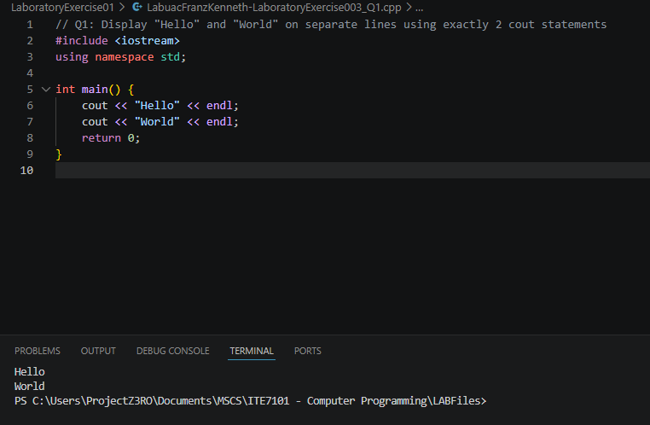
Source Code:
#include <iostream>
using namespace std;

int main() {
cout << "Hello" << endl;
cout << "World" << endl;
return 0;
}

Program Output:
Hello
World

Question 2
Write a program that displays "Hello" in one line, and "World" in another line using exactly ten (10) COUT statements.
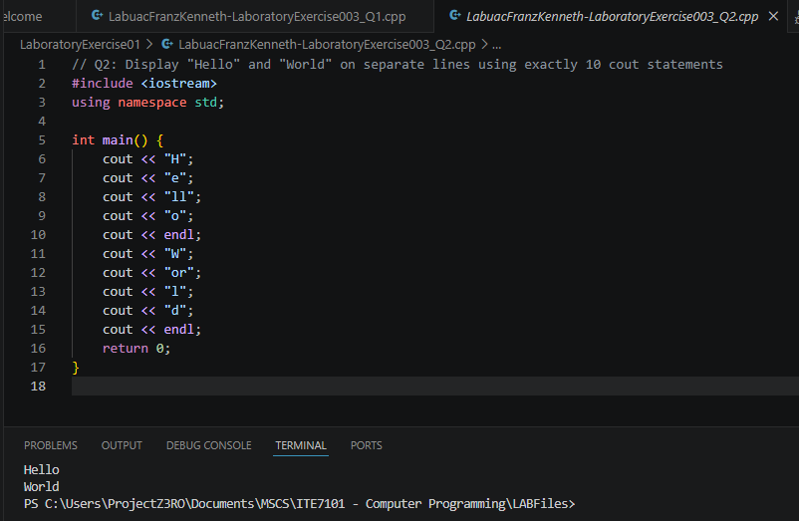
Source Code:
#include <iostream>
using namespace std;

int main() {
cout << "H";
cout << "e";
cout << "ll";
cout << "o";
cout << endl;
cout << "W";
cout << "or";
cout << "l";
cout << "d";
cout << endl;
return 0;
}

Program Output:
Hello
World

Question 3
Write a program that displays "Hello" using exactly one (1) COUT statement, and "World" using exactly five (5) COUT statements.
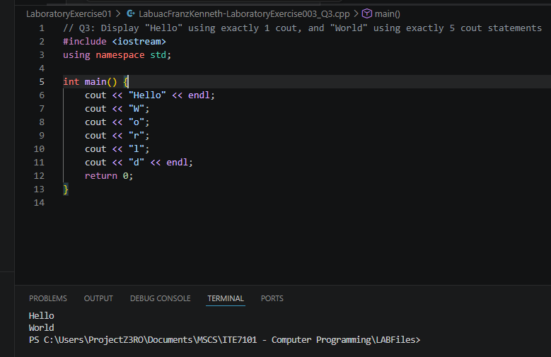
Source Code:
#include <iostream>
using namespace std;

int main() {
cout << "Hello" << endl;
cout << "W";
cout << "o";
cout << "r";
cout << "l";
cout << "d" << endl;
return 0;
}

Program Output:
Hello
World

Question 4 — Conclusion
Activity shows that there are various different implementations we can use to solve a problem.
A single cout can print an entire string including a newline, while multiple cout statements can each print a fragment of the same string, with the final result being identical on screen. This highlights that cout does not require a newline after each call and that output is buffered and displayed sequentially. The key takeaway is that C++ provides flexibility in how output is structured — fewer cout statements lead to cleaner and more maintainable code, while splitting output across many statements, though functionally equivalent, reduces readability. This also shows that there is rarely only one way to solve a programming problem; different approaches can achieve the same result.

