Lithium-Ion Batteries: Chemistry, Materials and Performance
A short technical overview prepared as a sample document for document parsing.

1. History
The first rechargeable lithium cell was built in the 1970s at Exxon by M. Stanley Whittingham, who used a titanium disulfide cathode. In 1980 John B. Goodenough showed that lithium cobalt oxide gives a much higher voltage, and in 1985 Akira Yoshino at Asahi Kasei replaced the reactive lithium metal anode with carbon. The three shared the Nobel Prize in Chemistry 2019.
Lithium-ion batteries made portable electronics and modern electric vehicles possible by combining high energy density with long cycle life.

1.1 Key milestones
Table 1. Milestones in lithium-ion battery technology
Year | Event | Organisation | People
1976 | Lithium metal / TiS₂ rechargeable cell | Exxon | M. S. Whittingham
1980 | LiCoO₂ cathode proposed | University of Oxford | J. B. Goodenough
1985 | Carbon anode, first practical Li-ion prototype | Asahi Kasei | A. Yoshino
1991 | First commercial Li-ion cell | Sony | —
1997 | LiFePO₄ (olivine) cathode reported | University of Texas at Austin | J. B. Goodenough, A. K. Padhi
2019 | Nobel Prize in Chemistry | Royal Swedish Academy of Sciences | Goodenough, Whittingham, Yoshino

2. Electrochemistry

2.1 Electrode reactions
During discharge, lithium ions leave the graphite anode and are inserted into the cathode. For a LiCoO₂ / graphite cell:
Cathode:
${Li}_{1−x}CoO_{2} + x{Li}^{+} + xe^{−} ⇌ LiCoO_{2}$
Anode:
${Li}_{x}C_{6} ⇌ C_{6} + x{Li}^{+} + xe^{−}$

2.2 Capacity and energy
The theoretical specific capacity of an electrode material follows from Faraday's law:
$Q_{th} = \frac{nF}{3.6M}$
where:
- n — number of electrons transferred per formula unit;
- F — Faraday constant, 96 485 C/mol;
- M — molar mass of the active material, g/mol;
- the factor 3.6 converts C/g to mAh/g.
The energy delivered by a cell is the integral of voltage over the charge passed:
$E = \int_{0}^{Q}{V\left(q\right) dq} ≈ V_{avg} · Q$
The charge or discharge current is often expressed as a C-rate: at 1C a cell is fully discharged in one hour, at 2C in 30 minutes, and in general:
$I = C · Q_{nom}, t = \frac{1}{C} h$

3. Cathode materials
The cathode largely determines cell voltage, capacity, cost and safety. Cobalt-rich layered oxides offer high energy density, while LiFePO₄ trades capacity for thermal stability and cycle life.
Table 2. Common cathode materials (approximate values)
Structure | Material | Nominal cell voltage, V | Specific capacity, mAh/g |  | Typical applications
Structure | Material | Nominal cell voltage, V | Theoretical | Practical | Typical applications
Layered oxide | LiCoO₂ (LCO) | 3.7 | 274 | ≈ 150 | Phones, laptops
Layered oxide | NMC811 | 3.7 | ≈ 275 | ≈ 200 | Electric vehicles
Spinel | LiMn₂O₄ (LMO) | 3.7 | 148 | ≈ 110 | Power tools
Olivine | LiFePO₄ (LFP) | 3.2 | 170 | ≈ 160 | EVs, stationary storage
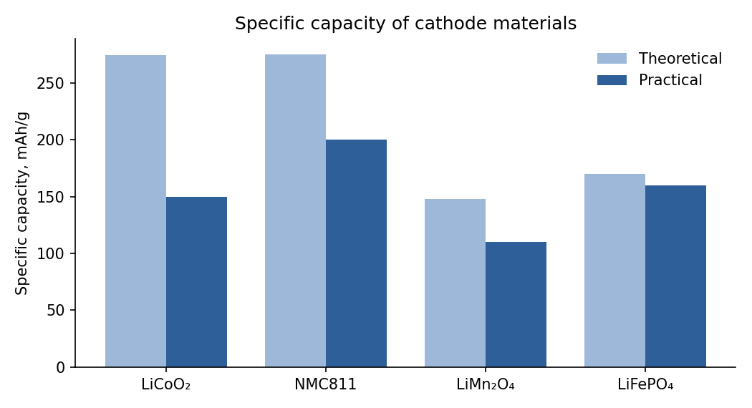
Figure 1. Theoretical vs practical specific capacity of cathode materials.

4. Computing theoretical capacity
The formula from Section 2.2 in Python:
F = 96485.0 # Faraday constant, C/mol

def theoretical_capacity(molar_mass: float, n: int = 1) -> float:
return n * F / (3.6 * molar_mass) # mAh/g

print(f"LiFePO4: {theoretical_capacity(157.76):.1f} mAh/g") # 169.9 mAh/g

5. Summary
- Lithium-ion technology was developed between 1976 and 1991 and commercialised by Sony.
- A cell consists of:
  - a graphite anode;
  - a transition-metal oxide or phosphate cathode;
  - a liquid electrolyte with a lithium salt, usually LiPF₆.
- Cathode choice trades off energy density, cost, safety and cycle life.

Glossary
Specific capacity — charge stored per unit mass of active material, mAh/g.
Intercalation — reversible insertion of ions into a host crystal structure without destroying it.
SEI — solid electrolyte interphase, a passivation layer formed on the anode during the first cycles.

The prize was awarded “for the development of lithium-ion batteries”.
Practical capacities depend on the upper cut-off voltage and on cell design; the table lists typical values.

