%MATLAB code for sampling
clc;
clear;
close all;

%% Parameters
fm = 1;
T = 4;

% Original signal
t = 0:0.001:T;
x = sin(2*pi*fm*t);

%% =============== CASE 1 : fs > 2fm ===============

fs1 = 10;
ts1 = 0:1/fs1:T;
xs1 = sin(2*pi*fm*ts1);

xr1 = reconstruct(ts1,xs1,t,fs1);

figure(1)

subplot(3,1,1)
plot(t,x,'b','LineWidth',2)
grid on
title('Original Signal')
xlabel('Time (s)')
ylabel('Amplitude')
xlim([0 4])
xticks(0:1:4)
yticks(-1:1:1)

subplot(3,1,2)
stem(ts1,xs1,'r','filled','LineWidth',1.5)
grid on
title('Sampling: f_s = 10 Hz > 2f_m')
xlabel('Time (s)')
ylabel('Amplitude')
xlim([0 4])
xticks(0:1:4)
yticks(-1:1:1)

subplot(3,1,3)
plot(t,x,'b','LineWidth',2)
hold on
plot(t,xr1,'r--','LineWidth',2)
grid on
title('Reconstructed Signal')
xlabel('Time (s)')
ylabel('Amplitude')
legend('Original','Reconstructed')
xlim([0 4])
xticks(0:1:4)
yticks(-1:1:1)

%% =============== CASE 2 : fs = 2fm ===============

fs2 = 2;
ts2 = 0.25:1/fs2:T;
xs2 = sin(2*pi*fm*ts2);

xr2 = reconstruct(ts2,xs2,t,fs2);

figure(2)

subplot(3,1,1)
plot(t,x,'b','LineWidth',2)
grid on
title('Original Signal')
xlabel('Time (s)')
ylabel('Amplitude')
xlim([0 4])
xticks(0:1:4)
yticks(-1:1:1)

subplot(3,1,2)
stem(ts2,xs2,'m','filled','LineWidth',1.5)
grid on
title('Sampling: f_s = 2f_m (Nyquist Rate)')
xlabel('Time (s)')
ylabel('Amplitude')
xlim([0 4])
xticks(0:1:4)
yticks(-1:1:1)

subplot(3,1,3)
plot(t,x,'b','LineWidth',2)
hold on
plot(t,xr2,'r--','LineWidth',2)
grid on
title('Reconstructed Signal at Nyquist Rate')
xlabel('Time (s)')
ylabel('Amplitude')
legend('Original','Reconstructed')
xlim([0 4])
xticks(0:1:4)
yticks(-1:1:1)

%% =============== CASE 3 : fs < 2fm ===============

fs3 = 1.5;
ts3 = 0:1/fs3:T;
xs3 = sin(2*pi*fm*ts3);

xr3 = reconstruct(ts3,xs3,t,fs3);

figure(3)

subplot(3,1,1)
plot(t,x,'b','LineWidth',2)
grid on
title('Original Signal')
xlabel('Time (s)')
ylabel('Amplitude')
xlim([0 4])
xticks(0:1:4)
yticks(-1:1:1)

subplot(3,1,2)
stem(ts3,xs3,'k','filled','LineWidth',1.5)
grid on
title('Sampling: f_s < 2f_m (Aliasing)')
xlabel('Time (s)')
ylabel('Amplitude')
xlim([0 4])
xticks(0:1:4)
yticks(-1:1:1)

subplot(3,1,3)
plot(t,x,'b','LineWidth',2)
hold on
plot(t,xr3,'r--','LineWidth',2)
grid on
title('Reconstructed Signal with Aliasing')
xlabel('Time (s)')
ylabel('Amplitude')
legend('Original','Reconstructed')
xlim([0 4])
xticks(0:1:4)
yticks(-1:1:1)

%% =============== Reconstruction Function ===============

function xr = reconstruct(ts,xs,t,fs)

xr = zeros(size(t));

for n = 1:length(ts)
xr = xr + xs(n)*sinc(fs*(t-ts(n)));
end

End

OUTPUT
CASE 1 : fs > 2fm

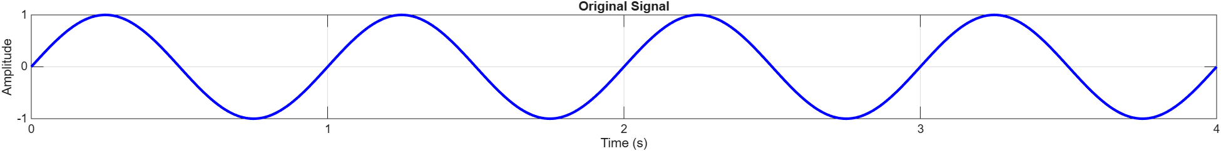

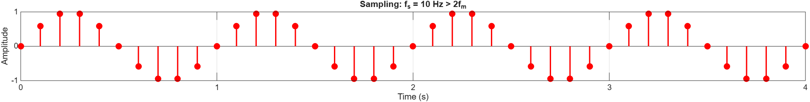

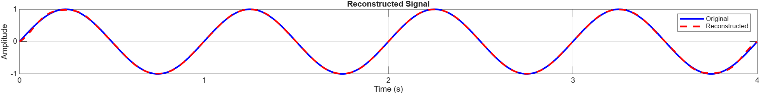

CASE 2 : fs = 2fm

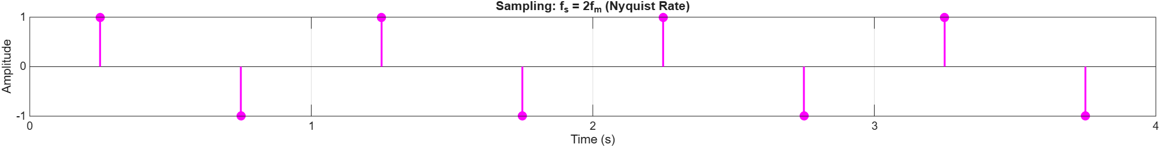

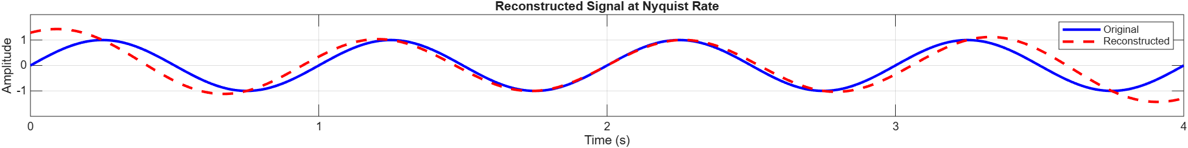

CASE 3 : fs < 2fm



