## CentroidScale1:

* **Average difference between the distances to neighbours:** 
  + 2.1469940658762883
* **Average distance to a point to its neighbours:** 
  + 50.44033027100041
* **Greedy:**
  1. Average entropy:

1.0622088782157757

* **Dijkstra:**
  1. Average entropy:

1.1864648672380205

* **Random:**
* **Random with boundary:**

**(Green – Fully Random ; Orange – Dijkstra ; Blue – Greedy; Red – Random with boundary 3 ; Purple – Random with boundary 5)**

## 

## CentroidScale2:

* **Average difference between the distances to neighbours:** 
  + 1.919986868367416
* **Average distance to a point to its neighbours:** 
  + 49.95115318164757
* **Greedy:**
  1. Average entropy:

1.1232377830287896

* **Dijkstra:**
  1. Average entropy:

1.28695961938847

* **Random:**
* **Random with boundary:**

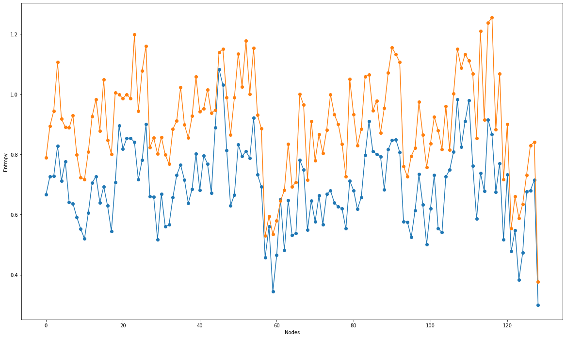  
3. CentroidScale 3:

* **Average difference between the distances to neighbours:** 
  + 1.7250142062391791
* **Average distance to a point to its neighbours:** 
  + 46.911944598979886
* **Greedy:**
  + **Average entropy:**
    - 1.252521685946955
* **Dijkstra**:
  + **Average entropy:**
    - 1.5166041388009948

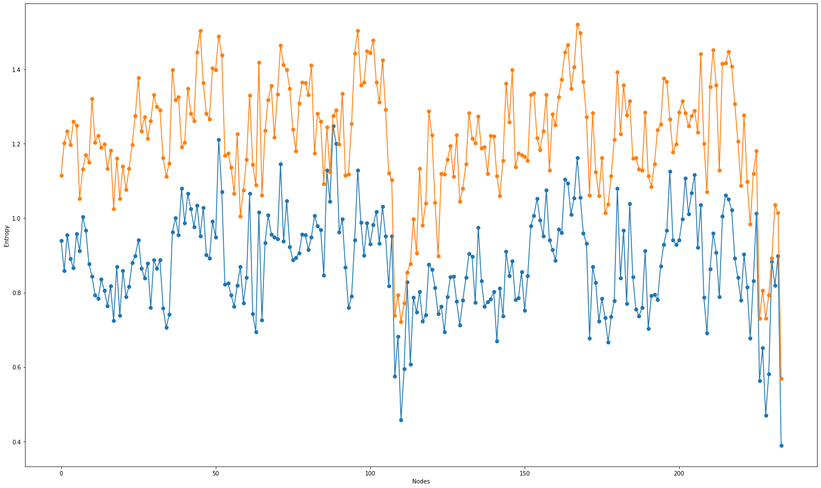

4. CentroidScale 4:

* **Average difference between the distances to neighbours:** 
  + 1.702842209736186
* **Average distance to a point to its neighbours:** 
  + 42.16484905286856
* **Greedy:**
  + **Average entropy:**
* **Dijkstra**:
  + **Average entropy:**

5. CentroidScale 5:

* **Average difference between the distances to neighbours:**
* **Average distance to a point to its neighbours:**
* **Greedy:**
* **Dijkstra**: