Assignment: P2SH 2-of-3 Multisig (Bitcoin Regtest)
Student: Ferdinantos Kottas
Network: regtest Bitcoin Core: v28.1 Python: 3.12
The next screenshots verify the regtest env and state what happen to the spend fund.
Figure 1 – Creating 2-of-3 P2SH multisig address from 3 public keys
Figure 2 – Funding the P2SH multisig address
Figure 3 – Mining confirmation
Figure 4 – Scanning UTXOs for the P2SH address using local regtest node
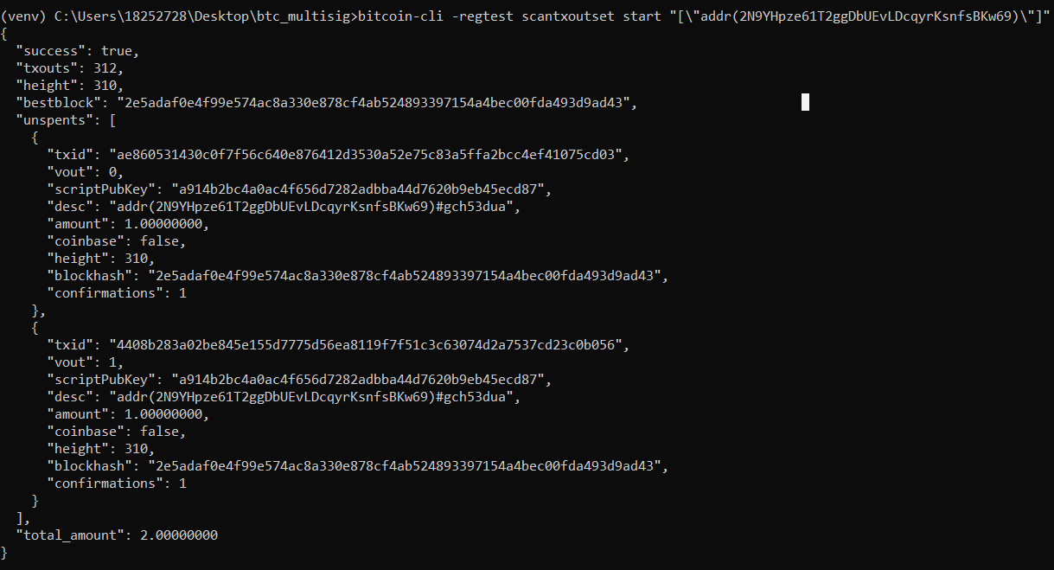

Figure 5 – Full spend
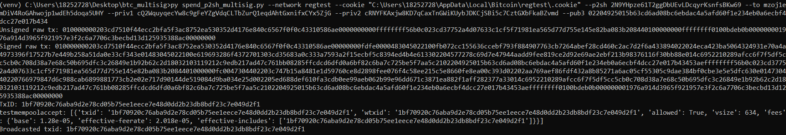
Unsigned tx:
Signed tx:
TxID:
Testmempoolaccept (verify tx is valid and accepted from the nodes):
Broadcast TxID (success):
Figure 6 – Destination P2PKH address receiving funds
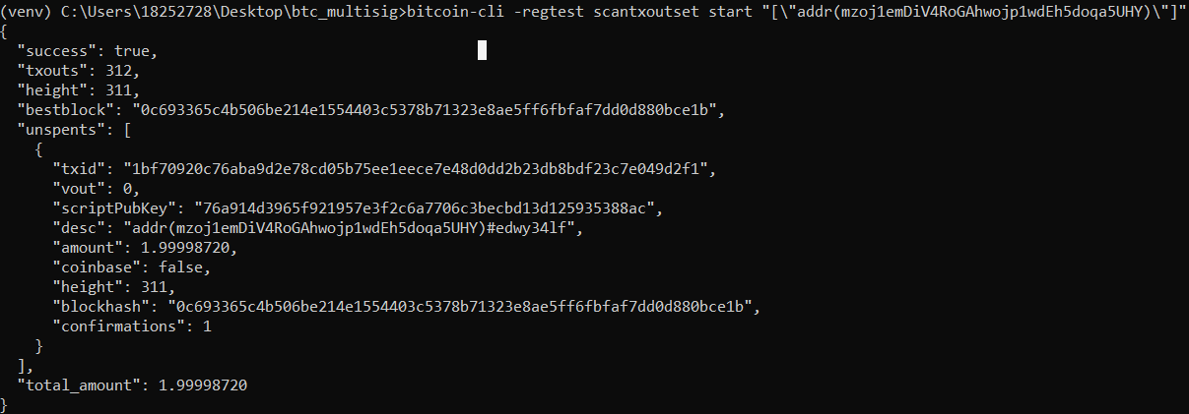

Figure 7 – P2SH is empty
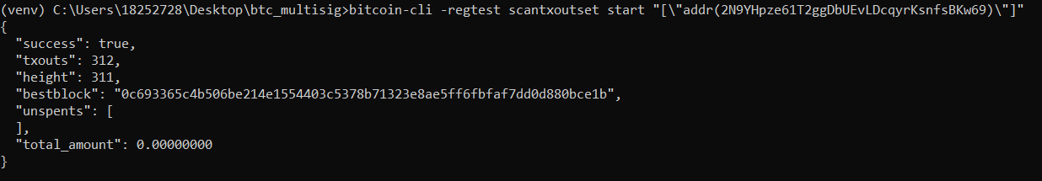
Mine 1 block:
Check the tx is in the chain
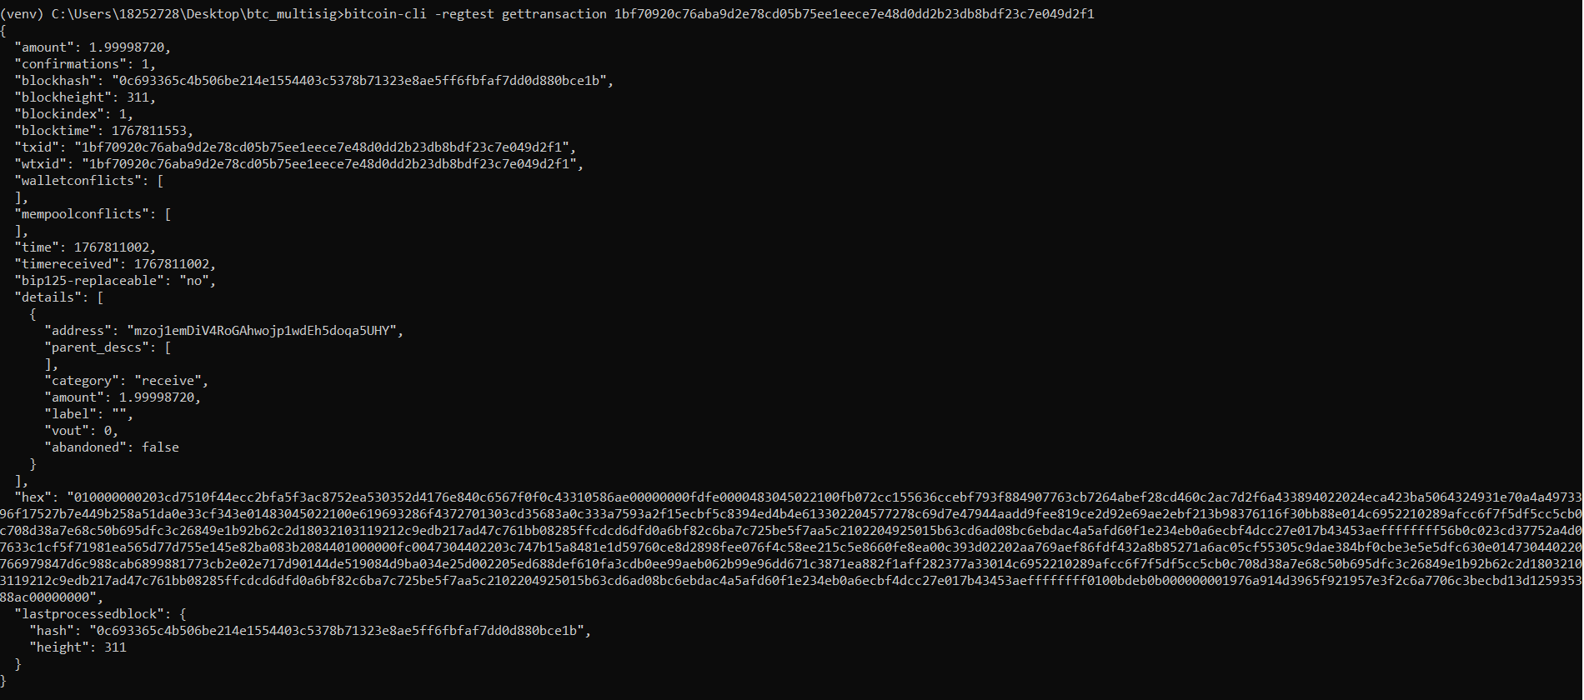
Confirm the P2SH is now empty (no UTXOs)
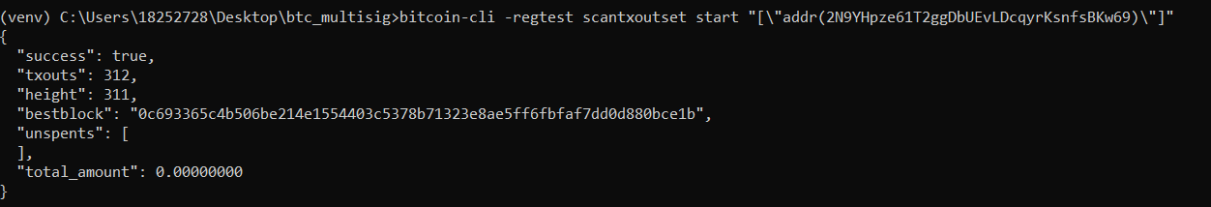

Confirm the destination address received funds
