START SCREEN – ZONE 1



START SCREEN – ZONE 2



START SCREEN – ZONE 3



START SCREEN – ZONE 4



ZONE 1 – Red

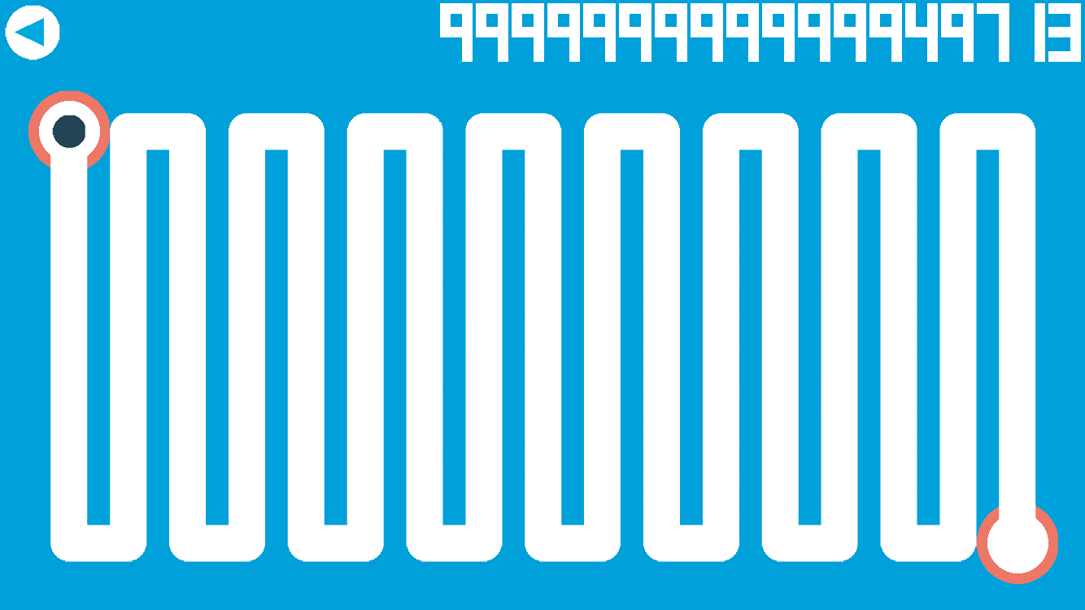

ZONE 1 – Yellow

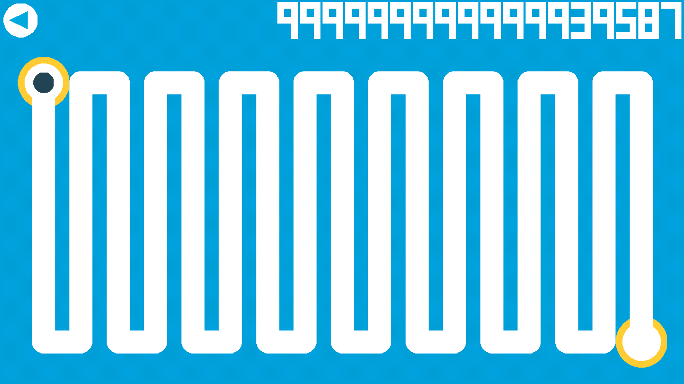

ZONE 1 – Green

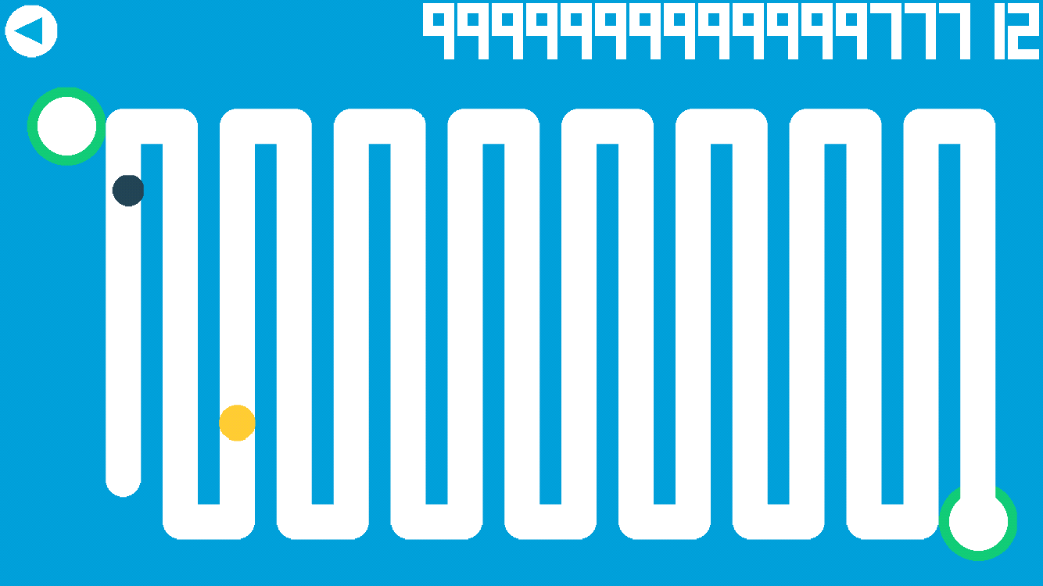

Ball

Pacer

Gameplay Elements:

* The ball is in black
* The pacer object is in yellow
  + The ball cannot collide with the pacer object
* The level starts disappearing one section at a time

ZONE 2 – Red

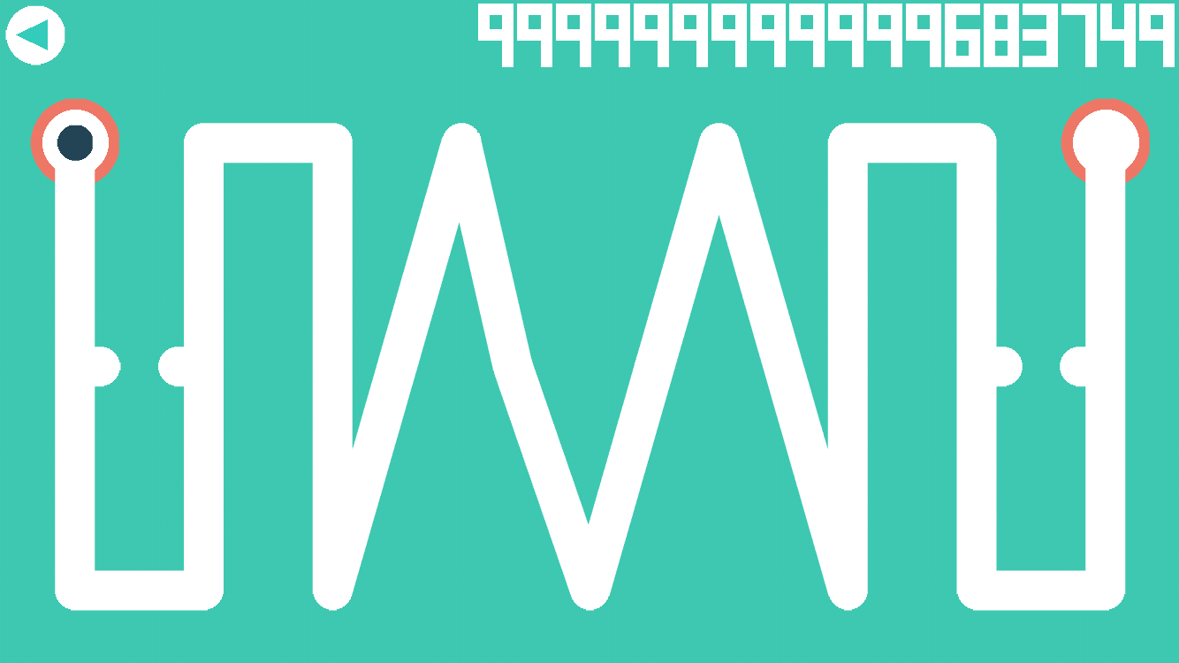

ZONE 2 – Yellow

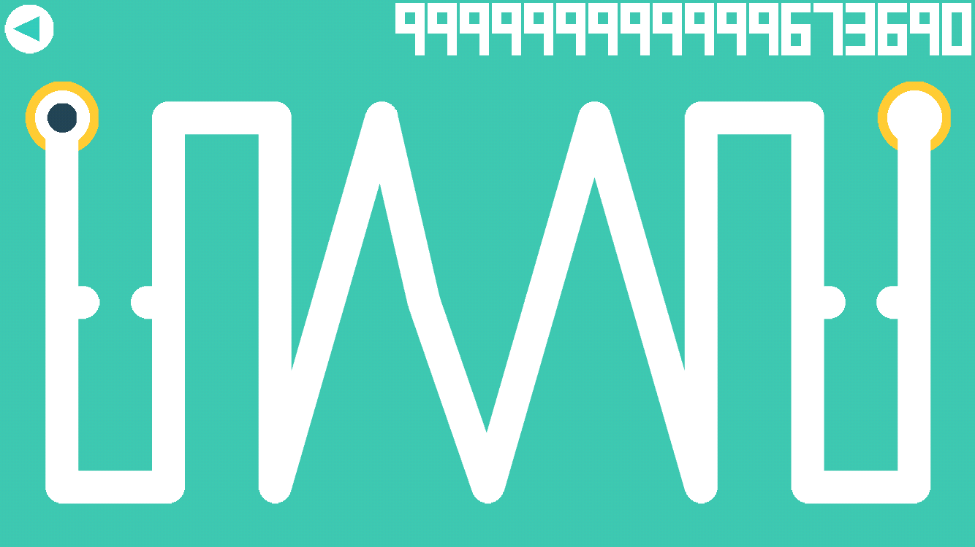

ZONE 2 – Green

Scaling part

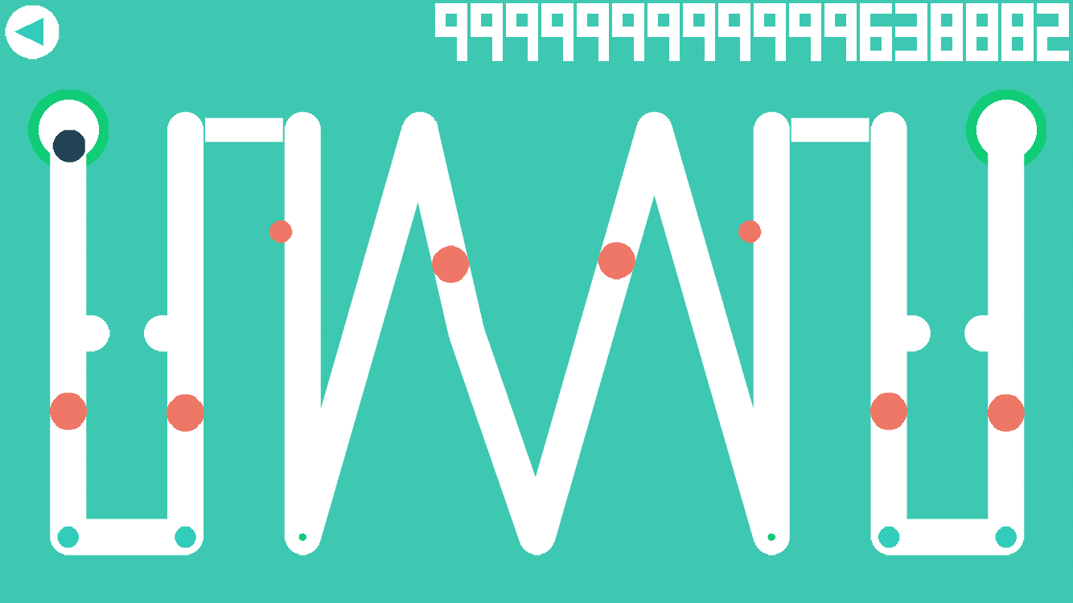

Oscillator

Follower

Holes

Gameplay Elements:

* Large red objects are followers
  + They follow a certain path in the level (either back and forth or they start and stop)
* Small red objects are oscillators
  + They move back and forth across a path
* Holes, match the color of the zone
  + They open and close, the ball can fall through them
* Some parts of the level can scale down and up again

ZONE 3 – Red

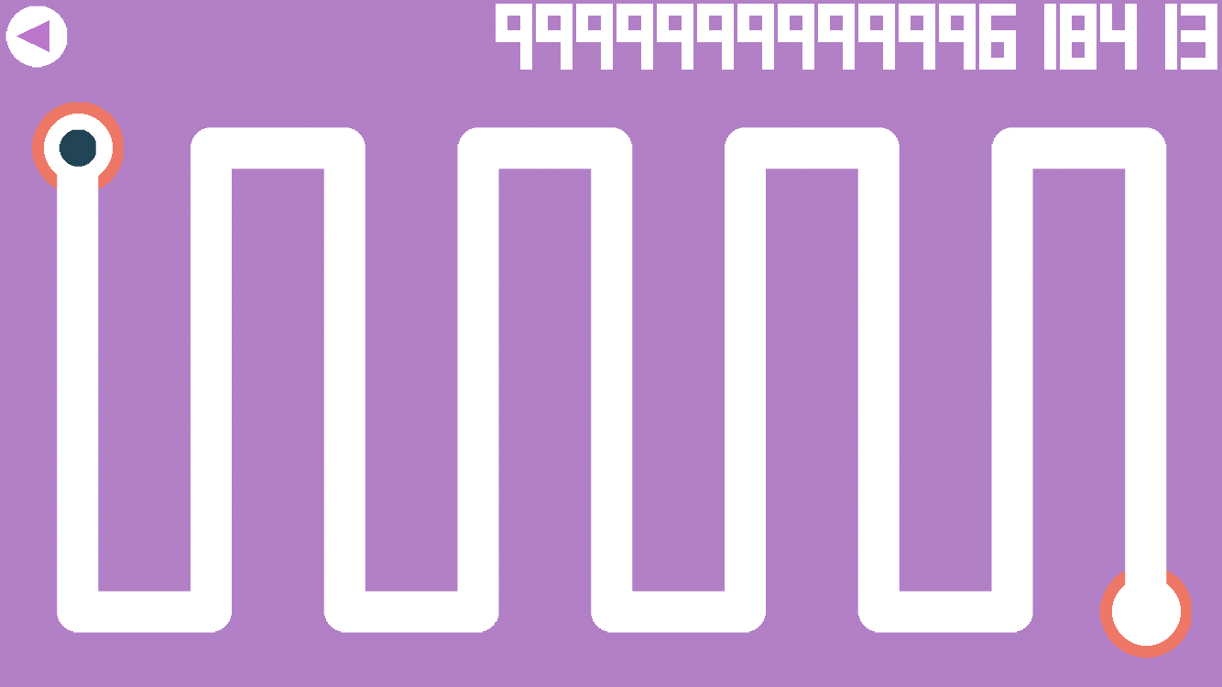

ZONE 3 – Yellow

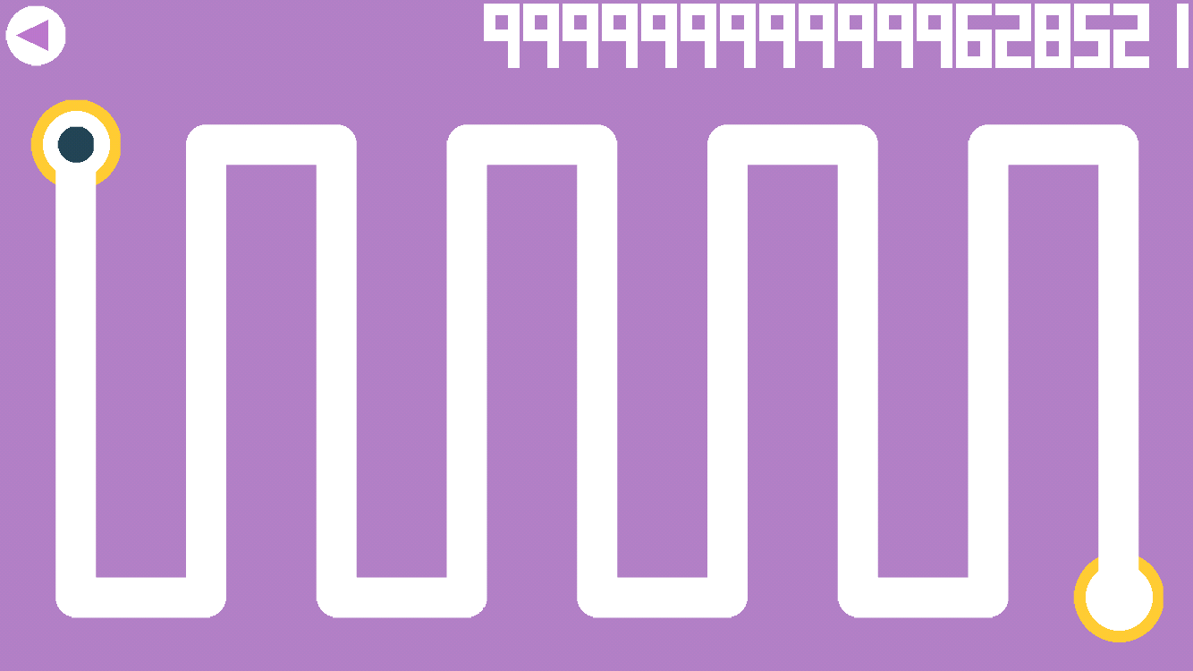

ZONE 3 – Green

Orbiter Pickups

Orbiters

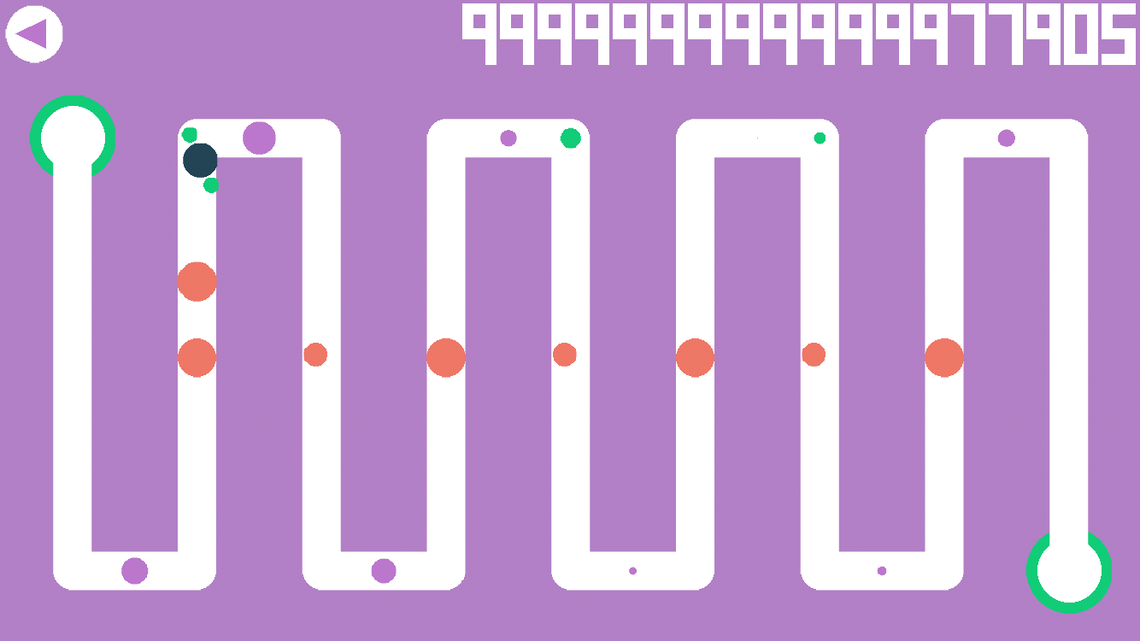

Gameplay Elements:

* Large red objects are followers
  + They follow a certain path in the level (either back and forth or they start and stop)
* Small red objects are oscillators
  + They move back and forth across a path
* Holes, match the color of the zone
  + They open and close, the ball can fall through them
* Orbiter pickups are bright green color
  + They represent pickups for the ball, if picked up the ball will have an orbiter that can destroy followers, pacers, oscillators (not holes)
  + The ball can have 1 or 2 of these orbiters orbiting around it

ZONE 4 – Red

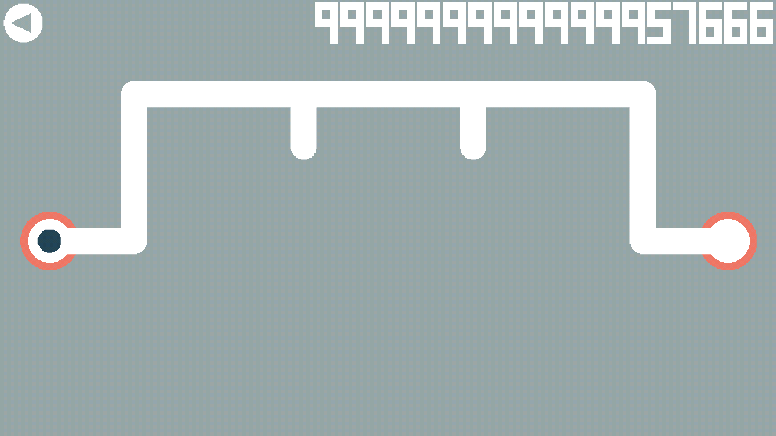

ZONE 4 – Yellow

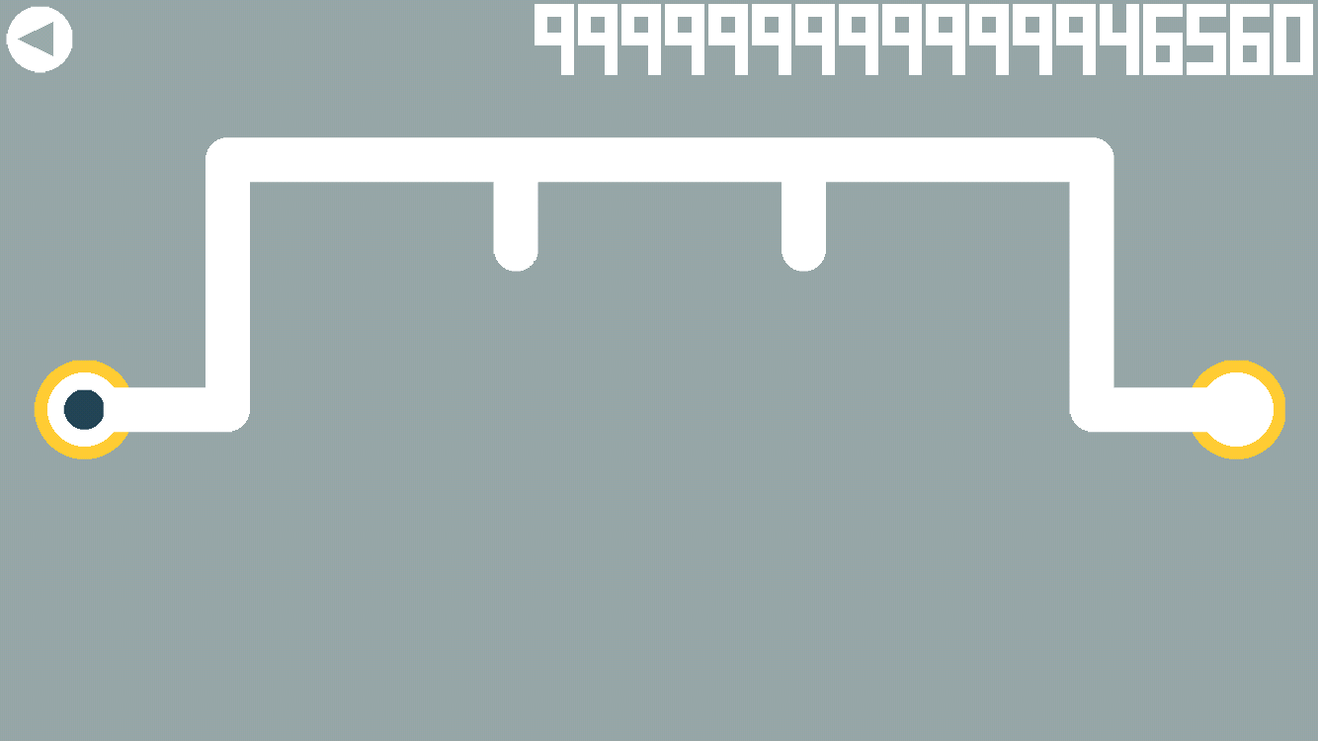

ZONE 4 – Green

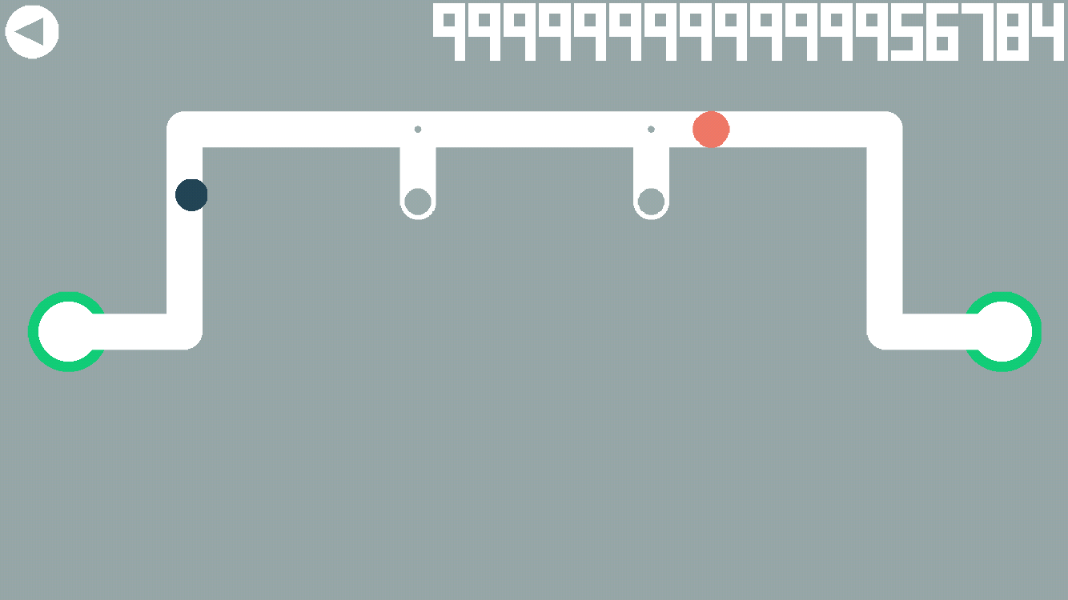

Gameplay Elements:

* Large red objects are followers
  + They follow a certain path in the level (either back and forth or they start and stop)
* Holes, match the color of the zone
  + They open and close, the ball can fall through them

GAME BEAT

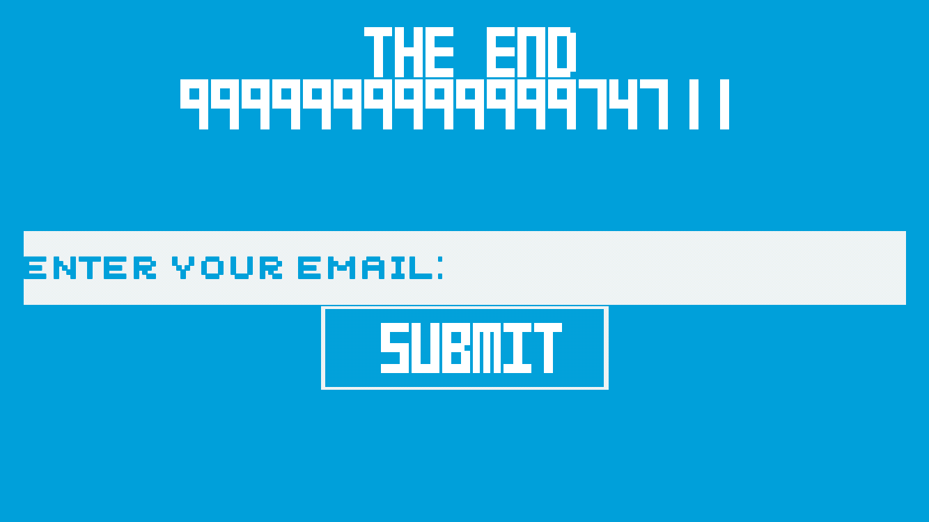

GAME LOST

