

JBossWS
Version: 1.1
23-Sep-2004

Thomas Diesler
Thomas.diesler@jboss.org

Overview
JBossWS is the implementation of J2EE compatible web services. This document describes the design principal and objectives of the JBoss SOAP stack that we aim to be part of the JBoss-5.0 release.
Within the JBoss-4.x series we have a J2EE-1.4 compatible web service (WS4EE) implementation that relies on a modified version of the Apache Axis-1.1 release. JBossWS is targeted to replace the Axis based SOAP implementation with a solution that fits better in the overall JBoss architecture and is geared towards the specific web service requirements in J2EE.

Goals
It is a primary goal of JBossWS to provide an implementation that is compatible with the emerging JAXRPC-2.0 specification. The goals stated in this section relate to the goals defined in the JAXRPC-2.0 specification and clarify those with respect to JBossWS where necessary.

JAXB With the release of JAXB 2.0 there is no reason to maintain two separate sets of XML mapping rules in the Java™ platform. JBossWS will delegate data binding-related tasks to the JAXB 2.0 specification that is being developed in parallel with JAX-RPC 2.0.

JAXB 2.0 will add support for Java to XML mapping, additional support for less used XML schema constructs, and provide bidirectional customization of Java⬄XML data binding.

Pluggable data binding JBossWS will defer data binding to JAXB unless there is a data binding plug-in provided. The idea is to optimize the data binding algorithm based on the nature of expected data.

SOAP 1.2 Whilst SOAP 1.1 is still widely deployed, it’s expected that services will migrate to SOAP 1.2 now that it is a W3C Recommendation. JBossWS will add support for SOAP 1.2 whilst continuing support for SOAP 1.1.

WSDL 2.0 TheW3C is expected to progress WSDL 2.0 to Recommendation. JBossWS will add support for WSDL 2.0 whilst continuing support for WSDL 1.1.

WS-I Basic Profile 1.1 WS-I Basic Profile 1.1 is expected to supersede 1.0 during the lifetime of JAX-RPC 2.0. JBossWS will add support for the additional clarifications it provides.

Metadata Facility (JSR 175) JBossWS will make use of Java annotations to simplify the most common development scenarios for both clients and servers.

Web Services Metadata (JSR 181) JBossWS will align with and complement the annotations defined by JSR 181.

Enterprise Web Services (JSR 109) The JSR 109 defined jaxrpc-mapping-info
deployment descriptor provides deployment time Java , WSDL mapping functionality. In conjunction with JSR 181, JBossWS will implement mapping functionality with development time Java annotations that control Java⬄WSDL mapping.

Asynchrony JBossWS will have support for client side asynchronous operations.

Non-HTTP Transports JBossWS will leverage the JBoss Remoting framework to improve the separation between the XML based RPC framework and the underlying transport mechanism to simplify use of JAX-RPC with non-HTTP transports.

Message Access JBossWS will simplify client and service access to the messages underlying an exchange.

Session Management JAX-RPC 1.1 session management capabilities are tied to HTTP. JBossWS will add support for message based session management.

Handlers JBossWS will simplify the development of handlers and will provide a mechanism to allow handlers to collaborate with service clients and service endpoint implementations.

Versioning and Evolution of Web Services JBossWS will ease the burden on developers when creating new versions of existing services.

Non-Goals
The following are non-goals:

SOAP Encoding Support Use of the SOAP encoding is essentially deprecated in the web services community, e.g., the WS-I Basic Profile excludes SOAP encoding. Instead, literal usage is preferred, either in the RPC or document style.

Support for Java versions prior to J2SE 1.5 JAX-RPC 2.0 relies on many of the Java language features added in J2SE 1.5. It is not a goal to support JBossWS on Java versions prior to J2SE 1.5.

Service Registration and Discovery It is not a goal of JBossWS to support registration and discovery of services via UDDI or ebXML RR. This capability is provided independently by JAXR.
Web Services Security (JSR 183) JAXRPC-2.0 lists this JSR in its goals. However, this JSR seems dead

WSDL Mapping
JBossWS provides tools for Java⬄WSDL mapping. It should be possible to deploy a server side Web Service without an accompanying WSDL file. It that case JBossWS will use sensible defaults and generate a valid WSDL internally.

For the reverse scenario JBossWS provides tools to generate client side artifacts from a valid WSDL. This is a manual process, i.e. Java source code is not automatically generated/compiled by JBossWS on the client side.

Java Annotations In conjunction with JAXB and JSR 181, JBossWS will support a set of annotations that may be used in Java source files to specify the mapping from Java artifacts to their associated WSDL components. The annotations will support mapping to both WSDL 1.1 and WSDL 2.0.

WSDL Annotations In conjunction with JAXB and JSR 181, JBossWS will support a set of annotations that may be used either within WSDL documents or as in an external form to specify the mapping from WSDL components to their associated Java artifacts. The annotations will support mapping from both WSDL 1.1 and WSDL 2.0.

Server Side Architecture
JBossWS uses the following components in a server side programming model.

Remoting Layer The Remoting layer abstracts the actual transport of the SOAP message. An abstract port in the Remoting Layer maps to a port address in the WSDL. When Remoting receives a SOAP message it provides an InputStream to the message data for further processing.
SOAP Receiver Synchronizes the incoming SOAP message with a ServiceDescription so that the endpoint method is known. It also initializes the javax.xml.soap.SOAPMessage, which provides lazy SAAJ access.
SAAJ Provider JAXRPC Handlers and service endpoints may access the SOAP message via the SAAJ API. However, this is optional so that the message processing phase that provides the SAAJ view of the message should be done on demand.
Request Handler Chain A JAXRPC handler may access and modify the SOAP message before it gets dispatched to the service endpoint. It does so using the SAAJ API. This must be done transactional. With the current JBoss Interceptor architecture, transactions are not started until after the dispatch to the service endpoint. It is desirable to find an approach that allows the processing of the handler chain before unmarhalling the message.
Unmarshalling The Service Receiver synchronized the incoming message with a port operation from the WSDL. Hence the abstract XMLSchema definitions for the data types are known. It is the responsibility of the marshalling layer to transform the message body and header elements into their respective Java object representation. Initially we base the Marshalling Layer on an implementation of JAXB. Pluggable Marshalling implementations will allow for more optimized processing.
Message Dispatcher The Message Dispatcher takes the method parameters from the Marshalling Layer and, going through the JBoss Interceptor stack, invokes a method on the service endpoint implementation.
Marshalling The Marshalling Layer transforms the operation return values to their respective XML representation according to the abstract type definitions from the WSDL. Initially we base the Marshalling Layer on an implementation of JAXB. Pluggable Marshalling implementations will allow for more optimized processing.
Response Handler Chain A JAXRPC handler may access and modify the SOAP message before it gets returned to the client. It does so using the SAAJ API. This must be done transactional.
SOAP Sender The response SOAP message is passed to the Remoting Layer for further processing.

The following figure shows the server side message flow.
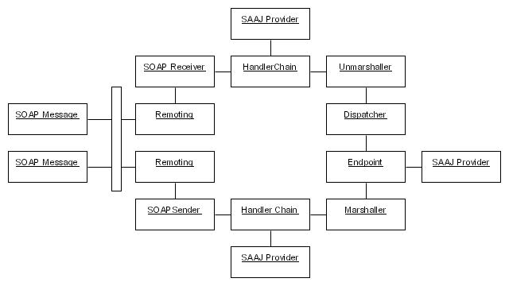

Client Side Architecture
JBossWS uses the following components in the client side programming model.

JAXRPC Client JBossWS provides an implementation of the JAXRPC-2.0 client API. During deployment of a Web Service client, a preconfigured javax.xml.rpc.Service object is bound into JNDI. It is also possible to use javax.xml.rpc.ServiceFactory to create the object from a WSDL.
Marshalling The Marshalling Layer transforms the operation parameters to their respective XML representation according to the abstract type definitions from the WSDL. Initially we base the Marshalling Layer on an implementation of JAXB. Pluggable Marshalling implementations will allow for more optimized processing.
Request Handler Chain A JAXRPC handler may access and modify the SOAP message before it gets dispatched to the service endpoint. It does so using the SAAJ API.
SOAP Sender The response SOAP message is passed to the Remoting Layer for further processing.
Remoting Layer The Remoting layer abstracts the actual transport of the SOAP message.
SOAP Receiver Initializes the javax.xml.soap.SOAPMessage, which provides lazy SAAJ access.
Response Handler Chain A JAXRPC handler may access and modify the SOAP message before it gets returned to the client. It does so using the SAAJ API.
Unmarshalling Transform the message body and header elements into their respective Java object representation to return them to the client.

The following figure shows the server side message flow.
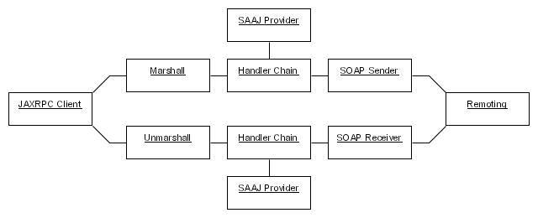

Marshalling Layer
JBossWS a pluggable marshalling layer that takes an abstract schema definition and some input data and transforms them into a graph of Java objects. The default implementation is based on JAXB.

