**DINESWIFT COMPLETE USE CASE REFERENCE TABLE**

**Document Version:** 1.0.0 **Date:** October, 13th, 2025

**Status:** Approved

**Authors:** Product Management Team

**Revision Focus:** Clear component responsibility assignment

# 

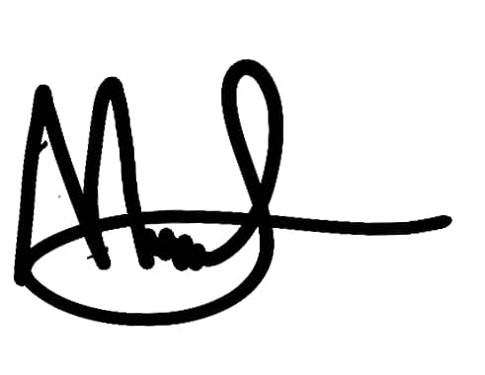

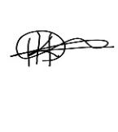

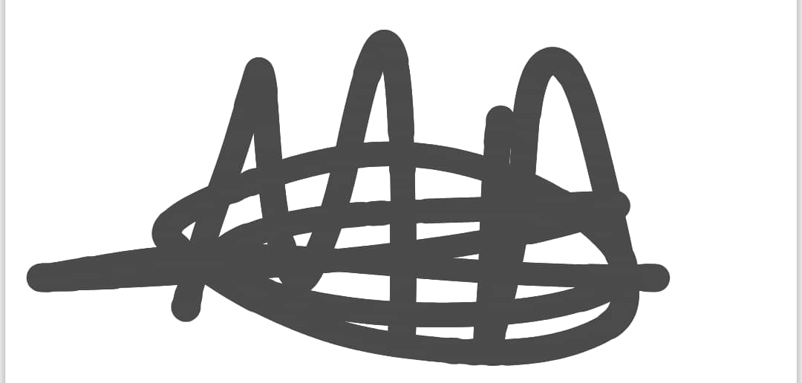

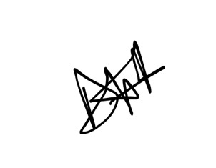

|  |  |  |  |
| --- | --- | --- | --- |
| **NAME** | **RegNo** | **EMAIL** | **PHONE** |
| Mushabe Moses | 23/U/12131/EVE | Mosesmushae9@gmail.com | 0752307875 |
| Drate Hillary | 23/U/23611 | dratehillary@gmail.om | 0758235980 |
| Mukyala Dorcus Nandy | 23/U/11911/EVE | mukyaladorcus@gmail.com | 0755011795 |
| Kiyimba Fahad | 23/U/0628 | kiyimbafwitty@gmail.com | 0762938957 |

Contents

1

1. MOBILE APP USE CASES (MOB) 2

2. LOCAL SERVER USE CASES (LOCAL) 3

3. CLOUD SERVER USE CASES (CLOUD) 5

4. WEB APP USE CASES (WEB) 7

5. MANAGEMENT DASHBOARD USE CASES (DASH) 8

6. SUMMARY STATISTICS 9

*This table serves as the definitive index for all functional use cases across the DineSwift platform components, categorized by the responsible system component, and cross-referenced with priority and implementation phase.*

# MOBILE APP USE CASES (MOB)

|  |  |  |  |  |  |
| --- | --- | --- | --- | --- | --- |
| **Use Case ID** | **Component** | **Module** | **Description** | **Priority** | **Phase** |
| **UC-MOB-ORDER-001** | Mobile App | Order | Scan QR Code | H | P1 |
| **UC-MOB-ORDER-002** | Mobile App | Order | Browse Menu | H | P1 |
| **UC-MOB-ORDER-003** | Mobile App | Order | Build Order | H | P1 |
| **UC-MOB-ORDER-004** | Mobile App | Order | Process Payment | H | P1 |
| **UC-MOB-ORDER-005** | Mobile App | Order | Display OTP Code | H | P1 |
| **UC-MOB-ORDER-006** | Mobile App | Order | Track Order Status | H | P1 |
| **UC-MOB-ORDER-007** | Mobile App | Order | Display OTP for Verification | H | P2 |
| **UC-MOB-BOOK-008** | Mobile App | Book | Search Available Tables | H | P1 |
| **UC-MOB-BOOK-009** | Mobile App | Book | View Restaurant Layout | H | P1 |
| **UC-MOB-BOOK-010** | Mobile App | Book | Select Table & Time | H | P1 |
| **UC-MOB-BOOK-011** | Mobile App | Book | Pay Deposit | H | P1 |
| **UC-MOB-BOOK-012** | Mobile App | Book | Display Digital Ticket | H | P1 |
| **UC-MOB-COMM-013** | Mobile App | Comm | Initiate Chat Session | M | P2 |
| **UC-MOB-COMM-014** | Mobile App | Comm | Send Message to Staff | M | P2 |
| **UC-MOB-COMM-015** | Mobile App | Comm | Rate Dining Experience | M | P2 |
| **UC-MOB-COMM-016** | Mobile App | Comm | Provide Detailed Feedback | M | P2 |
| **UC-MOB-COMM-017** | Mobile App | Comm | Rate Specific Waiter | M | P2 |
| **UC-MOB-LOYALTY-018** | Mobile App | Loyalty | View Loyalty Status | M | P2 |
| **UC-MOB-LOYALTY-019** | Mobile App | Loyalty | Browse Available Rewards | M | P2 |
| **UC-MOB-LOYALTY-020** | Mobile App | Loyalty | Redeem Points for Rewards | M | P2 |
| **UC-MOB-LOYALTY-021** | Mobile App | Loyalty | Track Points Balance | M | P2 |

# LOCAL SERVER USE CASES (LOCAL)

|  |  |  |  |  |  |
| --- | --- | --- | --- | --- | --- |
| **Use Case ID** | **Component** | **Module** | **Description** | **Priority** | **Phase** |
| **UC-LOCAL-ORDER-101** | Local Server | Order | Cache Menu Data | H | P1 |
| **UC-LOCAL-ORDER-102** | Local Server | Order | Generate OTP Codes | H | P1 |
| **UC-LOCAL-ORDER-103** | Local Server | Order | Calculate Preparation ETA | H | P1 |
| **UC-LOCAL-ORDER-104** | Local Server | Order | Process Offline Orders | H | P1 |
| **UC-LOCAL-ORDER-105** | Local Server | Order | Sync Orders to Cloud | H | P1 |
| **UC-LOCAL-DISPATCH-106** | Local Server | Dispatch | Monitor Order Readiness | H | P2 |
| **UC-LOCAL-DISPATCH-107** | Local Server | Dispatch | Create Delivery Batches | H | P2 |
| **UC-LOCAL-DISPATCH-108** | Local Server | Dispatch | Assign Waiter to Batch | H | P2 |
| **UC-LOCAL-DISPATCH-109** | Local Server | Dispatch | Optimize Delivery Routes | M | P2 |
| **UC-LOCAL-DISPATCH-110** | Local Server | Dispatch | Track Batch Progress | M | P2 |
| **UC-LOCAL-INVENTORY-111** | Local Server | Inventory | Track Stock Levels | H | P2 |
| **UC-LOCAL-INVENTORY-112** | Local Server | Inventory | Trigger Low Stock Alerts | H | P2 |
| **UC-LOCAL-INVENTORY-113** | Local Server | Inventory | Auto-deduct Inventory | H | P2 |
| **UC-LOCAL-INVENTORY-114** | Local Server | Inventory | Calculate Order Suggestions | M | P2 |
| **UC-LOCAL-COMM-115** | Local Server | Comm | Route Messages in Real-time | M | P2 |
| **UC-LOCAL-COMM-116** | Local Server | Comm | Prioritize Urgent Requests | M | P2 |
| **UC-LOCAL-COMM-117** | Local Server | Comm | Store Chat Sessions | M | P2 |
| **UC-LOCAL-LOYALTY-118** | Local Server | Loyalty | Apply Loyalty Discounts | M | P2 |
| **UC-LOCAL-LOYALTY-119** | Local Server | Loyalty | Validate Reward Eligibility | M | P2 |
| **UC-LOCAL-ANALYTICS-120** | Local Server | Analytics | Collect Real-time Data | M | P3 |
| **UC-LOCAL-ANALYTICS-121** | Local Server | Analytics | Sync Analytics to Cloud | M | P3 |

# CLOUD SERVER USE CASES (CLOUD)

|  |  |  |  |  |  |
| --- | --- | --- | --- | --- | --- |
| **Use Case ID** | **Component** | **Module** | **Description** | **Priority** | **Phase** |
| **UC-CLOUD-PAYMENT-201** | Cloud Server | Payment | Validate Payment | H | P1 |
| **UC-CLOUD-ORDER-202** | Cloud Server | Order | Store Order Records | H | P1 |
| **UC-CLOUD-MENU-203** | Cloud Server | Menu | Maintain Menu Master | H | P1 |
| **UC-CLOUD-BOOK-204** | Cloud Server | Book | Manage Booking Calendar | H | P1 |
| **UC-CLOUD-BOOK-205** | Cloud Server | Book | Process Deposit Payments | H | P1 |
| **UC-CLOUD-BOOK-206** | Cloud Server | Book | Generate Digital Tickets | H | P1 |
| **UC-CLOUD-BOOK-207** | Cloud Server | Book | Handle No-Show Forfeiture | M | P1 |
| **UC-CLOUD-INVENTORY-208** | Cloud Server | Inventory | Send Orders to Supplier | H | P2 |
| **UC-CLOUD-INVENTORY-209** | Cloud Server | Inventory | Track Order Status | M | P2 |
| **UC-CLOUD-INVENTORY-210** | Cloud Server | Inventory | Reconcile Payments | H | P2 |
| **UC-CLOUD-INVENTORY-211** | Cloud Server | Inventory | Rate Supplier Performance | M | P2 |
| **UC-CLOUD-COMM-212** | Cloud Server | Comm | Aggregate Feedback Data | M | P2 |
| **UC-CLOUD-COMM-213** | Cloud Server | Comm | Calculate Performance Metrics | M | P2 |
| **UC-CLOUD-COMM-214** | Cloud Server | Comm | Generate Analytics Reports | M | P2 |
| **UC-CLOUD-LOYALTY-215** | Cloud Server | Loyalty | Auto-enroll Customers | M | P2 |
| **UC-CLOUD-LOYALTY-216** | Cloud Server | Loyalty | Track Customer Metrics | M | P2 |
| **UC-CLOUD-LOYALTY-217** | Cloud Server | Loyalty | Manage Tier Progression | M | P2 |
| **UC-CLOUD-LOYALTY-218** | Cloud Server | Loyalty | Calculate Points Earned | M | P2 |
| **UC-CLOUD-LOYALTY-219** | Cloud Server | Loyalty | Update Points Balance | M | P2 |
| **UC-CLOUD-LOYALTY-220** | Cloud Server | Loyalty | Process Reward Redemption | M | P2 |
| **UC-CLOUD-LOYALTY-221** | Cloud Server | Loyalty | Maintain Rewards Catalog | M | P2 |
| **UC-CLOUD-ANALYTICS-222** | Cloud Server | Analytics | Capture Transaction Data | M | P3 |
| **UC-CLOUD-ANALYTICS-223** | Cloud Server | Analytics | Track Customer Behavior | M | P3 |
| **UC-CLOUD-ANALYTICS-224** | Cloud Server | Analytics | Monitor Staff Performance | M | P3 |
| **UC-CLOUD-ANALYTICS-225** | Cloud Server | Analytics | Record Inventory Movements | M | P3 |
| **UC-CLOUD-ANALYTICS-226** | Cloud Server | Analytics | Generate Performance Reports | M | P3 |
| **UC-CLOUD-ANALYTICS-227** | Cloud Server | Analytics | Forecast Demand | L | P3 |
| **UC-CLOUD-ANALYTICS-228** | Cloud Server | Analytics | Optimize Staff Scheduling | L | P3 |

# WEB APP USE CASES (WEB)

|  |  |  |  |  |  |
| --- | --- | --- | --- | --- | --- |
| **Use Case ID** | **Component** | **Module** | **Description** | **Priority** | **Phase** |
| **UC-WEB-KITCHEN-301** | Web App | Kitchen | View Kitchen Orders | H | P1 |
| **UC-WEB-KITCHEN-302** | Web App | Kitchen | Update Order Status | H | P1 |
| **UC-WEB-KITCHEN-303** | Web App | Kitchen | Mark Order Ready | H | P1 |
| **UC-WEB-KITCHEN-304** | Web App | Kitchen | Mark Order Ready (Dispatch) | H | P2 |
| **UC-WEB-KITCHEN-305** | Web App | Kitchen | View Order Queue | M | P2 |
| **UC-WEB-DISPATCH-306** | Web App | Dispatch | Receive Batch Assignment | H | P2 |
| **UC-WEB-DISPATCH-307** | Web App | Dispatch | View Delivery Route | M | P2 |
| **UC-WEB-DISPATCH-308** | Web App | Dispatch | Verify OTP Delivery | H | P2 |
| **UC-WEB-DISPATCH-309** | Web App | Dispatch | Mark Delivery Complete | H | P2 |
| **UC-WEB-BOOK-310** | Web App | Book | Validate Booking on Arrival | H | P1 |
| **UC-WEB-BOOK-311** | Web App | Book | Apply Deposit to Bill | H | P1 |
| **UC-WEB-BOOK-312** | Web App | Book | Manage Walk-in Customers | M | P1 |
| **UC-WEB-INVENTORY-313** | Web App | Inventory | View Inventory Alerts | H | P2 |
| **UC-WEB-INVENTORY-314** | Web App | Inventory | Create Purchase Orders | H | P2 |
| **UC-WEB-INVENTORY-315** | Web App | Inventory | Adjust Order Quantities | M | P2 |
| **UC-WEB-INVENTORY-316** | Web App | Inventory | Reject Delivery Items | H | P2 |
| **UC-WEB-INVENTORY-317** | Web App | Inventory | Capture Rejection Proof | M | P2 |
| **UC-WEB-COMM-318** | Web App | Comm | Receive Customer Messages | M | P2 |
| **UC-WEB-COMM-319** | Web App | Comm | Respond to Customer | M | P2 |
| **UC-WEB-COMM-320** | Web App | Comm | View Customer Feedback | M | P2 |
| **UC-WEB-COMM-321** | Web App | Comm | Handle Urgent Requests | M | P2 |

# MANAGEMENT DASHBOARD USE CASES (DASH)

|  |  |  |  |  |  |
| --- | --- | --- | --- | --- | --- |
| **Use Case ID** | **Component** | **Module** | **Description** | **Priority** | **Phase** |
| **UC-DASH-BOOK-401** | Dashboard | Book | Configure Table Layout | M | P1 |
| **UC-DASH-BOOK-402** | Dashboard | Book | Set Booking Policies | M | P1 |
| **UC-DASH-BOOK-403** | Dashboard | Book | View Booking Analytics | M | P1 |
| **UC-DASH-INVENTORY-404** | Dashboard | Inventory | View Inventory Analytics | M | P2 |
| **UC-DASH-INVENTORY-405** | Dashboard | Inventory | Analyze Supplier Performance | M | P2 |
| **UC-DASH-COMM-406** | Dashboard | Comm | View Staff Performance | M | P2 |
| **UC-DASH-COMM-407** | Dashboard | Comm | Analyze Customer Satisfaction | M | P2 |
| **UC-DASH-COMM-408** | Dashboard | Comm | Identify Improvement Areas | M | P2 |
| **UC-DASH-LOYALTY-409** | Dashboard | Loyalty | View Loyalty Analytics | M | P2 |
| **UC-DASH-LOYALTY-410** | Dashboard | Loyalty | Identify VIP Customers | M | P2 |
| **UC-DASH-LOYALTY-411** | Dashboard | Loyalty | Configure Reward Programs | M | P2 |
| **UC-DASH-LOYALTY-412** | Dashboard | Loyalty | Personalize Customer Offers | M | P2 |
| **UC-DASH-ANALYTICS-413** | Dashboard | Analytics | View Sales Dashboard | M | P3 |
| **UC-DASH-ANALYTICS-414** | Dashboard | Analytics | Monitor Live Order Status | M | P3 |
| **UC-DASH-ANALYTICS-415** | Dashboard | Analytics | Track Peak Hours | M | P3 |
| **UC-DASH-ANALYTICS-416** | Dashboard | Analytics | View Performance Reports | M | P3 |
| **UC-DASH-ANALYTICS-417** | Dashboard | Analytics | Analyze Customer Lifetime Value | L | P3 |
| **UC-DASH-ANALYTICS-418** | Dashboard | Analytics | Compare Period Performance | L | P3 |

# SUMMARY STATISTICS

|  |  |  |  |  |  |  |  |
| --- | --- | --- | --- | --- | --- | --- | --- |
| **Component** | **Total Use Cases** | **Phase 1** | **Phase 2** | **Phase 3** | **High Priority** | **Medium Priority** | **Low Priority** |
| **Mobile App** | 21 | 12 | 9 | 0 | 12 | 9 | 0 |
| **Local Server** | 21 | 5 | 14 | 2 | 12 | 9 | 0 |
| **Cloud Server** | 28 | 7 | 15 | 6 | 8 | 18 | 2 |
| **Web App** | 21 | 5 | 16 | 0 | 11 | 10 | 0 |
| **Dashboard** | 18 | 3 | 9 | 6 | 0 | 16 | 2 |
| **TOTAL** | **109** | **32** | **63** | **14** | **43** | **62** | **4** |