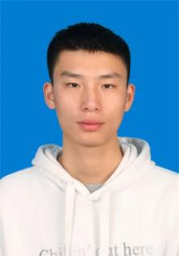
My name is Liang Peiyu, a master’s student in Bioengineering (Bioinformatics) at Guangdong Pharmaceutical University, co-trained with South China Sea Fisheries Research Institute, graduating in June 2026.
I worked as a Bioinformatics Engineer and Product Manager at Guangdong Magigene Biotechnology for over two years. I optimized eDNA multi-omics cloud analysis pipelines, finished cloud deployment and front-end interaction iteration, and built the company official website from zero to boost customer conversion.
My research focuses on AI viral metagenomics and intelligent bioinformatics systems. As the first author of one submitted paper and co-first author of two journal articles (JCR Q1/Q3), I optimized GNN and deep learning models to improve viral sequence detection accuracy and developed ViralAgent Suite with software copyright. I also built a vertical RAG-Agent intelligent Q&A system based on LangGraph, Milvus and FastAPI, applying Docker containerization to cut model hallucinations and automate omics analysis workflows.

