**何佳珩英文自我介绍**

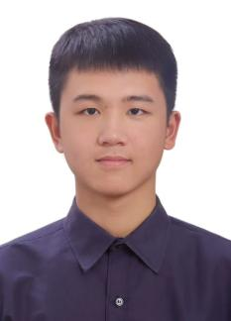

Jiaheng He is an undergraduate intern from Nankai University, where he majors in Biological Science. He has a strong interest in computational biology, particularly in the application of artificial intelligence to solve biological problems. At Yu Lab, Jiaheng He is eager to enhance his computational skills and deepen his biological insights. In his spare time, he likes to play badminton and table tennis.

E-mail：2413134@mail.nankai.edu.cn