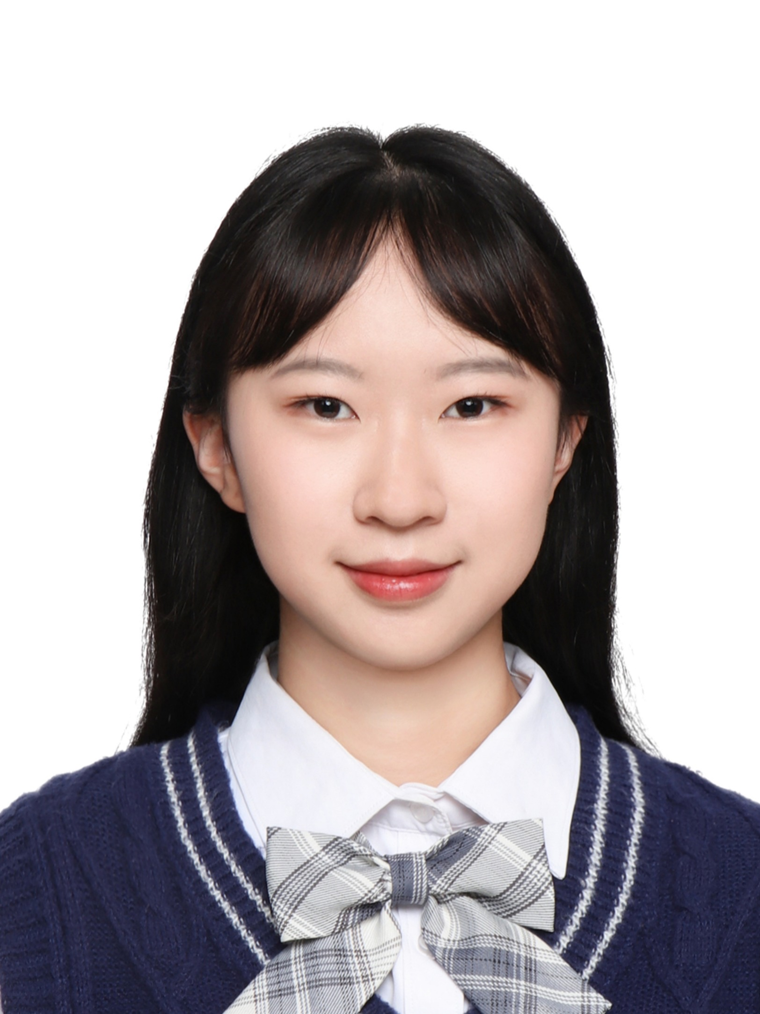

Yang Ye graduated from Harbin Medical University with a bachelor's degree in Intelligent Medical Engineering. Currently, she is pursuing a master's degree in Genetics at Guangzhou Medical University. She hopes to learn more new biological knowledge and skills in Yu Lab and contribute to the team's research.

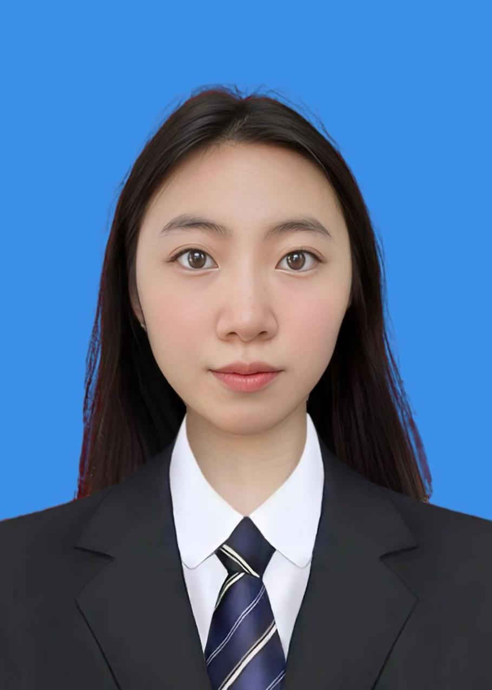Jiawen Wang obtained her Master’s degree in Biology and Medicine from the University of Chinese Academy of Sciences. As a Ph.D. student, she will specialize in the multimodal integration of next-generation single-cell multi-omics data, aiming to systematically dissect cellular heterogeneity and transcriptional regulatory networks in respiratory diseases. In her spare time, she enjoys middle and long distance running, especially distances between 3 to 10 kilometers.