Cojocaru Florin

Cotulbea Adrian

AC CTI RO AN 4

**Medbuddy**

**1. Introduction**

Welcome to Medbuddy app, built using Kotlin and Firebase. This app is designed to provide a seamless and secure platform for patients to connect with their doctors and manage their healthcare needs. With this app, patients can easily add and track their symptoms, choose a doctor from a list of qualified professionals, access their medical documentation, receive a treatment, live-chat with doctor, receive feedback and set reminders for upcoming medication. By leveraging the power of Firebase, we are able to ensure that all data is stored and transmitted securely, so that patients can have peace of mind knowing that their personal and medical information is safe. Whether you're a patient looking for a more convenient way to communicate with your doctor, or a doctor looking to streamline your patient interactions, this app is the perfect solution.

The motivation for choosing this particular app is to provide a convenient and efficient way for patients to communicate with their doctors and manage their healthcare needs. Medbuddy aims to bridge the gap between patients and doctors by providing a platform where patients can easily add and track their symptoms, choose a doctor, access medical documentation, and set reminders for appointments or medication. By using Firebase as the backend, the app ensures the security of patient data and the app can easily sync and scale the data for different users.

Medbuddy app is a combination of existing features from different healthcare and communication apps. Medbuddy have a lot of features, that we dont have one în app.By implementing this project, the app aims to provide a more convenient and efficient way for patients to communicate with their doctors. This app can help patients to easily access their medical information and communicate with their doctors in a timely manner. Additionally, Medbuddy can also help to reduce the load on clinics and hospitals, by providing patients with a convenient and easy way to access the information they need without having to visit the clinic or hospital.The idea of a real time chat make easily the communication between patient and doctor, after doctor set up an treatment and the patient need more information

**2. State of the Art**

Three similar existing applications are "Practo", "Doctor on Demand" and “Talkspace".

“Practo” is a popular healthcare app available on both iOS and Android platforms. It allows patients to search for doctors and book appointments, view medical records, and order medicine online. One of the key features of Practo is the ability for patients to search for and book appointments with doctors, as well as view their medical records. The app also provides patients with the ability to order medicine online, which is a convenient feature. However, Practo doesn't have the chat feature, request and feedback functions between patients and doctors that your application is proposing, it also lack of reminder feature and editing profile feature for doctors.

Doctor on Demand is a telemedicine app that is available on both iOS and Android platforms. It allows patients to have virtual consultations with doctors, view medical records, and receive remote treatment. However, it does not have features such as symptom tracking, reminder functionality, or a request feature for patients to create an appointment.

Talkspace is a mental health app that offers patients access to virtual therapy with licensed therapists. Users can access the app to schedule and manage therapy sessions, receive reminders and track their progress. However, it does not have features such as symptom tracking, reminder functionality, request feature, real-time chat and feedback functions between patients and doctors, and editing profile feature for doctors.

One potential advantage of Medbuddy app is the inclusion of real-time chat and feedback functions between patients and doctors, which could allow for more efficient communication and better management of healthcare needs. Additionally, the inclusion of symptom tracking and reminder functionality could help patients better manage their health, and the editing profile feature for doctors can provide a platform for doctors to manage their profile and improve the interaction with their patients. Medbuddy aims to provide a one-stop shop for patients and doctors to manage their healthcare needs, and by leveraging the power of Firebase, you can ensure that all data is stored realtime and transmitted securely.

| **Characteristics** | **App1** | **App2** | **App3** | **MedBuddy** |
| --- | --- | --- | --- | --- |
| ***Store link*** | [Practo](https://play.google.com/store/apps/details?id=com.practo.fabric) | [Doctor On Demand](https://play.google.com/store/apps/details?id=com.doctorondemand.android.patient) | [Talkspace](https://play.google.com/store/apps/details?id=com.talkspace.talkspaceapp) | - |
| ***Store grade*** | 4.4 / 5 | 4 / 5 | 2 / 5 | - |
| ***Nr. installs*** | 10M+ | 1M+ | 500k+ | - |
| ***Nr. ratings*** | 300k | 40k | 6K | - |
| ***Ads/ in-app purchases*** | x | x | x | - |
| *Communication with healthcare providers* | x | x | x | x |
| *Real-time chat* | - | - | - | x |
| *Access to medical records* | x | x | x | x |
| *feedback functions* | - | x | - | x |
| *Editing profile* | - | - | - | x |
| *Appointment scheduling* | x | x | - | x |
| *Medication management* | x | - | x | x |
| *Reminders* | - | x | x | x |
| *Virtual Request* | - | - | x | x |
| *Symptom tracking* | - | - | - | x |

**3. Design and Implementation**

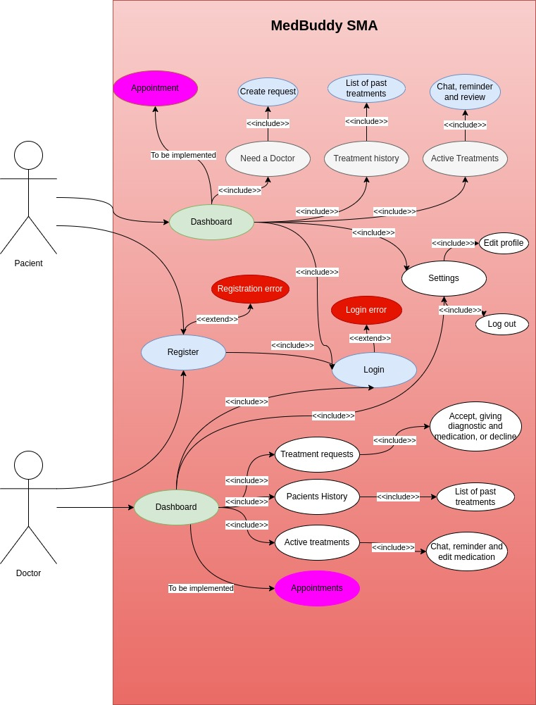

As user, I can register as Doctor or Patient.We have user Firebase Real Time database to store fullname,email, username, password, role, phone number.After setup profile, I have dashboard depending on role(PatientDashboard or DoctorDashboard)  
 If I am Patient, in my dashboard i have the option to create a request clicking on “need a doctor”button.After clicking I can choose the speciality of the doctor i need and give some symptoms.Now, the request is active and wait for a specialist medic accept the request  
Another option that i have as patient is to see active treatments(the treatments accepted by one medic).I this layout, named Patient Interaction, i m able to see diagnostic medication, my symptoms.Also i have the possibility to discuss on live chat with the medic who accept my request.At least, i have the option to set reminder for my medication or give a review to doctor.If a treatment is closed, i can able to see at treatment history and after click on them it will appear pop up with doctor, diagnostic and medication for that treatment.  
Also I have the ability to press settings and edit my profile, adding more fields such as gender, age and weight which helps the doctor to give me best medication.

If I am Doctor, in my dashboard i have the option to see pending request.It will appear a layout that contains name gender age weight and symptoms of patient, so i can give a diagnostic and medication.After completing this fields i can accept(that means the treatments will appear at active) or i can refuse, so other doctor ca accept the patient request.  
If I accept, the patient and diagnostic appear în active so i can click on them to open Doctor Interaction, here i can edit medication, i can chat with patient on live chat, i can set an appointment, i can set two type of reminder, i can end an treatment.After ending a treatment i can see the closed treatment în treatment history and if I clicked it will appear a pop up to see name of the patient, diagnostic, medication and review from patient.Also în my dashboard, i can change fullname, phone number or my role.

**4. System Usage**

If you are patient, press Need a Doctor am complete the request with speciality and symptoms

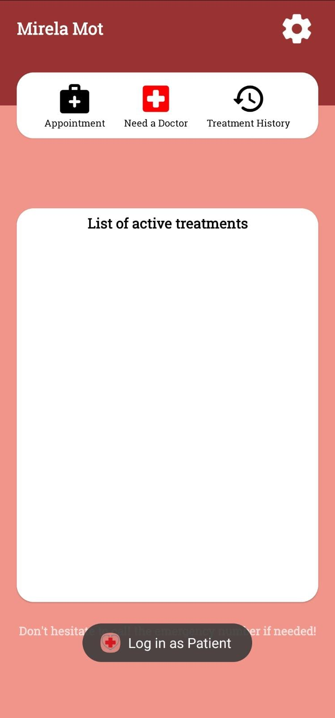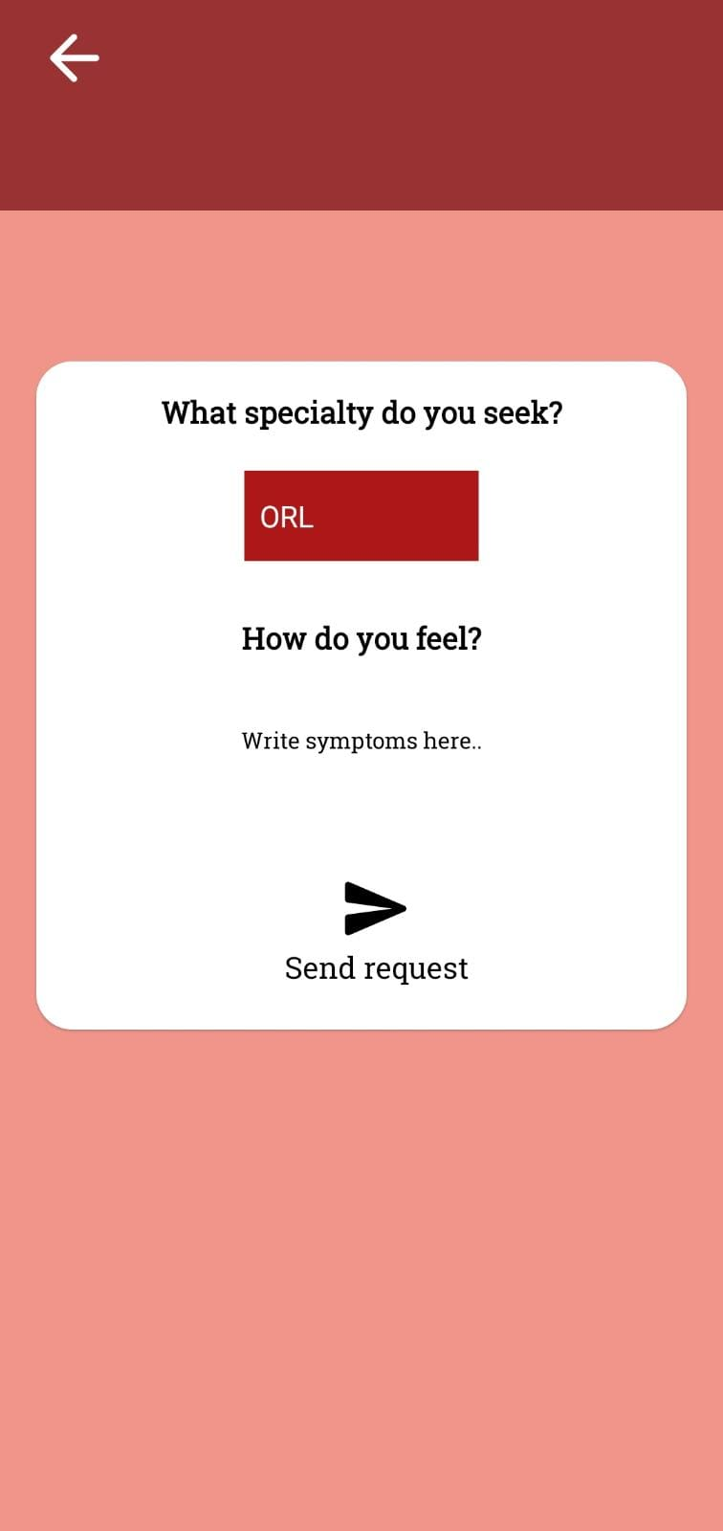

After accept, this is the PatientInteraction, you can press Reminder to set an reminder or you can chat with the patient, give an review, or set up an reminder to get your medication at right time

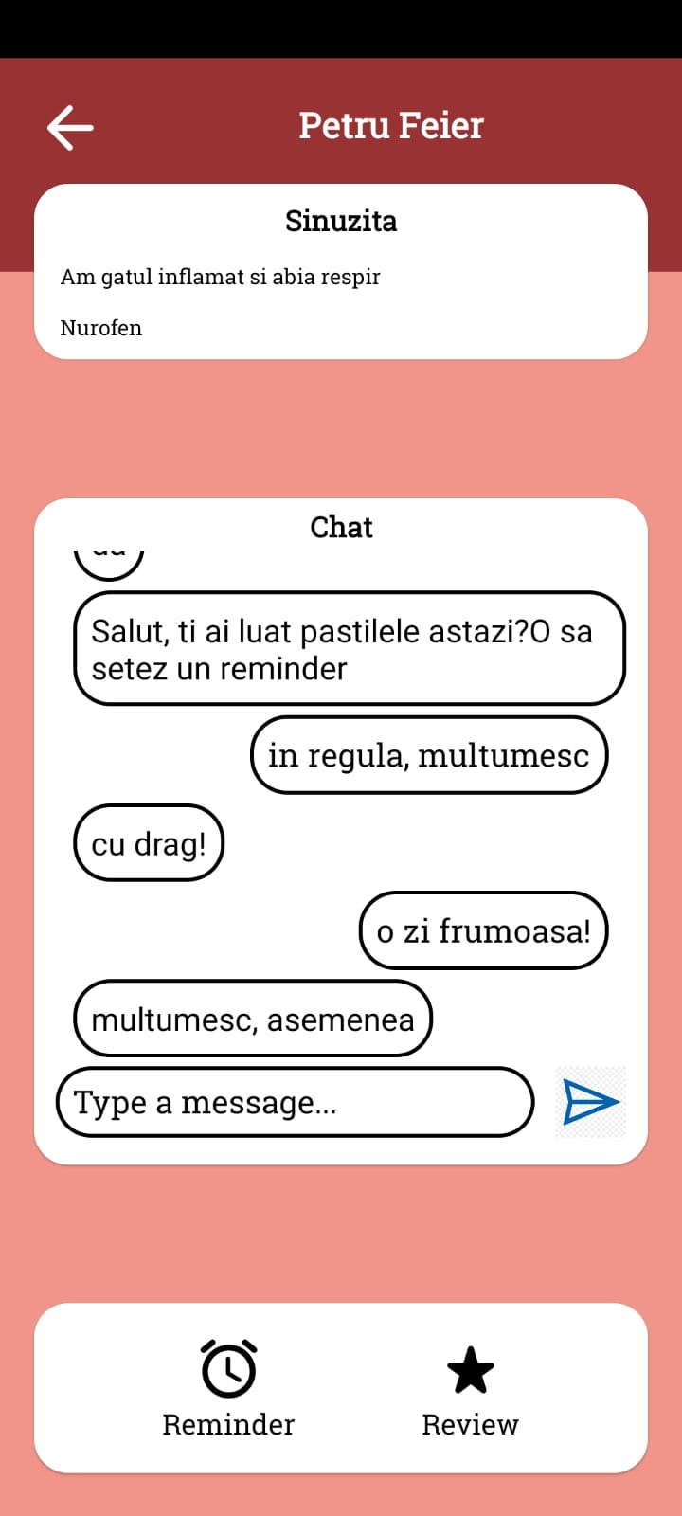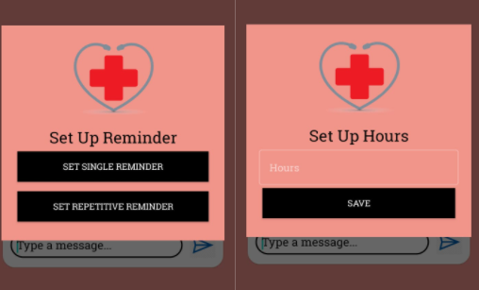

If you are doctor, you can press on active patients to see Doctor Interaction.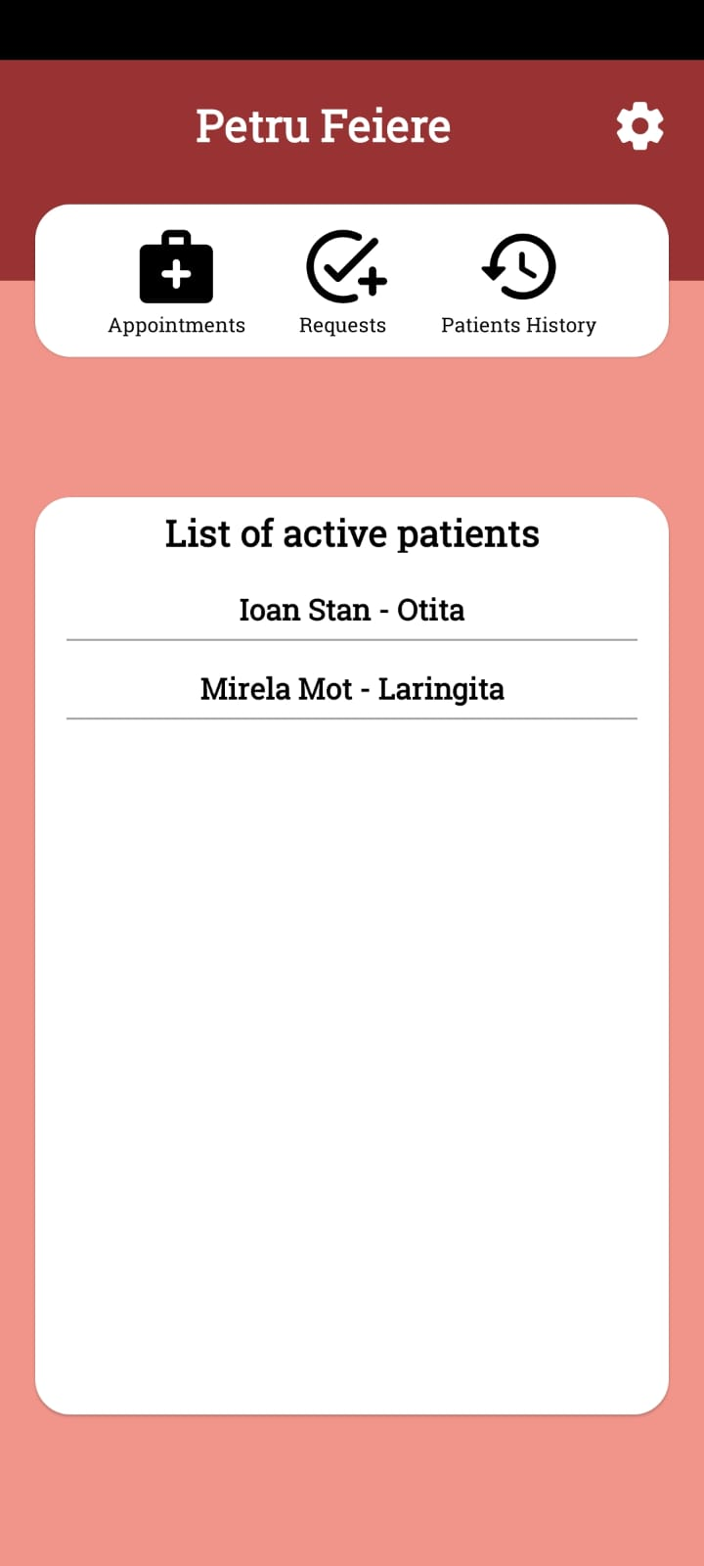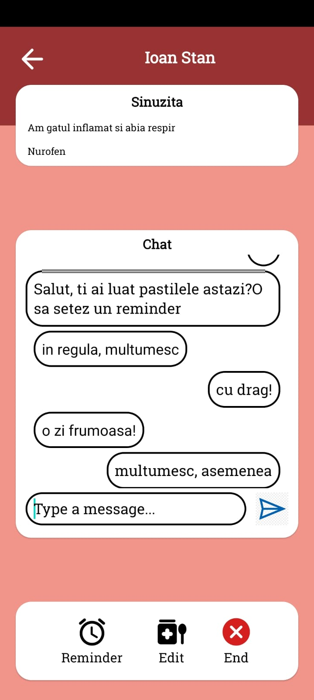

You can see details of patient, chat with patient, set up an reminder, edit medication or end if treatment is done

To accept one request you must clicked Request

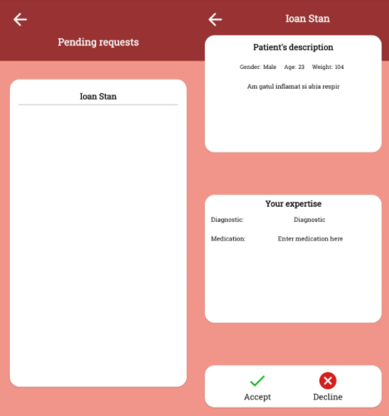

now you can accept or let for the other doctors

**5. Conclusions**

* + Application works properly. We are glad that we realize this application with success and we are excited that we could make an application that contains a lot of features and keeps a user friendly interface.
  + in the future, we want that application grow up on App Store and why not to be the best seller în this area because we think that an user friendly healthy appcare bring up positive reviews from user and în same time make the doctors job more easily to do.
  + We have learned a lot of things. We can say this laboratory was one of the most interesting parts of this field of study.We had the privilege to learn about kotlin, real time database, bluetooth communication and many others, so we can say that we are happy that we chose this laboratory as an optional.
  + A recommendation from our side would be that this laboratory be done in the first 2 years and last 2 semesters

**References** *(optional)*

<https://auth0.com/blog/get-started-with-android-authentication-using-kotlin-part-1/>

<https://developer.android.com/codelabs/advanced-android-kotlin-training-login#0>

<https://firebase.google.com/docs/database/android/read-and-write>

<https://www.geeksforgeeks.org/build-a-chat-app-in-android-using-kotlin/>

<https://developer.android.com/develop/ui/views/notifications/build-notification>

<https://developer.android.com/develop/ui>

<https://www.toptal.com/firebase/role-based-firebase-authentication>

<https://www.javatpoint.com/kotlin-android-popup-menu>

<https://firebase.google.com/docs/database/android/start>

<https://kotlinlang.org/>