PMV15T

Parameters Value Unit of Measurement

PTFE MEMBRANE 100% CAS No. 9002-84-0
WATER ENTRY PRESSURE (WEP) Min 265, Typical 370 mbar
AIR FLOW Min 45, Typical 75 l/hr/cm² Δp 70mbar
THICKNESS 0.18 mm ±0.03mm
IP RATING* 64,67 BS EN 60529: 1992
FILTRATION EFFICIENCY* 0.4µ IEST RP-CC007.2 2009
OLEOPHOBIC GRADE 8 AATCC TM 118 - 1997

The values stated above for Airflow and WEP are based on Porex QC test methods - Information available on request.
Testing is not to any national or international standard. Different test methods and equipment may produce different results.
* Values based on representative sample. Testing is not conducted as part of the roll approval process.
Samples are intended for evaluation purposes only and not intended for specification.

Additional Information

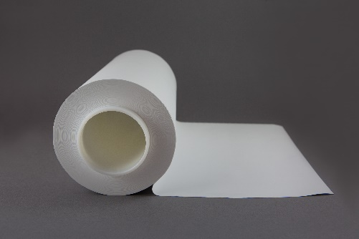
- Can be supplied in format of:
  - Master rolls (330 ±5mm width) on 75mm (3”) plastic core
  - Slit rolls on a 75mm (3”) plastic core
  - Die cut shapes
- Assembly Suggestions:
  - Ultrasonic welding
  - Thermal welding

  - Over-moulding
  - Pressure Sensitive Adhesive
  - Compression seal
- Raw material is compliant with:
  - PFOA Free, Compliant with (EC) No 1907/2006 REACH and Persistent Organic Pollutants (POP) EU 2019/1021.
  - Compliant with RoHS, WEEE, REACH
  - Operating temperature range: -40 to 260ºC
  - Passes salt fog test: Test Method ASTM B117-11
Other
Naturally hydrophobic

