

Advanced Artificial Intelligence

Coursework 1
Neural Networks and Genetic Algorithms

Student ID: UP2154598
Course: M33176 Advanced Artificial Intelligence
Date: 10th/May/2026

Table of Contents
Abstract 3
Introduction 3
Neural Network 3
Data Analysis and Pre-processing 3
Neural Network Design and Training 4
Results and Analysis 5
Conclusion and Recommendations 5
Genetic Algorithm 6
Analysis of Shekel Function 6
GA Configuration 6
Parameters, Stopping Criteria, and Convergence 7
Results and Analysis 7
Conclusion and Recommendations 8
Appendix A 9
Appendix B 14

Abstract
This report presents the design, training, and evaluation of two systems applied to distinct problem domains. A neural network is developed using MATLAB’s nprtool to classify osteoporotic vertebral fractures from a clinical dataset of 600 patients described by 25 features. The trained model achieved a test accuracy of 53.5%, an AUC of approximately 0.50, and an overall F1 score at 0.211. The limitations of mean imputation and the absence of class-balancing strategies are identified as the primary contributors to this outcome. A Genetic Algorithm (GA) is applied to minimise the Shekel family functions for m = 5 and m = 10 with MATLAB’s optimizer. The GA successfully locates the global minimum for Shekel10 (-10.5364) but converges to a local minimum for Shekel5 (-5.0552) multiple times. Illustrating the susceptibility of standard GA configurations to premature convergence in deceptive landscapes.

Introduction
Neural network and genetic algorithms represent two complementary paradigms within the field of intelligent systems. Neural networks are models capable of learning complex, non-linear patterns between inputs and outputs through iterative parameter optimisation. Best for prediction tasks in high-dimensional feature spaces. GA, are population-based search methods inspired by the principles of natural selection, designed to explore large and potentially non-convex solution spaces in search of global optima without requiring gradient information. This report addresses two separate tasks. The first involved developing a neural network classifier to distinguish between healthy patients and those with osteoporotic vertebral fractures, using a clinical dataset of 600 records. The second involves applying a GA to locate the global minima of the Shekel family functions. Both tasks are implemented in MATLAB. The report documents the methodology, results, and critical analysis for each task in turn.

Neural Network

Data Analysis and Pre-processing
The dataset comprises 600 patient records described by 25 clinical and lifestyle features, with a binary class label VBX denoting either Healthy (VBX=0) or Vertebral Fracture (VBX=1). Overall, there are 500 healthy patients and 100 who has vertebral fracture. This constitutes a markedly imbalanced dataset, with fracture cases representing only 16.5% of all records. Such imbalance poses a significant challenge to classifier training as model may achieve high accuracy by predicating the majority as healthy for all inputs. Prior to modelling, all missing values were identified. Two features exceeded the 45% missingness threshold as part of the requirement. These are Menopause with 56.5% and Heart Rate (HRT) with 45.7% missing values. Both were retained in the dataset for training the model, but subjected to domain-informed imputation. For menopause, male patients were assigned a value of 0 as this could not happen on male. Missing female patients were replaced with a mode value in female to represent a general situation for this group to avoid introducing biologically inconsistent values. HRT missing values were imputed using the column mean, as the variable is continuous in nature. The remaining features, including Alcohol, Alcohol24, Vitamin D, Calcium, and the physical activity dose variables exhibited missingness between 0.2% and 24.0% and were imputed with their means respectively. The aim is to preserve the distributional mean whilst introducing minimal distortion to the variance. Features with near-negligible missingness like Ethnic, smoking, has less than 5 missing values, were treated identically.
A correlation matrix was computed across all 25 features to examine inter-feature relationships prior to training. Strong positive correlations were identified between Weight, BMI, and Waist circumference, which is consistent with their shared physiological basis. Moderate positive correlations were also observed among the physical activity dose variable, indicating a coherent activity cluster. These correlations suggest that some degree of feature redundancy exists within the dataset, which may influence the effective dimensionality presented to the network.
All 25 features were standardised using normalisation before training to prevent features with large numerical range from dominating the gradient updates and distorting the learned weights. The dataset was subsequently partitioned using a random split-sampling strategy into training (70%, n=420), validation (15%, n=90), and test (15%, n=90) subsets in MATLAB’s Neural Network Pattern Recognition tool.

Neural Network Design and Training
A feedforward Pattern Recognition Neural Network was constructed using MATLAB’s nprtool. The network architecture comprised 10 hidden layers with a sigmoid activation function being given initially. A softmax output layer with two output nodes corresponding to the two classes, healthy or fracture. Cross-entropy was employed as the performance measure as it penalises confident misclassifications more heavily than mean squared error. The network received all 25 normalised features as inputs. A compact single-hidden-layer topology was given by MATLAB. Training was performed using the scaled conjugated gradient (SCG) backpropagation algorithm provided by nprtool in MATLAB to perform most efficient gradient descent with small and medium size dataset. Early stopping was implemented via the validation subset to prevent overfitting. The complete training run converged within seven epochs, with the best validation performance of 0.68 cross-entropy recorded at epoch two, as shown in Figure 4 in Appendix A. The training, validation, and test loss curves remained tightly clustered throughout, which indicates that the model did not overfit. However, it failed to learn a meaningful decision boundary under nprtool’s neural network training.

Results and Analysis
The trained network demonstrated a relatively less satisfactory overall performance across evaluation phases, a finding that is directly attributable to the severe class imbalance inherent in the data. The confusion matrices for the training, validation, and test subsets are presented in the figures below, as well as a figure for ROC curves.
During the training, the network correctly classified 178 out of 345 healthy samples and correctly identified 29 out of 75 fracture samples. The overall training accuracy of 49.3%. In the validation subset, 54 samples are correctly identified out of 90 samples with an overall accuracy rate of 60%. Testing subset shows only 48 samples are correctly classified with an overall accuracy rate of 53.3%. This data reveals a consistent pattern: the model is strongly biased towards predicting health for the majority of inputs. This behaviour is a classical consequence of training a standard cross-entropy loss function on an imbalanced dataset. The ROC curves in Figure 6 show what we just concluded, as all curves lie close to the diagonal line, indicating that the model performs approximately equivalently to random class assignment. The AUC is approximately 0.5 for all training, testing, and validation datasets. The F1 score for the fracture class on the test set was only 0.16, whilst the overall F1 of 0.211 further reflects the model’s inability to balance precision and recall across both classes under data imbalance. It is noteworthy that the training, validation, and test losses all converged to 0.68. This pattern is atypical of overfitting, in which training loss would be substantially lower than validation and test loss. It indicates that the data imbalance is the main issue rather than an architecture limitation in the model.

Conclusion and Recommendations
The neural network as trained demonstrated negligible ability to distinguish vertebral fracture from healthy patients, achieving test accuracy of 53.3% and an AUC of approximately 0.50 across all evaluation subsets. The root cause is the severe class imbalance, which, in the absence of corrective measures, causes the cross-entropy loss function to be dominated by the majority class, leading the network to adopt a near-constant output rather than a discriminative decision boundary. Several improvements would be implemented to produce a better result in the future. Firstly, applying class-weighted loss or synthetic minority oversampling before training would give minority class greater influence over all data to prevent imbalanced data structure affect training. Secondly, a cross-validation across multiple folds would provide a more statistically robust estimate of generalisation performance. Finally, the mean imputation adopted for features with moderate missingness introduces human intervention. Other approaches such as k-nearest neighbour imputation might be better for preserving the underlying data distribution and may contribute to improved model performance.

Genetic Algorithm

Analysis of Shekel Function
The Shekel family of functions is a benchmark for global optimisation algorithm. The general form is defined as:
f₄ˍₘ(x₁, ..., x₄) = −∑ᵢ⁼₁ᵐ [ ∑ⱼ⁼₁⁴ (xⱼ − aᵢⱼ)² + cᵢ ]⁻¹, m = 5, 7, 10
The function operates over a four-dimensional decision space with search bounds x_{i}∈[-15,20] for i=1,2,3,4. The parameter m governs the number of terms in the outer summation and directly determines the number of local minima present in the landscape: as m increases, additional valleys are introduced, each defined by the rows of the constant’s matrix A and the depth coefficient c_{i}. The known global minima are at f_{4,5}=-10.1532 at approximately (4.00004, 4.00013, 4.00004, 4.00013) and f_{4,10}=-10.5364 at approximately (4.00075, 4.00059, 3.99966, 3.99951). Two variants were selected for this investigation: Shekel5 and Shekel10, where m is set to 5 and 10 respectively. This pairing was chosen deliberately to examine how an increase in landscape complexity affects the GA’s search behaviour.

GA Configuration
The fitness function was implemented as a custom MATLAB function (shekel_func.m), implemented Shekel formulation, with the parameter m set to 5 or 10. Since MATLAB’s GA solver minimises by convention, the function was used directly without sign inversion, as the Shekel function is itself defined as a negative sum and therefore presents a minimisation objective natively. The solver was configured via the MATLAB Live Editor Optimize Task with a nonlinear objective, GA as the solver, a function handle pointing to the custom fitness function, and nvar=4 decision variables. Bounds were set to lower bound at -15 and upper bound at 20 for all 4 parameters as search domain specified in the requirement.
The default MATLAB GA selection strategy, stochastic uniform selection, was employed. Compared with fitness-proportional (roulette wheel) as a common method to use, the stochastic uniform selection reduces the variance in the number of times an individual dominating the population rapidly, preserving population diversity in the early stage.
The reproductive operators applied were MATLAB’s default scattered crossover and Gaussian mutation. They create a random binary vector to produce offspring that sample broadly from both parents’ solution components. Gaussian mutation perturbs each gene by adding a random value from a zero-mean Gaussian distribution, with the standard deviation that is scaled to the current generation. This adaptive reduction of the mutation step size over time promotes fine-grained exploration in later generations whilst allowing broader exploration in early generations.

Parameters, Stopping Criteria, and Convergence
A population of 50 individuals was used for both runs by default, which is a reasonable value considering the size if decision variables and to keep the ability to track each individual during the process. Two elite individuals were preserved unchanged into each successive generation, ensuring that the best solution found is never lost to stochastic operators. The maximum number of generations was set to the default of 100 × nvar = 400. However, both runs converged well before this limit, terminating at approximately 85 generations under the default function tolerance and stall generation criteria. The average distance between individuals’ plots (in Figure 8 and 9 in Appendix A) reveal a consistent pattern in both runs. Population diversity was high in the initial generations with about 15 to 25 units, reflecting the broad initial random sample across the search domain, and declined sharply over the first 20 generations as selection pressure directed the population towards promising regions. And then this number become nearly negligible after 40 generations suggesting complete convergence of the population. Nevertheless, this is a natural feature of the GA, the speed is indicative of premature convergence, especially in Shekel5, where the GA converted to a local rather than global minimum across repeated independent runs.

Results and Analysis
The results of both GA are summarised in Table1 (Appendix B). For Shekel10, the GA successfully located the global minimum, yielding a best fitness of -10.5364 and a solution vector of (4.0007, 4.0006, 3.9997, 3.9995). The best and mean fitness curves also converged to the same value, indicating that the entire population ultimately concentrated within the global basin of attraction. The Best, Worst, and Mean Scores plot shows a progressive reduction in score spread across generations, narrowing steadily from generation 15 onwards. For Shekel5, the GA converged to a local minimum with a best fitness of -5.0552 and a solution vector of (1.0002, 1.0002, 1.0001, 1.0002). This solution corresponds to the second row of the constant’s matrix A. The known global minimum for Shekel5 is -10.1532 at (4.00004, 4.00013, 4.00004, 4.00013). This outcome was consistent across repeated runs, indicating that the configuration used is systematically unable to escape the (1,1,1,1) attractor for this function variant. The score histograms for both runs exhibit a strongly right-skewed distribution of individual fitness scores with approximately 30 out of 50 individuals concentrated in the leftmost score. This clustering confirms that by the final generation, the majority of the population had converged to a nearly identical solution. That is also why near zero average distance values observed. The Genealogy plots reveal a sustained mixture of crossover (blue) and mutation (orange) children throughout the run. The selection function histograms for both runs follow a consistent pattern: a small number of highly ranked individuals are selected disproportionately often. This is characteristic of moderate selection pressure and is consistent with the stochastic uniform selection method, which does not impose the extreme bias of pure fitness proportional selection.

Conclusion and Recommendations
The GA demonstrated markedly different outcomes for the two Shekel variants examined. For Shekel10, the algorithm successfully identified the global minimum, confirming that the default configuration is capable of navigating a complex landscape when the initial population happens to seed sufficient individuals within the global basin’s region of influence. For Shekel5, repeated runs converged consistently to the local minimum at (1,1,1,1) with a fitness value only at -5.0552. This result reveals that the performance is sensitive to the relative depths and positions of local minima. The rapid collapse of population diversity indicates that premature convergence is a significant concern for this configuration. Several parameter adjustments and algorithmic modifications could reduce the likelihood. For instance, increasing the population size would provide a broader initial coverage and reduce the probability of the entire initial sample failing within the basin of a local minimum. Other methods like increase mutation rate or adopting non-decreasing mutation step size would also help to solve such issue.

Appendix A

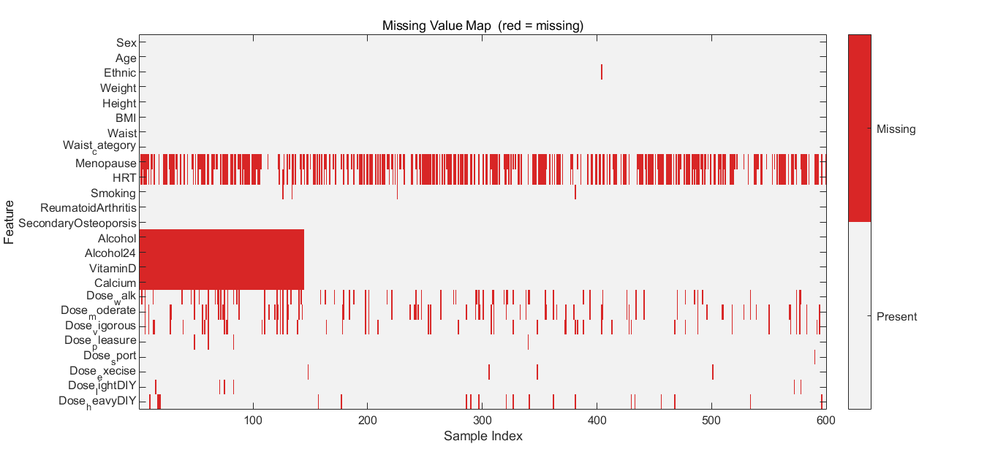
Figure1: Missing Value Map across all 600 Samples and 25 Features.

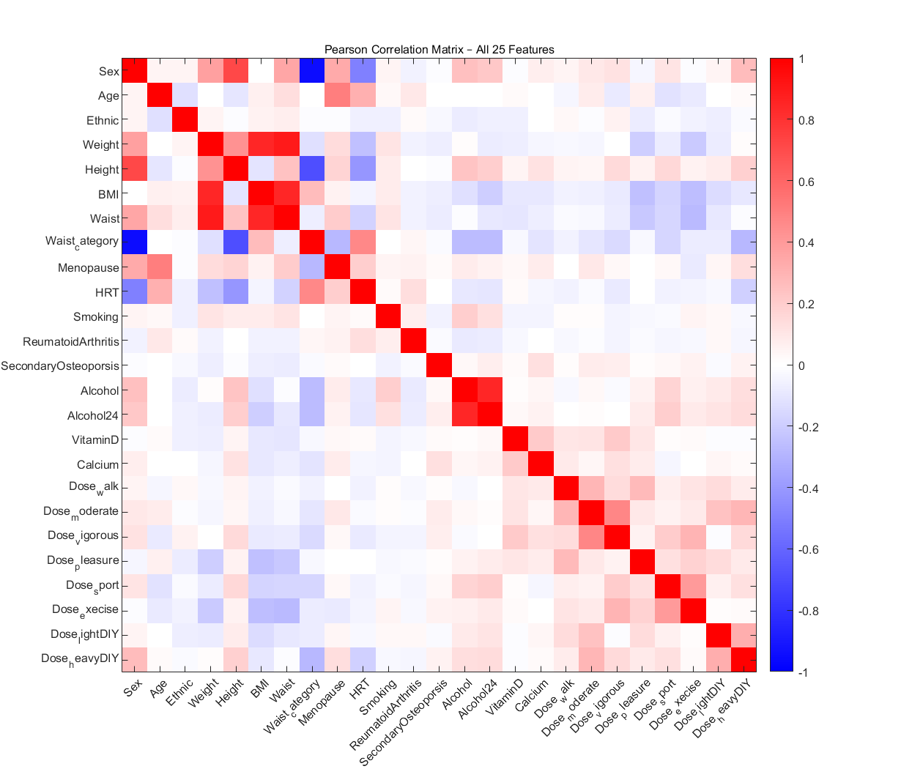
Figure2: Correlation Matrix across all 25 Features.
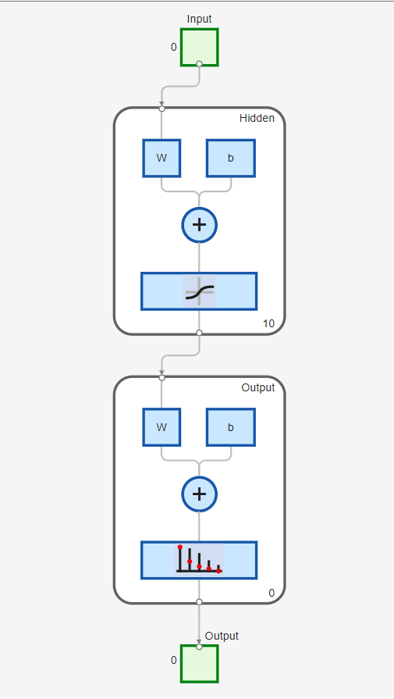
Figure 3: Neural Network Structure
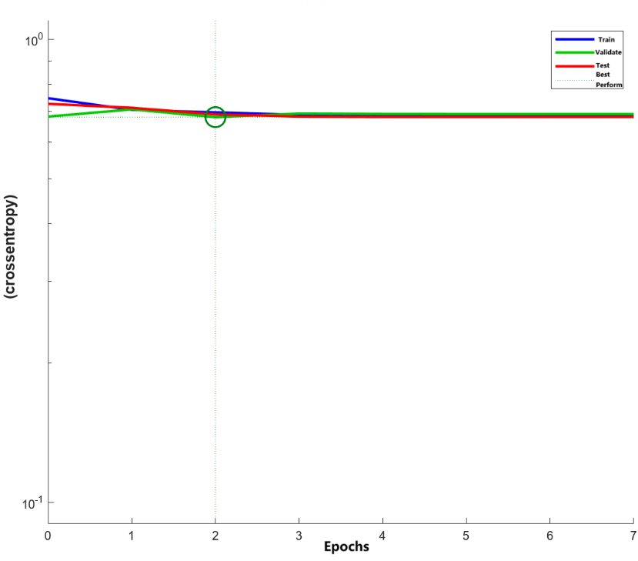
Figure 4: Performance Graph.

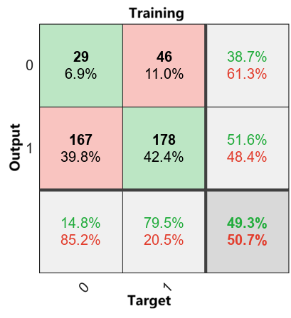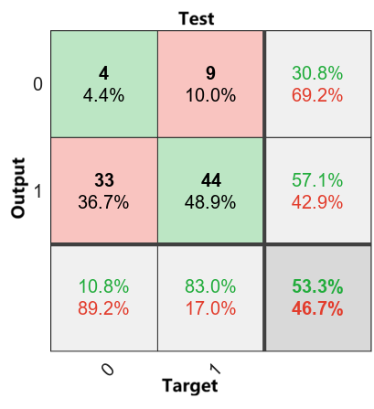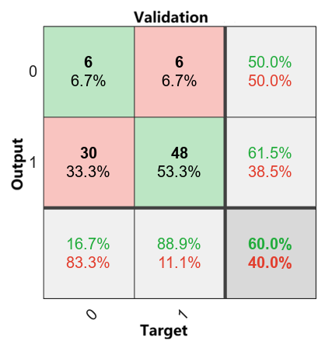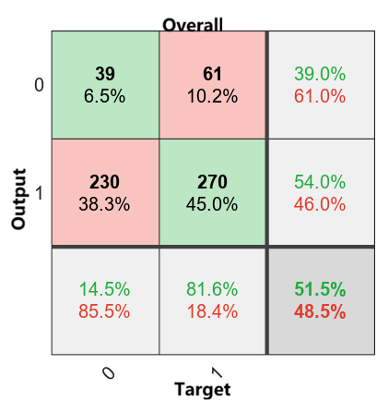
Figure 5: Confusion Matrices.

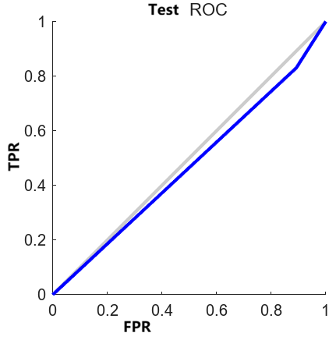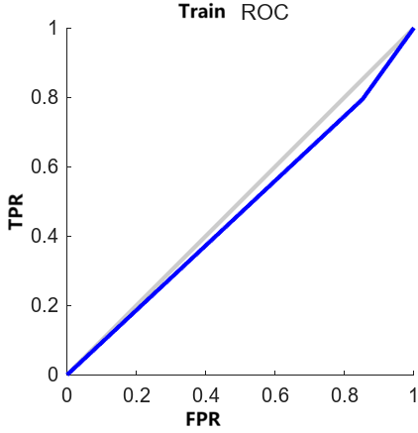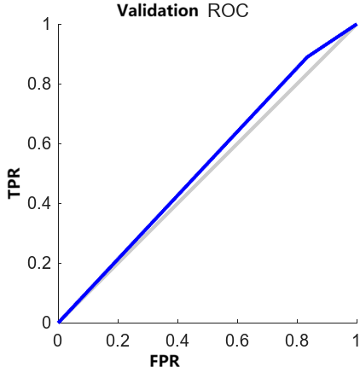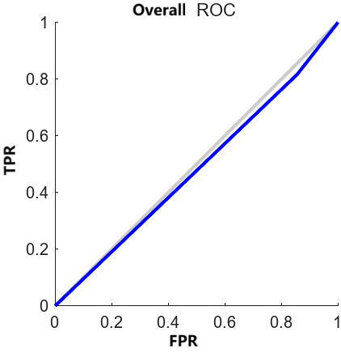
Figure 6: ROC Curves.

Figure 7: MATLAB Optimizer for GA in Live Script in Chinese Operating Language.
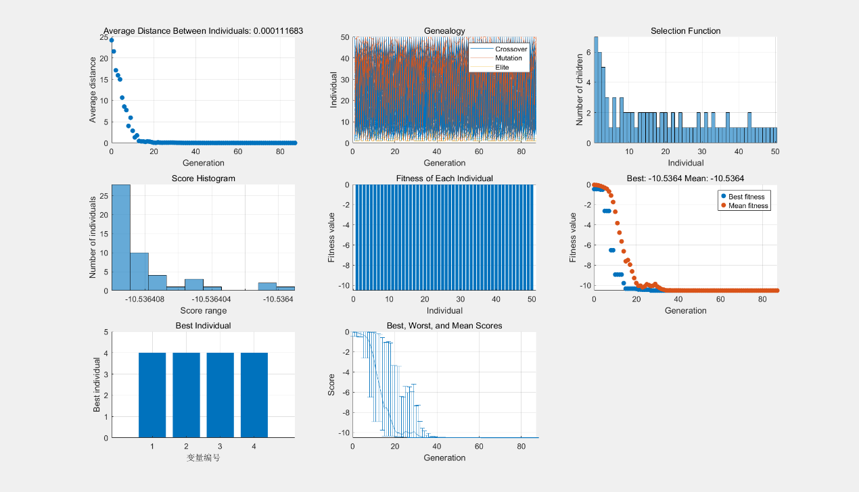
Figure 8: GA Results for Shekel10 (m=10), All Plots including Distance, Genealogy, Selection, Score Histogram, Fitness of Each Individual, Best/Mean Fitness, Best Individual, Best/Worst/Mean Scores.
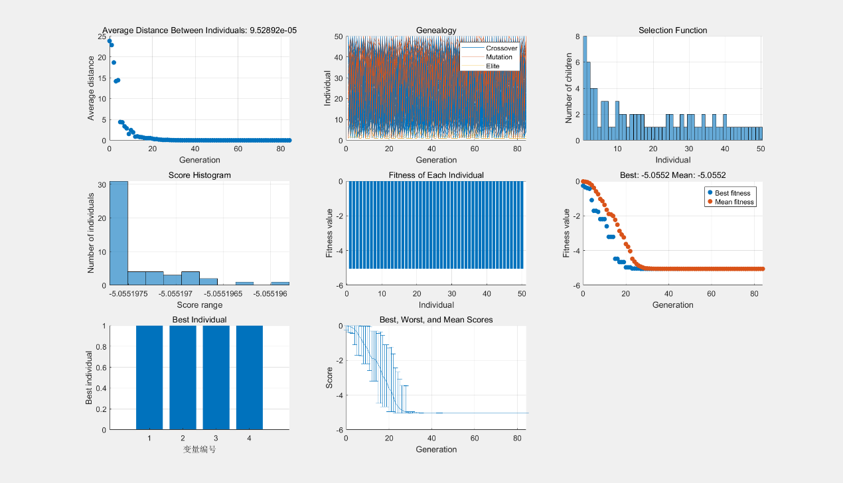
Figure 9: GA Results for Shekel5 (m=5), All Plots including Distance, Genealogy, Selection, Score Histogram, Fitness of Each Individual, Best/Mean Fitness, Best Individual, Best/Worst/Mean Scores.

Appendix B
Parameter | Shekel5 (m = 5) | Shekel10 (m = 10)
Best fitness found | −5.0552 | −10.5364
Solution (x₁, x₂, x₃, x₄) | (1.0002, 1.0002, 1.0001, 1.0002) | (4.0007, 4.0006, 3.9997, 3.9995)
Known Global Minimum | −10.1532 | −10.5364
Absolute error from global minimum | 5.0980  (local min) | ≈ 0.0000
Population size | 50 | 50
Approximate convergence generation | ≈ 35 | ≈ 30
Table 1: Summary of GA Results for SHEKEL5 and Shekel10.

