Matlab and Neural Network toolboxes. Single perceptron and Linearly separable classification problem

Lab 6

Perceptron - Learning outcomes

You will be able to construct simple neural network architectures using Matlab, change the network parameters and train the networks. You will also see the importance of preprocessing the dataset and how it influences the outcome of the training.

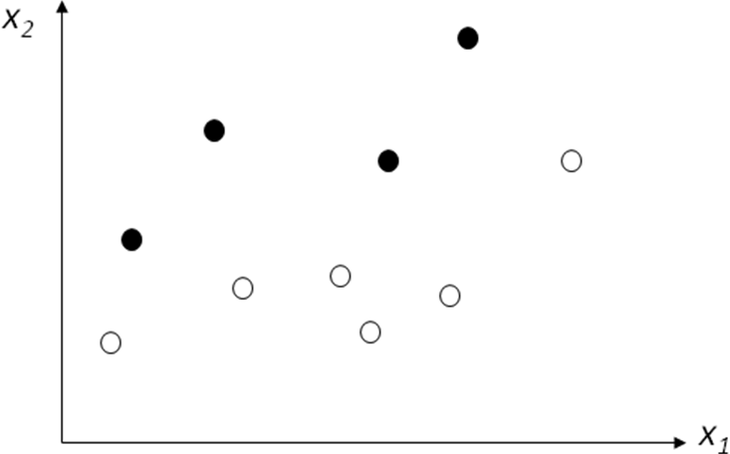


Fig. 1. A Linearly separable pattern classification problem: black points belong to Class0 and whites to Class1 (e.g., ‘thin’ and ‘fat’ classes for patients: x1–body weight [kilos]; x2- body height [centimeters]).

As we already learned, the perceptrons can be trained to solve a narrow class of classification problems (they can essentially divide data into two clusters with a 'decision line' (e.g., when solving simple classification problem)). Historically, their significance lies in being ones of the first neural networks to reliably solve linear classification problems and at the same time having a simple learning rule.
Copy and paste the following data into an m-file with a function name, name the file BodyMassData.m.
function D = BodyMassData
D = [ 0.800e+002 1.6e+002 1
0.900e+002 1.7e+002 0
0.110e+003 1.9e+002 0
0.115e+003 1.65e+002 1
0.125e+003 1.68e+002 1
0.128e+003 1.61e+002 1
0.130e+003 1.82e+002 0
0.140e+003 1.68e+002 1
0.149e+003 2.02e+002 0
0.170e+003 1.80e+002 1
0.200e+003 1.95e+002 1
];
The data consists of x1-x2 pairs (first two columns - body weight [kg] and height [cm]) assigned a 0 or 1 label, depending on which class/category (‘fat’ or ‘thin’) the point/sample belongs to.
x1 x2 category/class label
0.800e+002 1.6e+002 1
0.900e+002 1.7e+002 0
0.110e+003 1.9e+002 0
… … …

Now, load the data into a matrix Data using the following command (make sure Matlab has access to your BodyMassData.m file):
Data = BodyMassData
Before creating a new perceptron, you can visualize the data using the plot() function. Copy and paste (in the Editor window) the following code, save it in a plotData.m file and run it.
function plotData(Data)
hold
for i=1:length(Data(:,1))
if (Data(i,3)== 0)
plot(Data(i,1),Data(i,2),'bo'); %mark 'label 0' samples with 'o'
else
plot(Data(i,1),Data(i,2),'b*'); %mark 'label 1' samples as '*'
end
end
end

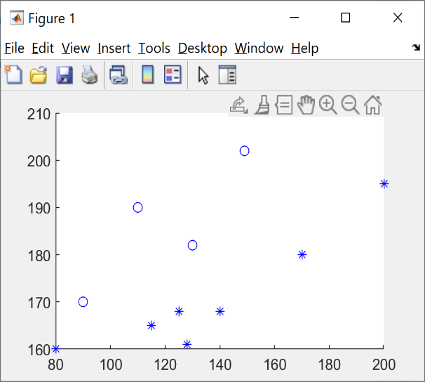
In Matlab Command window type:
plotData(Data)
You should see the figure to the right with two types of points (are they linearly separable?).
You can view the data values range with:
dmax = max(Data)
dmin = min(Data)

Get the third column as a target set:
target = Data(:,3)

Get the first two columns as the input set:
input = Data(:,1:2)

Perceptrons are provided in Matlab mostly of historical and educational interest. For solving more complex classification problems we will use the patternnet later. Recall also that Feedforward networks can be used for any kind of input - output mapping. A feedforward network with one hidden layer and enough neurons in it, can fit any finite input-output mapping problem (if such fit exists). Specialized versions of the feedforward network include fitting (fitnet) and pattern recognition (patternnet) networks. A variation on the feedforward network is the cascade forward network (cascadeforwardnet) which has additional connections from the input to every layer, and from each layer to all following layers.
As it is a very simple problem and we expect that a perceptron will properly classify the 11 input vectors from the input into the two categories given in the target.
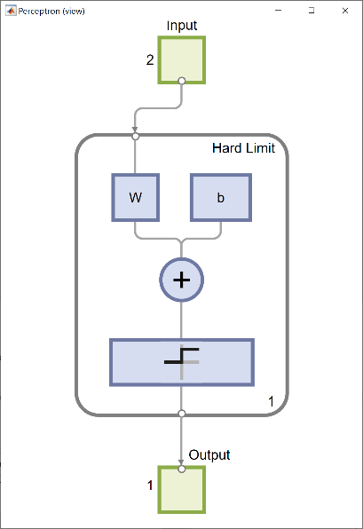
The perceptron() function creates a new network with ‘hardlim’ transfer function and ‘learnp’ learning rule. The network is then configured with the input and target data which results in initial values for its weights and bias. (Configuration is normally not necessary, as it is done automatically by adapt() and train() functions.)
Firstly, transpose your input and target data:
IN=input’;
TARGET=target’;
And then enter:
net = perceptron();
net = configure(net,IN,TARGET);
view (net);

The following command will show you some information about the network object net:
net
The ‘hardlim’ is the Heaviside (step) transfer function and configure() function configures network inputs and outputs based on input data IN and target data TARGET, preparing the network for best performance when trained on that data.
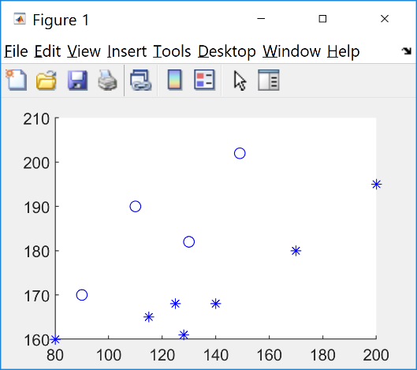
Add the neuron's initial attempt at classification to the plot. The initial weights are set to zero, so any input gives the same output and the classification line may not even appear on the plot (fig. to the right).
hold on
linehandle = plotpc(net.IW{1},net.b{1});

So, we are going to train it! We can train the perceptron to classify the data, using the adapt() function:
net = adapt(net,IN,TARGET);
(again, don’t use semicolon if you want to see the network parameters). The adapt() function returns a new network object (a better classifier); the network output; and the error.

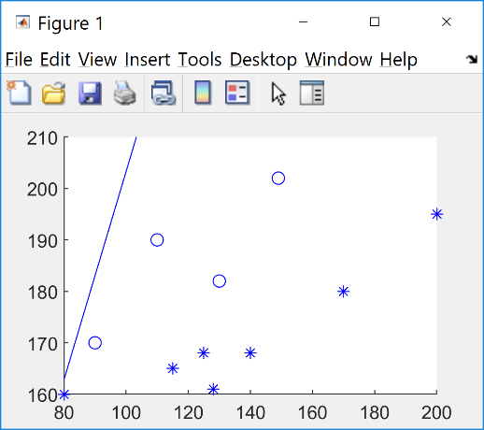
The following code (a loop) allows the network to adapt, plots the classification line, and continues until the error (e) becomes zero (you may have to interrupt the loop (Ctrl/c) if e is not converging to 0). The sum squared error performance function sse() calculates the network performance.
e = 1;
while (sse(e))
[net, Y, e] = adapt(net, IN, TARGET);
linehandle = plotpc(net.IW{1}, net.b{1}, linehandle);
drawnow;
end
You will see that the NN (net) can’t classify the problem (flickering line in the fig. to the right, use Ctrl/c to interrupt).
What to do then?

Let’s see if rearranging the data would help. Take a look at BMData.m file, it is the same data, just with rearranged rows (meaning, during training the samples will be presented to the NN in different order).
Run the following code again (copy/paste), or if you prefer you could save it in an .m file first and then run it, e.g., ‘learnBMData’).
Data = BMData
IN = Data(:,1:2)' % transposed
TARGET = Data(:,3)' % transposed
plotpv(IN, TARGET)
net = perceptron('hardlim','learnp'); % xxxx
net = configure(net,IN,TARGET);
hold on
linehandle = plotpc(net.IW{1},net.b{1});
e = 1;
count = 0;
while (sse(e)) % Sum squared error performance function
disp(strcat('The perceptron classification squared error before adaptation ', num2str(count), ' is: ', num2str(sse(e)), '.'));
[net,Y,e] = adapt(net,IN,TARGET); % Adapt the neural network ‘net’
linehandle = plotpc(net.IW{1},net.b{1},linehandle);
drawnow;
count = count + 1;
pause(0.5) % pause between perceptron adaptations in miliseconds
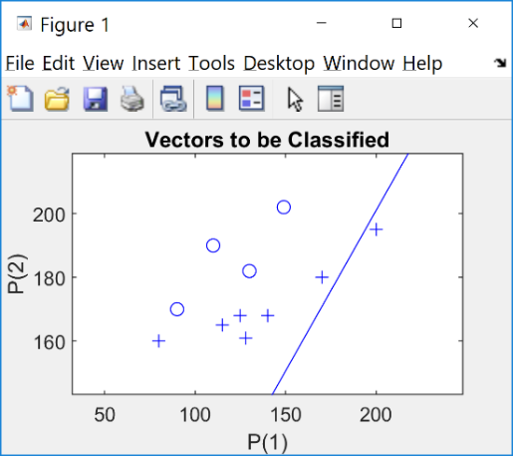
end
disp(strcat('The final perceptron classification squared error is: ', num2str(sse(e)),' after: ', num2str(count), ' adaptations.'));

You will see a sequence of messages similar to:
” The perceptron classification squared error before adaptation51 is:4.”

It isn’t working, again you should see a flickering line (stop it with Ctrl/c)!
This is getting a bit frustrating, but don’t give up, we shall try something else!

Let’s preprocess (standardize) the data, so that it has 0 mean and unit (1) standard deviation. We can use the mapstd()function, which processes the data by mapping its mean and standard deviations to 0 and 1 respectively (you can always use help to read more about it).
[Z, settings] = mapstd(IN)
plotpv(Z, TARGET)
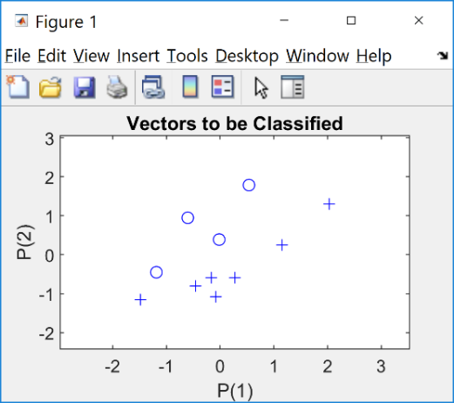
You will see (right) the same class distribution, just with a standardised data (Z now contains the standardised inputs). You can try:
std(Z')
and you will see that the data now has a unit (1) std.
So, let’s try to train the net again:
net= perceptron();
net= configure(net,Z,TARGET);
hold on
linehandle= plotpc(net.IW{1},net.b{1});
e = 1;
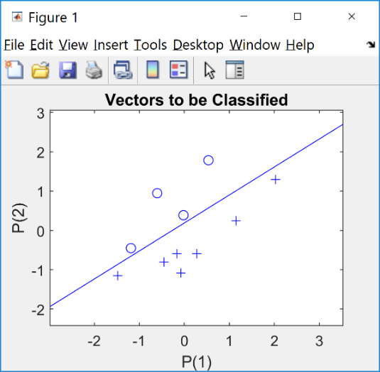
while (sse(e))
[net,Y,e] = adapt(net,Z,TARGET);
linehandle = plotpc(net.IW{1},net.b{1},linehandle);
drawnow;
end

At the end, success (see the figure to the right)!

How do we know if the training was successful and the network learned to generalise?
Firstly, we will simulate the action of the net (using the sim() function) on the same data and expect to see correct classification.
Y = sim(net,Z)
Does your simulation produce the same outputs in Y as the ones in TARGET? Try

Y-TARGET

If you get 11 zeroes, the net training was OK, it can classify this particular (already seen) data.

But it doesn’t mean it can generalize!
Now, to see if the trained NN can generalize, we shall test it on unseen data.

In file stdData.txt, the following four samples (columns):
-2.5 -2.2 0.23 1.5
-2.0 1.3 -0.69 2.1
and their labels (class labels) are saved:
1 0 1 0
Load the data with (make sure the file is in the path):
data = load('stdData.txt')
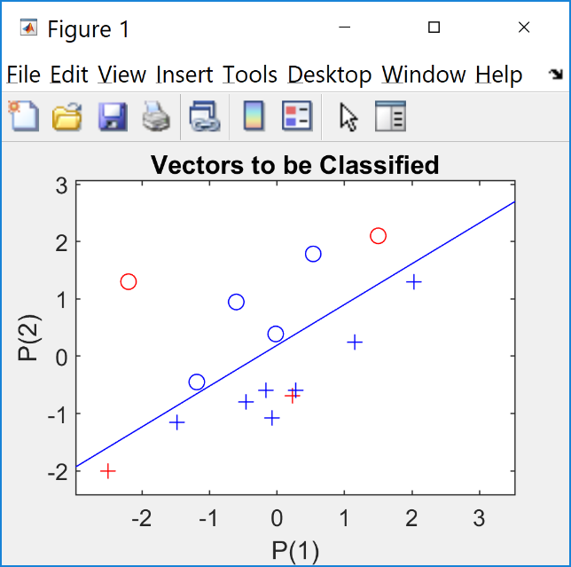
Get the inputs/outputs only:

TInput = data(1:2,:)
TOutput = data(3,:)

And test the net object generalization abilities:
Y= net(TInput) % or Y=sim(net,TInput)
plotpv(TInput,Y);
circle = findobj(gca,'type','line');
set(circle,'Color','red');
hold on;
plotpv(Z,TARGET);
plotpc(net.IW{1},net.b{1});
hold off;
The new test samples (given in red in the fig.) are correctly classified, so we can assume that the training was successful and the NN (saved in object net) can generalize! (Is there something wrong with the test samples?)

Nonlinear classification problem.

Now, try to do the same with the data bellow, i.e., try to train a perceptron that can clasify the data, as given in the target column. Call your data file perceptronData2.m (just type the filename perceptronData2 in the command window).
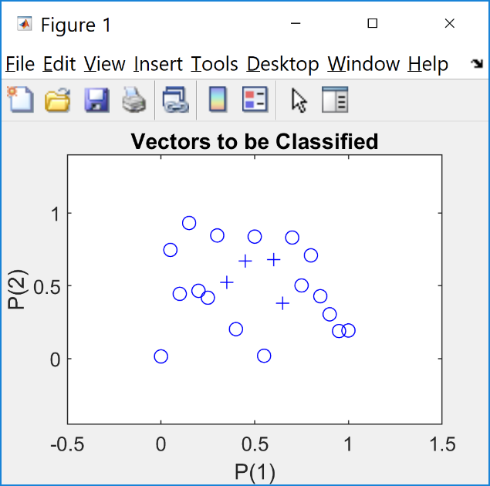
x y category/class
0.0e+000 1.5273927e-002 0
5.0e-002 7.4678568e-001 0
1.0e-001 4.4509643e-001 0
1.5e-001 9.3181458e-001 0
2.0e-001 4.6599434e-001 0
2.5e-001 4.1864947e-001 0
3.0e-001 8.4622142e-001 0
3.5e-001 5.2515250e-001 1
4.0e-001 2.0264736e-001 0
4.5e-001 6.7213747e-001 1
5.0e-001 8.3811845e-001 0
5.5e-001 1.9639514e-002 0
6.0e-001 6.8127716e-001 1
6.5e-001 3.7948102e-001 1
7.0e-001 8.3179602e-001 0
7.5e-001 5.0281288e-001 0
8.0e-001 7.0947139e-001 0
8.5e-001 4.2889237e-001 0
9.0e-001 3.0461737e-001 0
9.5e-001 1.8965375e-001 0
1.0e+000 1.9343116e-001 0

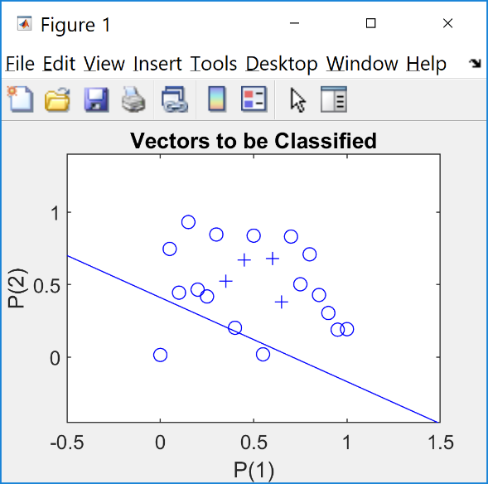
Visualize the data:

Data = perceptronData2
IN = Data(:,1:2)'
TARGET = Data(:,3)'
plotpv(IN, TARGET)

Try to train a perceptron to classify it (use Ctrl/c again to stop the line flickering):
net1 = perceptron('hardlim','learnpn');
net1 = configure(net1,IN,TARGET);
hold on
linehandle = plotpc(net1.IW{1},net1.b{1});
e = 1;
while (sse(e))
[net1,Y,e] = adapt(net1,IN,TARGET);
linehandle = plotpc(net1.IW{1},net1.b{1},linehandle);
drawnow;
end
Obviously, a single perceptron can’t classify it, because it is a nonlinear problem!

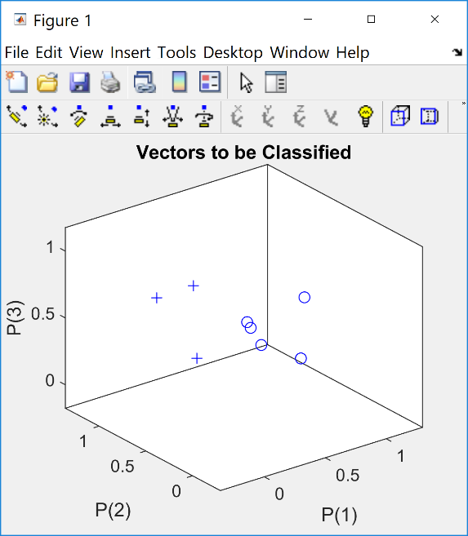
If you have time write an m-file, which will create a perceptron to classify a given dataset presented in a 3 column matrix Data, similar to the matrices you have been working with (but of course you will want it to work with a matrix with any number of rows). Then modify the m-file, so that it can classify n (> 2) dimensional data using a simple perceptron. From the “View” on your Figure toolbar, you can choose the “Camera Toolbar” to edit your figure.

Test your perceptron on the data from perceptronData3.txt file. Save the code below as perceptron3.m file and run it
Data = load('perceptronData3.txt')
IN = Data(:,1:3)'
TARGET = Data(:,4)'
plotpv(IN, TARGET)
net2 = perceptron('hardlim','learnpn');
net2 = configure(net2,IN,TARGET);
hold on
linehandle = plotpc(net2.IW{1},net2.b{1});
e = 1;
while (sse(e))
[net2,Y,e] = adapt(net2,IN,TARGET);
linehandle = plotpc(net2.IW{1},net2.b{1},linehandle);
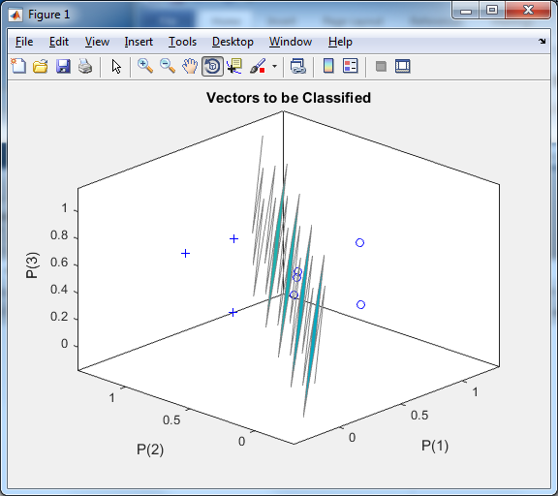
drawnow;
end

Then use your mouse to rotate/visualize from different angles the figure displayed by Matlab (to the right).

You can see the parameters of the new object net2 and view the architecture:

net2
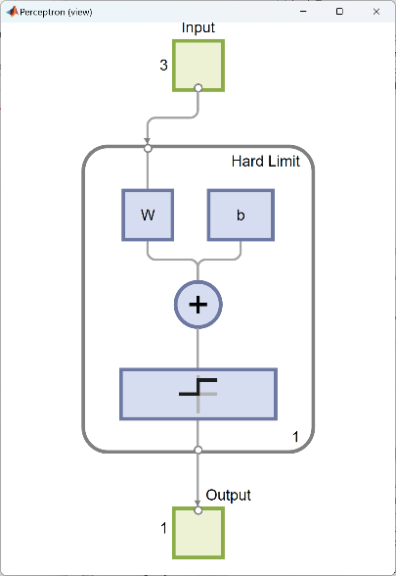
view (net2)

