

School of Computing
M33147-INTELLIGENT DATA AND TEXT ANALYTICS
Coursework 2
Date of Submission: 19/01/2026
Module Lecturers: Dr Atefeh Khazaei, Dr Ella Haig, Dr Alaa Mohasseb, Dr Grace Golcarenarenji
Student ID: UP2154598

Table of Content

Chapter 1: Introduction 5
Chapter 2: Text Pre-processing 6
2.1 Remove Noise: Punctuations and Numbers 6
2.2 Vocabulary Reduction: Stop Word Filtration 7
2.3 Text Normalisation: Convert to Lower Case 8
2.4 Lemmatisation 9
Chapter 3: Classification 11
3.1 Bag-of-Words and TF-IDF 11
3.2 Exploratory Feature Analysis 11
3.3 Experiment Setup and Algorithms 13
3.3.1 Decision Tree (DT) 13
3.3.2 Naïve Bayes (NB) 16
3.3.3 Support Vector Machine (SVM) 17
3.4 Comparative Analysis 18
Chapter 4: BERT Implementation 20
4.1 BERT Implementation and Fine-Tuning 20
4.2 Results and Discussion 20
4.3 Comparative Analysis 22
Chapter 5: Topic Detection 24
5.1 Methodology and Algorithm Selection 24
5.2 Analysis of Detected Topics 25
5.3 Data Visualisation 27
Chapter 6: Conclusion 30

List of Figures

Figure3.2.1: Distribution of TF-IDF Weights for the Term 'movie'. 13
Figure3.3.1.1: Confusion Matrix of Decision Tree (TF-IDF) 14
Figure3.3.1.2: Receiver Operating Characteristic (ROC) Curve for Decision Tree 15
Figure3.3.2.1: Confusion Matrix of Multinomial Naive Bayes (TF-IDF). 16
Figure3.3.3.1: Confusion Matrix of Support Vector Machine (BoW). 18
Figure3.4.1: Comparison of Accuracy Scores across Algorithms. 19
Figure4.2.1: Training and Validation Loss/Accuracy Curves. 21
Figure4.2.2: Confusion Matrix of BERT. 22
Figure5.1.1: Distribution of Review Text Lengths before (left) and after (right) pre-processing. 24
Figure5.2.1: Topics (1-9) with Top 9 Words in Each Topic. 27
Figure5.3.1: Intertopic Distance Map. 28
Figure5.3.2: Document Distribution and Topic Density. 29

List of Tables

Table2.1.1: Impact of Noise Removal of Punctuations and Numbers on Reviews. 7
Table2.2.1: Impact of Stop-Word Removal on Reviews. 8
Table2.3.1: Convert All Texts into Lower Case. 9
Table2.4.1: Impact of Lemmatisation on Reviews. 10
Table3.2.1: Top 10 Most Frequent Words by TF-IDF Weight. 12
Table3.2.2: Descriptive Statistics for the Term 'movie' (n=1000). 12
Table3.3.1.1: Performance Metrics for Decision Tree Classifier (TF-IDF). 14
Table3.3.2.1: Performance Metrics for Naive Bayes Classifier (TF-IDF). 16
Table3.3.3.1: Performance Metrics for SVM Classifier (BoW). 17
Table4.2.1: Classification Report for BERT Model. 21
Table4.3.1: Accuracies of Different Approaches. 23
Table5.2.1: Summary of Extracted Topics and Keywords 26

Chapter 1: Introduction
This report presents a text mining analysis of the IMDb labelled dataset for sentiment classification and topic detection. The scope of this study encompasses the complete natural language processing pipeline. The dataset comprises 1000 labelled reviews, equally balanced between positive and negative sentiments. Initially, the raw textual data undergoes pre-processing, including noise removal in punctuation, numerical, stop words, changing all uppercase letters to lowercase letters, and lemmatisation, to enhance the quality of the input features. Following this, the textual data is transformed into a numerical representation using the Term Frequency Inverse Document Frequency (TF-IDF) weighting scheme.
A core component of this report is the comparative analysis of classification algorithms. The performance of machine learning models, specifically Naive Bayes, Decision Tree, and SVM, is produced and evaluated against a BERT model. This comparison aims to critically assess the efficacy of deep learning architectures versus classical probabilistic approaches in handling sentiment analysis tasks. Finally, the report extends beyond supervised classification to unsupervised learning by employing topic modelling techniques to identify themes within the corpus, specifically extracting ten distinct topics. Future work and recommendation is given at the end of the conclusion.

Chapter 2: Text Pre-processing
To prepare the raw IMDb data set for computer analysis, a systematic pre-processing was implemented in advance. The primary objective was to reduce feature dimensionality and eliminate noise that does not contribute to semantic sentiment. This section details the sequential transformations applied to the text, tracking four specific sample reviews through each stage of the process to illustrate the impact of the methodology. The numbers of documents changed after each process is also being counted.

2.1 Remove Noise: Punctuations and Numbers
The initial stage involved cleaning the raw text strings. Punctuation marks were stripped to prevent the model treating original word and word with punctuation as distinct tokens. 999 comments out of 1000 have been modified, indicating that almost all of the documents contain some form of punctuation. Following this, numerical digits were removed. While numbers can be significant in some contexts, in sentiment analysis for film reviews, however, only 69 out of 1000 comments have been modified with this process.
As demonstrated in Table2.1.1, the sentences have been firstly removed all the punctuations, then the numbers have been removed subsequently, leaving only the qualitative text. For instance, Text4 has been removed a comma at the end. Then, number 9 and 10 are replaced with space.

Original Text 1 | A very, very, very slow-moving, aimless movie about a distressed, drifting young man.
Post-Punctuation Removal 1 | A very very very slowmoving aimless movie about a distressed drifting young man
Post-Numerical Removal 1 | A very very very slowmoving aimless movie about a distressed drifting young man
Original Text 2 | Not sure who was more lost - the flat characters or the audience, nearly half of whom walked out.
Post-Punctuation Removal 2 | Not sure who was more lost the flat characters or the audience nearly half of whom walked out
Post-Numerical Removal 2 | Not sure who was more lost the flat characters or the audience nearly half of whom walked out
Original Text 3 | Attempting artiness with black & white and clever camera angles, the movie disappointed - became even more ridiculous - as the acting was poor and the plot and lines almost non-existent.
Post-Punctuation Removal 3 | Attempting artiness with black white and clever camera angles the movie disappointed became even more ridiculous as the acting was poor and the plot and lines almost nonexistent
Post-Numerical Removal 3 | Attempting artiness with black white and clever camera angles the movie disappointed became even more ridiculous as the acting was poor and the plot and lines almost nonexistent
Original Text 4 | All in all I give this one a resounding 9 out of 10.
Post-Punctuation Removal 4 | All in all I give this one a resounding 9 out of 10
Post-Numerical Removal 4 | All in all I give this one a resounding out of
Table2.1.1: Impact of Noise Removal of Punctuations and Numbers on Reviews.

2.2 Vocabulary Reduction: Stop Word Filtration
The third stage involved filtering 'stop words'. These are high-frequency functional words, such as "the", "is", "and", "of", that possess high syntactic density but low semantic content. Using the NLTK library's standard English stop-word list, these tokens were excised.
This step was highly effective, modifying 1000 out of 1000 reviews. As displayed in Table2.2.1, by comparing with the original context and the Post-Numerical Removal text, this process significantly reduced the sentence length.

Original Text 1 | A very, very, very slow-moving, aimless movie about a distressed, drifting young man.
Post-Numerical Removal 1 | A very very very slowmoving aimless movie about a distressed drifting young man
Post-Stop Word Removal 1 | slowmoving aimless movie distressed drifting young man
Original Text 2 | Not sure who was more lost - the flat characters or the audience, nearly half of whom walked out.
Post-Numerical Removal 2 | Not sure who was more lost the flat characters or the audience nearly half of whom walked out
Post-Stop Word Removal 2 | sure lost flat characters audience nearly half walked
Original Text 3 | Attempting artiness with black & white and clever camera angles, the movie disappointed - became even more ridiculous - as the acting was poor and the plot and lines almost non-existent.
Post-Numerical Removal 3 | Attempting artiness with black white and clever camera angles the movie disappointed became even more ridiculous as the acting was poor and the plot and lines almost nonexistent
Post-Stop Word Removal 3 | Attempting artiness black white clever camera angles movie disappointed became even ridiculous acting poor plot lines almost nonexistent
Original Text 4 | All in all I give this one a resounding 9 out of 10.
Post-Numerical Removal 4 | All in all I give this one a resounding out of
Post-Stop Word Removal 4 | give one resounding
Table2.2.1: Impact of Stop-Word Removal on Reviews.

2.3 Text Normalisation: Convert to Lower Case
The final phase ensured consistency across the vocabulary. First, all characters were converted to lower case. This step modified 483 out of 1000 reviews, ensuring that capitalised words at the beginning of sentences were treated identically to their mid-sentence counterparts rather than an identical word. For instance, in example Text3 in the Table2.3.1, the word “Attempting” is converted into “attempting”.

Original Text 1 | A very, very, very slow-moving, aimless movie about a distressed, drifting young man.
Post-Stop Word Removal 1 | slowmoving aimless movie distressed drifting young man
Lower Cased Text 1 | slowmoving aimless movie distressed drifting young man
Original Text 2 | Not sure who was more lost - the flat characters or the audience, nearly half of whom walked out.
Post-Stop Word Removal 2 | sure lost flat characters audience nearly half walked
Lower Cased Text 2 | sure lost flat characters audience nearly half walked
Original Text 3 | Attempting artiness with black & white and clever camera angles, the movie disappointed - became even more ridiculous - as the acting was poor and the plot and lines almost non-existent.
Post-Stop Word Removal 3 | Attempting artiness black white clever camera angles movie disappointed became even ridiculous acting poor plot lines almost nonexistent
Lower Cased Text 3 | attempting artiness black white clever camera angles movie disappointed became even ridiculous acting poor plot lines almost nonexistent
Original Text 4 | All in all I give this one a resounding 9 out of 10.
Post-Stop Word Removal 4 | give one resounding
Lower Cased Text 4 | give one resounding
Table2.3.1: Convert All Texts into Lower Case.

2.4 Lemmatisation
Finally, lemmatisation was applied using the WordNetLemmatizer. Unlike stemming, which crudely truncates words, lemmatisation analyses morphological structure to return words to their dictionary base form. This step affected 717 out of 1000 reviews. Table2.4.1 highlights the necessity of this step, revisiting Text3 as an example again, the word “attempting” is normalised to “attempt”, “disappointed” converted into “disappoint”, and the word “acting” is changed into “act”. This ensures that the subsequent classification algorithms recognise different inflections as the same semantic concept, thereby condensing the feature space without losing meaning.

Original Text 1 | A very, very, very slow-moving, aimless movie about a distressed, drifting young man.
Lower Cased Text 1 | slowmoving aimless movie distressed drifting young man
Lemmatising Text 1 | slowmoving aimless movie distressed drift young man
Original Text 2 | Not sure who was more lost - the flat characters or the audience, nearly half of whom walked out.
Lower Cased Text 2 | sure lost flat characters audience nearly half walked
Lemmatising Text 2 | sure lose flat character audience nearly half walk
Original Text 3 | Attempting artiness with black & white and clever camera angles, the movie disappointed - became even more ridiculous - as the acting was poor and the plot and lines almost non-existent.
Lower Cased Text 3 | attempting artiness black white clever camera angles movie disappointed became even ridiculous acting poor plot lines almost nonexistent
Lemmatising Text 3 | attempt artiness black white clever camera angle movie disappointed become even ridiculous act poor plot line almost nonexistent
Original Text 4 | All in all I give this one a resounding 9 out of 10.
Lower Cased Text 4 | give one resounding
Lemmatising Text 4 | give one resound
Table2.4.1: Impact of Lemmatisation on Reviews.

At the end, the resulting pre-processing texts are now reduced to its essential semantic components, serves as the input for the vectorisation stage described in the following section.

Chapter 3: Classification
Following the noise removal stage, the textual data was transformed into a numerical formatting suitable for computational modelling. This section addresses the core classification task, detailing the feature representation method, the experimental setup for three selected algorithms, and a critical comparative evaluation of their performance.

3.1 Bag-of-Words and TF-IDF
To translate the unstructured linguistic content into machine readable vectors, the Bag-of-Words model was deployed. While a standard count vectoriser simply tallies word occurrences, this study utilised the Term Frequency-Inverse Document Frequency (TF-IDF) weighting scheme to provide a more robust representation.
The TF-IDF transformation operates on two statistical principles:
- Term Frequency (TF): Measures the local importance of a word within a specific review.
- Inverse Document Frequency (IDF): Penalises words that appear ubiquitously across the reviews, thereby assigning higher weights to discriminative terms that help distinguish between positive and negative sentiments.
The vectoriser was configured with a theoretical upper limit of 10,000 features to accommodate a broad vocabulary. However, following the pre-processing steps, the reviews was detailed down to 2,626 unique terms as the result. Consequently, the full corpus of 1000 reviews were converted into a matrix of shape (1000, 2626), capturing the complete vocabulary without truncation. This matrix served as the input features for the classifiers.

3.2 Exploratory Feature Analysis
The top 10 features with the highest cumulative TF-IDF scores across the corpus were extracted. As shown in Table3.2.1, the most significant terms include a mixture of domain-specific nouns, for example, “movie” and “film”, and high-polarity sentiment adjectives, for instance, “bad” and “great”. The presence of these sentiment indicators in the top features confirms that the TF-IDF transformation successfully highlighted words relevant for the classification task.

1st | 2nd | 3rd | 4th | 5th | 6th | 7th | 8th | 9th | 10th
movie | film | bad | one | see | good | like | watch | really | great
Table3.2.1: Top 10 Most Frequent Words by TF-IDF Weight.

The highest-ranked term, “movie”, reveals the inherent sparsity of the feature matrix. Table3.2.2 presents the descriptive statistic for this feature’s TF-IDF weights.

count | 1000.000000
mean | 0.040069
std: | 0.093317
min: | 0.000000
25% | 0.000000
50% | 0.000000
75% | 0.000000
max | 0.598910
Table3.2.2: Descriptive Statistics for the Term 'movie' (n=1000).

Figure3.2.1 provides a visual confirmation of the feature sparsity. The histogram shows a heavily right-skewed distribution, with a massive peak at 0.0. This visually demonstrates that while "movie" is the most frequent term globally, it is absent from the vast majority of individual document vectors. The distinct "long tail" extending towards 0.6 represents the subset of reviews where the term explicitly appears and carries varying degrees of TF-IDF weight. This confirms that the dataset is composed primarily of zero-values, justifying the use of sparse matrix operations and probabilistic models like Naive Bayes.

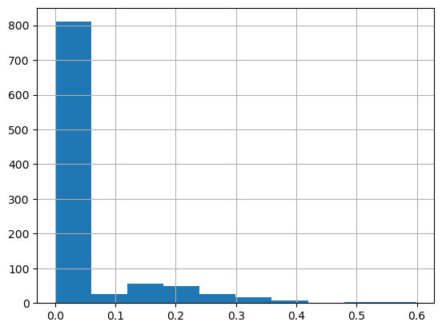
Figure3.2.1: Distribution of TF-IDF Weights for the Term 'movie'.

3.3 Experiment Setup and Algorithms
To evaluate the efficacy of the extracted features, three distinct classification algorithms were selected: Decision Tree (DT), Naive Bayes (NB), and Support Vector Machine (SVM). These algorithms were selected to represent different learning paradigms: rule-based, probabilistic, and linear discriminative modelling, respectively.
For each algorithm, models were trained using both the Bag-of-Words and TF-IDF feature sets. Performance was evaluated using Accuracy, Precision, Recall, and F1-score, with a specific focus on the metrics for each sentiment class (Positive and Negative) to detect potential biases.

3.3.1 Decision Tree (DT)
The Decision Tree classifier was deployed using the entropy criterion. As anticipated for high-dimensional text data, the Decision Tree yielded the lowest performance among the selected algorithms.
 | Precision | Recall | F1-score | Accuracy
Positive | 0.61 | 0.63 | 0.62
Negative | 0.68 | 0.67 | 0.68
Weighted Ave | 0.65 | 0.65 | 0.65 | 0.65
Table3.3.1.1: Performance Metrics for Decision Tree Classifier (TF-IDF).

As presented in Table3.3.1.1, the model achieved an accuracy of 65% using TF-IDF features. The performance was marginally lower using Bag-of-Word features with 62.5% in accuracy. The confusion matrix indicated a significant number of misclassifications, with 34 false positives and 36 false negatives.

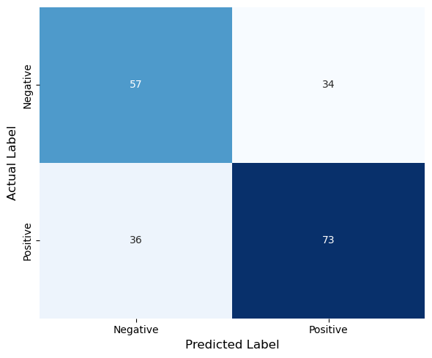
Figure3.3.1.1: Confusion Matrix of Decision Tree (TF-IDF)

Figure3.3.1.1 illustrates the confusion matrix for the Decision Tree. The error distribution is relatively symmetrical, with 34 False Positives (negative reviews incorrectly labelled as positive) and 36 False Negatives (positive reviews that missed). This balance in errors suggests that the model does not exhibit a strong bias towards a single class; rather, it struggles generally to separate the two sentiments, likely due to the algorithm's tendency to overfit on the sparse feature space of textual data.

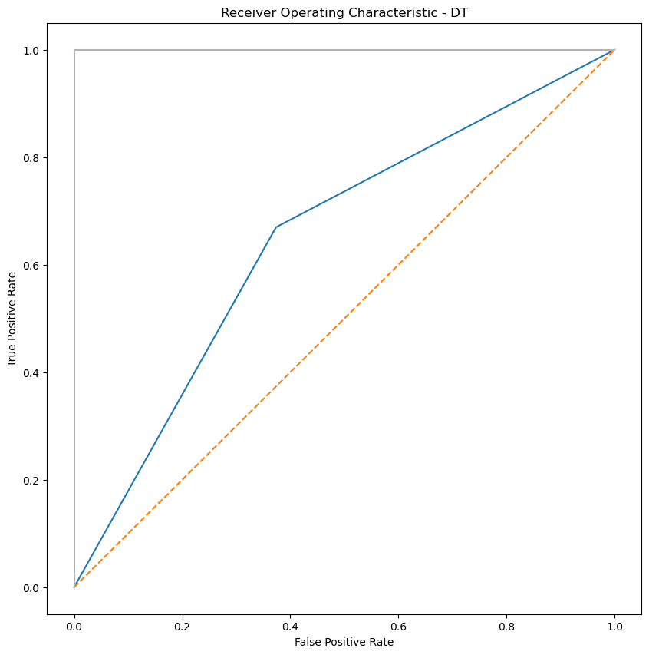
Figure3.3.1.2: Receiver Operating Characteristic (ROC) Curve for Decision Tree

Figure 3.3.1.2 illustrates the ROC curve for the Decision Tree. The curve deviates only slightly from the diagonal line of no-discrimination, yielding an Area Under the Curve (AUC) score of approximately 0.648. This visualises the model’s limited ability to distinguish between positive and negative reviews, likely due to the algorithm's tendency to overfit on the sparse feature space of textual data.

3.3.2 Naïve Bayes (NB)
The Naïve Bayes classifier, which assumes independence between features, demonstrated superior performance.

 | Precision | Recall | F1-score | Accuracy
Positive | 0.74 | 0.79 | 0.77
Negative | 0.82 | 0.77 | 0.79
Weighted Ave | 0.78 | 0.78 | 0.78 | 0.78
Table3.3.2.1: Performance Metrics for Naive Bayes Classifier (TF-IDF).

Table3.3.2.1 indicates that NB model achieved the highest accuracy of 78% with TF-IDF vectors. Notably, the precision and recall scores are balanced across both positive and negative classes (0.79 against 0.77 recall). This suggests that the probabilistic assumption of the Naive Bayes model aligns well with the distribution of word frequencies in the dataset.

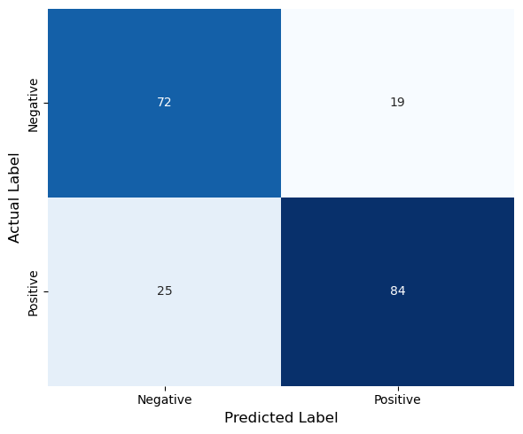
Figure3.3.2.1: Confusion Matrix of Multinomial Naive Bayes (TF-IDF).
The confusion matrix in Figure3.3.2.1 reveals a significant reduction in misclassifications compared to the Decision Tree. Notably, the model achieved a high number of True Negatives (72) and kept False Positives low (19). This indicates that the Naive Bayes classifier is particularly robust at correctly identifying negative sentiments, rarely mistaking a criticism for praise.

3.3.3 Support Vector Machine (SVM)
A linear Support Vector Machine by using SGDClassifier, was applied to find an optimal hyperplane separating the two sentiment classes. Unlike the other classifiers, the SVM achieved slightly higher accuracy of 72.5% with the Bag-of-Words feature compared to 71.5% of the TF-IDF feature.

 | Precision | Recall | F1-score | Accuracy
Positive | 0.72 | 0.65 | 0.68
Negative | 0.73 | 0.79 | 0.76
Weighted Ave | 0.72 | 0.72 | 0.72 | 0.725
Table3.3.3.1: Performance Metrics for SVM Classifier (BoW).

The SVM model achieved an accuracy of 72.5%. However, a closer inspection of the class-level metrics reveals a disparity. The model performed significantly better on the Negative class (Recall 0.79) compared to the Positive class (Recall 0.65). This indicates a bias where the hyperplane is effective at identifying negative sentiment markers but struggles to capture the nuances of positive reviews.

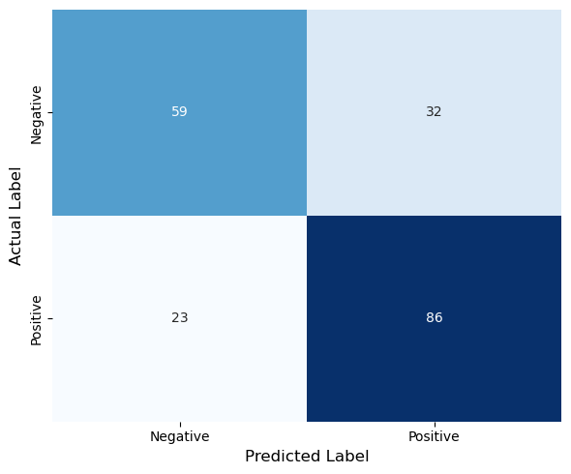
Figure3.3.3.1: Confusion Matrix of Support Vector Machine (BoW).

Figure 3.3.3.1 highlights a distinct behaviour in the SVM's predictions. While the False Negatives (23) are comparable to Naive Bayes, the False Positives (32) are noticeably higher. This increase in False Positives compared to Naive Bayes indicates that the SVM hyperplane is more aggressive in classifying reviews as 'Positive'. Consequently, while it captures most positive reviews, it sacrifices precision by incorrectly labelling a significant portion of negative reviews as positive.

3.4 Comparative Analysis
Across all three algorithms, the TF-IDF representation outperformed or matched the Bag-of-Word approach. In Naïve Bayes, Bag-of-Word approach has precision of 0.765 and the TF-IDF approach has 0.78. In Decision Tree, Bag-of-Word approach has precision of 0.625 and the TF-IDF approach has 0.65. This confirms that penalising common word helps the classifiers focus on semantically rich terms, reducing the impact of noise.

Figure3.4.1: Comparison of Accuracy Scores across Algorithms.

Naïve Bayes model emerged as the most robust model for this specific task. Its success can be attributed to its ability to handle high-dimensional, sparse data effectively. In contrast, the Decision Tree performed poorly, with 0.13 lower accuracy than NB model. This suggests that DT struggle to create generalised rules from the vast vocabulary without overfitting. Naïve Bayes also significantly outperformed SVM in avoiding False Positives. In the context of sentiment analysis, this means Naïve Bayes is more reliable when flagging a review as negative.
SVM, however, showed a marginal performance dip when using TF-IDF. This anomaly could be attributed to the relatively small size of the dataset, as only 200 test samples, where the raw frequency of strong sentiment words proved slightly more predictive than their weighted counterparts for the linear separator. Nevertheless, the difference is only 0.1, suggesting that both feature sets provide comparable information for the SVM. The confusion matrix for SVM demonstrated a bias towards the positive class, resulting in a lower recall for positive reviews compared to negative ones.

In conclusion, the probabilistic approach of Naive Bayes provided the best balance between precision and recall for this specific dataset, effectively managing the trade-off between identifying true sentiments and avoiding false alarms.

Chapter 4: BERT Implementation
To further research on the limitations of Bag-of-Words approach identified in Chapter3, this study progressed to a deep learning methodology utilising Bidirectional Encoder Representations from Transformers (BERT). Unlike traditional models that treat words as independent tokens, BERT leverages an attention mechanism to understand the contextual relationship between words, capturing semantic nuances such as sarcasm and negation.

4.1 BERT Implementation and Fine-Tuning
A small BERT architecture, bert_en_uncased_L-4_H-512_A-8, was selected rather than the full BERT-base model. This lighter architecture retains the core contextual understanding of BERT while significantly reducing training time and memory usage. The implementation utilised the TensorFlow and Hugging Face transformers library. The textual data was pre-processed using the corresponding BERT tokenizer. The dataset was split into training (600 samples), validation (200 samples), and testing (200 samples) sets.
The model was fine-tunned for binary classification using AdamWeightDecay with an initial learning rate of 3e-5 as default, a Binary Cross-Entropy Loss Function, 6 epochs with a batch size of 16. The total training process required approximately 20 minutes, with 3 minute per epoch in average.

4.2 Results and Discussion
The training process exhibited rapid convergence. As illustrated in Figure4.2.1, the training loss decreased significantly from an initial 0.69 to 0.11 by the sixth epoch. The validation accuracy as indicated in blue, tracked the training accuracy closely, reaching a plateau around 0.92. This indicates that the model successfully generalised patterns without suffering from the severe overfitting often associated with deep neural networks on small datasets.

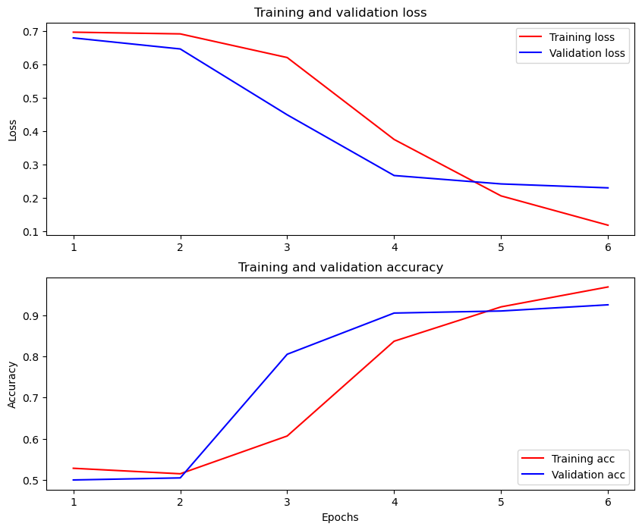
Figure4.2.1: Training and Validation Loss/Accuracy Curves.

Upon evaluation on the held-out test sets, the fine-tuned BERT model achieved an impressive Accuracy of 93% and an AUC score of 0.93.

 | Precision | Recall | F1-score | Support
0 | 0.90 | 0.97 | 0.93 | 100
1 | 0.97 | 0.89 | 0.93 | 100
Accuracy |  |  | 0.93 | 200
Table4.2.1: Classification Report for BERT Model.

The classification report in Table4.2.1 reveals that the model is exceptionally balanced. Unlike the SVM model in Chapter 3, which struggled with precision, BERT maintained high precision and recall across both sentiment classes.
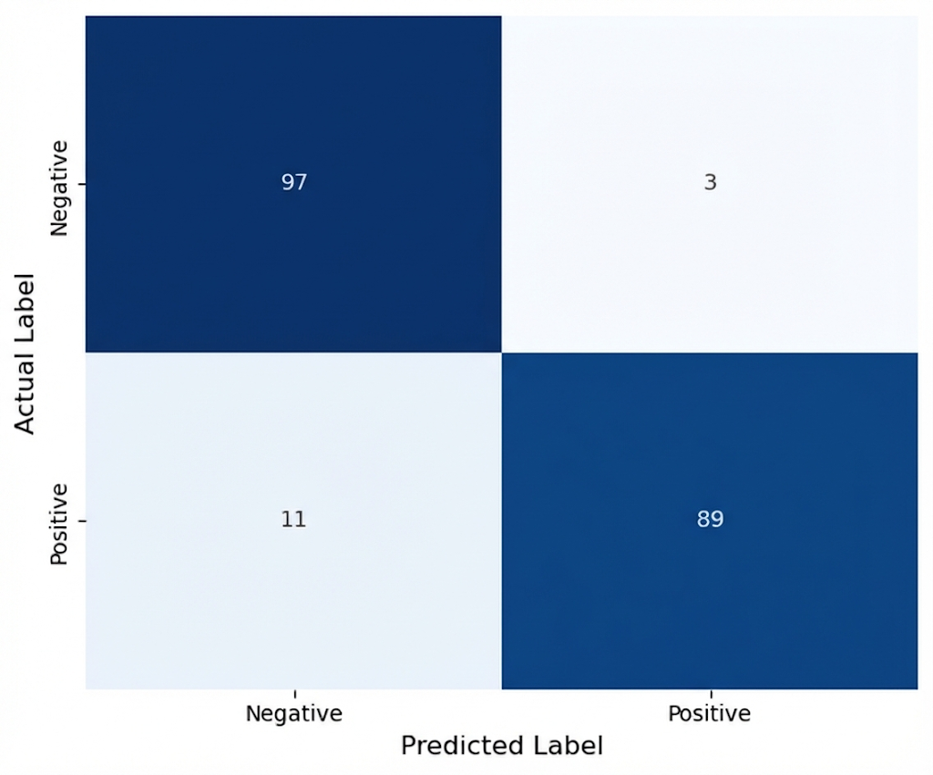
Figure4.2.2: Confusion Matrix of BERT.

The confusion matrix further corroborates this robustness with True Negative of 97, and only 3 False Negative, and 89 True Positive with 11 False Positive. The extreme low False Positive rate demonstrates the model’s superior ability to discern subtle negative sentiments that traditional models might miss.

4.3 Comparative Analysis
After using light-weighted BERT model with fine tuning, we are now able to compare the result with 3 algorithms, Naïve Bayes, Decision Tree, and SVM that have been used and discussed in Chapter 3. The comparison considers both accuracy and the underlying theoretical limitations of each approach. As shown in Table4.3.1, the deep learning approach (BERT) yielded a substantial performance improvement over all traditional baselines.

Method/Model | Accuracy
BERT | 0.93
Decision Tree (BoW) | 0.625
Decision Tree (TF-IDF) | 0.65
Naïve Bayes (BoW) | 0.765
Naïve Bayes (TF-IDF) | 0.78
SVM (BoW) | 0.725
SVM (TF-IDF) | 0.715
Table4.3.1: Accuracies of Different Approaches.

The Decision Tree was the weakest performer in this study, achieving accuracy of 62.5% in BoW and 65% in TF-IDF. BERT achieved 93%, with a difference of approximately 30%. This could be because Decision Trees in text classification often suffer from instability and overfitting to specific keywords in the training set. BERT utilises pre-trained knowledge from a massive corpus, allowing it to generalise far better on unseen test data rather than relying on brittle if-then rules derived from a small vocabulary.
The SVM model achieved 72.5% accuracy with Bag-of-Words, which Is 20.5% lower than BERT. This is due to the linear SVM attempts to find a hyperplane to separate positive and negative sentiments based on word presence. However, sentiment is often non-linear, for examples, the sarcasm. BERT maps words into a high-dimensional contextual embedding space where these complex, non-linear relationships are computationally resolved via the self-attention mechanism, far exceeding the capacity of a linear separator.
Naïve Bayes was the best performing model in Chapter 3, with 78% accuracy, yet BERT still outperformed Naïve Bayes by a significant margin of 15%. The fundamental flaw of the Naïve Bayes algorithm is the “independence assumption” it holds. Under this principle, it will treat every word as independent of its neighbours. For example, it sees “not” and “good” as separate probabilities. BERT processes the entire sequence simultaneously. Its attention heads explicitly model the relationship between "not" and "good", understanding that the former negates the latter. This shift from independent probability in Naïve Bayes to contextual dependency in BERT, is the primary driver of the 15% accuracy gain.
Overall, the experimental results confirm that for complex natural language tasks, the contextual dependency method offers a statistically significant advantage over BoW and TF-IDF. Although BERT requires significantly more computational resources, the reward is promising with high accuracy.

Chapter 5: Topic Detection
After the supervised classification, an unsupervised topic modelling approach was employed to uncover topics within the IMDb reviews. Unlike classification, which predicts predefined labels, topic modelling discovers hidden semantic patterns without prior annotation.

5.1 Methodology and Algorithm Selection
The corpus was loaded and pre-processed. Unlike Chapter 2, to ensure high quality input, an advanced lemmatization strategy was implemented using NLTK’s WordNetLemmatizer with Part-of Speech (POS) tagging. This technique distinguishes between word usages to preserve sematic accuracy. The distribution of review lengths before pre-process and after pre-process was analysed to understand the corpus structure. As shown in Figure5.1.1, the data exhibits a right-skewed distribution. It suggests that most reviews are concise.

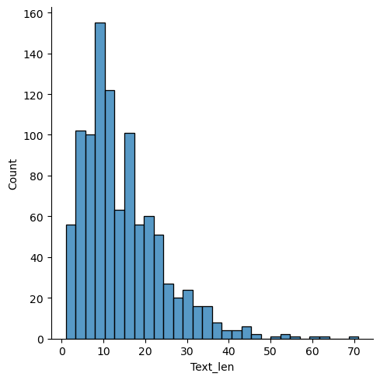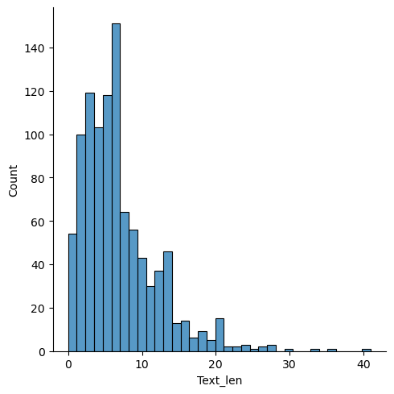
Figure5.1.1: Distribution of Review Text Lengths before (left) and after (right) pre-processing.

For the topic detection task, BERTopic was selected over traditional Latent Dirichlet Allocation (LDA). BERTopic utilises pre-trained transformer embeddings, paraphrase-MiniLM-L3-v2, to capture contextual semantic relationships, making it significantly more effective for short, unstructured text than statistical frequency-based models. The algorithm was configured with parameter to force the reduction of clusters to a manageable, interpretable set of ten distinct themes.

5.2 Analysis of Detected Topics
The model successfully extracted ten topics. A summary of the topics, their document counts, and top keywords is presented.

Topic | Count | Name | Top Words
-1 | 394 | bad_didnt_character_work | bad, didnt, character, work, good, scene, even, much, act, really
0 | 239 | actor_like_watch_movie | actor, like, watch, movie, film, character, well, cast, good, great
1 | 123 | love_funny_recommend_great | love, funny, recommend, great, good, really, worth, give, fun, definitely
2 | 123 | bad_act_awful_dialogue | bad, act, awful, dialogue, stupid, say, even, terrible, thing, well
3 | 39 | waste_boring_dont_time | waste, boring, dont, time, never, money, forget, trash, anyone, lose
4 | 24 | music_song_sound_effect | music, song, sound, effect, soundtrack, speak, shakespear, impressive, subject, score, emotion
5 | 20 | plot_every_hole_there | plot, every, hole, there, line, go, doesnt, nothing, much, way
6 | 15 | never_forget_cease_meaning | never, forget, cease, meaning, wont, nothing, dont, alert, excite, regrettably
7 | 12 | psychological_sense_attention_attempt | psychological, sense, attention, attempt, try, lot, interest, give, loyalty, intensity
8 | 11 | script_flaw_hole_big | script, flaw, hole, big, know, write, finish, coherent, contract, card
Table5.2.1: Summary of Extracted Topics and Keywords

The Topic -1, which comprises the largest share of the corpus with 394 documents. In density-based clustering algorithms, this label designates ‘noise’ or ‘outliers’, which are documents that could not be assigned to any dense cluster with sufficient confidence. These reviews are often too generic or semantically ambiguous to form a cohesive theme. While Topic -1 itself is not a meaningful thematic cluster, it ensures that the remaining Topic 0 to Topic 8 maintain high coherence and semantic density.
The remaining topics are:
- Topic 0: Keywords like actor, watch, film, movie, representing general discussions about the experience of the movie.
- Topic 1: Keywords that are positive and express the feeling of like, words like love, funny, recommend shows all the positive feedback.
- Topic 2: Opposite to Topic 1, these keywords are negative critique. This cluster captures harsh sentiment with words like bad, act, awful, dialogue specifically targeting production quality.
- Topic 3: A specific critique focused on engagement, defined by waste, boring, time.
- Topic 4: Keywords show a general comment about the sound effect on the movies.
- Topic 5: Focuses on writing flaws, highlighted by plot, hole, line.
- Topic 6: Keywords that express general feeling and thoughts with keywords never, forget, cease.
- Topic 7: This is another genre-specific, this cluster focuses on Psychological/Thriller elements.
- Topic 8: This is a topic about scripting. A niche cluster focusing on script flaws.

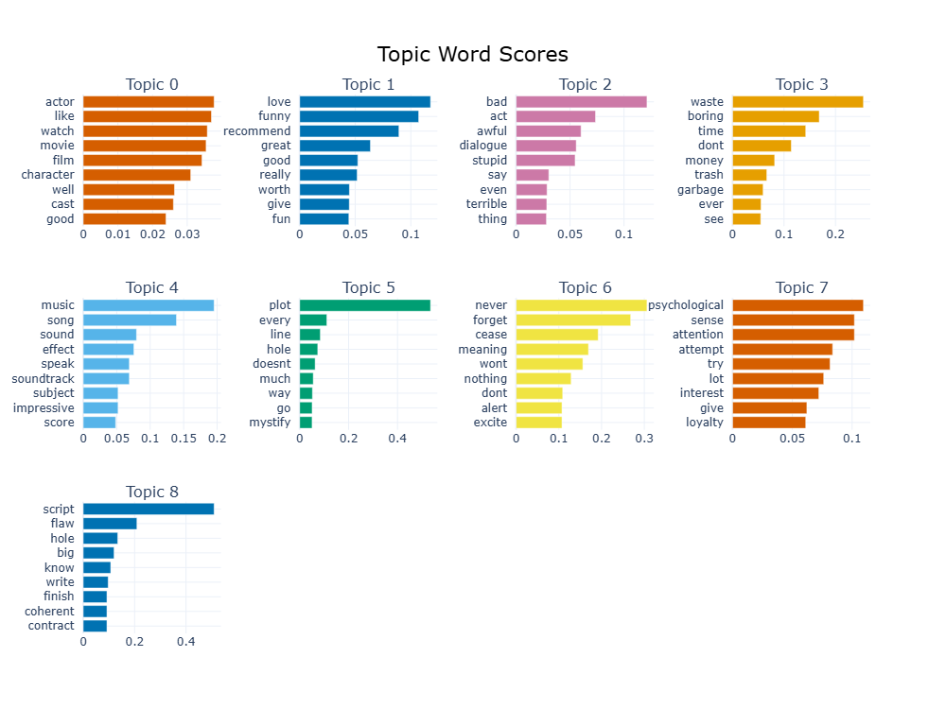
Figure5.2.1: Topics (1-9) with Top 9 Words in Each Topic.

5.3 Data Visualisation
To validate the extracted topics, visualisations of both the semantic distance and the document-level distribution were generated.

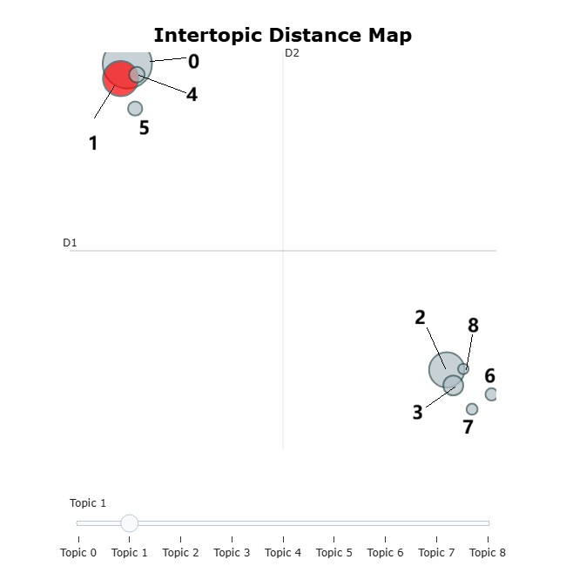
Figure5.3.1: Intertopic Distance Map.

Figure5.3.1 provides a macro-level view of the semantic landscape of our dataset. It shows the groups like Topic 4 and 5 are spatially separated with Topics 6 and 7. It confirming that the model has successfully disentangled different genres. Topic 2 and Topic 3 that both related to negative and critiques, appear closer together and have semantic overlapping with each other on the map.

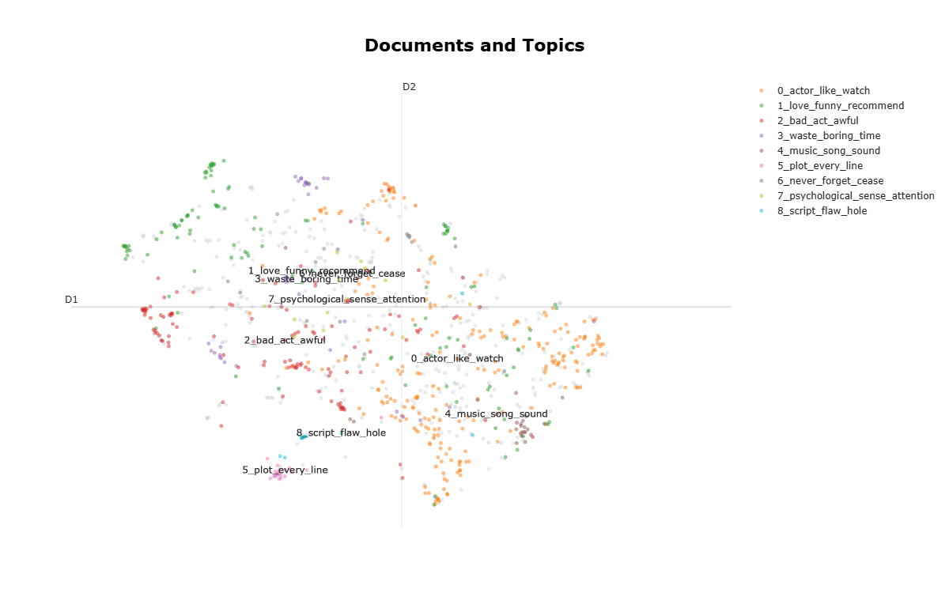
Figure5.3.2: Document Distribution and Topic Density.

Figure5.3.2 offers a detailed view of the dataset by projecting the 384-dimensional BERT embeddings into a 2-dimensional space using UMAP. The coloured clusters represent the coherent topics (0-8). For instance, Topic 2 in the bottom left in reds forms a dense, tight grouping, indicating high semantic consistency among the negative reviews.
The scattered, grey points in the background represent Topic -1. This visualisation empirically justifies the exclusion of these outliers. They are spatially dispersed and do not form the dense structures required to constitute a meaningful theme. This confirms that the model correctly filtered out ambiguous data to preserve the quality of the identified topics.

Chapter 6: Conclusion
This investigation presented an analysis of the IMDb dataset after progressing from fundamental text pre-processing to advanced supervised and unsupervised machine learning techniques. Firstly, the pre-processing pipeline proved essential in reducing the feature dimensionality. The removal of punctuation, numbers, stop words, converting all letters to lower case, and the lemmatisation transformed the raw data into a dense, machine-readable format.
Secondly, the comparative analysis highlighted the limitations of the Naïve Bayes model, the Decision Tree model, and the SVM model. The Naïve Bayes classifier using the TF-IDF approach performed commendably with 78% accuracy. The BERT model was able to achieve an accuracy of 93%, demonstrating a significant improvement over the other three classification methods.
Finally, the unsupervised Topic Detection successfully extracted distinct thematic clusters, ranging from genre-specific discussions to critiques of production quality. The top ten topics were discussed, and their semantic relationship were displayed on a 2-Dimensional map.
Based on the limitations identified during this study, the following recommendations are proposed for future investigations to further enhance model performance and insight generation:
- A significant portion of the corpus was categorised as noise by the BERTopic algorithm. To mitigate this, future work should explore semi-supervised topic modelling. By providing the model with a small set of seed keywords for known genres, the algorithm could be guided to classify ambiguous documents more effectively, thereby reducing the volume of outliers.
- The current analysis was limited to 1,000 reviews. While the Small BERT model generalised well, deep learning models typically thrive on larger datasets. Integrating data augmentation techniques or expanding the dataset to include the full IMDb corpus would likely improve the robustness of the classifier and allow for the training of larger, more complex architectures.
- The SVM model in Chapter 3 exhibited a bias towards the positive class. Future experiments could implement a systematic Grid Search to optimise the regularisation parameter and the kernel coefficient.

