Parallel Programming Lab Book

UP2154598
Table of Content
List of Tables
Lists of Pictures

Lab 01
  - Introduction
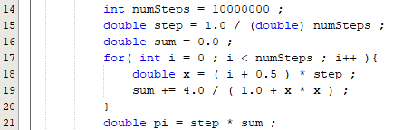

  - Calculating Pi
    - Sequential VS Parallel
At first, we use sequential method to get the time for calculating pi as a benchmark using currentTimeMillis() functions to get the start time, Ts, and end time, Te, of the sequential calculation process. The total time consume, Td, will be time difference between Te and Ts.
By doing that, we get the Td of 50 milliseconds for 10000000 steps.

Then we can move on to parallel programming using two threads. The same method of calculating total time is applied. And this time we get the Td of 28 milliseconds for 10000000 steps.
We can double the number of cores of calculating Pi further to 4 threads. This time the Td is 21 milliseconds for 10000000 steps. And if we increase further to 8 threads, it will be 18 milliseconds for 10000000 steps.
We can you a parameter, parallel speedup, to evaluate the ability of parallel programming under different number of cores are used with 10000000 steps.
 | Sequential (Benchmark) | 2 Threads | 4 Threads | 8 Threads
Total Time (ms) | 50 | 28 | 21 | 18
parallel speedup | 1 | 1.786 | 2.381 | 2.778

    - Increase Time Precision
For now, the function is all using currentTimeMillis() function in millisecond precision. The modern CPU common frequency is about 2.6GHz. This means each oscillation happened within 1.25 millisecond. By further increase the time precision, can give a better understanding on the true power of parallel programming. The total time and the parallel speedup with respective to each scenario are displayed in the table below.
 | Sequential (Benchmark) | 2 Threads | 4 Threads | 8 Threads
Total Time (ns) | 56651600 | 32047700 | 23180600 | 19768400
parallel speedup | 1 | 1.768 | 2.444 | 2.866

  - Conclusion

